Entrees

(Served with choice of steamed rice or fried rice)

Gourmet Delights

|  |  |  |  |
| --- | --- | --- | --- |
| Combination Lo Mein | $13.50 | Singapore Chow Fun | $13.25 |
| Happy Family | $13.25 | Kung Pao Delight | $13.25 |
| Sesame Prawn or Beef | $14.50 |  |  |

Pork

|  |  |  |  |
| --- | --- | --- | --- |
| Moo Shu Pork (with 4 pancakes) | $12.25 | Pork Lo Mein | $11.75 |
| Sweet & Sour Pork | $11.75 | Pork with Mixed Vegetable | $11.75 |

Chicken

|  |  |  |  |
| --- | --- | --- | --- |
| General Tso's Chicken | $11.75 | Lemon Chicken | $12.50 |
| Moo Shu Chicken (with 4 pancakes) | $12.25 | Chicken/Cashew Nuts | $11.75 |
| Sweet & Sour Chicken | $11.75 | Curry Chicken | $11.75 |
| Chicken with Snow Pea | $12.25 | Chicken Lo Mein (soft noodle) | $11.75 |
| Chicken with Broccoli | $12.25 | Chicken/Mixed Vegetables | $11.75 |
| Kung Pao Chicken | $12.25 | Almond Fried Chicken | $11.75 |
| Chicken with Garlic Sauce | $12.25 | Mandarin Chicken | $11.75 |
| Orange Chicken | $13.25 | Honey Walnut Chicken | $13.95 |

Beef

|  |  |  |  |
| --- | --- | --- | --- |
| Moo Shu Beef (with 4 pancakes) | $12.95 | Beef Lo Mein (soft noodle) | $12.25 |
| Beef with Broccoli | $12.25 | Beef with Mixed Vegetable | $12.25 |
| Beef with Cashew Nuts | $12.25 | Kung Pao Beef | $12.25 |
| Mongolian Beef | $12.95 | Teriyaki Beef (or chicken) | $12.75 |
| Pepper Steak | $12.25 | Beef with Tomato (soft noodle) | $12.75 |
| Schezuan Beef | $12.25 | Beef with Black Bean Sauce | $12.75 |

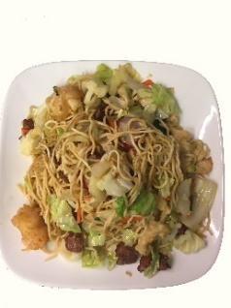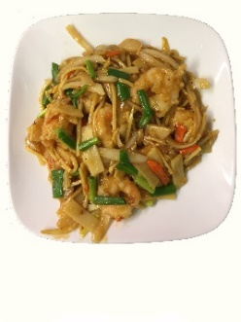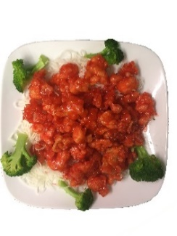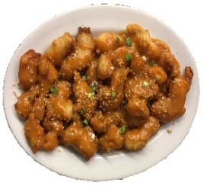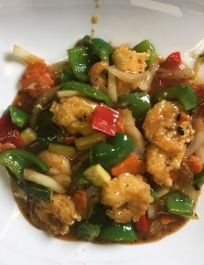Seafood

|  |  |  |  |
| --- | --- | --- | --- |
| Honey Walnut Prawns | $14.95 | Prawn with Garlic Sauce | $13.50 |
| Moo Shu Prawns | $13.95 | Curry Prawns | $13.50 |
| Sweet & Sour Prawns | $13.50 | Shrimp Lo Mein | $13.50 |
| Prawn with Cashew Nuts | $13.50 | Prawn /Mixed Vegetables | $13.50 |
| Kung Pao Prawns | $13.50 | Prawn with Broccoli | $13.50 |
| Shrimp with Lobster Sauce | $13.50 | Princess Prawns | $13.50 |
| Prawn with Snow Peas | $13.50 | Shrimp Chow Fun | $13.50 |

Combination

Lo Mein

Orange Chicken

Shrimp with Black Bean Sauce

Almond Fried Chicken

Shrimp in Garlic Sauce