Appetizer

|  |  |  |  |
| --- | --- | --- | --- |
| House Appetizers (Egg roll, Crab Cheese Won Ton, BBQ Pork, Fried Prawns) | | | #081 |
| Crab Cheese Won Ton (8) | #082 | Dumplings (steamed or pan fried) | #086 |
| BBQ Pork | #083 | Fried Won Ton Skin | #087 |
| Egg roll (1) | #084 | Golden Fried Prawns (6) | #088 |
| Spring roll (2) | #085 |  |  | |

Soups

(Add tofu for $1.50 more)

|  |  |  |  |
| --- | --- | --- | --- |
| Egg Flower Soup | #074 | Hot & Sour Soup | #076 |
| Wan Tan Soup | #075 | Vegetables Soup | #077 |

Combinations Dinners

Served with Soup and Fortune cookie. Substitution .75 or more

|  |  |  |
| --- | --- | --- |
| #1  Sweet & Sour Pork  Cashew Chicken Chow Mein  Pork Fried Rice  #121 | #2  Egg Foo Young  Almond Pork Chow Mein  Sweet & Sour Spareribs  #122 | #3  Pork Chow Mein  Sweet & Sour Chicken  Egg roll  Pork Fried Rice  #123 |
| #4  Fried Prawns  Egg Foo Young  Sweet & Sour Pork  Pork Fried Rice  #124 | #5  Fried Prawns  Almond Fried Chicken  Sweet & Sour Pork  Pork Fried Rice  #125 | #6  Chicken Chow Mein  Sweet & Sour Prawns  BBQ Pork  Pork Fried Rice.  #126 |
| #7  Pork Chow Mein  Almond Fried Chicken  BBQ Pork  Egg Roll  Pork Fried Rice  #127 | #8  BBQ Pork  Sweet & Sour Chicken  Almond Pork Chow Mein  Fried Prawns  Pork Fried Rice  #128 | #9  Egg Roll  General Tso’s Chicken  Chicken Lo Mein  Pork Fried Rice  #129 |

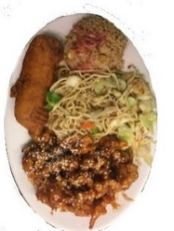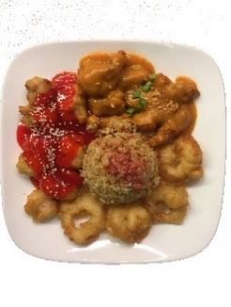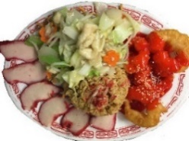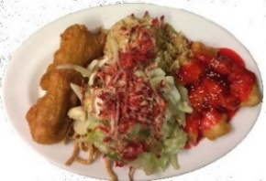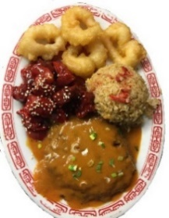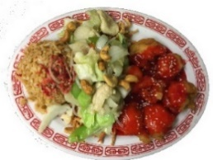

9

5

4

1

6

3