Entrees

(Served with choice of steamed rice or fried rice)

Gourmet Delights

|  |  |  |  |
| --- | --- | --- | --- |
| Combination Lo Mein | #001 | Singapore Chow Fun | #004 |
| Happy Family | #002 | Kung Pao Delight | #005 |
| Sesame Prawn or Beef | #003 |  |  |

Pork

|  |  |  |  |
| --- | --- | --- | --- |
| Moo Shu Pork (with 4 pancakes) | #007 | Pork Lo Mein | #009 |
| Sweet & Sour Pork | #008 | Pork with Mixed Vegetable | #010 |

Chicken

|  |  |  |  |
| --- | --- | --- | --- |
| General Tso's Chicken | #012 | Lemon Chicken | #020 |
| Moo Shu Chicken (with 4 pancakes) | #013 | Chicken/Cashew Nuts | #021 |
| Sweet & Sour Chicken | #014 | Curry Chicken | #022 |
| Chicken with Snow Pea | #015 | Chicken Lo Mein (soft noodle) | #023 |
| Chicken with Broccoli | #016 | Chicken/Mixed Vegetables | #024 |
| Kung Pao Chicken | #017 | Almond Fried Chicken | #025 |
| Chicken with Garlic Sauce | #018 | Mandarin Chicken | #026 |
| Orange Chicken | #019 | Honey Walnut Chicken | #027 |

Beef

|  |  |  |  |
| --- | --- | --- | --- |
| Moo Shu Beef (with 4 pancakes) | #029 | Beef Lo Mein (soft noodle) | #035 |
| Beef with Broccoli | #030 | Beef with Mixed Vegetable | #036 |
| Beef with Cashew Nuts | #031 | Kung Pao Beef | #037 |
| Mongolian Beef | #032 | Teriyaki Beef (or chicken) | #038 |
| Pepper Steak | #033 | Beef with Tomato (soft noodle) | #039 |
| Schezuan Beef | #034 | Beef with Black Bean Sauce | #040 |

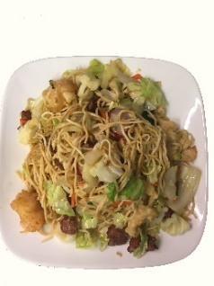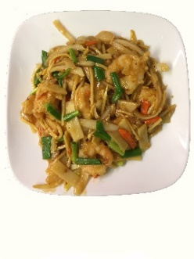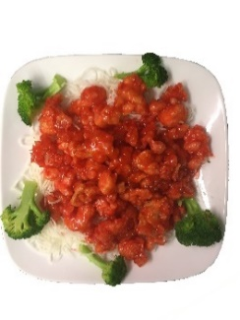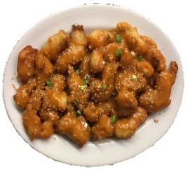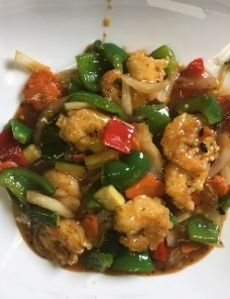Seafood

|  |  |  |  |
| --- | --- | --- | --- |
| Honey Walnut Prawns | #042 | Prawn with Garlic Sauce | #048 |
| Moo Shu Prawns | #043 | Curry Prawns | #049 |
| Sweet & Sour Prawns | #044 | Shrimp Lo Mein | #050 |
| Prawn with Cashew Nuts | #045 | Prawn /Mixed Vegetables | #051 |
| Kung Pao Prawns | #046 | Prawn with Broccoli | #052 |
| Shrimp with Lobster Sauce | #047 | Princess Prawns | #053 |
| Prawn with Snow Peas | #054 | Shrimp Chow Fun | #055 |

Combination

Lo Mein

Orange Chicken

Shrimp with Black Bean Sauce

Almond Fried Chicken

Shrimp in Garlic Sauce