CS 175: Project in AI
Project Status Report
Project: A Comparative Study of Classical Algorithms for Solving Sudoku
Team: Mathieu Khalaf (mathieuk, 55978896), Tyler Kuwada (tkuwada, 47259885)
Group: GROUP 1000
Quarter: Spring 2026

1. Project Summary
Our team’s project is a comparative study of classical algorithms for solving Sudoku. Sudoku falls into the “puzzle, no feedback from environment” category from the course topics slide, so we are not using RL or deep learning.
Our goal is to implement multiple classical AI solvers (plain backtracking, CSP-based backtracking with AC-3 and search heuristics, and Knuth’s Dancing Links / Algorithm X) and compare them on a shared puzzle bank across difficulty tiers ranging from easy puzzles up to the 17-clue minimum sudokus from Royle’s collection. We evaluate each solver on time taken, search nodes expanded, and backtracks performed.
The goals from the proposal have not changed. The four-solver lineup (plus the two stretch goals) is still what we are aiming for. What has changed is that we now have working code for the first two solvers, real benchmark numbers, and concrete evidence that the AC-3 + MRV/LCV approach delivers the dramatic improvement over plain backtracking that the proposal predicted.

2. Approach / Algorithm
We framed Sudoku as a Constraint Satisfaction Problem with 81 variables (the cells), each with a domain that is a subset of {1, …, 9}, and 27 AllDifferent constraints (one per row, column, and 3x3 box).
The clue cells start with singleton domains, and empty cells start with the full domain. We reach a solution when every cell has a singleton domain, and no constraint is violated.
Solver 1: Plain Backtracking. This is the baseline. The algorithm scans the grid for the next empty cell in row-major order, tries digits 1 through 9 in order, and then descends recursively and backtracks on conflict. It does no propagation and uses no heuristics. The validity check at each step is a very simple scan of the cell’s row, column, and 3x3 box.
Solver 2: Backtracking + AC-3 + MRV / Degree / LCV. This is the smarter CSP solver. It has three improvements over Solver 1:
- AC-3 constraint propagation. Whenever a cell’s domain is reduced to a singleton, that value is propagated to all the cell’s peers (the 20 other cells that share its row, column, or box), removing it from their domains. Here, we used the standard AC-3 queue. If any domain becomes empty during propagation, the algorithm backs up.
- MRV (Minimum Remaining Values) with degree tiebreaker. Instead of picking the next empty cell in row-major order, the solver picks the unassigned cell with the smallest current domain. Also, the ties are broken by degree (the number of unassigned peers).
- LCV (Least Constraining Value). When trying values for the chosen cell, the solver orders them by how many options they would eliminate from peer domains, trying the least disruptive value first.
The combination is essentially the standard textbook CSP solver (Russell & Norvig, AIMA ch. 6) with the original AC-3 formulation from Mackworth (1977). On every assignment, AC-3 is re-run from the affected cell’s peers, propagating the consequences before recursing.
Solver 3 (in progress): Dancing Links / Algorithm X. Knuth’s exact-cover formulation. We are reformulating Sudoku as an exact-cover problem: a 729 × 324 sparse binary matrix in which each row represents a possible (row, column, digit) placement, and each column represents one of the 324 constraints. Algorithm X, using the dancing-links sparse data structure, finds an exact cover. This is the solver Hira et al. found to dominate on the hardest puzzles, so we expect it to outperform Solver 2 on the 17-clue minimum puzzles.
AC-3 pseudocode (Mackworth 1977), and our code update step, which solver 2 runs after each assignment below:
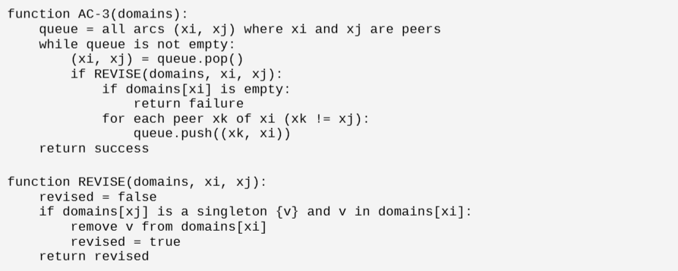

3. Schedule / Milestones, Remaining Goals, Challenges

3.1 Original schedule vs. current progress
Week | Planned | Status
5 | Repo setup, I/O parsing, test harness, Solver 1 | Done
6 | Solver 2 (forward checking + AC-3) | Done
7 | Heuristics (MRV, degree, LCV). Start Dancing Links | Done (combined into Solver 2)
8 | Solver 3 (Dancing Links), first full benchmark, progress report | In progress

Solvers 1 and 2 are working, they are validated against a known easy solution, and benchmarked against the full puzzle bank (15 puzzles across 5 difficulty tiers). The I/O layer accepts 81-character strings (0 or . for empty), JSON arrays, and plain text files. The verifier checks all 27 AllDifferent constraints plus consistency with the original clues. We have 9 passing pytest tests covering parsing, verification, both solvers, and cross-solver agreement on the solution.
We are a bit ahead of the proposal schedule because the heuristics layer (MRV, degree, LCV) was natural and simpler to combine into Solver 2 rather than implementing it as a standalone solver.

3.2 Remaining goals
- The implementation of Dancing Links / Algorithm X is our most critical remaining task, with a target completion by the end of week 9, keeping the team focused and motivated on this matter.
- We plan to expand the benchmark set from 15 puzzles to approximately 1,000, including the full Project Euler problem 96 set (50 puzzles) and a 500-puzzle sample from Royle’s sudoku17 collection, increasing validation robustness.
- Per-technique ablation of Solver 2 (turn off AC-3, MRV, LCV one at a time) to see which technique is doing the most work.
- Stretch goal: preemptive-set detection (Crook) or simulated annealing (Chi & Lange), pick one based on remaining time.
- Visualizations. Search-tree visualizations for hard puzzles, comparison plots, and tables for the final report.

3.3 Anticipated challenges
The main risk here is ensuring the correctness of Dancing Links. The doubly-linked matrix structure is tricky to get right, and bugs in the cover and uncover operations can produce silent, unnoticed wrong answers.
Mitigation: We will verify Dancing Links output against Solver 2 on every puzzle in the bench, since Solver 2 is now known to be correct.
A secondary concern is simulated annealing’s known failure mode on hard puzzles (Chi & Lange report it gets stuck in local minima on the Top 95 benchmark). If we implement it as a stretch goal, we expect it will fail on the hardest tier, confirming that result on our own bank would itself be the finding.

4. Evaluation
Because Sudoku has a verifiable ground truth, our evaluation has two parts: an automatic correctness check (where we check:” does the solver actually produce a valid solution that matches the original clues?” ) and a performance comparison (where we look for how fast, and how much work it has to do). We have a working test harness that runs both checks automatically on every solver and every puzzle. Figure 1 shows our test suite passing on Solvers 1 and 2 across nine independent unit tests, including format parsing, the verifier, both solvers running on a known puzzle, and cross-solver agreement on the produced solution.
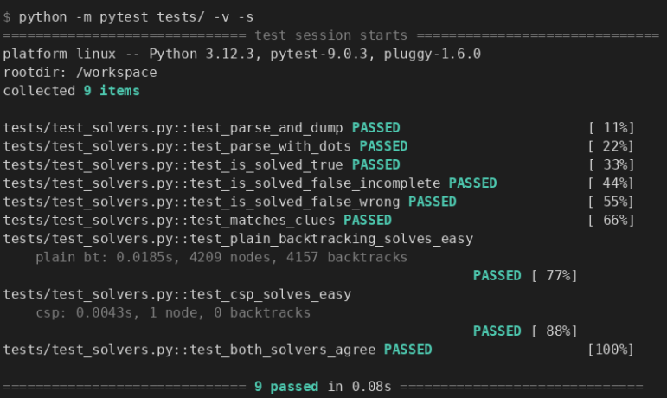
Figure 1: pytest output showing all 9 unit tests passing. Tests cover I/O parsing in both string and dot formats; the verifier on solved/unsolved/invalid grids. Both solvers produce a correct solution on a known easy puzzle, and a cross-solver agreement test in which both implementations are required to produce byte-identical solutions on the same input.

4.1 Quantitative results so far (15 puzzles, 5 difficulty tiers)
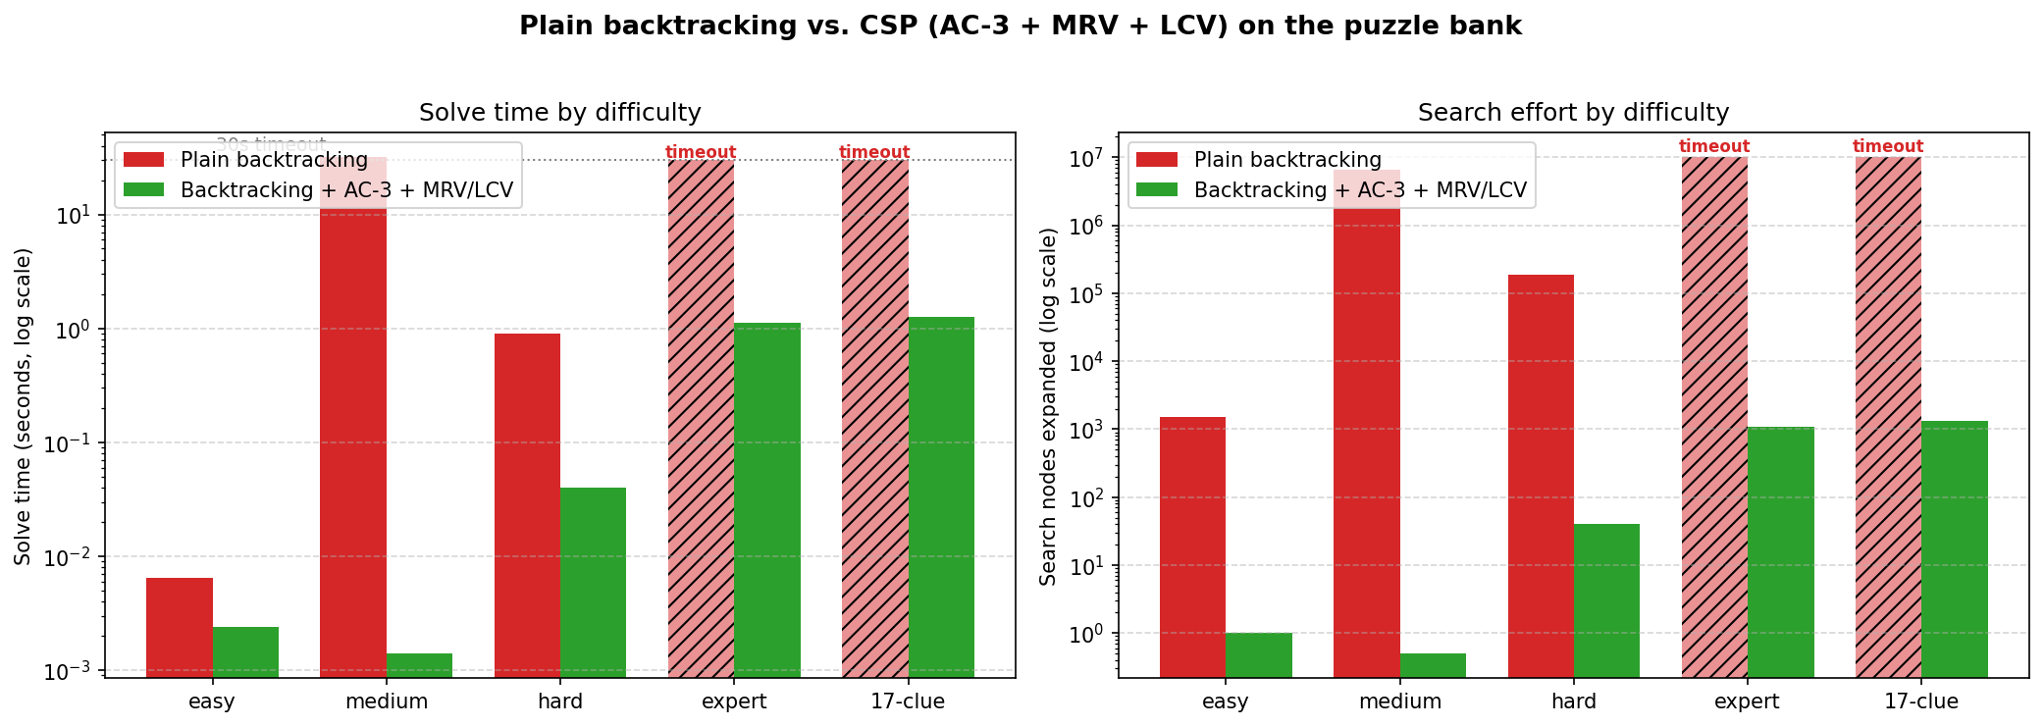
Figure 2: Plain backtracking vs. CSP (AC-3 + MRV + LCV). Both axes are log scale. The hatched red bars indicate plain backtracking hit the 30-second timeout. The CSP solver solved every puzzle in the bank.
Difficulty | Solver | Avg time (s) | Avg nodes | Avg backtracks
easy | Plain backtracking | 0.0064 | 1,526 | 1,493
easy | CSP (AC-3 + MRV + LCV) | 0.0024 | 1 | 0
medium | Plain backtracking | 31.73 | 6,546,495 | 6,546,479
medium | CSP (AC-3 + MRV + LCV) | 0.0014 | 0 | 0
hard | Plain backtracking | 0.90 | 188,453 | 188,392
hard | CSP (AC-3 + MRV + LCV) | 0.040 | 40 | 51
expert | Plain backtracking | timeout (>30s) | - | -
expert | CSP (AC-3 + MRV + LCV) | 1.12 | 1,090 | 2,162
17-clue | Plain backtracking | timeout (>30s) | - | -
17-clue | CSP (AC-3 + MRV + LCV) | 1.27 | 1,315 | 2,616

These are averaged over 3 puzzles per tier. We skipped Plain backtracking on expert and 17-clue puzzles after preliminary runs took longer than 30 seconds (Hira et al. report over 200 seconds for plain backtracking on a single hard puzzle, which our numbers are consistent with).

4.2 Interpretation
The CSP solver is roughly 2x to 22,000x faster than plain backtracking on puzzles where both finish. On medium puzzles, especially, plain backtracking expanded 6.5 million nodes on average. The CSP solver solved the same puzzles with constraint propagation alone, without any search at all (0 nodes expanded). This is exactly the kind of speedup our proposal predicted, and matches the qualitative findings of Hira et al. The CSP solver also handles all expert and 17-clue puzzles in our bank in under 3 seconds, which shows that the prototype is working as intended.

4.3 Qualitative checks
- Sanity case: we return a fully solved puzzle immediately with zero search nodes.
- Cross-solver agreement: when both solvers complete, they produce identical solutions on every puzzle.
- Verifier: independently checks all 27 AllDifferent constraints on every one of the outputs.

4.4 Remaining evaluation work
For the final report, we will expand to a benchmark of around 1,000 puzzles, add Dancing Links to the table, run the per-technique ablation (AC-3 off, MRV off, LCV off, each in isolation), and produce search-tree visualizations for one hard puzzle per solver.

5. Resources Used
- Python 3.11. Standard library only. Did not use third-party dependencies in the solver code.
- pytest for unit tests.
- matplotlib for the benchmark chart.
- Docker to reproduce the environment (Dockerfile in repo).
- Reference papers (course-provided): Hira et al., Crook, Chi & Lange.
- Knuth, D. E. (2000). Dancing Links. arXiv:cs/0011047. Used as the reference for Solver 3.
- Mackworth, A. K. (1977). Consistency in Networks of Relations. Used as the reference for the AC-3 implementation.
- Russell & Norvig. Artificial Intelligence: A Modern Approach, chapters on CSP. Used as the reference for the MRV / LCV / degree heuristic setup.
- Royle’s sudoku17 collection (University of Western Australia) for the 17-clue minimum puzzles.
- Project Euler Problem 96 for the standard 50-puzzle benchmark.
- GitHub for collaboration. Repo: cs175-sp26-sudoku.

