        if (args.length < 1) {

            System.out.println("Please enter n.");

            return;

        }

        double startTime = System.nanoTime();

        int userPassedValue = Integer.parseInt(args[0]);

        // - 2 because array starts at number 2 (visually shown in docs at bottom)

        boolean[] primeNumbers = new boolean[userPassedValue - 2];

        for (int i = 0; i < Math.sqrt(userPassedValue) - 1; i++) {

            int currentVal = i+2;

            // if current index of primeNumber list is prime

            if (!primeNumbers[i]) {

                for (int j = currentVal*currentVal; j < userPassedValue; j+=currentVal) {

                    primeNumbers[j-2] = true;

                }

            }

        }

        int k = 0;

        for (int i = primeNumbers.length - 1; i > 0; i--) {

            if (!primeNumbers[i]) {

                System.out.println(i + 2);

                k++;

                if (k > 4) break;

            }

        }

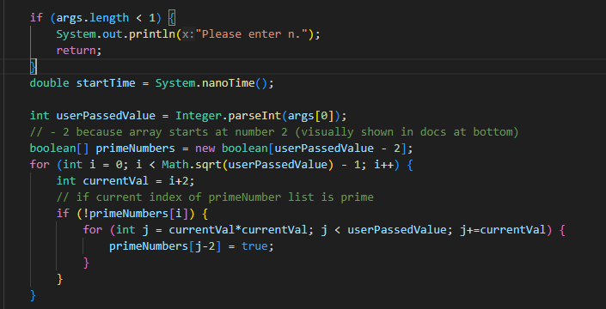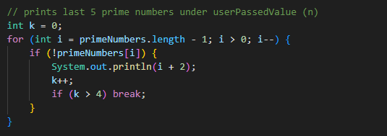

<!DOCTYPE html>

<html>

<head>

<title>Tyler McKenna's Site</title>

<meta name="author" content="Tyler McKenna">

</head>

<body>

<header>

<nav>

<h3>Useful Links</h3>

<li><a href="https://www.w3schools.com/" target="_blank" title="W3 Schools">W3 Schools</a></li>

<li><a href="https://ocuonline.okcu.edu/d2l/home" target="_blank" title="OKCU D2L">OKCU D2L</a></li>

</nav>

</header>

<div class="Introduction" style="font-family: monospace; font-size: 17px;">

<h1 text-align="center">

Tyler's Website

</h1>

<h2>

Introduction

</h2>

<p>

My name is <mark>Tyler McKenna</mark>. <br>

I am a sophomore computer science major at Oklahoma City University. <br>

Here is some info about me:

</p>

<ul>

<li>I love playing piano &#x1F3BC;</li>

<li>I am a runner &#x1F3C3;</li>

<li>I am looking forward to becoming an <b style="color:red">HTML MASTER</b> &#x1f9d9;</li>

</ul>

</div>

<hr>

<footer>

<h2>

Contact Me:

</h2>

<ul>

<li><u>tylertheprogrammer@gmail.com</u></li>

<li>(405)123-5813</li>

<li>2357 Prime Way, Atlanta, GA</li>

</ul>

</footer>

</body>

</html>

<!DOCTYPE html>

<head>

<title>Programming Inline Website</title>

</head>

<body>

<p> I'll be <span style="color:blue">showing</span> code in java to compute 5 prime numbers down from n<s></s></p>

<pre>

<code>

if (args.length < 1) {

System.out.println("Please enter n.");

return;

}

double startTime = System.nanoTime();

int userPassedValue = Integer.parseInt(args[0]);

// - 2 because array starts at number 2 (visually shown in docs at bottom)

boolean[] primeNumbers = new boolean[userPassedValue - 2];

for (int i = 0; i < Math.sqrt(userPassedValue) - 1; i++) {

int currentVal = i+2;

// if current index of primeNumber list is prime

if (!primeNumbers[i]) {

for (int j = currentVal*currentVal; j < userPassedValue; j+=currentVal) {

primeNumbers[j-2] = true;

}

}

w// prints last 5 prime numbers under userPassedValue (n)

int k = 0;

for (int i = primeNumbers.length - 1; i > 0; i--) {

if (!primeNumbers[i]) {

System.out.println(i + 2);

k++;

if (k > 4) break;

}

}

</code>

</pre>

<p> And here's the 5 numbers it outpus with n = 100<s></s></p>

<pre>

<samp>

97

89

83

79

73

</samp>

</pre>

</body>

</html>