### Oklahoma City University

CSCI 3403_01-Assignment 03

**Total: 100 points**  
**Requirements:**

**Part 1: 30 points**

Create this using a Canvas

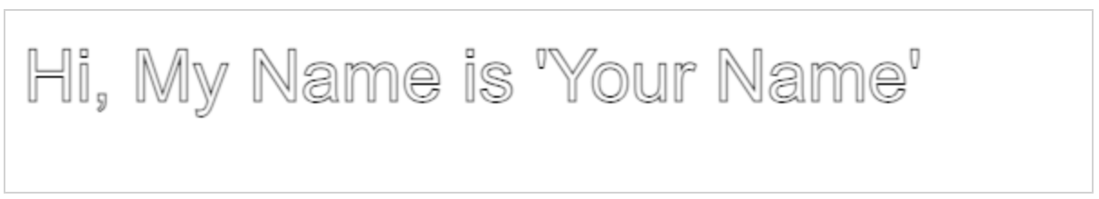

**Part 2:**

**30 points**

Create a table like this below:

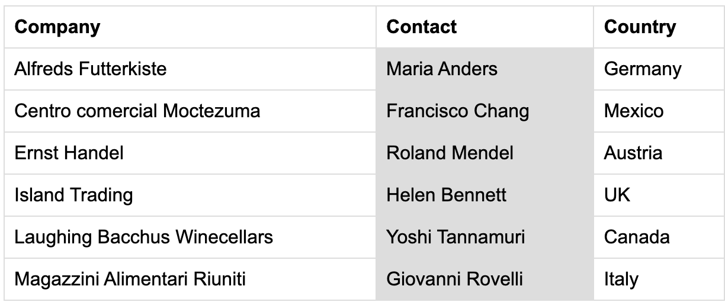

**Part 3: 40 points**

Create a registration page like the screenshot below:

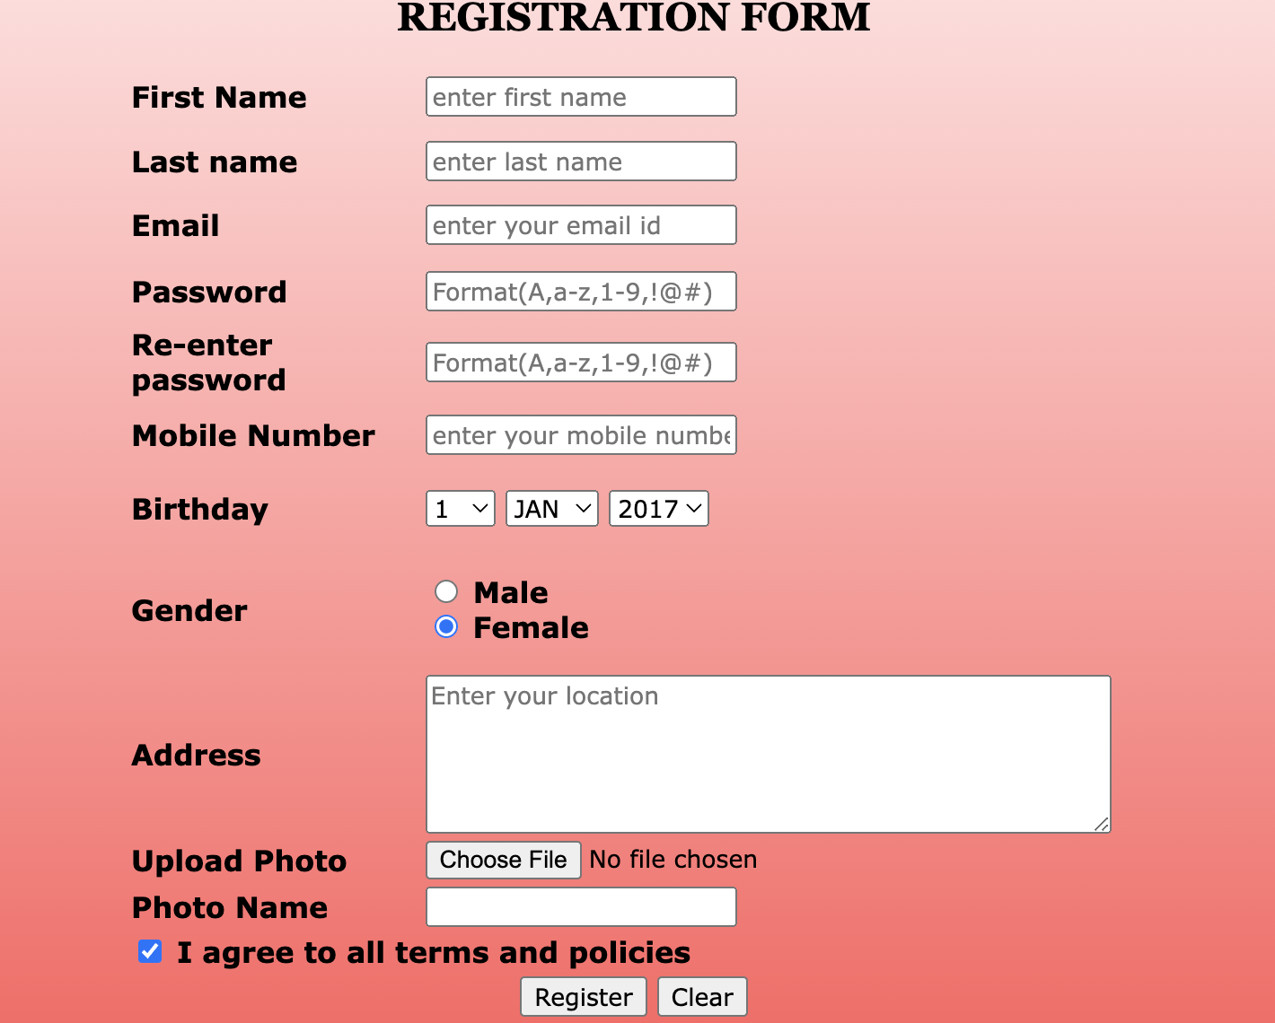

Execute the codes and take screenshots. Submit both the codes and screenshots in a zip folder.