MealMate — Design Documentation

Application Description
MealMate is a mobile app that helps users plan their weekly meals and build a shopping list automatically. It pulls meal data and images from TheMealDB API. Users can browse meals by category, search by name, view full recipes with ingredients and instructions, and save meals to a weekly plan.
The app has six screens: a home screen with a featured meal and category cards, a category browser showing meals in a selected category, a search screen, a meal detail screen with the full recipe, a meal plan screen where users assign meals to days of the week, and a shopping list that auto-generates from the planned meals.

Functional Requirements
Requirement | How It Works
Browse categories | Home screen loads all meal categories from TheMealDB with thumbnail images
View meals in category | Tapping a category shows all meals in that category as scrollable cards
Search meals | Search screen lets users type a meal name and see matching results from the API
View meal detail | Tapping a meal opens a detail page with photo, ingredients with measurements, and step-by-step instructions
Add to meal plan | From the detail screen, users pick a day of the week to assign the meal to their plan
Manage meal plan | Meal plan screen shows all 7 days with assigned meals; users can remove meals or reset the entire plan
Auto shopping list | Shopping list pulls ingredients from all planned meals, combines duplicates, and shows a checkable list
Persistent storage | Meal plan and search history are saved to AsyncStorage so data survives app restarts
Featured meal | Home screen shows a random meal from the API as a featured card each time the app opens

Non-Functional Requirements
Area | What It Means
Navigation | Back buttons work on every screen, navigation feels natural with clear flow from browsing to detail to saving
Loading | Spinner with message shows while waiting for the API so the app does not feel frozen
Errors | If something goes wrong, a message and retry button appear instead of crashing
Empty states | Screens with no data show a friendly message explaining what to do next
Layout | Consistent color scheme and spacing across all six screens using shared style constants
Stability | No crashes during normal use; all API calls and storage operations have error handling

Wireframes
Home Screen (index.ts):
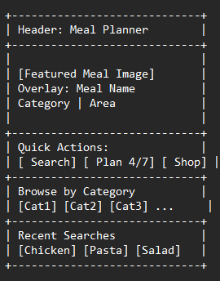
Categories Screen (categories.tsx):
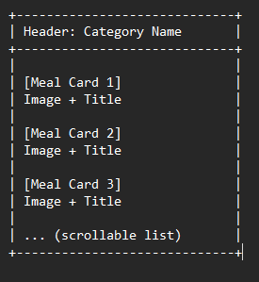
Search Screen (search.tsx)
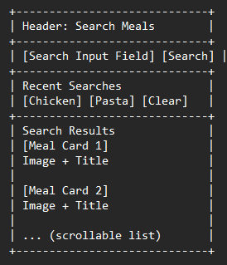
Meal Detail Screen (meal/[id].tsx)
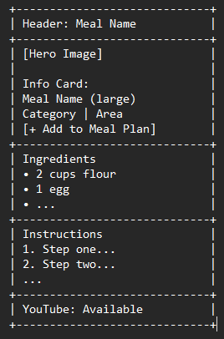
Meal Plan Screen (mealplan/index.tsx)
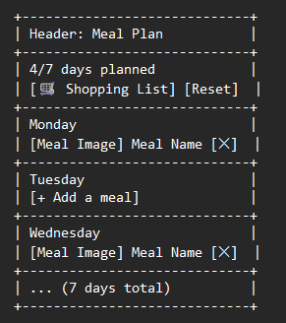
Shopping List Screen (mealplan/shopping.tsx)
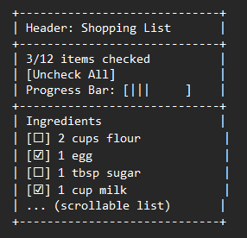

Component and Data Flow

Navigation
The app uses Expo Router with a Stack navigator. There are six routes:
Route | File | What It Does
/ | app/index.tsx | Home — featured meal, categories, quick actions
/categories | app/categories.tsx | Category browser — meals filtered by category
/search | app/search.tsx | Search — find meals by name
/meal/[id] | app/meal/[id].tsx | Meal detail — photo, ingredients, instructions
/mealplan | app/mealplan/index.tsx | Weekly meal plan — assign meals to days
/mealplan/shopping | app/mealplan/shopping.tsx | Shopping list — auto-generated checklist
The meal detail route uses a dynamic parameter [id]. When you tap a meal card anywhere in the app, it navigates to /meal/52772 (for example) and the detail screen reads that ID to fetch the full recipe from the API.

How Data Flows
Remote data: TheMealDB API provides categories, meal lists, search results, meal details, and random meals. All API calls live in src/services/api.ts and use a shared fetch wrapper with error handling. If a call fails, the screen shows an error message with a retry button.
Local data: The meal plan and search history are stored in AsyncStorage through helper functions in src/utils/storage.ts. The meal plan is managed by a React Context (MealPlanContext) that wraps the entire app. Any screen can call useMealPlan() to read or write the plan. The context auto-saves to AsyncStorage whenever the plan changes.
Derived data: The shopping list is not stored anywhere. It is computed on the fly by fetching full details for each planned meal, parsing all their ingredients, and combining duplicates. This logic lives in src/utils/shoppingList.ts.

Reusable Components
MealCard (src/components/MealCard.tsx) — the card shown for each meal. Takes a meal summary and navigates to the detail screen on tap.
CategoryCard (src/components/CategoryCard.tsx) — a compact card for each category on the home screen. Navigates to the category browser on tap.
LoadingSpinner (src/components/LoadingSpinner.tsx) — a centered spinner with a message. Used on every screen while waiting for data.
ErrorDisplay (src/components/ErrorDisplay.tsx) — an error message with a retry button. Used on every screen when an API call fails.
EmptyState (src/components/EmptyState.tsx) — a friendly message when a screen has no data to show.
IngredientCheckbox (src/components/IngredientCheckbox.tsx) — a checkable row on the shopping list with ingredient name and measurement.

APIs Used
All data comes from TheMealDB (https://www.themealdb.com/api.php). It is free and does not need an API key.
Endpoint | What It Returns
GET /api/json/v1/1/categories.php | All meal categories with thumbnails and descriptions
GET /api/json/v1/1/filter.php?c={cat} | All meals in a specific category
GET /api/json/v1/1/search.php?s={query} | Meals matching a search term
GET /api/json/v1/1/lookup.php?i={id} | Full meal detail with ingredients and instructions
GET /api/json/v1/1/random.php | One random meal

MealMate — Testing Documentation

Test Plan
Each test was run on the Android Emulator through Expo. The tables below cover navigation, data loading, user interaction, storage, and error handling.

Navigation Tests
ID | Test Case | Steps | Expected Result | Status
N-1 | Home screen loads | Launch app | Featured meal, categories, and quick actions visible
N-2 | Navigate to category | Tap a category card | Category screen opens with filtered meals
N-3 | Navigate to search | Tap Search quick action | Search screen opens with input focused
N-4 | Navigate to meal detail | Tap any meal card | Detail screen opens with photo and recipe
N-5 | Back navigation | Tap back arrow from detail | Returns to previous screen
N-6 | Navigate to meal plan | Tap Meal Plan quick action | Meal plan screen opens showing 7 days
N-7 | Navigate to shopping list | Tap Shopping List button | Shopping list screen opens

Data Loading Tests
ID | Test Case | Steps | Expected Result | Status
D-1 | Categories load | Open app with internet | Category cards shown on home screen
D-2 | Featured meal loads | Open app | Random meal card at top of home screen
D-3 | Meal images load | Tap a meal card | Photo displays on detail screen
D-4 | Ingredients display | View meal detail | Ingredient list with measurements shown
D-5 | Instructions display | View meal detail | Full cooking instructions shown

User Interaction Tests
ID | Test Case | Steps | Expected Result | Status
U-1 | Search filters meals | Type "chicken" in search | Shows matching chicken meals
U-2 | Add meal to plan | Tap Add to Meal Plan, pick Monday | Confirmation shown, meal appears on Monday
U-3 | Remove meal from plan | Tap X on a planned meal | Meal removed, day shows empty slot
U-4 | Reset meal plan | Tap Reset, confirm | All days cleared
U-5 | Check shopping item | Tap an ingredient checkbox | Item shows strikethrough, progress updates
U-6 | Search history tap | Tap a previous search term | Search runs with that term, results shown

Storage and Error Tests
ID | Test Case | Steps | Expected Result | Status
P-1 | Plan persists on restart | Add meals, close app, reopen | Meal plan still there
P-2 | Search history persists | Search, close app, reopen | Previous searches shown
P-3 | Empty plan state | Open meal plan with none set | Shows empty slots for all 7 days
E-1 | Empty search results | Type "xyzabc" in search | Shows "No results" message
E-2 | Empty shopping list | Open shopping list with no plan | Shows "No items yet" message

Test Evidence
Test | Screen | Observation
N-1 | 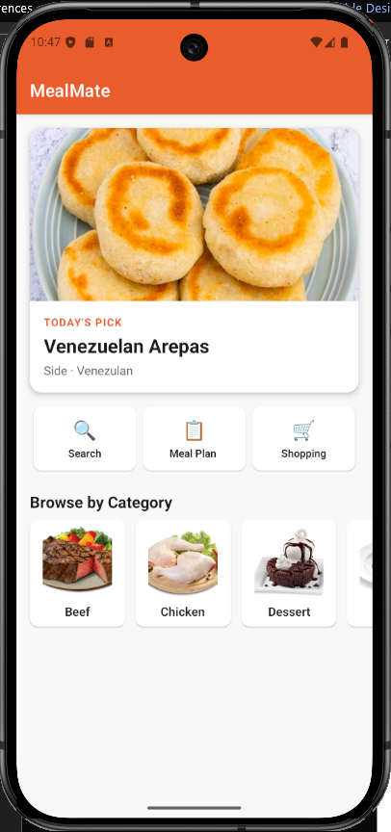 | Home Screen Loads successfully
N-2 | 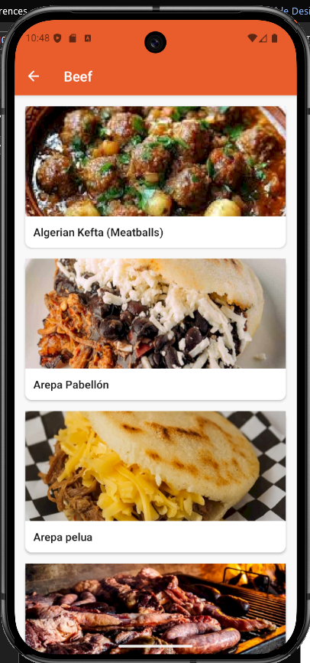 | Successful navigation
N-3 | 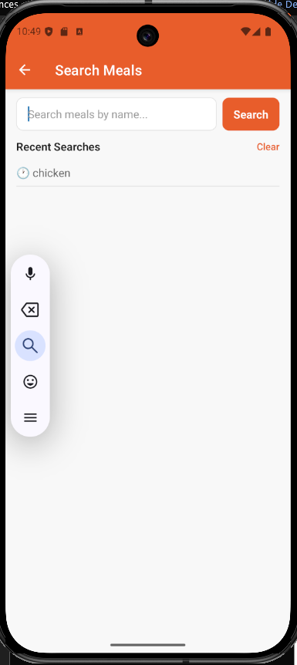 | Search loads successfully
N-4 | 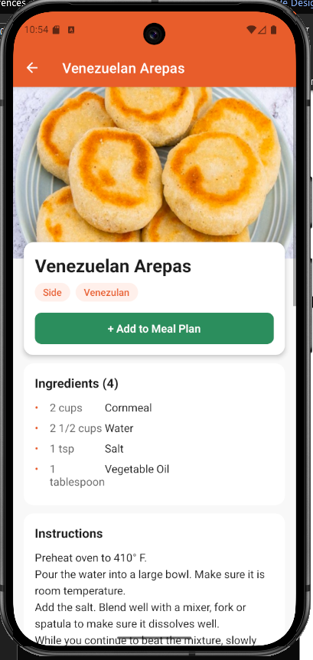 | Meal card loaded successfully
N-5 | 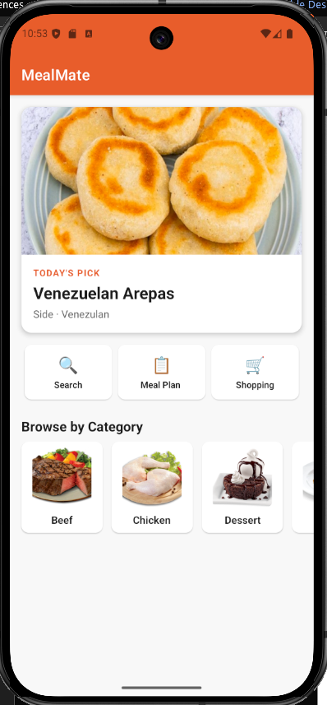 | Back navigation functions as intended
N-6 | 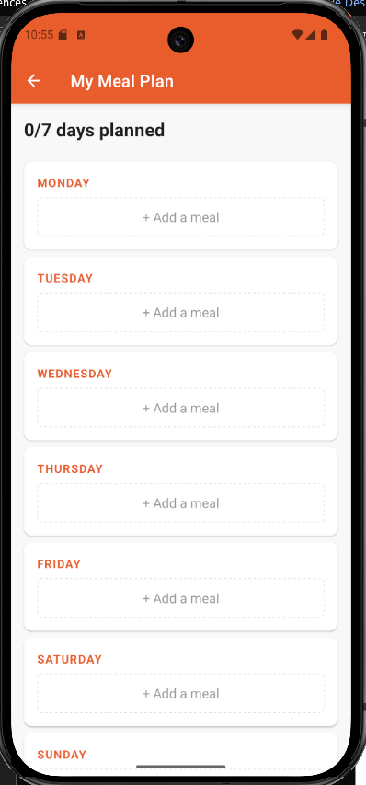 | Meal Plan successfully loaded
N-7 | 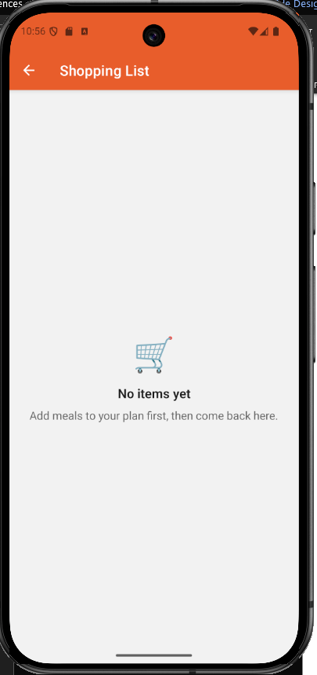 | Shopping page loads successfully
D-1 |  | Categories load as expected
D-2 |  | Featured meal loads as expected
D-3  D-4  D-5 |  | Recipe image loads as expected  Ingredient list loads as expected  Recipe loads as expected
U-1 | 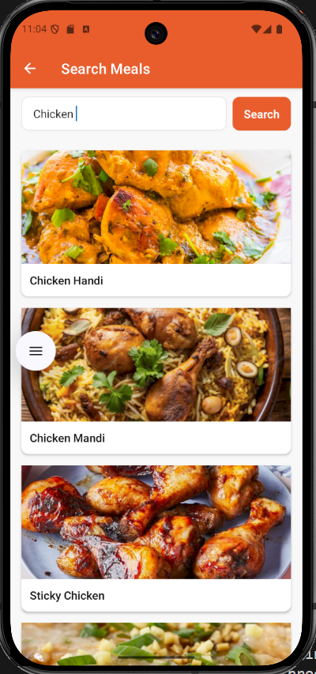 | Correct results returned
U-2 | 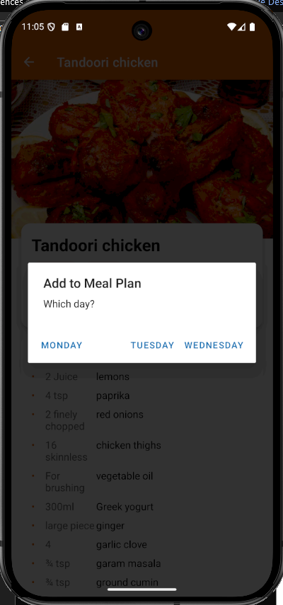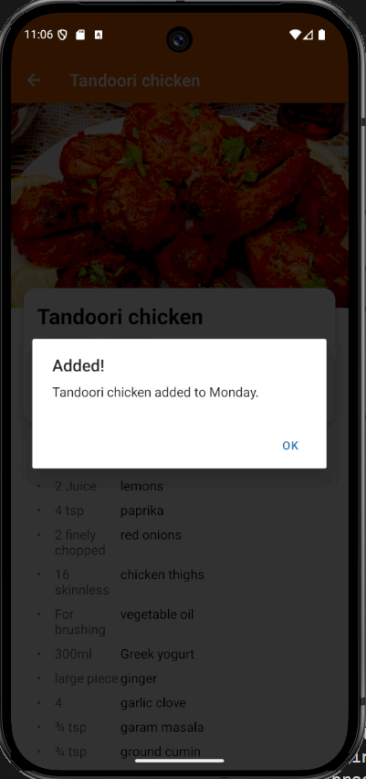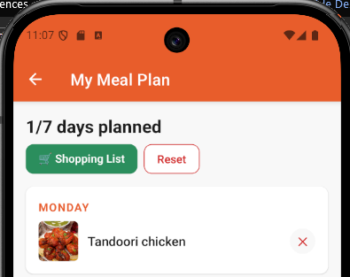 | Confirmation Dialogue displayed  Meal added successfully
U-3 | 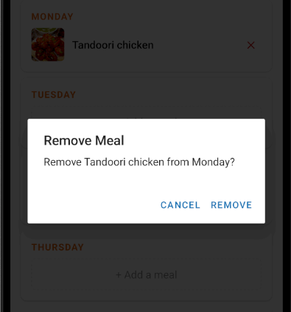  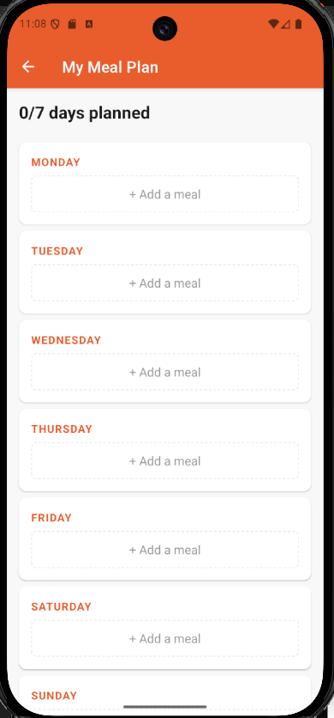 | Confirmation dialogue displayed  Meal removed from plan successfully
U-4 | 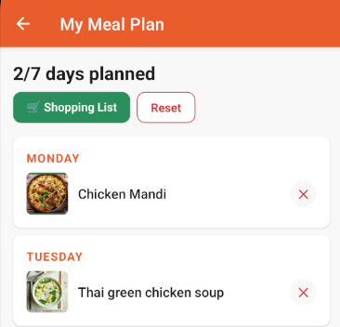  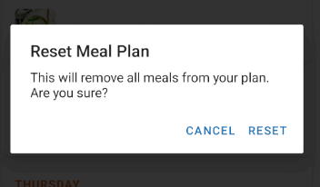  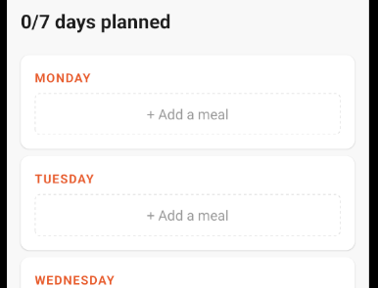 | Meals before test  Reset dialogue displayed successfully  Meals removed successfully
U-5 | 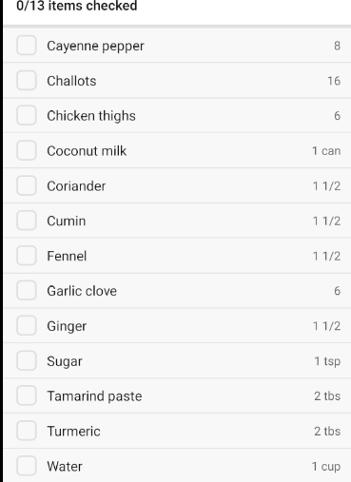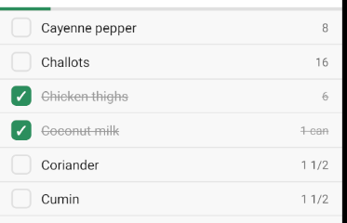 | List before check  Successful strikethrough on checked items
U-6 | 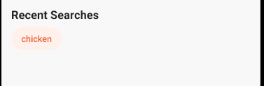  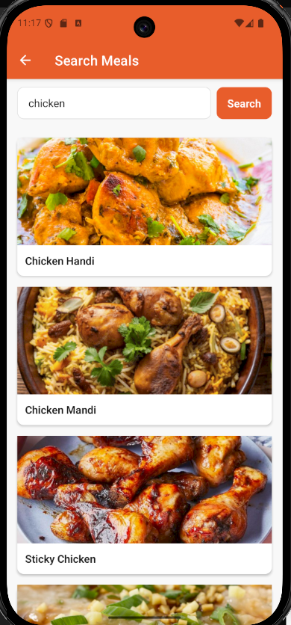 | Recent search terms on Home screen  Correct seach results loaded
P-1 | 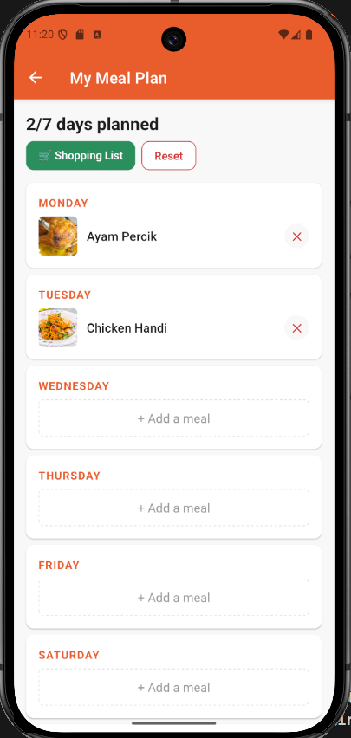 | Meal plan persists after restart
P-2 | 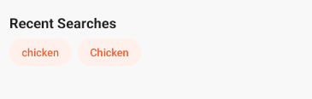 | Recent searches persist after restart
P-3 |  | Empty plan displayed after restart (empty plan before restart)
E-1 | 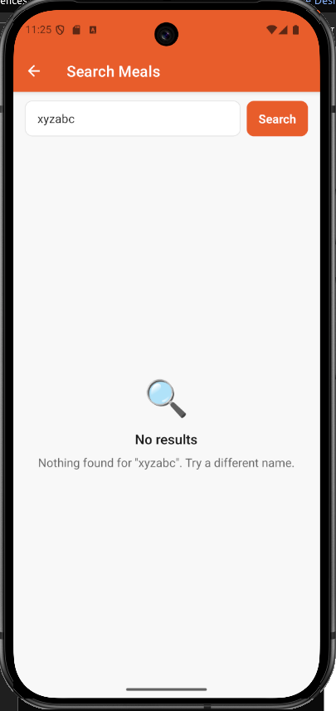 | No results message correctly displayed
E-2 | 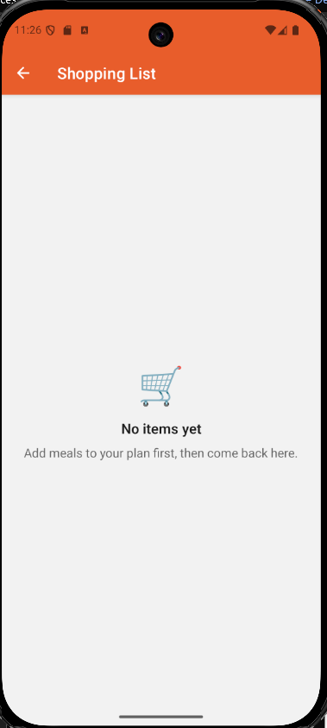 | Empty shopping list correctly displayed

Bugs Encountered
# | Bug | Cause | How We Fixed It
1 | Async storage not working | Flaw in internal logic | Fixed internal logic
2 | App not loading properly when open | Virtual machine internet issue | Fixed virtual machine, ensured fallback state for network issues

