Tyler Quackenbush
3D Reconstruction

Task 1 – 3D Measurement

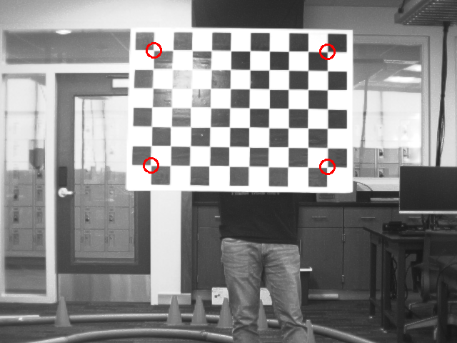

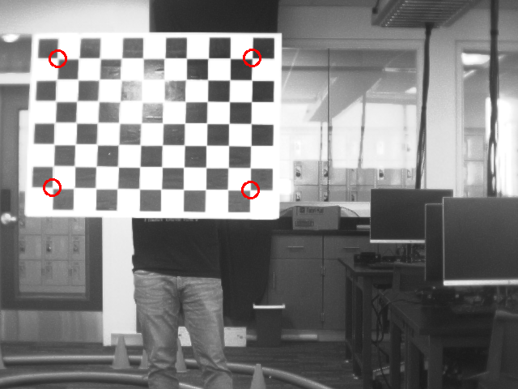

3D Points:
[[-39.33149551 -21.1752864 246.06981279]
[ -4.38294564 -20.9110623 248.59067383]
[-39.15833264 1.98685894 242.36382857]
[ -4.35128465 2.2281351 245.49180282]]

