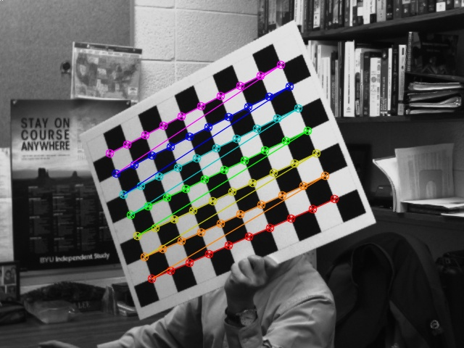
Task 1 – Corner Detection

Task 2 – Intrinsic Parameters

Calculated focal length: 8.48mm

Intrinsic parameters: [[1145.05898, 0.00000000, 328.612905]
[0.00000000, 1.14344385, 222.325254]
[0.00000000, 0.00000000, 1.00000000]]

Distortion parameters: [[-0.254256031
-0.053261965
-0.001409690
-0.001437376
2.28132168]]

Task 3 – Distortion Correction

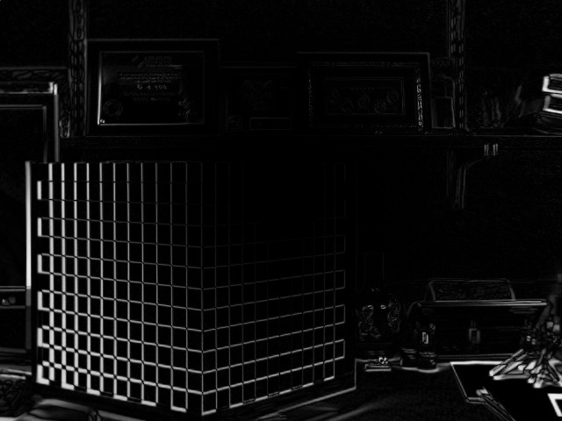

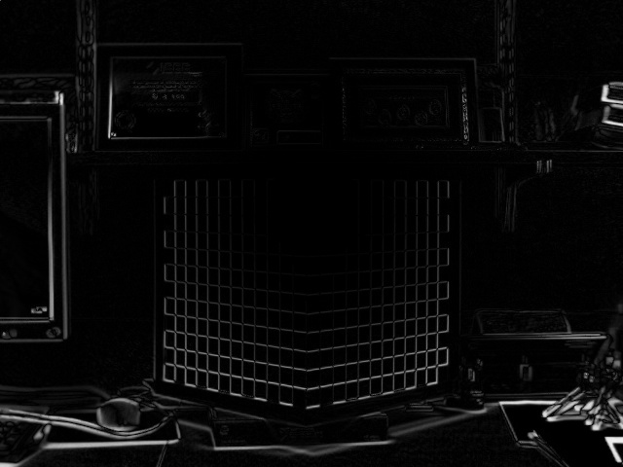

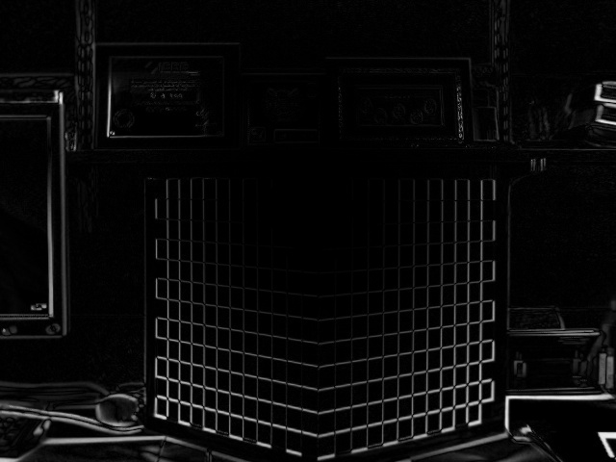

Task 4 – Object Pose Estimation

R: [[ 0.73551327 -0.67738374 0.0130958 ]
[-0.00323282 -0.02283801 -0.99973395]
[ 0.67750261 0.73527525 -0.01898752]]

Euler Angles: [[ 1.51392294]
[-0.57974373]
[ 0.58824618]]

Translation: [[-1.95992139e-02]
[ 1.04877854e+01]
[ 4.67009922e+01]]

Task 5 – My Camera’s Intrinsic Parameters

Focal length is 10.88 mm (based on the 135 pix/mm, couldn’t find a datasheet for mine)

Camera Matrix: [[1.46831591e+03 0.00000000e+00 6.13104006e+02]
[0.00000000e+00 1.40684920e+03 4.59626663e+02]
[0.00000000e+00 0.00000000e+00 1.00000000e+00]]

Distortion: [[0.04017643
0.87701138
-0.00515214
-0.00955139
-3.39992284]]

Task 6 – Distortion Correction on My Camera

My camera has a plastic lens and is pretty cheap. Here’s what I got!

