Tyler Quackenbush
Homography

Task 1 – Feature Description

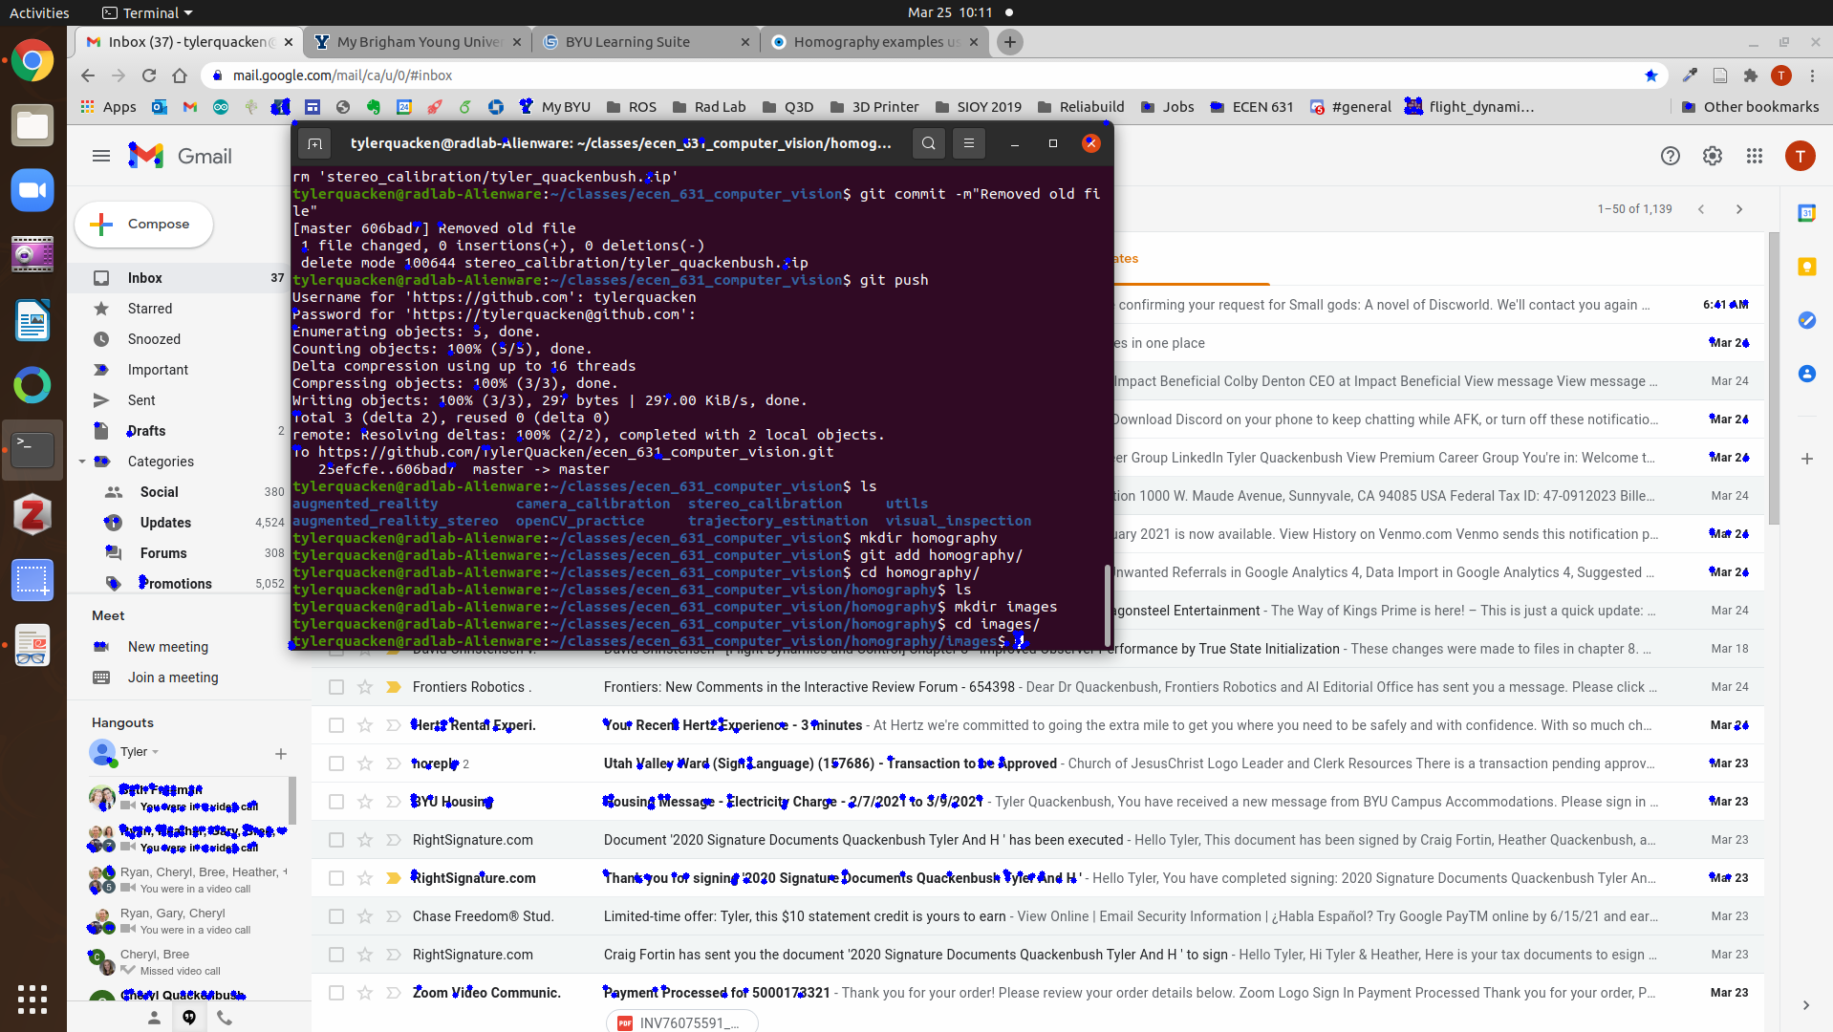

Task 2 – Live Demo

See the included .avi file for the video

My homography worked decently, but was pretty jumpy for a number of reasons. I think feature matching was one of the big reasons, since corner detection could’ve been done, but I wanted the experience of feature matching. In addition, I think the fact that I was using a poor quality camera to take video of a computer monitor didn’t help much.

