**Vision Box**

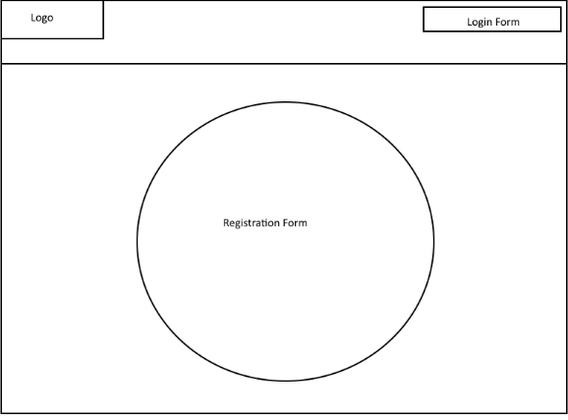

**Elevator Speech**

SquadUP is a new form of social media centralizing around group connections. This new concept of social media has recently been popping up with apps like Band however none seem to have taken the market over. Our project will be a Frankenstein social media platform, with the primary focus being able to interact with people that you are connected to and groups you are a part of. We plan to include similar functionality present in other popular social media sites; photo and video uploads, private messaging (if available replaced with instant messaging), friends list, groups, among others.

**Feature Breakdown Structure**

Login/Register page

User Login

-logs user in. opens up home page

Register form

-creates an account. Brings new user to home page

Home Page

Make forum post

-allows the user to post a text message on a forum board that will be visible to their friends

-allows the user to post media such as pictures

Search bar

-allows the user to search other users of the site

Navigation bar

-allows the user to navigate that page using hypertext links

Newsfeed

-Displays forum posts from other users

Profile Page

Profile picture

-The user selects a picture to display at the top of their profile page

Edit account

-The user can edit their account information

-User can edit security options for their account

Friends list

-Display a list of the user’s friends

Suggested Page

Suggested friends

-a list of suggested users for the user to add as friends. Based on location and or friends in common

Popular posts

-Displays popular posts from other users

Create squad page

Create option

-Allows the user to create a group with friends

Edit Groups

-Allows the user to manage the groups they are a part of

Squad Page

Make forum post

-allows the user to post a text message on a forum board that is visible to the squad

Squadfeed

-Displays forum posts from other users in the squad

**Project Data Sheet**

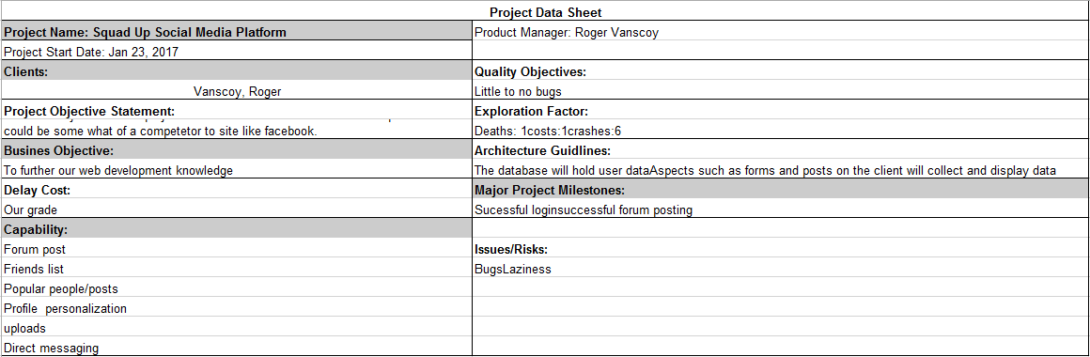

**Technology Selection**

HTML5:

We have chosen to use the markup language HTML5 over others like XHTML due to the simplicity and developer friendly capabilities along with personal experience amongst team members.

CSS:

We have chosen to use CSS to stylize our web pages due to our team member’s knowledge on the text styling language.

ASP.Net & C#:

We have chosen to use ASP.Net & C# due to its versatility and connectivity with our database choice MS SQLS as well as our team members’ experience with the technology.

MS SQLS:

We have chosen to use MS SQLS due to its connectivity with our development choice ASP.Net & C# as well as our team members’ experience with the technology.

**Software Architecture**

