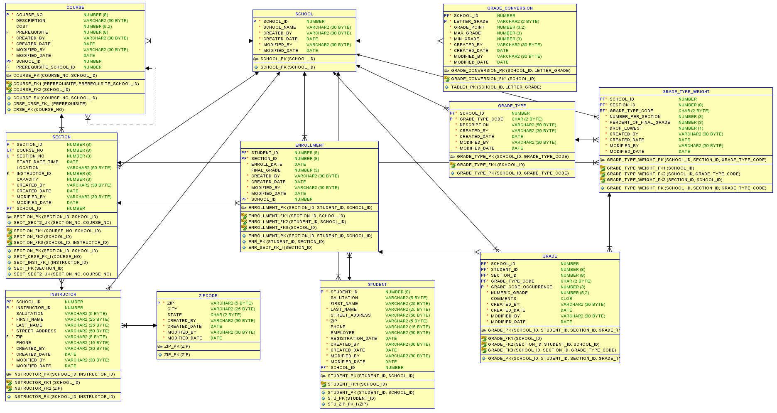

Assignment for PS4.

1. I will give you the script to:
   1. Build PS2
   2. Apply changes to make PS2 = PS3 (PS3_delta.sql)
2. I want a delta script to change PS3 into PS4 (PS4_delta.sql)

The PS4_delta.sql script should:

1. Build the remaining tables (INSTRUCTOR, GRADE, GRADE_TYPE, etc).
2. Set the appropriate FKs. Make sure if there’s an adjustment to an existing PS2/PS3 table, you catch it.
3. Create sequences for Course, Section, Instructor, Student. Make sure sequence values are built into the insert trigger.
4. Build the package. Do it the easy way… Right click table, select ‘Table’, then select ‘Generate Table API’.
5. I’m giving you all the DML that will stand up the data in this schema. Execute the script I’ve attached. If it doesn’t work, you have a problem in your build (wrong table name, wrong column name, etc).
6. I would probably wait until after you run the DML script to set the sequences (the scripts have real values, we want to use the real key values).

We’re going to need this stood up in your schema for the next set of quizzes.

Scripts included with this lab:

|  |  |
| --- | --- |
| File Name | Description |
| zap_objects.sql | Gets rid of all objects in the database |
| PS2_Solution.sql | Solution for PS2 |
| PS3_Delta.sql | Adds the stuff required to change PS2 to PS3 |