Build the ASPNet provider schema. Doing this correctly, you should learn how to generate a basic Blazor project, and how to use ‘Code First’ to push updates to the database.

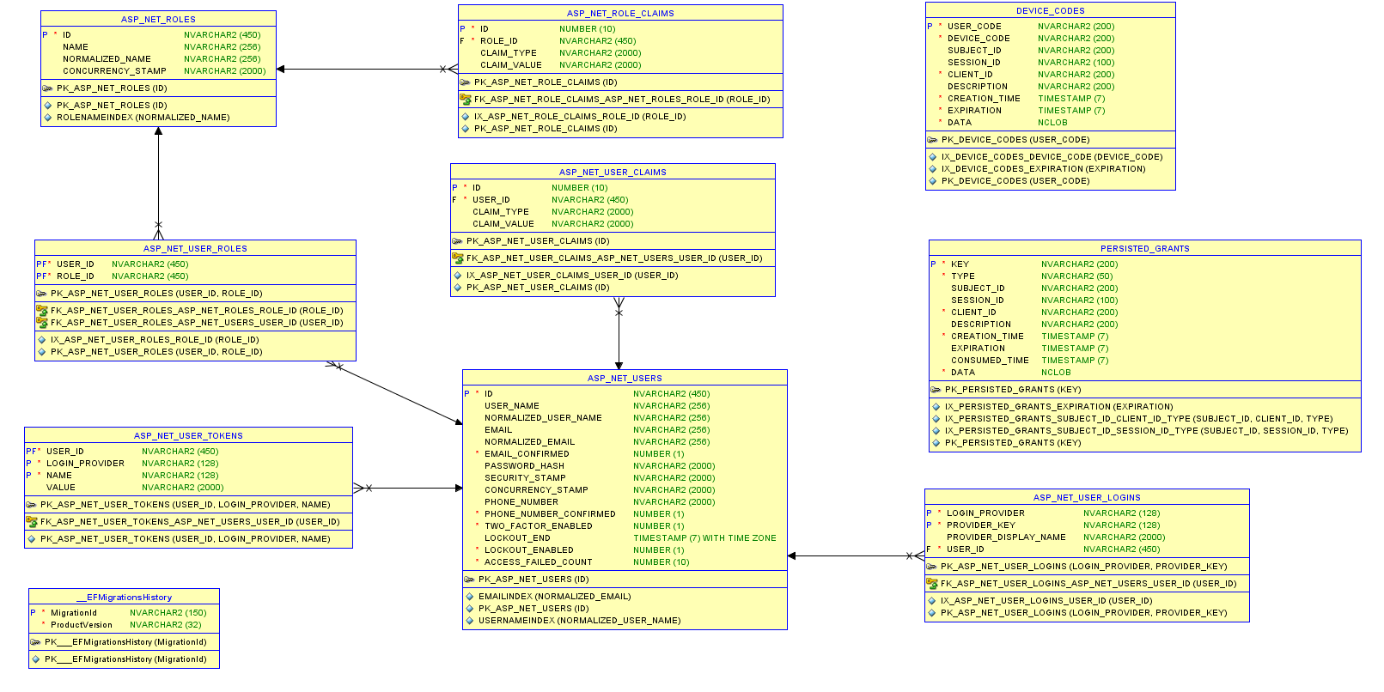

This is the standard Identity model from ASP.NET.

To start, clear out your schema (zap_objects). We’ll bring the schema back in the next lab. I want to start fresh and implement the ASP Identity Framework (schema above).

Start Visual Studio 2019, continue without code

Run the following command to build a new project:

dotnet new blazorwasm -au Individual -ho -o YOUR_PROJECT

Refer to the 3/22/2022 lecture for VS 2019 install, and how to create/start your project.

The following are deliverables for PS5:

1. Private, committed github repository with your code, shared with CISC181 (forgive me, I only have one ‘official’ github education account).
2. The extract / full schema for the tables above.

I have to be honest… There’s not a lot of code you have to enter… the scaffolding does most of the work for you… it’s just tweaks to get the standard ASP identity provider generated.