Implement row-level security on your schema. Do the following to set up your schema:

1. Run Zap_objects
2. Run ‘lab1.sql’, then ‘lab2_delta.sql’, then ‘lab3_delta.sql’, then ‘lab4_delta.sql’
3. Run ‘add-migration’ and ‘update-database’

You’ll end up with a schema close to this:

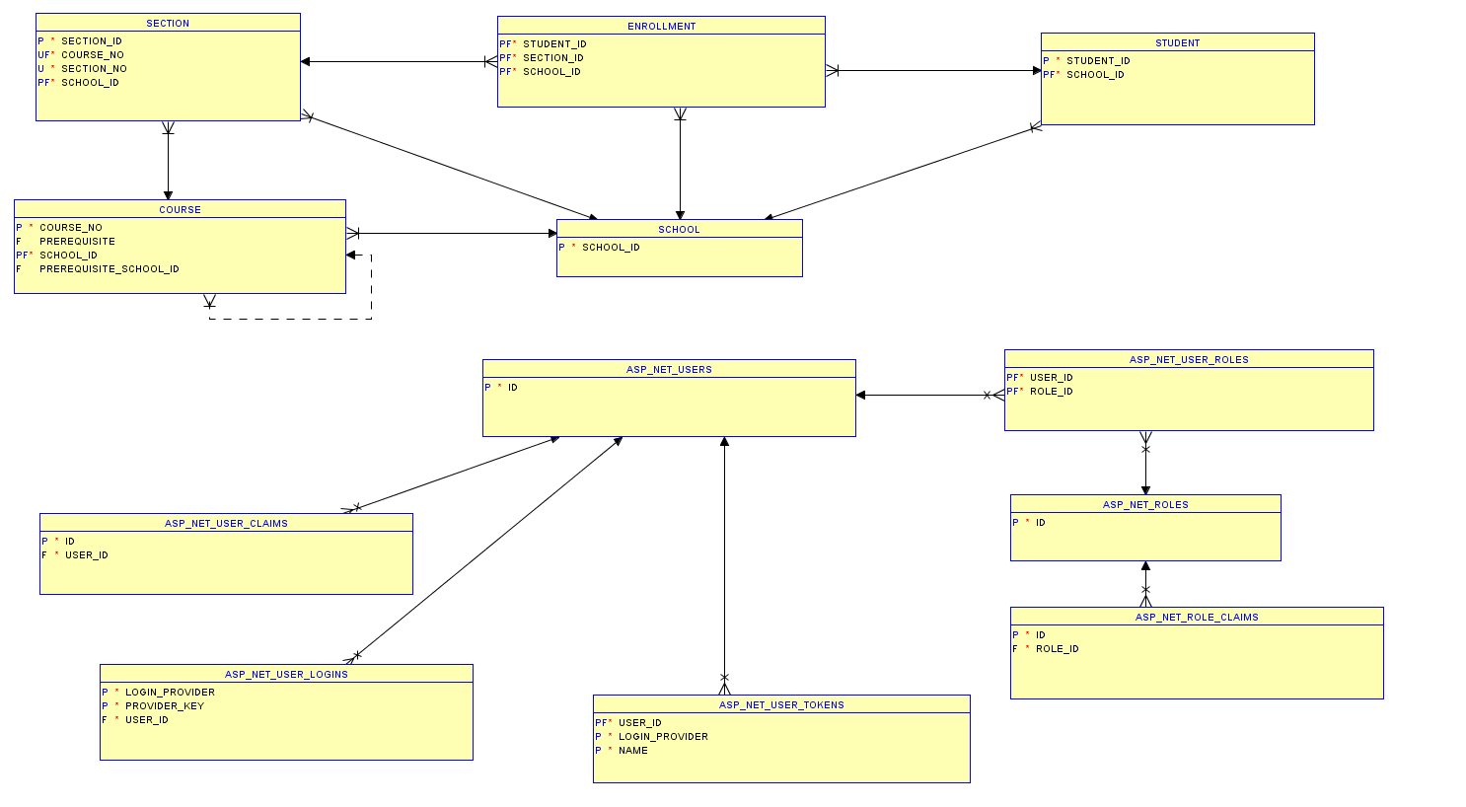

This is a diagram with the schema… without the ‘grade’ tables and showing only PK/FK/UK columns.

It’s essentially two clusters- the parts of the schema we worked on from PS1-PS4 and the part of the schema we worked on for PS5.

For PS6, we need a new table to act as an intersect between SCHOOL and ASP_NET_USERS. I want the new table to be called SCHOOL_USER. The new table should have two columns, USER_NAME and SCHOOL_ID. I’d tweak the ASP_NET_USERS table and add a unique constraint on USER_NAME and build the foreign key relationship on USER_NAME (not ID in ASP_NET_USERS).

I already have a context set up and a trigger to set the context. The following query will expose the SCHOOL_IDs that are available to the current user:

select sys_context('C##SCHOOL_CONTEXT','SCHOOL_IDS') from dual;

|  |  |
| --- | --- |
| **Condition** | **Result of context query** |
| No schools assigned in SCHOOL_USER | (0) |
| Table SCHOOL_USER doesn’t exist in current schema | (0) |
| Columns USER_NAME or SCHOOL_ID doesn’t exist in SCHOOL_USER | (0) |
| School 1 is assigned | (1) |
| School 1,2,3 assigned | (1,2,3) |

To complete RLS security, you need to create a security package. I’m looking for the select, update, insert and delete methods coded, and the DBMS_RLS.ADD_POLICY on each table. There is a sample security package attached to the assignment.

There are two users you can use to test your package:

C##USER1/C##USER1 and C##USER2/C##USER2.

I’ve create a role and provisioned both users access to the role:

create role C##CISC437_STUDENT_ROLE;

GRANT C##CISC437_STUDENT_ROLE TO C##USER1;

GRANT C##CISC437_STUDENT_ROLE TO C##USER2;

You will have to grant access to your table(s) to C##CISC437_STUDENT_ROLE. For example:

Grant select,update,insert,delete on COURSE to C##CISC437_STUDENT_ROLE;

Deliverable:

Script to add the security package and to add policies to your tables.