Tyler Sarnowski
Fall 2018
Cit-130
West Hills

https://github.com/TylerSarnowski/CIT130

Produces a private key from the public key and encrypts a message. This program uses AES/ECB/PKCS5Padding type encryption with SHA-1.

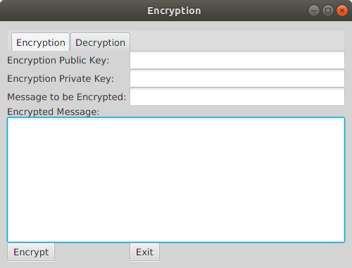
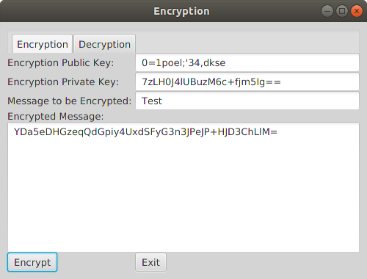
I still need to add in the decryption feature and switching between tabs. The length of the key should be shown to only be 16 characters. To be allowed to switch between different encryptions.

