Individual Assignment: Wireframe

Tyler Smith

University of Phoenix

Mobile Fundamentals

MBL/400

Earl Campbell

July 31, 2017

This week I chose to improve upon a mobile app that I have a lot of experience with, both personally and professionally. As a Barista for Starbucks, I interact with their mobile app every single time I go to work. Whether I’m getting asked about how to connect to our wifi, scanning customers gift cards from their app, or making orders that were made over the app; there are a few common fumbles with the app that I would like to fix. First off, the Starbucks app looks great and I don’t think I could really improve upon the style that they utilize, nor could I fault the internal systems that the app runs on. No, the most common issue I encounter with my customers is their lack of understanding of our product. I would bet that less than half my customers know what is in the drinks that they order every day, and this can cause some serious issues with communication. A miscommunication quickly turns into a messed up drink, which in turn slows down the crew as we work to fix the issue. If our customers had a more informed opinion of what goes in their cup, I think we could drastically reduce these kinds of communication errors.

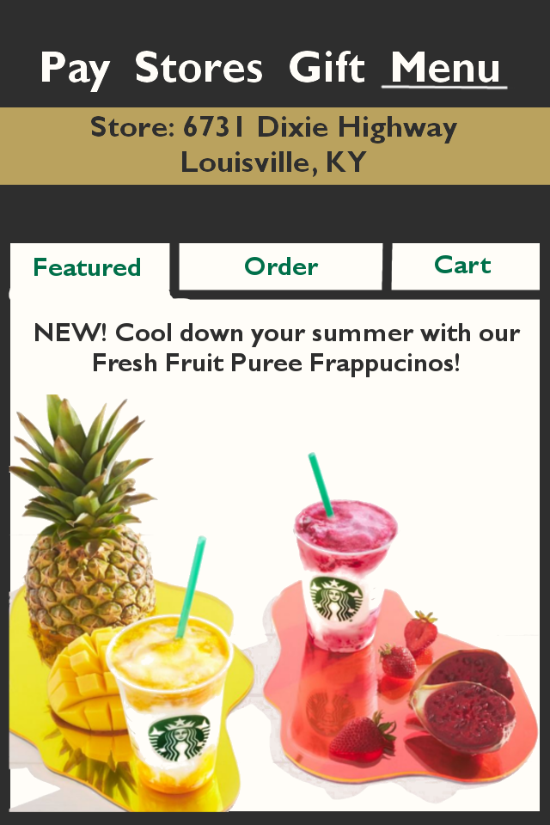In this assignment, I recreated some elements of the menu tab of the Starbucks app, and changed them to help clarify what goes in our signature beverages. Since Starbucks has a new featured beverage every month, I thought it important to add a ‘Featured’ tab that included information about our newest beverage. I would also change the app to clearly display which store you are placing an order to, because we commonly see customers placing orders to the wrong Starbucks location.

A screenshot of a cell phone

Description generated with very high confidenceWhen customers order a beverage on my new version of the app, they will see a menu that displays each of the basic types of our core beverages. These include beverages like lattes and cappuccinos, and also Iced Teas or Refreshers. Once a customer clicks on a beverage that seems interesting to them, the app will expand the item’s display and also give a short description of the beverage. If they like what they see, they can continue to the customer beverage screen to make their own unique creation. I thought it important to emphasize what each basic type of beverage it is because so many people don’t know what a cappuccino really is, or what ingredients go in our signature Mocha beverages.

A close up of a map

Description generated with very high confidence Once they’ve selected a basic category of beverage, they can then swipe through our offerings for each category, select one they like, and change any part of it they want by pressing on the part of the beverage they want to change. For example, if they wanted no foam in their White Mocha, they could click on the foam section of the beverage and then select ‘no foam’ from the new menu. With a visual aid such as this, customers can gain a better understanding of what it is they are ordering, and will naturally begin to learn how our menu works.