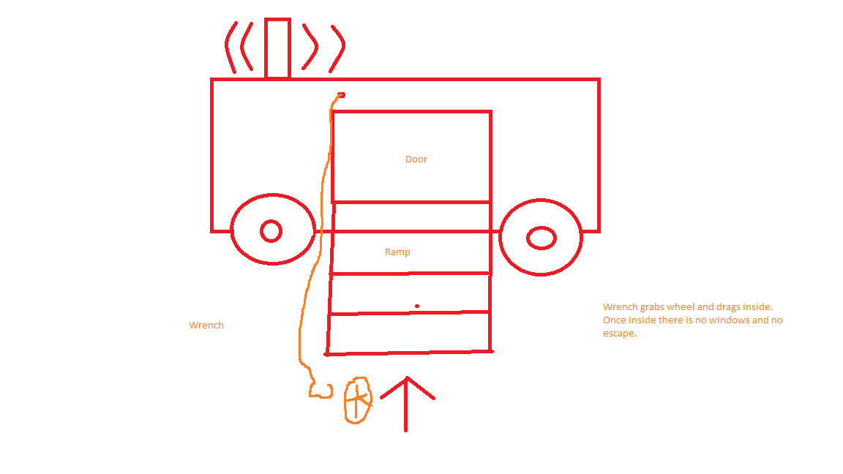The awesome claw bus is an Uber like bus except for handicapped people. Our company Comfort Unbounded: New Transportation Services™ LLC Inc. (CUNTS) will be in charge of handling the design and implementation of said “The Awesome Claw Bus ™”. The victim will approach the bus after being summoned after notifying CUNTS that they need a pick up on the CUNTS app. Once the vehicle arrives and pulls up next to the person a claw will eject from the bus and grab the wheel of the wheel chair and pull it up a ramp where the ramp will fold up and close. There will be no doors and windows on the vehicle, literally nothing on the inside but darkness. The bus will then fill with foam to ensure the passenger does not bounce around too much during the duration of the trip. The only exit is the ramp and there is a spinning sensor on top of the vehicle. This is to make the person feel safer and the spinning sensor on top really does nothing but spin. Once the passenger arrives at the designation he will be ejected out of the vehicle by a large hydraulic piston down the ramp.

The claw on the bus will be radar controlled.

The disadvantages is the passenger may not be fully comfortable the lack of climate control. Fuel costs is low because This will likely be an unbalanced wheel inside the bus that’s constantly spinning. The advantages is its pretty cheap to make compared to fully featured vehicles and the likelihood it’ll explode in flames is low.