Lab Questions (9 @5 points each for a total of 45)
Your answers for each question should fill at least 1/2 page. You may use any drawing application to create the designs and then copy/paste the pictures into this document. If you use Visio, just use the flowchart shapes; you may be able to use the Word flowchart auto shapes; you might need to scan your drawing to a .jpg or .bmp or whatever and then paste it here.

---------------------------------------------------------------------
A grocery chain needs a database designed in order to keep track of inventory and sales; the scenario to model is as follows:
A customer goes to one of the stores to make a purchase, which contains one or more products. The employee ID of the cashier will be stored for the purchase; if the customer is a member of the loyalty program, his membership ID will be associated with the purchase as well (although this is not required).
Each product will have a current price and stock inventory count for that store; the purchase amount will be the total of all product prices times their quantity. After the customer pays, the purchase should be marked as paid, and the stock inventory count for all items in the purchase should be reduced accordingly.
---------------------------------------------------------------------

Q1. Read through the above scenario and determine which entities are involved (identify all of the things and decide whether they are entity classes or attributes). Create a simple ERD to show only the entities and the relationships between them (see the first lecture example). Name the relationships (e.g. “employs”, “schedules”, etc) but do not show the relationship cardinalities nor any of the attributes. It is expected and perfectly OK to have at least one many-to-many and/or ternary relationship here, because these will be changed in the next step.
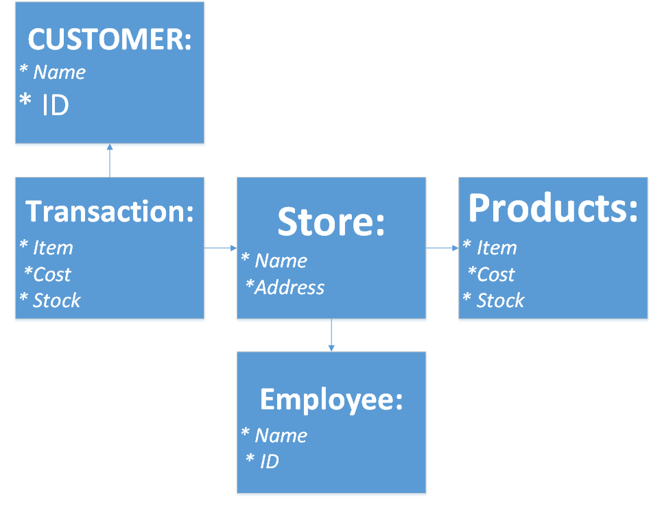
(Customer → Transaction)
Q2. Expand the ERD from the previous question by adding the minimum and maximum relationship cardinalities to the model; eliminate any ternary and/or many-to-many relationships from the previous ERD by creating an intersection entity between them. Show optional/mandatory cardinalities and use crows-feet notation to display the “many” sides. Include cardinality for all relationships between two entities.

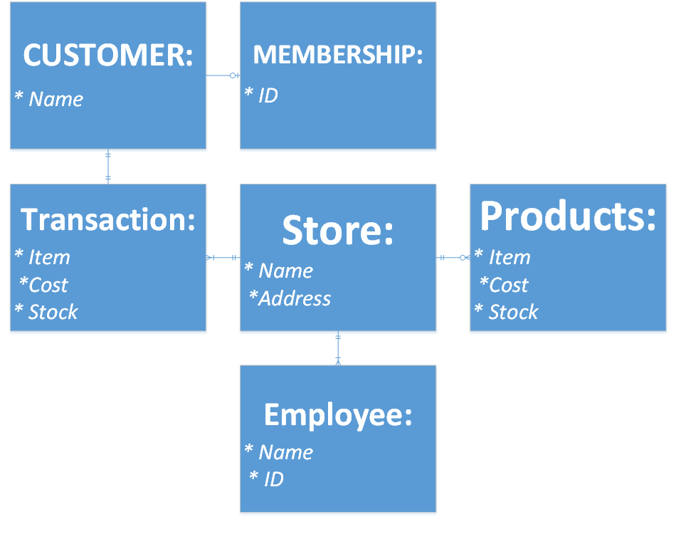
Q3. Taking each pair of related entities at a time, write one sentence describing the relationship cardinalities (minimum and maximum) in each direction. For example, this relationship

...may be stated:
An employee builds zero to many stoves / A stove is built by exactly one employee.
A Customer can have zero or 1 memberships / a membership can have only 1 customer.
A Transaction can have only 1 Customer / a customer can only have 1 transaction
A Store can have 1 or more transactions / but a transaction cannot have multiple stores.
An employee can work at one store / but a store can have multiple employees.
A product can have only 1 store / a store can have many products.
Q4. Turn four of your entities into relations. Select an attribute(s) to represent the primary key; display this first, underlined. Include other attributes you would expect to find for this entity. Lastly, include any foreign keys which reference other entities; display these in italics.
Example from the FiredUp database:
STOVE (SerialNumber, Type, Version, DateOfManufacture, Color, FK_EmpID)
Customer ( Name, FK_ID )
Membership( PK_ID )
Transaction ( FK_Item, FK_StoreID, Cost, Stock (Quantity) )
Store ( PK_StoreID, Address, Stock )

Q5. What are some questions you may have to ask the user in order for you to continue the design process? Include at least five questions. Be sure to address any ambiguities in the scenario that might affect your design.
Do you have more than one store?
Do your employees also work at other locations?
What information about the customer do you want to keep track of?
What information about the membership do you want to keep track of?
Can a customer (like a family) share a membership?
Q6. A weak entity is an entity whose existence depends upon another entity. Examine the ERD for the FiredUp database and identify two entities that can be considered to be weak (note: this ERD does not use rounded-corner representation of weak entities; you will have to identify them logically). Explain why each of these entities is weak.
PO_LINE_ITEM (FK_PONbr) is a weak entity because its dependent on PK_PONbr in the PURCHASE_ORDER table.
FK_PartNbr in INV_LINE_ITEM is weak because its department on PK_PartNbr in the PART table.

Q7. Again, examine the FiredUp ERD. Identify two intersection entities (i.e. entities which were created to break apart a N:M relationship). Explain what tells you that these are intersection entities.
A PART can have many PURCHASE_ORDERs and many PURCHASE_ORDERs can have many PART(s). PO_LINE_ITEM breaks them a part.
PART'S can have many STOVE'S and Stoves can have any PART's. INV_LINE_ITEM breaks them a part. And or though a series of events so does Repair_line_item Stove repair and employee... but thats not really an intersection, more of a road with a bunch of intersections.

Q8. Examine the data in the relations in Figure 3-17, above. Explain why we can say that Buyer determines Department, but Department does not determine Buyer.
Because the buyer has a Department column and the department table does not have a buyer column or any form of ID-ing a buyer.

Q9. Explain why SKU -> (SKU_Description, Department, Buyer).
Because SKU is dependent on the buyer who is also dependent to the department and the description is dependent on the SKU table?

