The following figure is the WolframAlpha multiplication for Problem 1: x = R^{-1}*Q^T*b
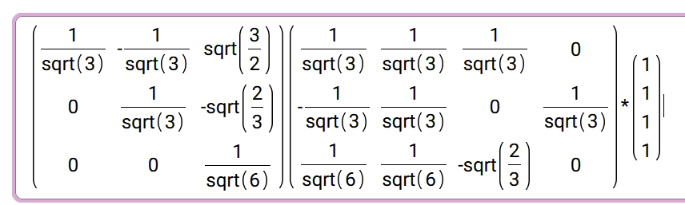
The following figure shows spy(hello) for my code of the matrix in Problem 3.
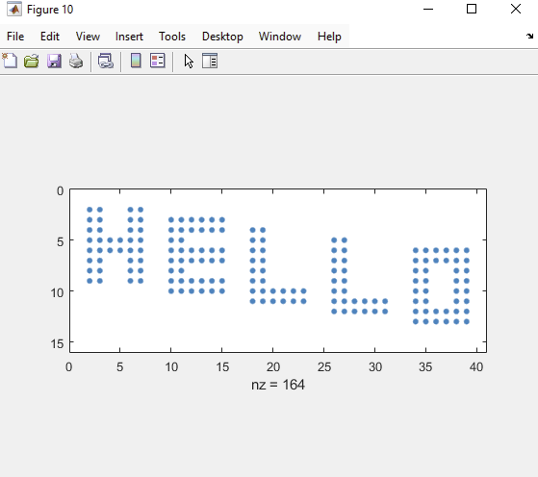

The following figure is the regular plot of the singular values:
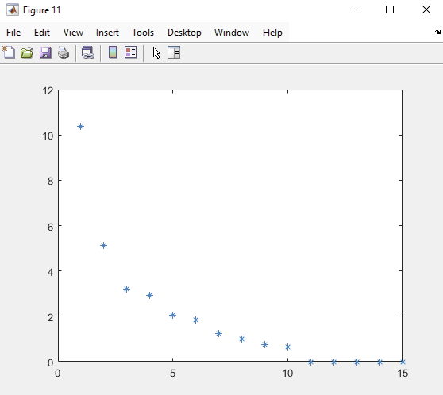
The following figure is the semiology plot of the singular values:
