To: European Union Agency for Law Enforcement Cooperation (EUROPOL)

From: Tyler Wilson

Date: August 10, 2018

Subject: Migration in the Mediterranean

______________________________________________________________________________

**Introduction**

The European refugee crisis has been a defining factor in recent European foreign policy. In 2017, 172,301 refugees arrived on the coasts across southern Europe, and in 2018 around 60,000 have arrived thus far adding to the over 1.8 million refugees who have crossed the Mediterranean since 2014. These refugees are fleeing conflict areas strife with corruption, political unrest, and economic instability. While there is variation in the source of European migrants, a stark majority of refugees cross the Mediterranean from Libya, a country where refugee smuggling has become a billion-dollar industry. This becomes further problematic when refugees attempting to cross the Mediterranean through Libya are swept into human trafficking, prostitution, and other forms of abuse.

Because of this, crossing the Mediterranean is a task that has become increasingly difficult. Adding to the danger of smugglers, low quality boats and poor weather, and wave height make the voyage from Northern Africa to Europe uniquely dangerous. Since 2014, over 17,000 migrants have either died or gone missing at sea. However, migrants continue to make the trip.

Using data on the height of waves in the Mediterranean and the number of riots across northern Africa we can see the how they affect the number of migrants who arrive on the shores of Europe. Using data, we were able to regress immigrant arrivals against the frequency of riots and Mediterranean wave height. on Understanding how these variables and their effects on migration can help predict arrivals. This information can be used by the EUROPOL and surrounding NGOs to optimize the number of refugees saved from potential death at sea.

**Regression Analysis**

1. The first regression we ran was the natural log of total arrivals (*ln_arrival_total)* regressed against the natural log of riots in the previous week *(ln_riots_prevweek).*

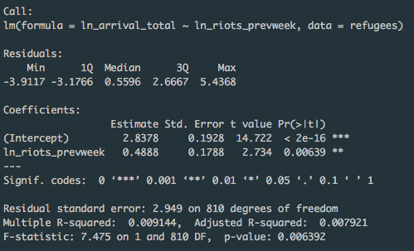

*Fig 1. Arrivals Regressed Against Riots*

In this regression, we see that our estimate value for ln_arrivals_total is 2.8378. Our estimate value for ln_riots_prevweek is .4888. These numbers are both natural logs, which means we can interpret the integers as percents. For every 1% increase riots, there will be a .4888% increase in arrivals. Given the std. error and t value, a strong correlation between the riots and arrivals can be seen.

1. The second regression ran was *ln_arrival_total* against the natural log of wave height in the Mediterranean during the previous week (*ln_wave_height_prevweek)*.

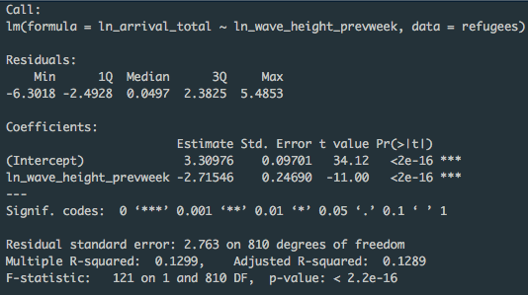

*Fig 2. Arrivals Regressed Against Wave Height*

In this regression we see a negative correlation between wave height and arrivals. For every 1% increase in wave height, arrivals decrease by 2.71546%. We see that the the probability of our estimate being larger than the t value is extremely small (<2e-16). This means we cannot reject our null hypothesis. In other words, wave height and total migrant arrivals are highly correlated.

1. The third regression was *ln_arrival_total* against both *ln_riots_prevweek* and *ln_wave_height_prevweek*.

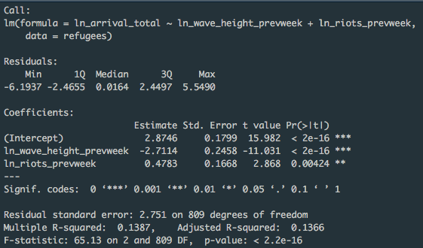

*Fig 3. Arrivals Regressed Against Wave Height and Riots*

When we put both independent variables in the regression we see that the marginal difference of percent change between wave height an riots is 2.2331%. Given that both are statistically significant, we can presume that wave height has a larger effect in magnitude on total migrant arrivals. More generally, the t value can explain which regressor has the largest effect on the dependent variable. Here we see a t-value of 11.031 for wave height, while a 2.868 t-value for riots. This tells us that the probability that wave height is affecting arrivals is much higher. The reason for this difference could be several factors. It could be that migrants were already planning to travel before riots. It could be that the riots only effect a percentage of migrants, while wave height effects all of them crossing. The most likely answer will account for all of these factors.

1. 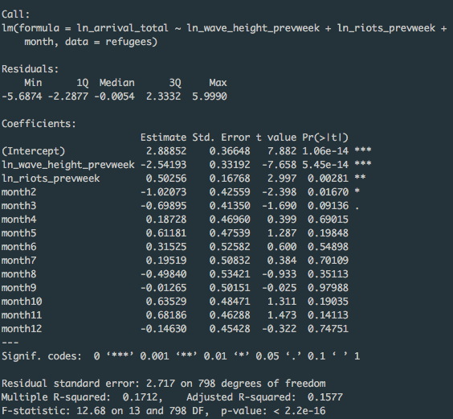In the last regression, fixed effects have been added to account for seasonal change in the data set.

*Fig 4. Multivariate Regression with Seasonal Fixed Effects*

Here our summary table is broken down by month. It gives the output for each month and compares it to January which is our base month. What the fixed effects do is show us how each month’s estimates differ from the average. We see that there is seasonal effect, however the coefficients for both riots and wave height are still significant without seasonal effects. Wave height and riots then combined with the changing of seasons can generally better predict arrivals across the years.

**Graphs**

**Migrant Death Rate at Sea Over Time**

**Mediterranean Wave Height Over Time**







**Seasonal Effect on Migrant Death Rate at Sea and Mediterranean Wave Height**

**Recommendation**

What the first graph can tell us is that the death rate of migrants at sea is significantly higher from around the months January to May. The second graph shows a strikingly similar seasonal trend in wave height. The high correlation between wave height and migrant arrivals seen in our regression analysis is also visible in the combined graph. During the winter and spring months of the year, migrants who are crossing the Mediterranean are susceptible to a more dangerous voyage, and subsequently higher death rates. With this data, EUROPOL can more appropriately know when to look for migrants and when to prepare for larger sums of migrant arrivals.