Assignment 3.3

Tyler Anderson

December 15, 2019

## Attendance per month

Since attendance is the main variable to determine what day is best to run a marketing promotion we will use that in our plots. In this example we can see July has a highest maximum attendance rate but on average is not that impressive. Jun however, has a high attendance rate and has a high average.

ggplot(dodger, aes(x = month, y = attend, color)) +  
 geom_boxplot(na.rm = TRUE)

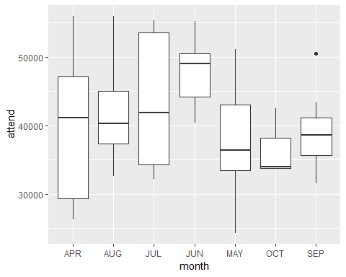

## Attendance per promotion

When looking at the promotions we can see that when bobbleheads are promoted they tend to have higher attendance.

ggplot(dodger, aes(x = bobblehead, y = attend)) +  
 geom_point(na.rm = TRUE) +  
 geom_jitter()

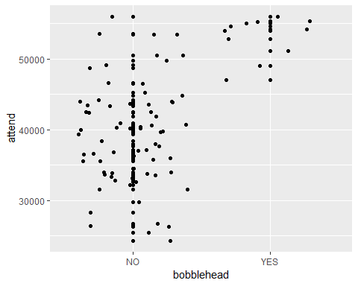

ggplot(dodger, aes(x = cap, y = attend)) +  
 geom_point(na.rm = TRUE) +  
 geom_jitter()

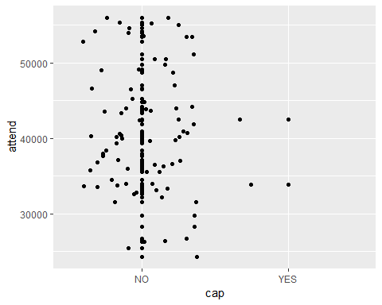

ggplot(dodger, aes(x = shirt, y = attend)) +  
 geom_point(na.rm = TRUE) +  
 geom_jitter()

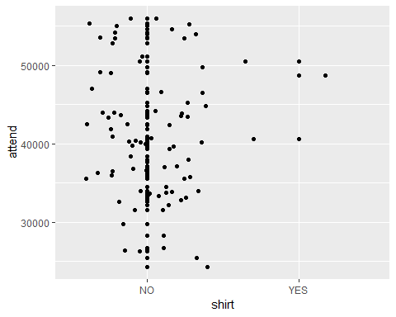

ggplot(dodger, aes(x = fireworks, y = attend)) +  
 geom_point(na.rm = TRUE) +  
 geom_jitter()

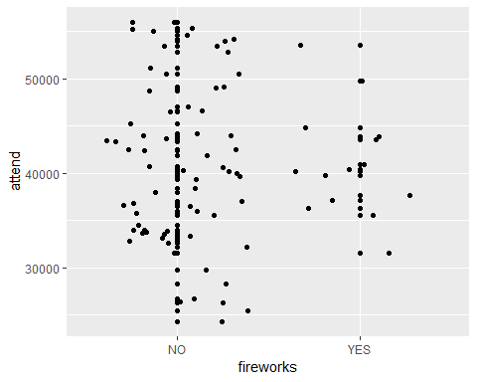

## Day of Week and time of game

We can see there are more games played at night and a higher attendance on tuesday.

ggplot(dodger, aes(x = day_of_week, y = attend)) +  
 geom_boxplot(na.rm = TRUE) +  
 geom_jitter()

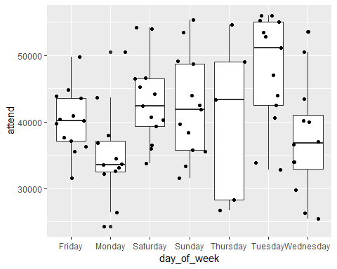

ggplot(dodger, aes(x = day_night, y = attend)) +  
 geom_point(na.rm = TRUE) +  
 geom_jitter()

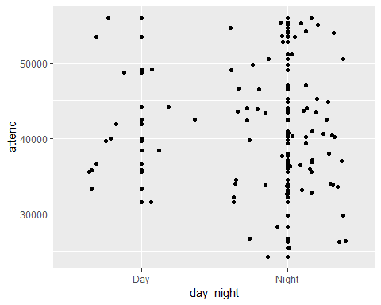

### Conclusion

Looking at our data and our exploration, Bobbleheads are a large driving factor in high attendance along with games in July and June. If the goal is to pick a day with the highest amount of attendance in both months then the top 3 days are July 1st, 14th and Jun 12th. All three of these dates had a bobblehead promotion and were all warm nights. If the goal was to pick a date where there was low attendance and use that to determine what promotion to use to drive up attendance, then I would pick May 14th. It had the lowest attendance and no promotion. A promotion of bobbleheads might have driven up attendance.