The Right iPhone

Name: Tyler Eck

Student ID: 410821337

Introduction

**The Right iPhone** is a program that will allow users to choose the specific type, model, and memory of iPhone that is available on the market, search for the different prices on different websites, and compile all this information together for the user to observe.

Motivation

Each iPhone type has its own set of models, and each model has its own set of memory. Selecting a specific iPhone combination is such a trivial task that should be easier. The Right iPhone’s GUI makes it easy for users to view and select the different combinations for searching.

We all want the best possible product at the cheapest price, especially when it is something as important and expensive as an iPhone. By making a simple program that automatically searches prices on different websites and compiles the data together in a neat way, Users will save time and find it easier to select where to buy the iPhone.

Purpose

The main purpose of this project is to develop a program that allows users to select the combination of different iPhone names, models, and memory. With the click of a button, this iPhone selection will be searched on three popular technology websites: Apple, PCHome, and StudioA to find the best available prices. These prices will then be sorted and available for viewing in an easy-to-read GUI table.

Relative work

Currently, there are no other programs that I know of that does this compilation and finds the best price of iPhone. Only the different websites such as Apple, PCHome, and Studio A have their own functionality and search results. My program will compile and make these available in one spot allowing for convenience and saving time for the user.

System Description

The main program was built using Python 3.0 and uses the below libraries:

**Tkinter** – the main GUI screen with menu selections, **Threading** – used to run searching threads, **Pillow** – used to format images that I used for menu, **Numpy** – used to format the arrays, **Pandas** – used to format all the global arrays and data, **BeautifulSoup** – used for scraping the web and retrieving data, **Selenium** – used to open browsers and navigate webpages, **Time** – used to delay program to wait for webpages to load

The two main functions of The Right iPhone are:

1.) GUI Selection/ Menu – allow users to select the specific iPhone they want

2.) Searching – search three websites for prices and compile them into a table.

For the GUI, I decided to use **Tkinter** with the **Azure theme** to give it a cleaner look. To give the users a chance to visually see the difference between the iPhone names and models, I made the selection simply as a guided menus with pictures.

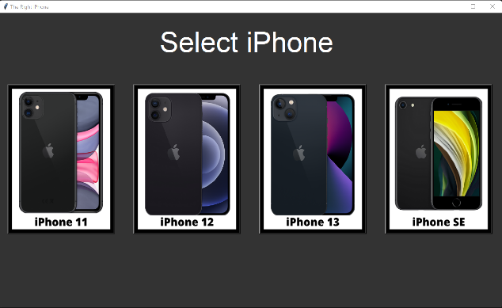 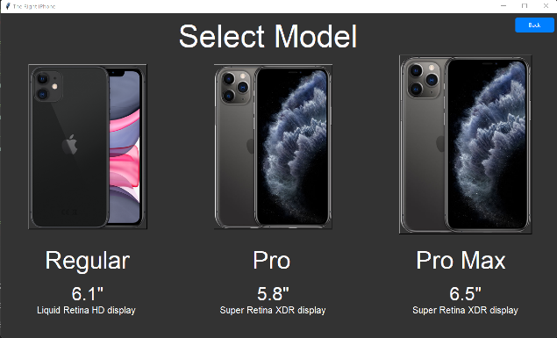

**iPhone Guided Menu Screens**

The first page shows a picture of all the iPhone types including the 11,12,13 and SE, the second page shows a picture of the Model types (which are dependent on the iPhone selection), and lastly the third page shows a picture of the Storage types (which are dependent on **BOTH** the iPhone selection **AND** the Model Selection)

To decide which models to display for each iPhone type, an array called “t_for_n” (type for name) is used to get the index of the last value in the model list.

Model list: [ Regular, Pro, Pro Max, Mini ]

Example:

* t_for_n(iPhone 11) ->>> 3 ->>> Regular, Pro, Pro Max
* t_for_n(iPhone 12) ->>> 4 ->>> Regular, Pro, Pro Max, Mini
* t_for_n(iPhone 13) ->>> 4 ->>> Regular, Pro, Pro Max, Mini
* t_for_n(iPhone SE) ->>> 1 ->>> Regular

To decide which memories to display, I used a 2D array called “m_for_mem” (memory for model) that uses the name number as the row index and model number as the column index to get the specific tuple of the start and end index of the storage types.

Storage_Types = [ 64 GB, 128 GB, 256 GB, 512 GB, 1 TB ]

Example:

* m_for_mem(iPhone 11 Regular) ->>> (0,2) ->>> 64 and 128 GB
* m_for_mem(iPhone 11 Pro) ->>> (0,4) ->>> 64,128, 256, and 512 GB
* m_for_mem(iPhone 11 Pro Max) ->>> (0,4) ->>> 64,128, 256, and 512 GB

After the storage page, users will be guided to the instructions/confirmation page to confirm selection and start the search. This page also contains instructions for the user to read. If any mistakes are made, a Back button was also installed on the top right.

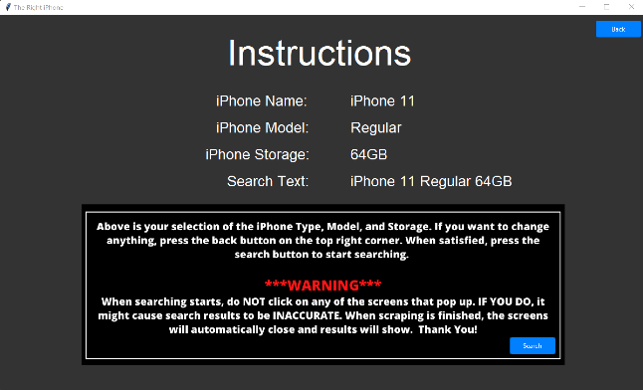

**Instructions/Confirmation Page and Search Results**

For searching. I used Selenium to open the chrome web browsers and the Beautiful Soup to get the desired information from the websites. The three main things that I needed from all the websites were: **Price, Name, and URL**.

Because each of these websites have its own set of functionality and flow, I created functions to start searching for each of these websites: Apple: search_apple() , PCHome: search_pchome(), and Studio A: search_studioA().

After scraping was done, I created a **Tkinter Treeview** object that can display the pandas dataframe that held all the compiled data. As shown above, the last page to be shown is the Search Results page that shows the search text and all the data that was scraped from the webpages. The number of each source was counted and displayed. In the table contains the information from the Pandas dataframe: Name on the Web, Location, Price, and Link. If the user wants to check out the website, they can just press the item and a webpage will pop up that holds the desired link.

This project was started on May 26th and finished on June 11th. A total of 2 weeks with an average of 15 hours a week brings the total work time to 30 hours total spent on developing The Right iPhone. About 90%, including the python file, documents, and edited pictures were all done by me. About 10% was allocated for the GUI design: Azure theme which was pulled from GitHub and used in this project. It is a popular public repository that is widely used and therefore implemented in this project.

Conclusion

After 2 weeks of development and many problems, I have successfully created a program that allows users to select their desired iPhone combination and search the three websites for the best prices. A GitHub repository was made for this project on May 26th. I mainly used it to hold version of my code in case anything went wrong in the development process. A link to this repository is here: <https://github.com/Tylereck81/TheRightiPhone>