CS 305 Project Two: Practices for Secure Software Report
Artemis Financial
Tyler Martin
Southern New Hampshire University
CS 305: Software Security
October 20, 2026

1. Algorithm Cipher
Artemis Financial needs to protect customer information while exchanging financial data. I selected SHA-256 for checksum generation because it produces a fixed 256-bit digest that can be compared to detect changes in a message. SHA-256 is a cryptographic hash algorithm, not an encryption cipher: it does not conceal plaintext and does not provide confidentiality. The application uses Java MessageDigest with UTF-8 input, and converts the digest to a 64-character hexadecimal string (National Institute of Standards and Technology [NIST], 2015).
For secure communications, HTTPS uses TLS to protect data in transit. The local certificate uses an RSA public key and a SHA-384-with-RSA certificate signature. The certificate signature algorithm is separate from the SHA-256 checksum algorithm. Production deployments should use supported TLS versions, trusted certificates, and maintained cryptographic libraries (OWASP Foundation, n.d.-b).
Symmetric encryption uses the same secret key to encrypt and decrypt information, making it efficient for protecting large amounts of data. Asymmetric encryption uses a public and private key pair and supports functions such as authentication and secure key establishment. For Artemis Financial, TLS uses cryptographic mechanisms to establish a protected connection and symmetric encryption to protect application data during transmission. SHA-256 serves a different purpose because it creates a digest that can help verify data integrity rather than encrypting information. Using these methods together supports confidentiality, integrity, and authentication (NIST, 2015; OWASP Foundation, n.d.-b).

2. Certificate Generation
I used a PKCS12 keystore containing a self-signed certificate for localhost. Keytool verification displayed alias “selfsigned,” owner and issuer CN=localhost / O=Artemis Financial, creation date September 27, 2026, validity through September 24, 2036, a 2048-bit RSA public key, and SHA384withRSA signature. Because the issuer and owner are the same, this certificate is appropriate for demonstrating local TLS but is not trusted by default by public browsers (Oracle, n.d.).
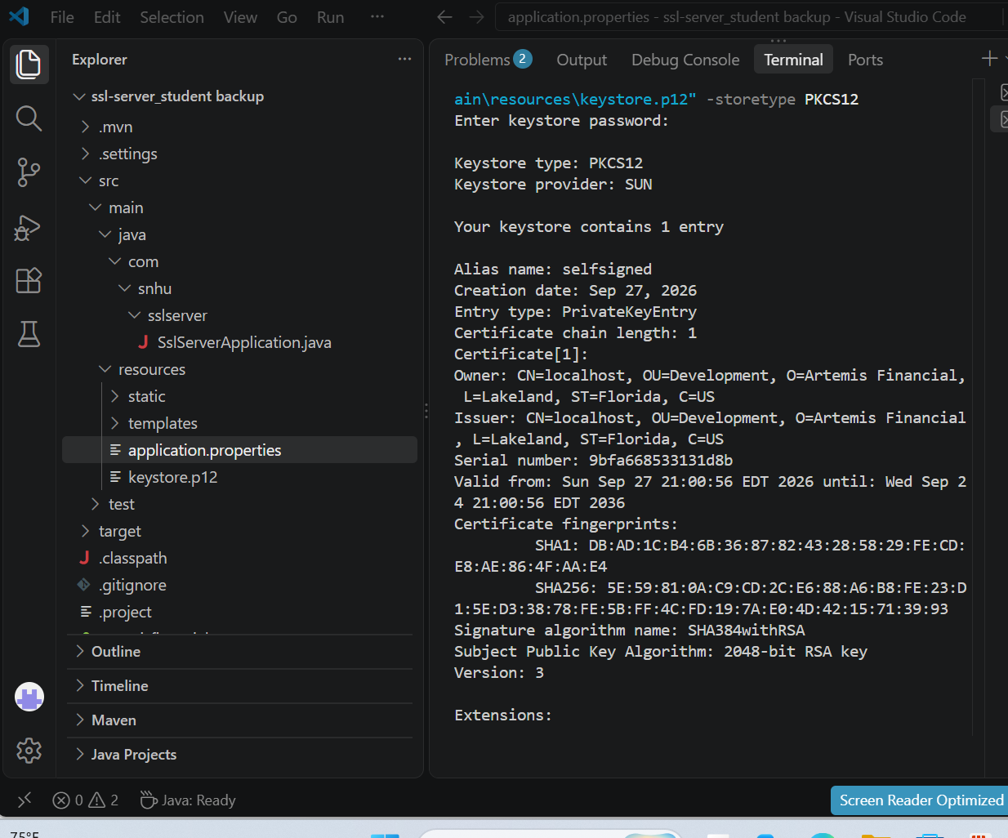
Figure 1. Certificate Generation and Verification
Java keytool output confirming the creation of a self-signed certificate for Artemis Financial. The certificate uses a 2048-bit RSA public key, a SHA384withRSA signature, and a PKCS12 keystore with the alias selfsigned.

3. Deploy Cipher and Checksum Verification
In SslServerApplication.java, the GET /hash endpoint defines the message “Hello World Check Sum!”, obtains MessageDigest.getInstance("SHA-256"), hashes UTF-8 bytes, and returns the original message with its hexadecimal digest. I opened https://localhost:8443/hash and observed both the message and checksum, confirming the endpoint ran. This demonstrates checksum generation; a separate comparison against an independently calculated digest would strengthen integrity verification (NIST, 2015).
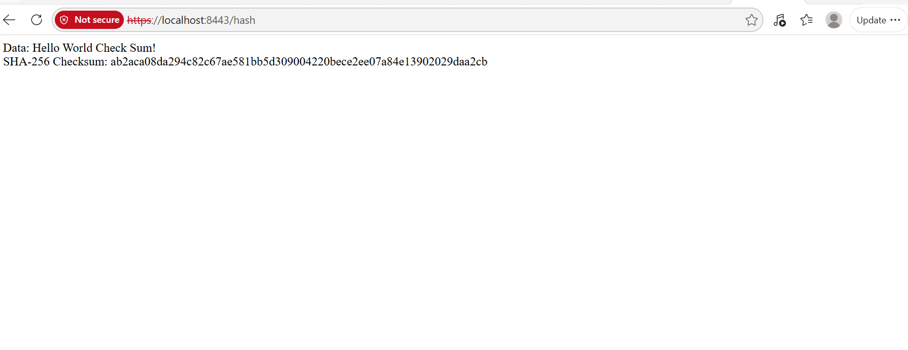
Figure 2. SHA-256 Checksum Verification
Browser output displaying the Artemis Financial application running at https://localhost:8443/hash. The endpoint successfully generates and displays a SHA-256 checksum for the message "Hello World Check Sum!" using Java's MessageDigest functionality.

4. Secure Communications
The Artemis Financial application was refactored to support secure HTTPS communication instead of relying on an unencrypted HTTP connection. In the application.properties file, I configured the server to use port 8443, enabled SSL/TLS, identified the PKCS12 keystore, and selected the selfsigned certificate alias. I also replaced the plaintext keystore password with the environment variable ${KEYSTORE_PASSWORD} to reduce the risk of exposing credentials in the application's configuration file.
After completing these changes, I successfully started the Spring Boot application and verified that Tomcat was running on port 8443 using HTTPS. I then opened https://localhost:8443/hash and confirmed that the application displayed the original message and its SHA-256 checksum. Although the browser displayed a security warning because the certificate was self-signed and not trusted by a public certificate authority, the test demonstrated that HTTPS was functioning locally. In a production environment, Artemis Financial should use a trusted certificate authority and supported TLS configurations to protect sensitive financial information during transmission (OWASP Foundation, n.d.-b).
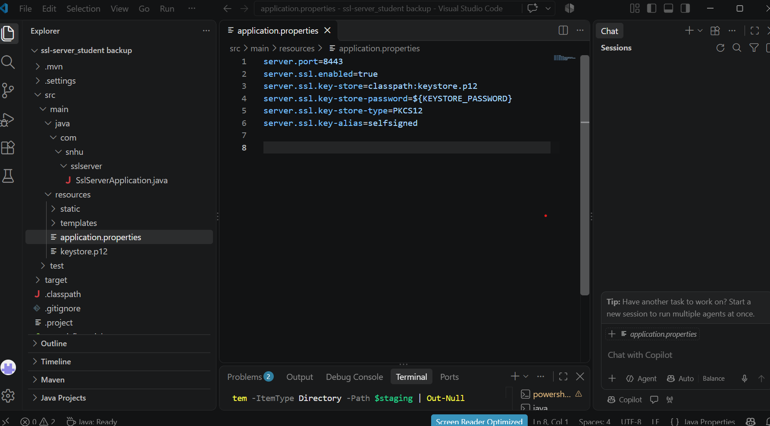
Figure 3. Secure Communications Configuration
The application.properties file showing HTTPS enabled on port 8443, the PKCS12 keystore configuration, and the use of the KEYSTORE_PASSWORD environment variable instead of storing the keystore password directly in the configuration file.

5. Secondary Testing
I ran OWASP Dependency-Check Maven 12.1.3 after the HTTPS and checksum changes. The October 25, 2026 HTML report showed 49 dependencies scanned (31 unique), 16 vulnerable dependencies, 292 reported vulnerabilities, and zero suppressed vulnerabilities. The Maven command completed with BUILD SUCCESS. This confirms the scan executed, not that the dependencies are secure. Dependency-Check findings require manual validation because automated matching can produce false positives and may miss vulnerabilities (OWASP Foundation, n.d.-a).
The findings remain unresolved in the evidence reviewed. Recommended follow-up work includes identifying affected direct and transitive dependencies, prioritizing critical and high-severity findings, upgrading the outdated Spring Boot 2.2.4.RELEASE stack to a currently supported release through a tested migration, rescanning, and documenting any verified false positives rather than broadly suppressing CVEs. I cannot claim the reported vulnerabilities were fixed based on this scan.
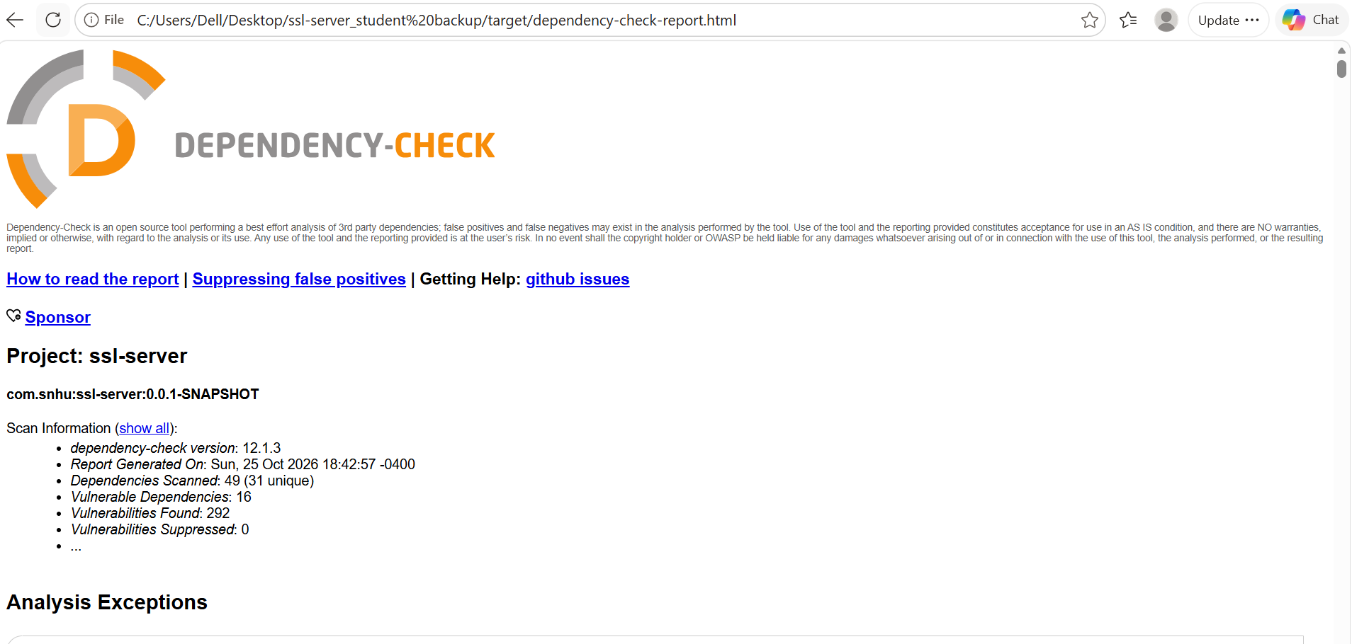
Figure 4. OWASP Dependency-Check Results
OWASP Dependency-Check report showing 49 dependencies scanned, 16 vulnerable dependencies, and 292 reported vulnerabilities. The results identify dependency-related security risks requiring further investigation and remediation.

6. Functional Testing
I ran the Maven clean test command after refactoring. The results showed one test run, zero failures, zero errors, zero skipped tests, and BUILD SUCCESS. I also manually confirmed the /hash endpoint returned its checksum over HTTPS. These results show the configured automated test and tested endpoint functioned; they do not establish complete test coverage or resolve the dependency vulnerabilities.
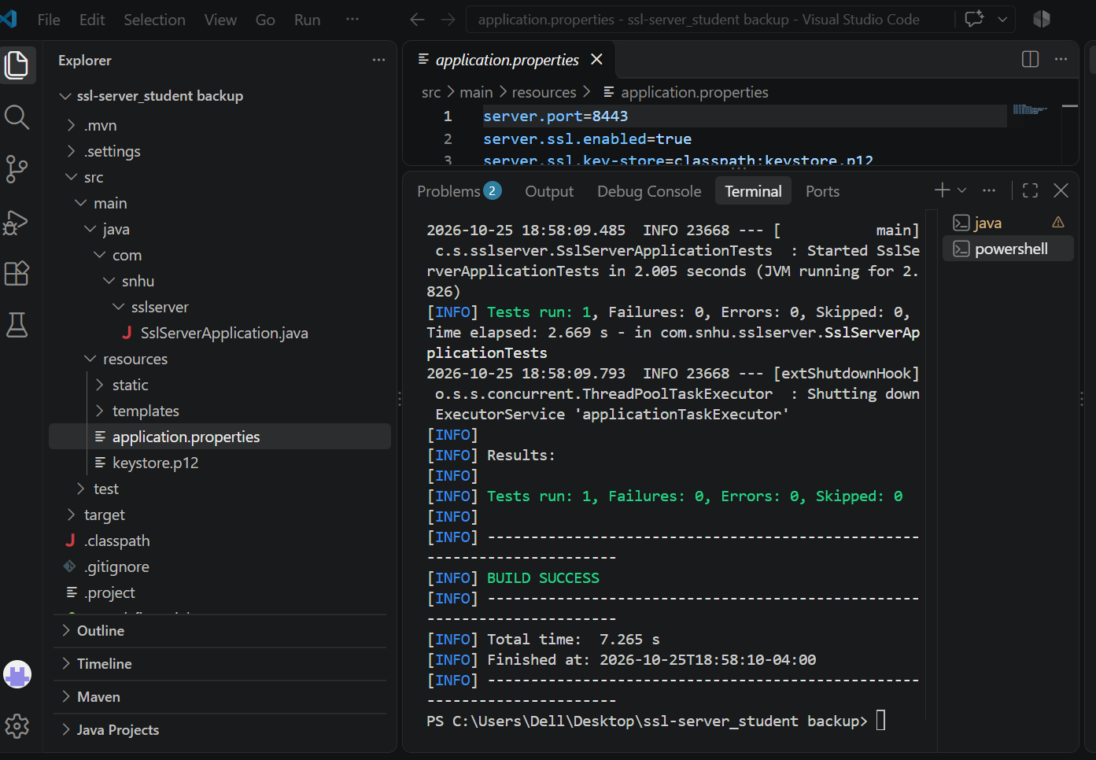
Figure 5. Functional Testing Results
Maven test output confirming successful execution of the application's automated tests. The results show one test completed, zero failures, zero errors, zero skipped tests, and BUILD SUCCESS after the security refactoring.

7. Summary
Throughout this project, I improved the security of the Artemis Financial application by implementing SHA-256 checksum generation, configuring HTTPS communication, and using a self-signed certificate stored in a PKCS12 keystore. I also improved credential handling by replacing the plaintext keystore password in application.properties with an environment variable. After refactoring the application, I verified that the HTTPS endpoint worked correctly and that Maven completed the functional tests with one test executed, zero failures, and zero errors.
The OWASP Dependency-Check scan identified 292 reported vulnerabilities across 16 vulnerable dependencies. Although the scan completed successfully, these findings remain unresolved and require further investigation. Before deploying the application in a production environment, I would prioritize high-risk vulnerabilities, update affected dependencies, repeat security testing, and replace the development certificate with one issued by a trusted certificate authority (OWASP Foundation, n.d.-a; OWASP Foundation, n.d.-b).
Layers of security should include input validation, secure API interactions, strong cryptographic choices, HTTPS/TLS configuration, careful error handling, dependency management, and code review. These correspond to the architecture, cryptography, client/server, code-quality, and code-review stages shown in the supplied Vulnerability Assessment Process Flow Diagram (Southern New Hampshire University, n.d.).

8. Industry Standard Best Practices
Following industry-standard security practices is important when developing financial applications because these systems process sensitive information that must remain protected. Throughout this project, I applied several security practices, including using the SHA-256 hashing algorithm, configuring HTTPS communication, generating a certificate with Java keytool, and performing automated dependency and functional testing. I also improved secret management by replacing the plaintext keystore password in application.properties with the ${KEYSTORE_PASSWORD} environment variable.
Additional best practices for Artemis Financial include applying the principle of least privilege, validating application inputs, maintaining supported software dependencies, conducting regular code reviews, and monitoring security vulnerabilities. The OWASP Dependency-Check results demonstrated why dependency management is necessary, since the scan identified numerous vulnerabilities that still require investigation and remediation. For production use, the application should use a trusted TLS certificate, a dedicated secrets-management solution, updated dependencies, and repeated security assessments. These practices would help reduce the application's attack surface and improve its overall security (OWASP Foundation, n.d.-a; OWASP Foundation, n.d.-b).
References
National Institute of Standards and Technology. (2015). Secure hash standard (SHS) (FIPS PUB 180-4). https://doi.org/10.6028/NIST.FIPS.180-4
Oracle. (n.d.). The keytool command. Java documentation. https://docs.oracle.com/en/java/javase/25/docs/specs/man/keytool.html
OWASP Foundation. (n.d.-a). OWASP Dependency-Check. https://owasp.org/www-project-dependency-check/
OWASP Foundation. (n.d.-b). Transport layer security cheat sheet. OWASP Cheat Sheet Series. https://cheatsheetseries.owasp.org/cheatsheets/Transport_Layer_Security_Cheat_Sheet.html
Southern New Hampshire University. (n.d.). Vulnerability assessment process flow diagram [Course diagram]. CS 305 course materials.

