**Team Q**

**HungryText Software Requirements Initial Specifications**

**Version 1.0**

| HungryText | Version: 1.0 |
| --- | --- |
| Software Requirements Specification | Date: 17/03/2025 |
| https://docs.google.com/document/d/1CGr03JZGYcQfr_HsvZwWLYgp_dvnjPRue1BZOw0jxPM | |

**Revision History**

| **Date** | **Version** | **Description** | **Author** |
| --- | --- | --- | --- |
| 17/03/2025 | 1.0 | Initial Specifications | Team Q |
|  |  |  |  |
|  |  |  |  |
|  |  |  |  |

Confidential ©<Company Name> Page 1

**Table of Contents**

1. Introduction 4

| 1.1 | Purpose | 4 |
| --- | --- | --- |
| 1.2 | Scope | 4 |
| 1.3 | Definitions, Acronyms, and Abbreviations | 4 |
| 1.4 | References | 4 |
| 1.5 | Overview | 4 |

2. Overall Description 4

2.1 Use-Case Model Survey 5

2.2 Assumptions and Dependencies 5

3. Specific Requirements 5

3.1 Use-Case Reports 5

3.2 Supplementary Requirements 5

4. Supporting Information

**Software Requirements Specification**

**1. Introduction**

**1.1 Purpose**

The purpose of this document is to define the software requirements for the LLM-Based Cooperative Text Editor. The system, titled HungryText, is designed to enable users to edit texts collaboratively with the assistance of a Large Language Model (LLM), enforcing access control based on account types and integrating a token-based economy for paid users.

**1.2 Scope**

The system functions as an LLM-integrated text editor, allowing users to:

- Submit and edit text using AI assistance.

- Share and collaborate on documents.

- Manage access via different user roles: Free Users, Paid Users, and Super Users.

- Enforce blacklisted words and logging mechanisms.

- Utilize a token-based system to regulate the actions that paid users can take.

- Be hosted as either a local application or an online platform.

**1.3 Definitions, Acronyms, and Abbreviations**

- LLM: Large Language Model, used for text correction.

- Tokens: A virtual currency used by paid users for system features.

**1.4 References**

- [CSC 322 Team Q Project Overview Document](https://docs.google.com/document/d/1BrA2LXJOAdEAfHKduX8m3mRpg3o_v97kZ-IXvs2v-6w/edit?usp=sharing)

- [CSC 322 Team Q Use Case Diagram](https://drive.google.com/file/d/186g3A9s8gIwXW8enjyHQbAzq0wHA2Rn3/view?usp=sharing)

- [Project Requirements Document](https://www.dropbox.com/scl/fi/7o8yt4vgr4l1qm3r08qq7/proj_req.pdf?rlkey=n4t8chm7c69bdlhryxs572jg7&e=2&st=eygrqreb&dl=0)

**1.5 Overview**

This document outlines the functional and non-functional requirements of the system, focusing on user role and permissions, text editing capabilities, collaboration features, and administrative controls.

**2. Overall Description**

**2.1 Use-Case Model Survey**

- Guest Users: Can sign up and sign in.

- Free Users: Can submit up to 20 words but have limited privileges.

- Paid Users: Can edit text, purchase tokens, collaborate, and use LLM correction.

- Super Users: Can handle complaints, manage user accounts, and oversee system rules.

- System: Dummy user type to represent automatic actions.

- Account System: User registration, sign-in, upgrading to paid accounts, account removal.

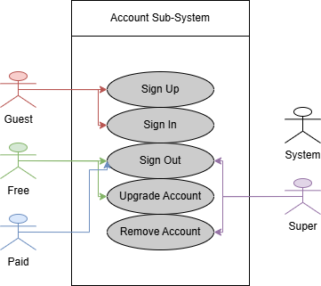

**(Please Proceed To Next Page)**

- File System: Text submission, LLM/self-correction, file management, collaborator complaints.

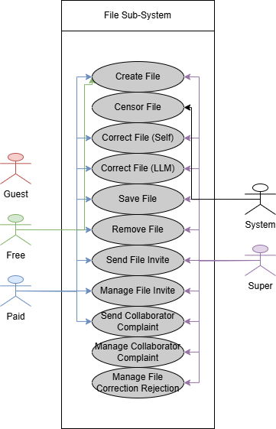

**(Please Proceed To Next Page)**

- Token System: Managing user tokens for accessing features.

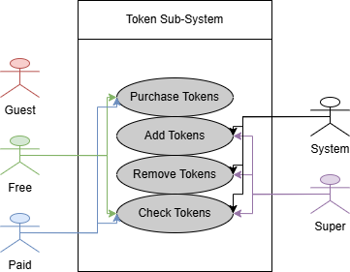

- Blacklist System: Sharing documents, handling invites, and managing user disputes.

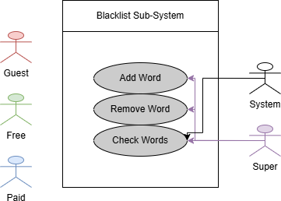

**(Please Proceed To Next Page)**

- Log System: Logging actions for statistics and administrative oversight.

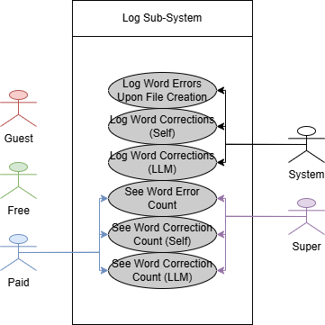

**2.2 Assumptions and Dependencies**

- The system assumes users will primarily work with text-based documents.

- LLM features will be powered by an open-source model (e.g., Llama, DeepSeek).

- The token-based system regulates access for paid users.

- Super users will handle moderation and administrative tasks.

**3. Specific Requirements**

**3.1 Use-Case Reports**

1. User Account Management

- Free users can register and submit up to 20 words per text.

- Paid users can upgrade accounts and purchase tokens.

- Super users can suspend, fine, or terminate users for violations.

2. Text Submission & Editing

- Users can input text manually or upload a file.

- Blacklisted words are automatically censored.

- Users can choose between self-correction or LLM correction.

- LLM corrections are highlighted for user review.

3. Token-Based System

- Paid users are charged tokens per submission and correction.

- If a user lacks tokens, they receive a penalty.

- Users receive bonus tokens if LLM finds no errors in long text submissions.

4. Collaboration Features

- Paid users can share documents and invite collaborators.

- Invitees can accept or reject invitations.

- Super users resolve complaints and disputes among collaborators.

5. Logging & Analytics

- User actions are logged for analysis.

- Paid users can view their editing history and correction statistics.

**3.2 Supplementary Requirements**

- System should have a graphical user interface (GUI) designed for usability.

- The software should support both online and offline functionality.

- LLM integration must be local or use free APIs to avoid reliance on paid services.

- Users should have access to a statistics panel to monitor token usage and correction history.