

Figure 1: creating prosumer flow chart



Figure 2: The adoption model flow chart



Figure3: flowchart of the dynamic price model



Figure 4: flow chart of the static price model

Figure 5: PV system cost prediction over the next 20 years

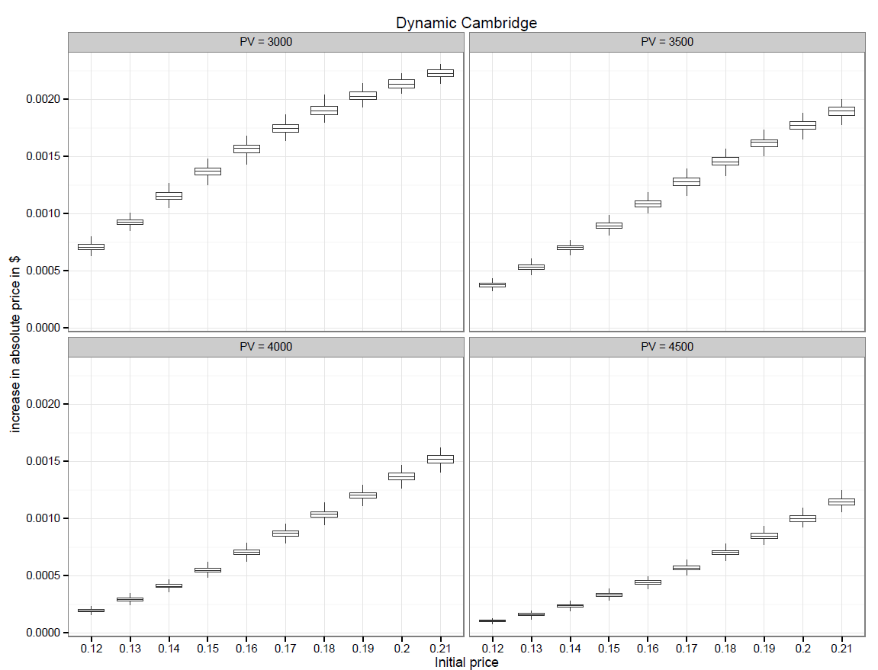

Figure : Dynamic model for Cambridge

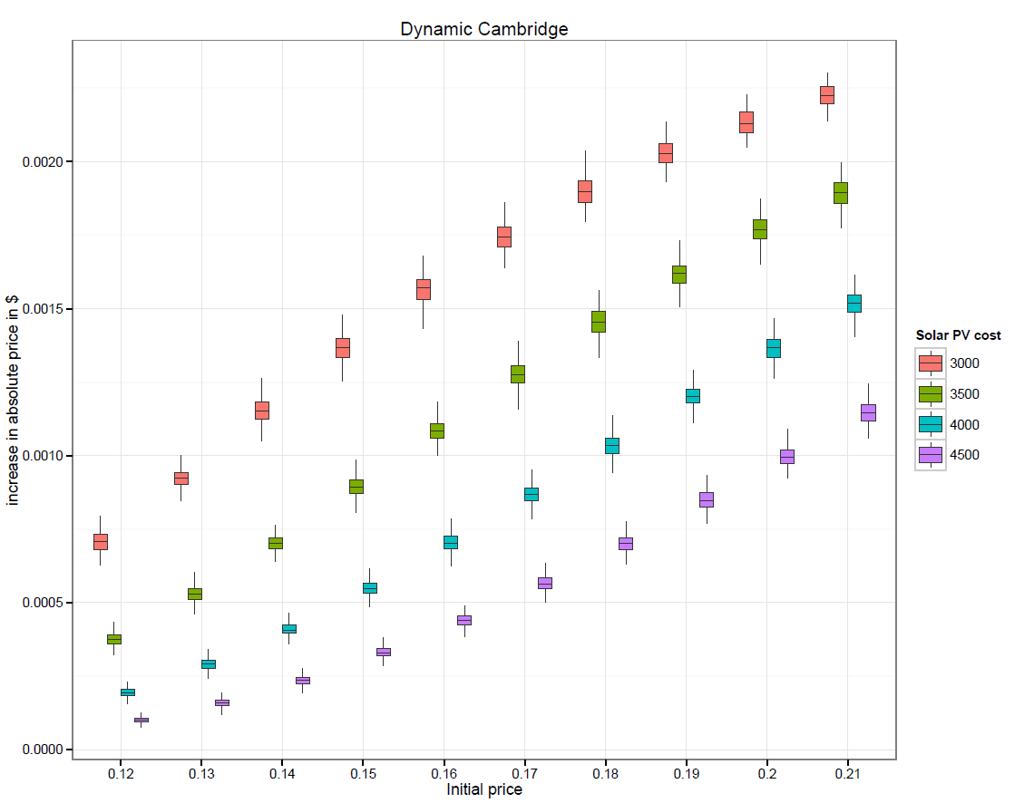

Figure : Dynamic model for Cambridge

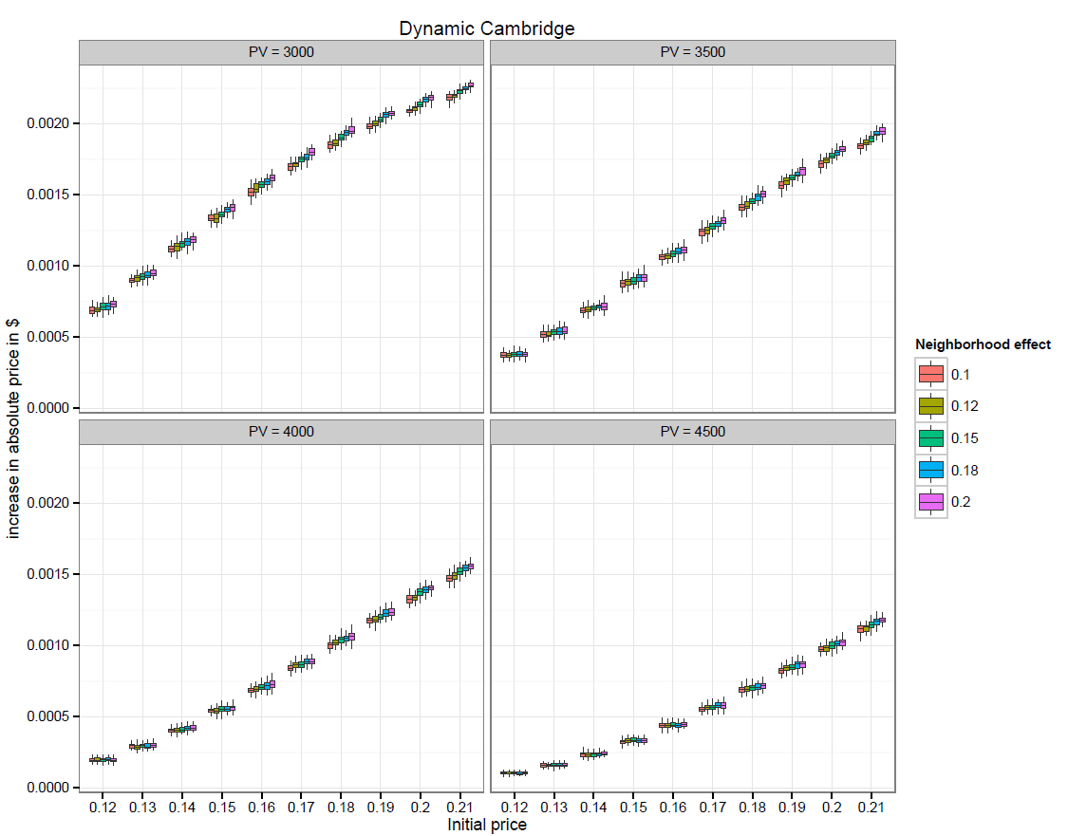

Figure : Dynamic model for Cambridge with neighborhood effect

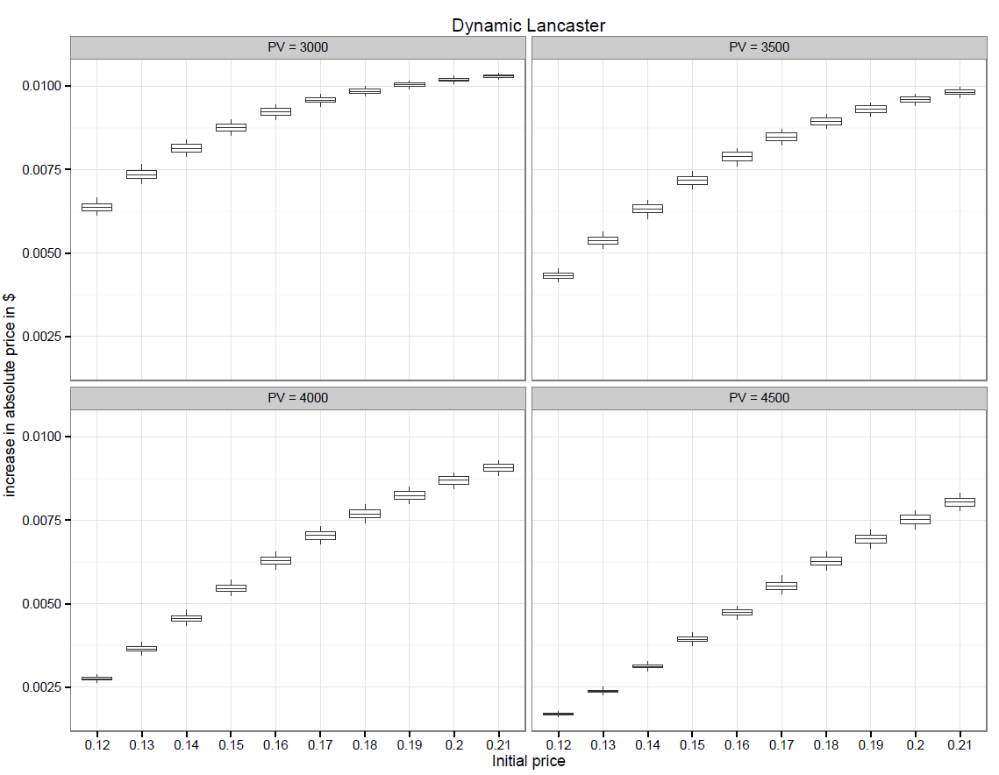

Figure : Dynamic model for Lancaster

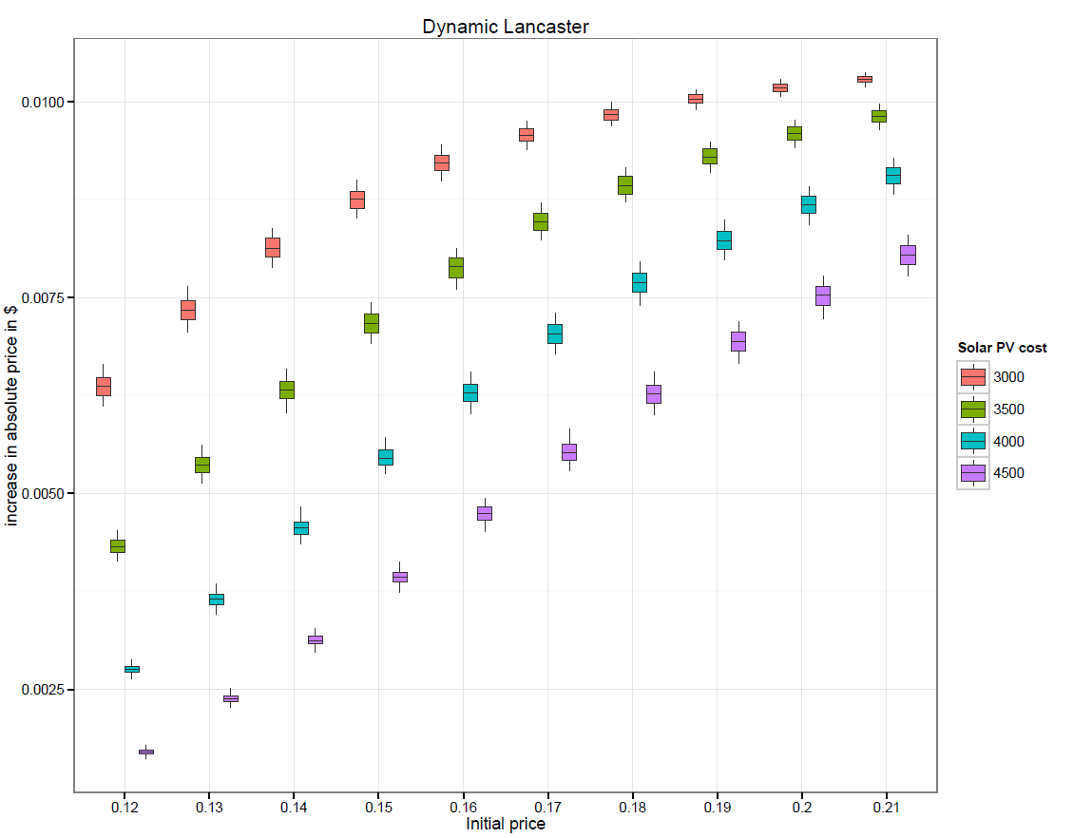

Figure : Dynamic model for Lancaster

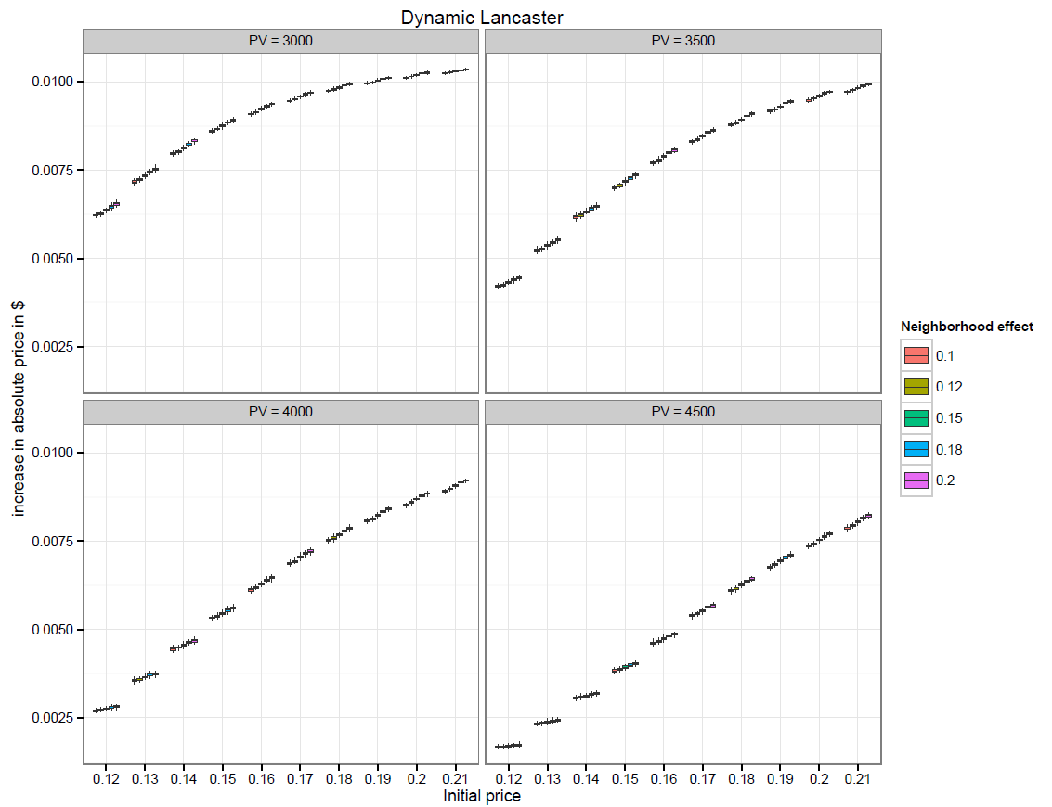

Figure : Dynamic model for Lancaster with neighborhood effect

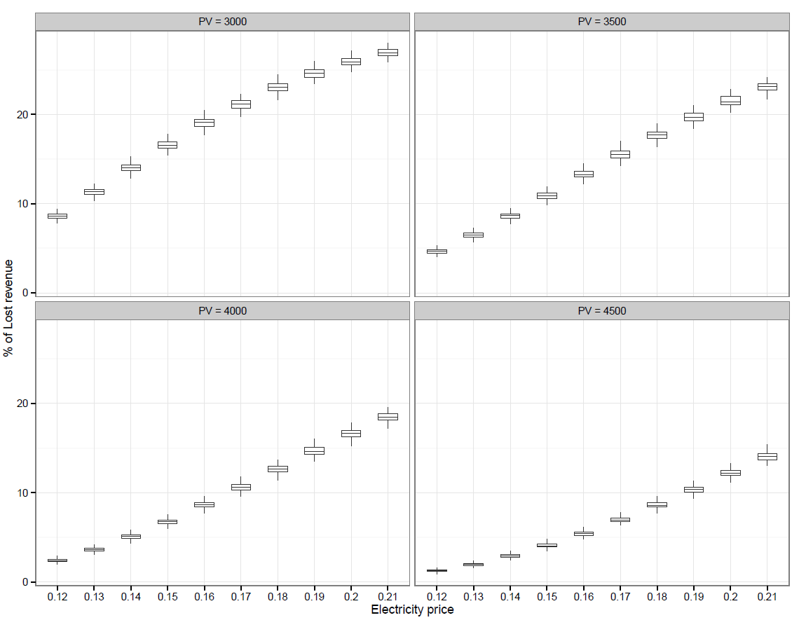

Figure : Static model for Cambridge

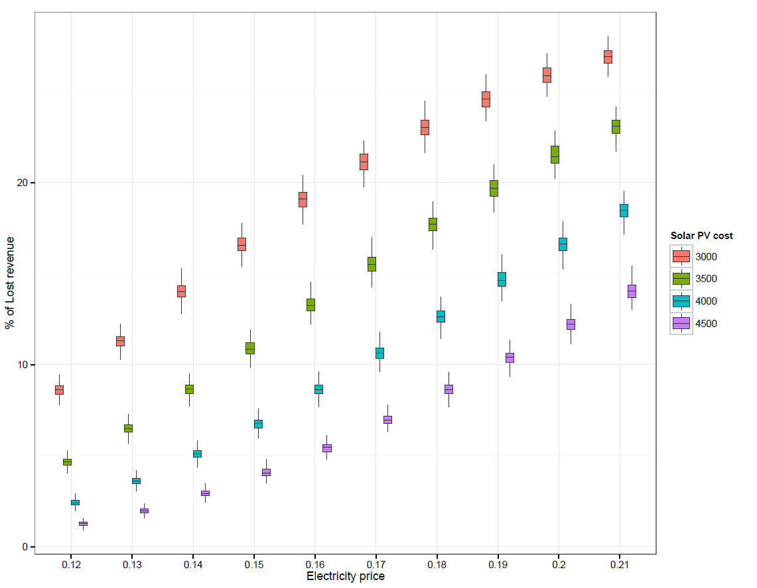

Figure : Static model for Cambridge

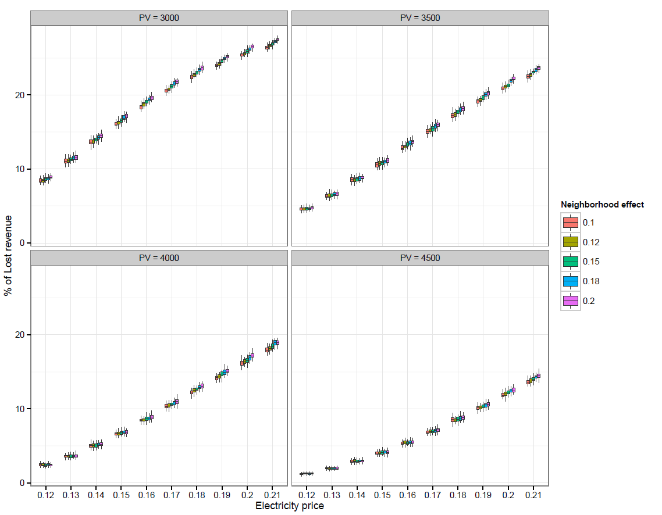

Figure : Static model for Cambridge with neighborhood effect

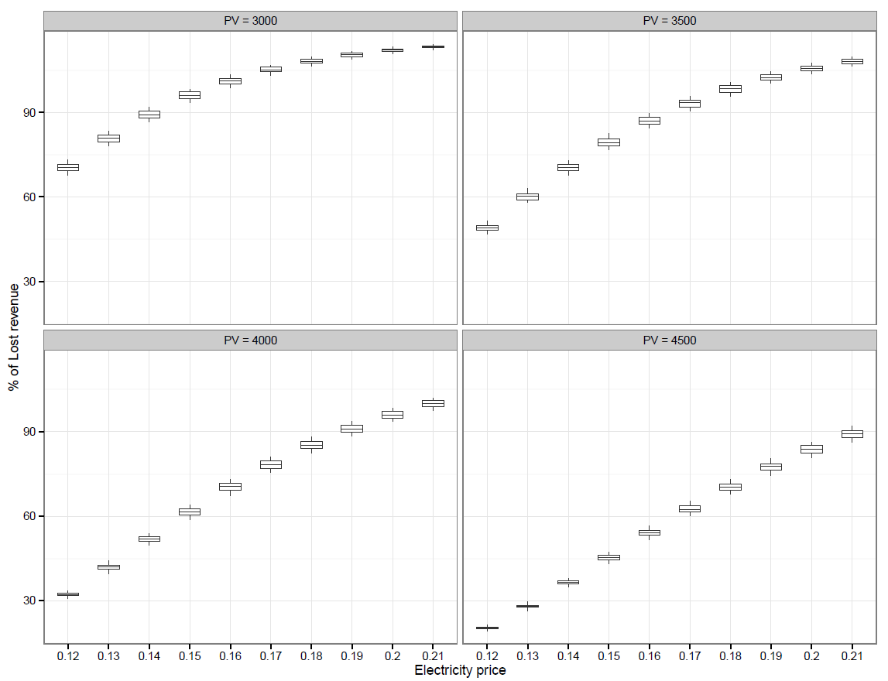

Figure : Static model for Lancaster

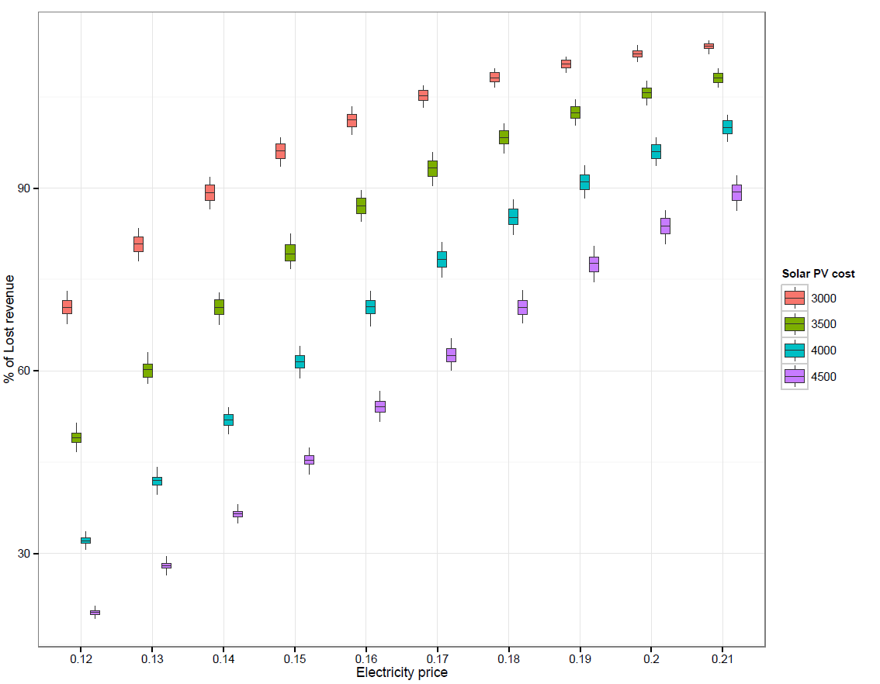

Figure : Static model for Lancaster

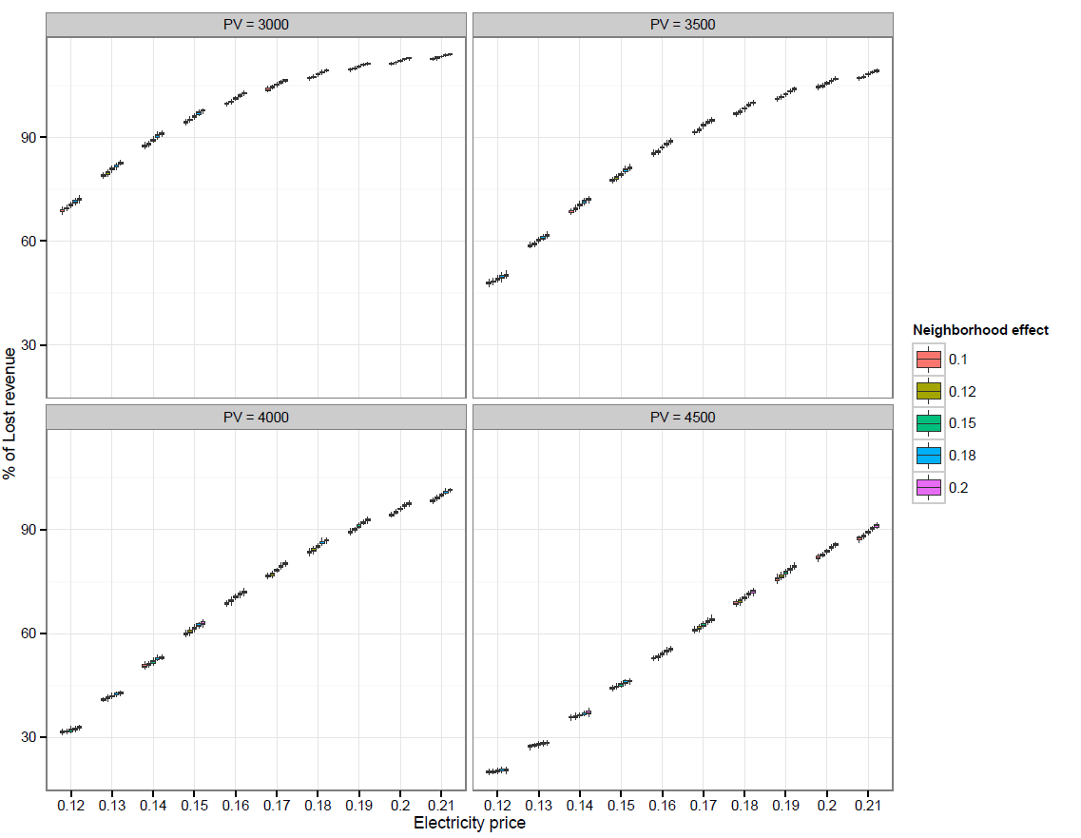

Figure : Static model for Lancaster with neighborhood effect