**Ichimoku Cloud**

## **The Ichimoku Cloud**

* Is a technical indicator, developed by Goichi Hosoda in 1960, composed of five lines:
* Conversion (Tenkan) and Base (Kinjun) lines: a 9-period average, a 26-period average of high and low prices.
* Lagging Span (Chikou Span), 26 closing price line.
* Leading Span A (Senkou Span A) line, average of Base line and Close price (Senkou Span B), and Leading Span B line, a 52-period average of high price. The space between these two lines forms the Cloud. Used to forecast support and resistance price.

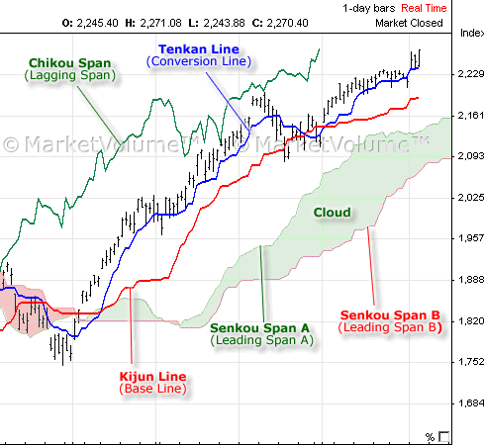

## **The Formulas for the Ichimoku Cloud**

The following are the five formulas for the lines that comprise the Ichimoku Cloud indicator.

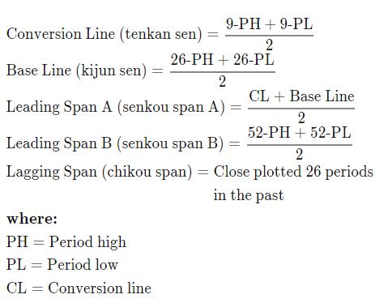

**Strategy using Ichimoku Cloud, Tenkan-sen and Kijun-sen lines**

To build this strategy we use The Technical Analysis Library for Python, ta, and call the data for Tenakan-sen (trend-ichimoku-a) and Kinjun_sen (trend-ichimoku-b) to create the buy/sell signals for the crossover called 'trend_ichimoku':

'trend_ichimoku'= where ('trend_ichimoku_a' > 'trend_ichimoku_b', buy,sell).

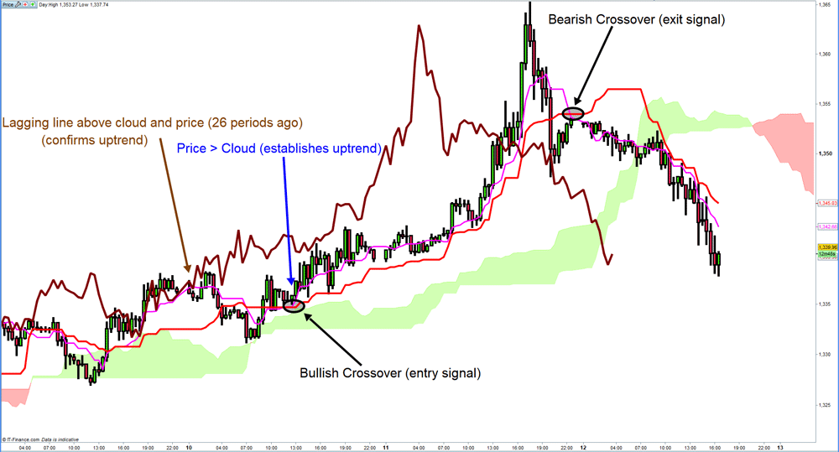

We tried this strategy in different time frames ( 5years/daily, 6months/hour and 60days/5min) being the most effective the shortest time frame, as we compared the back test Cumulative Returns of the strategy against the one holding the position for each period, as we show it bellow:

Example for TSLA

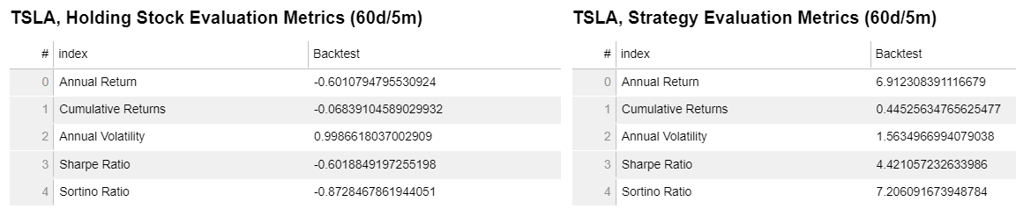

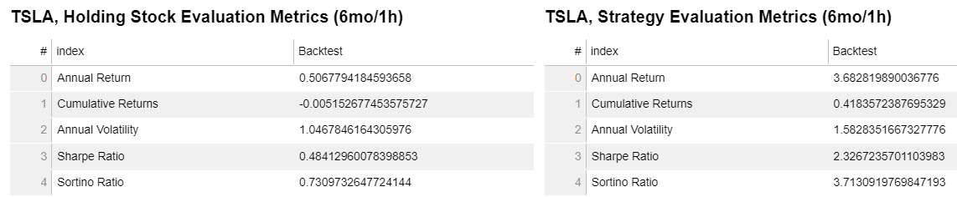

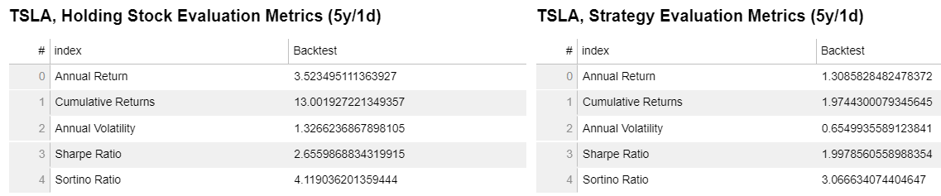

**Conclusions**

The Strategy is more recommended to be use in a short time frame (60 days/5 min) where it shows the cumulate returns most of the time is better than holding the position for the same time frame.

In stocks with negative trend, the strategy can mitigate the loss compared to the one holding the position.

**References:**

Investopedia: <https://www.investopedia.com/terms/i/ichimoku-cloud.asp>

Ichimoku Cloud image: <https://www.google.com/url?sa=i&url=https%3A%2F%2Flaisasantos.com.br%2Fcharts-confirmation%2Fichimoku-technical-analysis-best-relative-strength-index-tutorial%2F&psig=AOvVaw0PMZEmyWFDXB8zBtaSXhaq&ust=1623355695363000&source=images&cd=vfe&ved=0CAIQjRxqFwoTCLCorK6ti_ECFQAAAAAdAAAAABAk>

Wikipedia: [Ichimoku Kinkō Hyō - Wikipedia](https://en.wikipedia.org/wiki/Ichimoku_Kink%C5%8D_Hy%C5%8D)

Technical Analysis Library in Python: [Documentation — Technical Analysis Library in Python 0.1.4 documentation (technical-analysis-library-in-python.readthedocs.io)](https://technical-analysis-library-in-python.readthedocs.io/en/latest/ta.html?highlight=ichimoku#ta.trend.ichimoku_b)

Strategy Example (image): <https://a.c-dn.net/c/content/igcom/en_EN/ig-financial-markets/market-news-and-analysis/trading-opportunities/2018/04/23/ichimoku-cloud-trading-strategies-explained/jcr%3Acontent/newspar3/panel_child_1762474082/mp-parsys2/textimage/image.webimg.png/1540977473245.png>

<https://github.com/bukosabino/ta>

<https://technical-analysis-library-in-python.readthedocs.io/en/latest/ta.html>

<https://school.stockcharts.com/doku.php?id=technical_indicators:ultimate_oscillator>