These are the libraries(3rd party software) needed to build the system

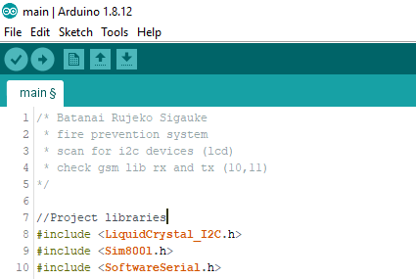

Hardware pinout definitons on the Arduino uno gsm global parameter(line 22-24)

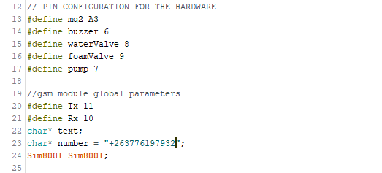

Definition of utility parameters to be used inside the program

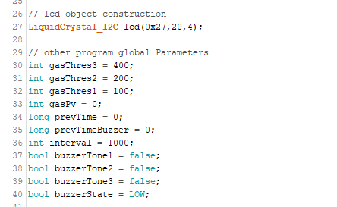

Initialization of hardware components and software libraries

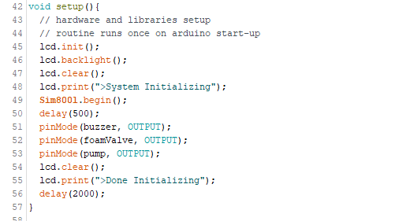

Program loop

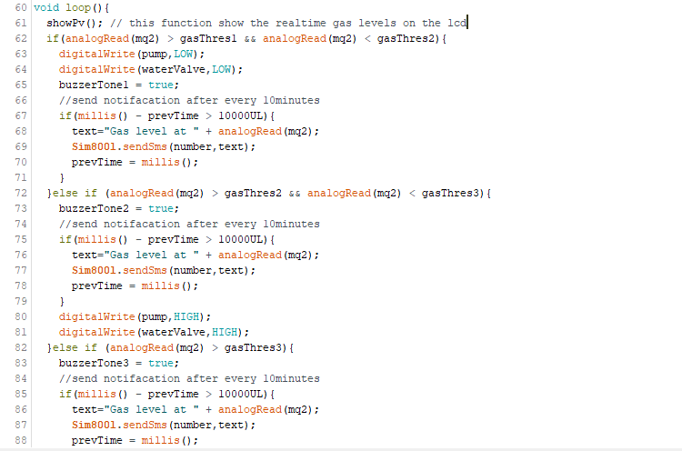

Contnd..

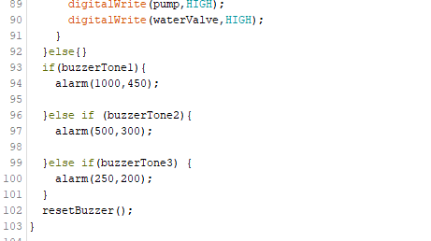

This function raises alarms

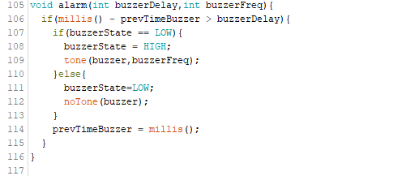

This is the function responsible for displaying real-time gas levels on the lcd

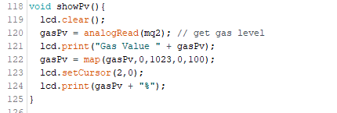

Clearing alarms and reseting the buzzer for new alarms to be noticed

