Healthcare Data Cleaning Report
Tynisha Niles
2026-05-06
library(here)
library(dplyr)
library(ggplot2)
library(reshape2)
## Warning: package 'reshape2' was built under R version 4.3.3

1. Dataset Overview
data_raw <- readRDS(here("data","interim","data_ingested.rds"))
data_clean <- readRDS(here("data","processed","data_cleaned.rds"))
cat("Raw Data:\n")
## Raw Data:
cat("Rows:", nrow(data_raw), " Columns:", ncol(data_raw), "\n\n")
## Rows: 1000 Columns: 10
cat("Cleaned Data:\n")
## Cleaned Data:
cat("Rows:", nrow(data_clean), " Columns:", ncol(data_clean), "\n")
## Rows: 50 Columns: 10

2. Data Quality Diagnostics (Before Cleaning)
missing_before <- colSums(is.na(data_raw))
missing_before
## Patient.Name Age Gender Condition Medication Visit.Date Blood.Pressure Cholesterol
## 0 159 0 0 0 0 166 231
## Email Phone.Number
## 384 179

3. Cleaning Decisions
The following cleaning steps were applied:
- Patient names standardised (lowercase, punctuation removed)
- Gender, Condition, Medication normalised
- Visit dates parsed into proper date format
- Phone numbers cleaned (digits only, blanks converted to NA)
- Age cleaned (text → numeric, missing values replaced with median)
- Duplicate patient records resolved using Patient Name + Visit Date

4. Imputation Applied
- Variable: Age
- Method: Median imputation
- Reason: Median reduces impact of outliers

5. Post-Cleaning Summary
summary(data_clean)
## Patient.Name Age Gender Condition Medication Visit.Date
## Length:50 Min. :25 Length:50 Length:50 Length:50 Min. :2018-04-05
## Class :character 1st Qu.:35 Class :character Class :character Class :character 1st Qu.:2019-03-25
## Mode :character Median :40 Mode :character Mode :character Mode :character Median :2019-12-01
## Mean :44 Mean :2019-07-08
## 3rd Qu.:60 3rd Qu.:2020-01-15
## Max. :70 Max. :2020-02-20
##
## Blood.Pressure Cholesterol Email Phone.Number
## Length:50 Min. :160.0 Length:50 Length:50
## Class :character 1st Qu.:180.0 Class :character Class :character
## Mode :character Median :200.0 Mode :character Mode :character
## Mean :195.2
## 3rd Qu.:220.0
## Max. :220.0
## NA's :8
missing_after <- colSums(is.na(data_clean))
missing_after
## Patient.Name Age Gender Condition Medication Visit.Date Blood.Pressure Cholesterol
## 0 0 0 0 0 0 7 8
## Email Phone.Number
## 22 21

6. Charts

6.1 Missingness Before vs After
missing_df <- data.frame(
Variable = names(data_raw),
Before = colSums(is.na(data_raw)),
After = colSums(is.na(data_clean))
)
missing_long <- reshape2::melt(missing_df, id.vars="Variable")
ggplot(missing_long, aes(x=Variable, y=value, fill=variable)) +
geom_bar(stat="identity", position="dodge") +
theme(axis.text.x = element_text(angle=45, hjust=1)) +
labs(title="Missingness Before vs After Cleaning")
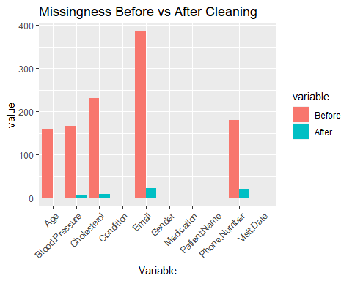

6.2 Age Distribution
ggplot(data_clean, aes(x=Age)) +
geom_histogram(bins=10) +
labs(title="Age Distribution")
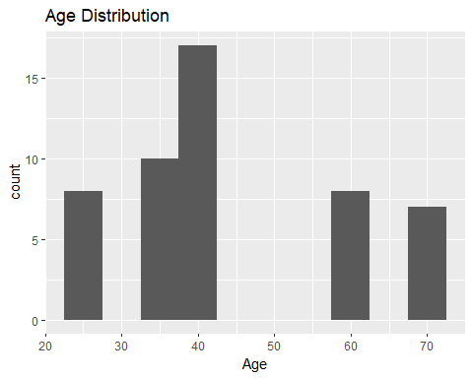

6.3 Age Density
ggplot(data_clean, aes(x=Age)) +
geom_density() +
labs(title="Age Density After Cleaning")
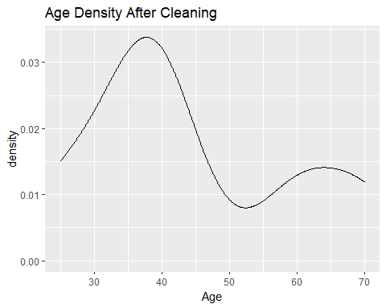

6.4 Condition Distribution
ggplot(data_clean, aes(x=Condition)) +
geom_bar() +
theme(axis.text.x = element_text(angle=45, hjust=1)) +
labs(title="Condition Frequency")
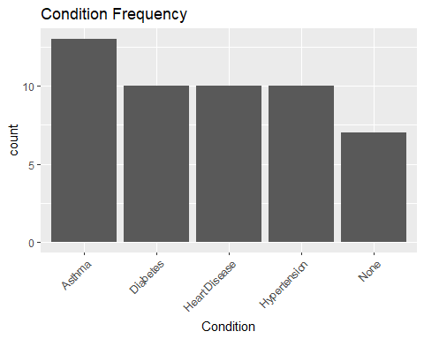

7. Limitations
- Some missing phone numbers remain
- Median imputation may not reflect true values
- Duplicate detection may not capture all cases

8. Conclusion
The dataset has been cleaned and standardised and is ready for analysis.

