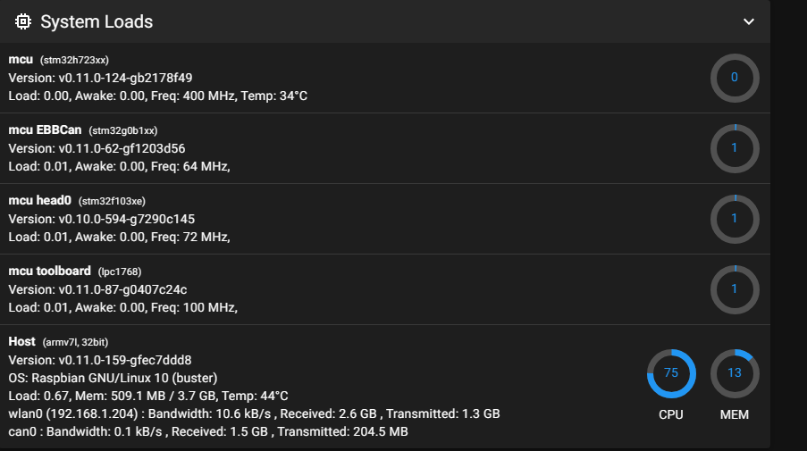

Kommandon:

cd ~/klipper/

make menuconfig  
make

1. Copy the firmware.bin to the root directory of SD card (make sure SD card is in FAT32 format)

BTT Octopus Pro. Nya snabbarae H723 chippet.

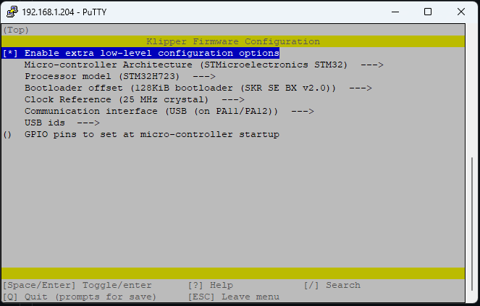

BTT SKR 1.3:

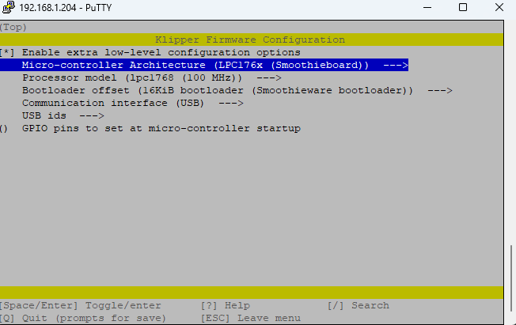

[HUVUD](https://github.com/bondus/KlipperToolboard/blob/master/doc/klipper.md#firmware-configuration)

Enable Micro-controller Architecture (STMicroelectronics STM32)

* Pick STM32F103
* Pick Bootloader offset (2KiB bootloader (HID Bootloader))
* Disable Use USB for communication (instead of serial)
* Enable Use CAN for communication (instead of seria)l
* Pick CAN pins (Pins PB8(rx) and PB9(tx))
* Clock Reference 8mhz (according to the spec sheet)
* Set your CAN bus rate (500k) !!!!

It is possible to use USB instead of the CAN bus, like most other controller boards.

# [Bootloader and Flashing](https://github.com/bondus/KlipperToolboard/blob/master/doc/klipper.md#bootloader-and-flashing)

The boards come preloaded with the HID bootloader for flashing over USB. Note that the board can not be powered over USB.

To enter the bootloader pin BOOT1 must be connected to 3.3V when the board is powered up or reset. When in the bootloader the green LED will flash quickly. Flash with the command "make flash FLASH_DEVICE=1209:beba"

Hopefully a CAN capable bootloader will be developed to allow flashing over CAN bus.

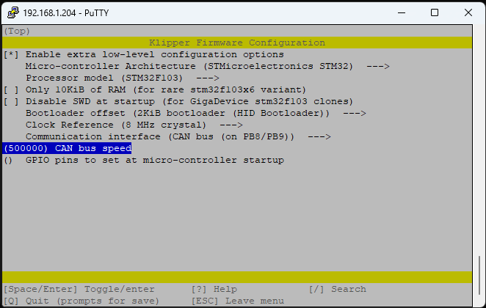

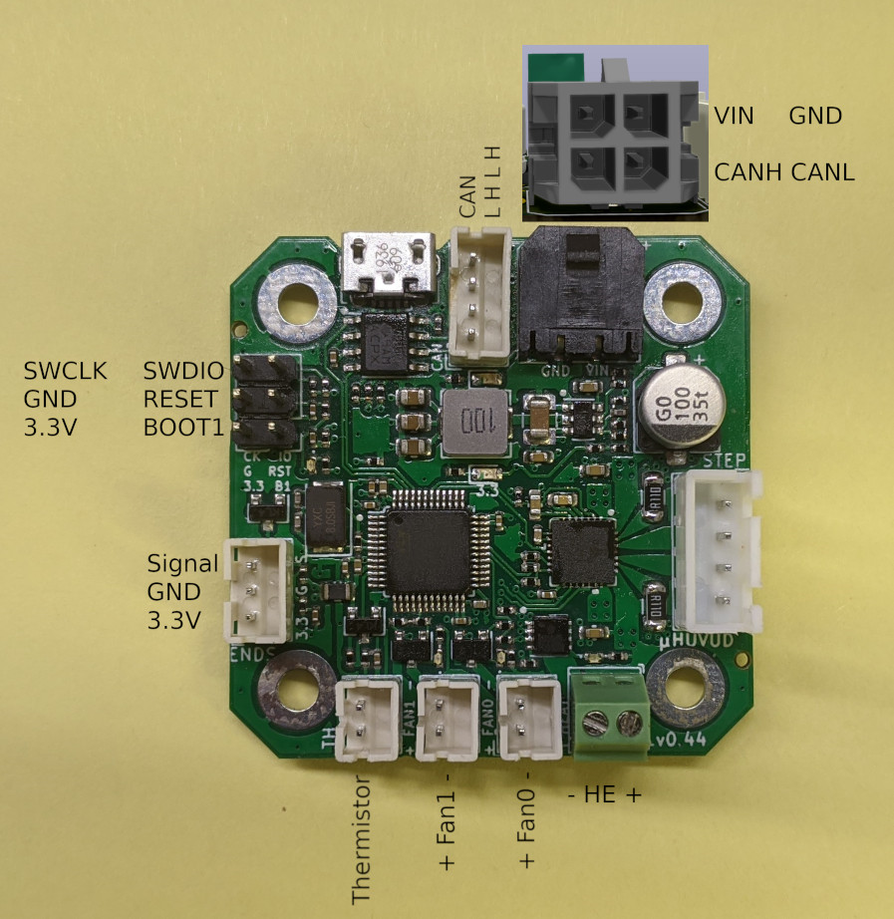

EBB42

PA2 is used for the hotend MOSFET in EBB36 & 42 CAN V1.1, The high level in the DFU mode change the hotend into heating state. Therefore, please pay attention **to disconnect the main power VIN of the hotend** when using the DFU of Type-C port to update the firmware, or ensure that the firmware update is completed soon and goto the normal working mode. Never keep MCU in DFU mode for a long time when the main power supply and hotend are connected.

Första gången, Bra Youtubefilm:  
https://www.youtube.com/watch?v=EA-oBfenxAE

Första gången använd Katapult:

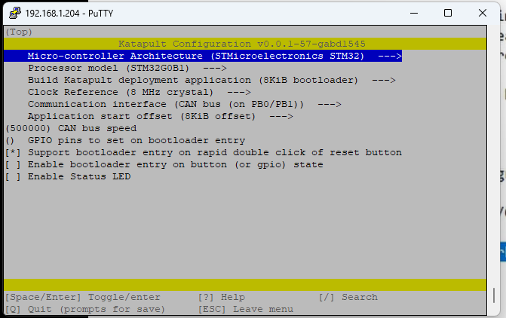

Vid uppdatering använd Klippper med bootloader offset:

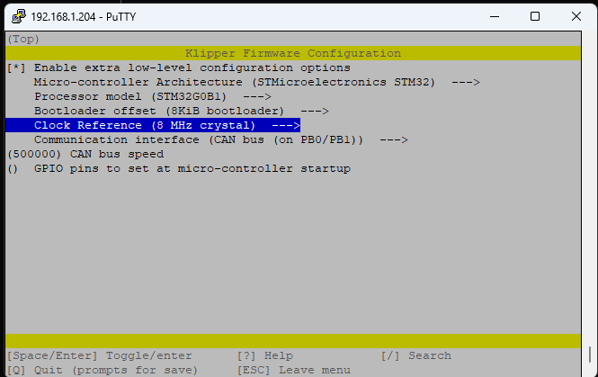

Få reda på UUID:  
~/klippy-env/bin/python ~/klipper/scripts/canbus_query.py can0

Kör sedan kommandon:  
~/katapult/scripts/flash_can.py -u UUID

Linux:

