Card Games Documentation
Echo Schwartz | 24 October 2024
Framework Overview
Overview
The base class for the games is CardGame. This class has a name and instructions which are passed to it in the constructor. It also has virtual Play and PrintHUD methods. I did this to make sure that every game is consistent and behaves the same way. The Play method lets every type of CardGame call that to start it, and the PrintHUD method ensures that the heads up display uses the same format in each type of CardGame. Each of the individual games inherit from CardGame, so that they all have the same framework.
The Card class holds an int Rank, string Suit, and string Name. The rank is passed as a string, but converted into an int. “ace” returns 1, “jack” returns 11, etc. This approach allows for easy comparison between the ranks of cards. The Suit is passed directly. The Name is formatted as $”{Suit} of {Name}”. This Name also is returned when calling ToString() on a card, and it makes sure that Cards are easy to tell what values they hold in a way that is commonly read in real life.
The Deck class has a string Name, string[] Suits, int SuitSize, int DeckSize, and List<Card> Cards. The Name and Suits are passed directly, but the constructor also takes a suitSize with a default value of 13. The suitSize and length of Suits determine how the Deck is generated. This approach makes it easier to initialize a Deck, as instead of passing in how many cards you want in a Deck, you can just send in how many cards you want in a single suit, and it will automatically distribute equal amounts of cards per suit. It has a Shuffle() method which uses the Fisher-Yates Shuffle algorithm. It also has a Deal() method which pops the highest value and returns it, acting like taking the top card off of a real life deck. Finally, it has a display method which returns a string telling each card in a the Deck. It’s also returned when calling ToString().
The UI class has methods to load the main menu and settings menu, which handles all the basic navigation so that Program.cs does not need to do too much.
The Library namespace holds static utility methods and helpful classes, which is a class library. The code can be found at https://github.com/TypeEcho01/Library. It runs on the version from 30 September 2024.
Overall, my goal with these classes is to simplify the logic in each game as much as possible.

UML Diagram
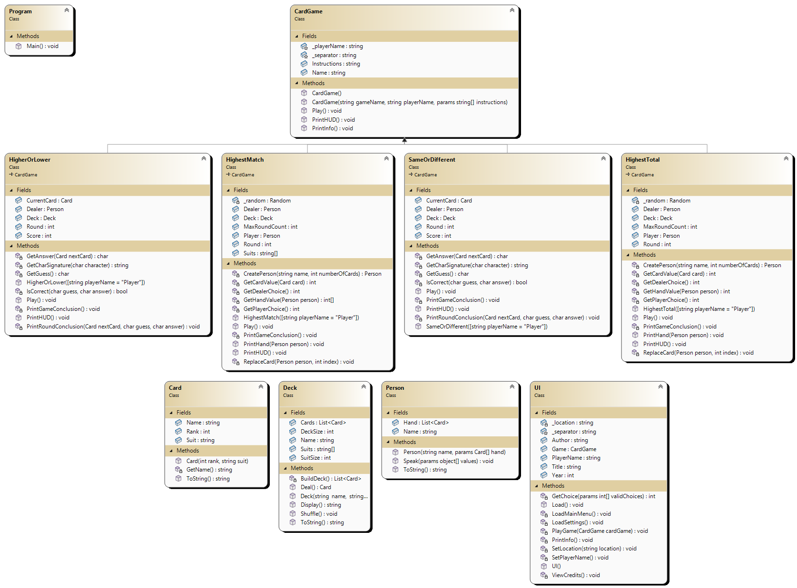
Object-Oriented Programming
Polymorphism
Definition: Polymorphism is the ability for a single method to have multiple ways in which it can work depending on the circumstances.
Brief code excerpt(s) from your project:
CardGame.cs
public virtual void Play()
{
Console.Title = Name;
PrintInfo();
Pause("Press Enter to play");
}

HighestMatch.cs
public override void Play()
{
base.Play();
…

Explain usage in your project: The use of polymorphism here lets the base class of CardGame define a Play() method which is overridden in HighestMatch. No matter what type of CardGame it is, it will always have a Play() method, but it can behave differently for each subclass.
Inheritance (“is a”)
Definition: Inheritance is when a class is a subclass of a derived class, meaning it has everything the derived class has but expands on it.
Brief code excerpt(s) from your project:
CardGame.cs
public class CardGame
{
…

HighestMatch.cs
public class HighestMatch : CardGame
{
…

Explain usage in your project: The use of inheritance allows for a CardGame class to act as the blueprint of sorts for all card games. This allows for consistency in each game and the ability to quickly update all of the card games at once.
Encapsulation
Definition: Also known as a “has a” relationship, Encapsulation is when one object stores another object in its attributes.
Brief code excerpt(s) from your project:
Deck.cs
public class Deck
{
…
public List<Card> Cards;
…

Explain usage in your project: Here, each instance of the Deck class has a List of type Card. Keeping the Cards in the Deck class allows it to act as a container of Cards. With inheritance, this Deck class not only stores Cards but also has methods that act on the Cards it holds. This removes the need to manually make arrays or methods in each class that requires the Card class.
Experimentation and Questions
Card Class: I thought if I should have a Value attribute in the Card class itself or if it’d be better to let each game decide the value. I chose the latter, as it opens more opportunities for scoring systems being different in each card game. Instead, I settled for a Rank attribute that works like a Value attribute but solely represents the number equivalent to the string version of the Rank and doesn’t inherently have anything to do with value.
Deck Class: I considered if I wanted to be able to add Cards to a Deck after it had been instantiated, but I decided against it because none of the card games I was making would need that, so it would have been a waste of development time. I also thought it would be easier to simply send the number of cards per suit rather than the total number of cards, that way when instantiating a Deck, you would not have to do math on how many cards there should be to make each suit have the same amount. It helps against errors and simplifies the process of making a Deck.
Person Class: Originally, I had each person have a Deck attribute so that there would always be a Dealer Person that the card games would draw from, but this turned out to be a problem when I added Players, since Players did not need their own Deck. Ultimately, I removed the Deck attribute and instead had each card game hold the Deck instances. This would have worked better if I decided to make a subclass of Person for the Dealer and maybe even a subclass of Person for the Player, but I also decided this would have overcomplicated things when these subclasses would have very little differences.
UI Class: I think one of the failures of the UI Class was to have a settings menu. It ended up being unnecessary since the only setting was changing the Player’s name. I think it would have been easier to have that option in the main menu itself. However, if I were to expand on this program, it would make it easier to add more settings, so at least there is a silver lining.
CardGame Class and Subclasses: Ultimately, I regret making almost all the attributes of the CardGame subclasses public. I think that it doesn’t add anything, as the only publicly available thing that is needed is the Play method. I would change that to be the only public thing, looking back. Another thing I would change looking back is how I created a new Random instance for the HighestTotal and HighestMatch card games, but I already had methods to get random numbers in my Library namespace. I wish I had used those instead to simplify the code even more. However, a success is that the PrintHUD() method was a virtual one, allowing for a custom heads up display for each CardGame subclass. This really prevented having to write more Print() methods for the card games than was necessary.
Library namespace: The Library namespace provided a lot of useful utility methods, like Print(), Input(), RandomShuffle(), and more. However, I think I could have expanded on it more, especially making Print() a Delegate in case this program were to be moved to a GUI app instead of a console app. The good news is that the Library namespace is a general class library that isn’t solely for this application, so I will continue to expand on it and improve its capabilities for future projects.
Overall, this project taught me to be careful with what attributes I make publicly available and when to / not to make subclasses. I look forward to employing the things I learned from this project on to future projects.
Credits
Created by Echo Schwartz in Fall 2024
Sources:
- Random number and shuffling code from PROG 201 class demo
Playtesting
Test date: 21 October 2024
Names of testers:
1) Max Cross
2) Jay Gujral
3) Adelle Raymond
What were the three most successful aspects of your project?
- The communication was highly praised. People enjoyed the clear game instructions and that they remained on screen the whole time.
- The UI was praised. People said it was effective, clean, easy to navigate, and the fact that it was cleared after every time it printed something new was appreciated.
- The Dealer was highly praised. The AI decision making was well received and the Dealer speaking to the player was well liked.
What were the three biggest issues with your project?
- People requested an option to exit out of a game while it was active, rather than only in the main menu. Also, the aesthetic of the game was criticized, as they said it lacked personality with its “cut-and-dry” menus and lack of color.
- The controls, though simple, could be improved so that the user can enter numbers to do actions instead of just H for higher, D for different, etc. to reduce hand movement.
- Although the Dealer AI was generally well received, one tester said that the Dealer never replaced a card in the Highest Total game. I tested this myself and the Dealer did replace cards, but maybe the AI could be refined.
How will you use what you learned to improve your application for the next version?
First, I could add more personality to the main menu, including colors and more fun text. Next, I could implement multiple ways to select what the user wants to do. Finally, I could further refine the Dealer AI so that it makes better choices more often.

