Alexander Kazantsev
Pattern Recognition
Dr. Andrew Cohen

Classification of Swapped Faces

In todays modern state of computer vision cute little apps are created that leverage computer vision to entertain the masses. Face swapping is a technique that utilizes facial recognition techniques to (as the name may imply) swap the faces of two or more users. Recently there have been research efforts that have succeeded in significantly improving the technique of face swapping [1] [2]. In Nirkin et al research effort the team was able to improve face swapping techniques to include face obstructions and noise [1]. Thies et al were able to dynamically alter facial configuration in real time based off an actors facial conferencing [2].

These new techniques raise an important question; is it possible to classify faces as “swapped” or “original”. The importance of this question lies in preventing possible nefarious use cases of such technology. Classifying a face as “swapped” could prevent the falsification of visual data.

Deep learning has been shown to be highly successful in image classification [3]. This would make it a good starting point for constructing a model responsible for classification.

Constructing an appropriate data set for training will require some work. There are no data sets available that contained swapped faces, but there is a sizable dataset of faces available for free [4]. Using Nirkan et al source code a data set of randomly swapped faces can be generated and labeled.

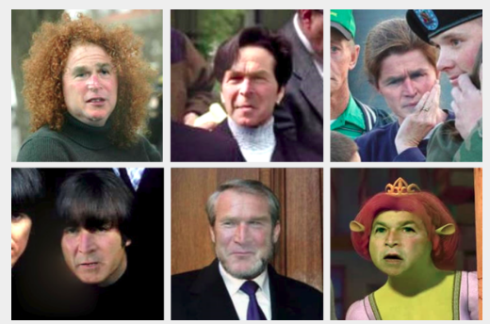

Figure 1. G.W. Bush face swapped in noisy/obustructed environments [1]

References
[1] Yuval Nirkin, Iacopo Masi, Anh Tuan Tran, Tal Hassner, Gerard Medioni “On Face Segmentation, Face Swapping, and Face Perception“

[2] Justus Thies, Michael Zollhofer, Marc Stamminger, Christian Theobalt, Matthias Nießner “Face2Face: Real-time Face Capture and Reenactment of RGB Videos”
[3] Yann LeCun, Yoshua Bengio, Geoffrey Hinton “Deep learning”

[4] http://web.mit.edu/emeyers/www/face_databases.html

