


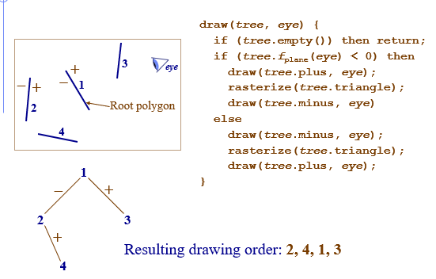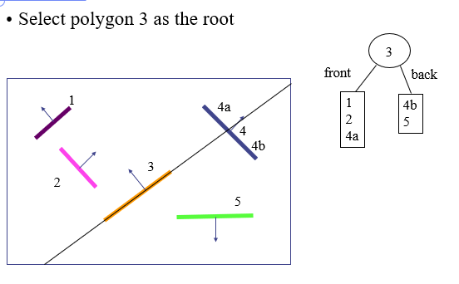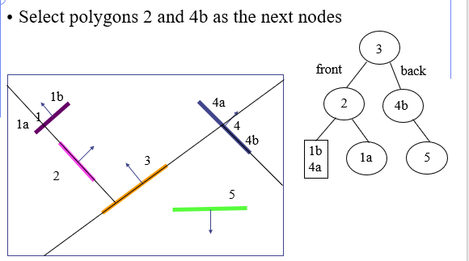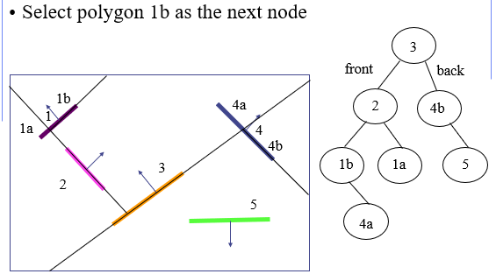
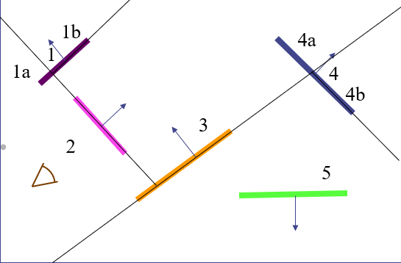
- Since the eye is in front of 3, scan convert the polygons in back of 3 first
- The eye is behind 4b, so scan convert the polygons in front of 4b first (there are none)
- Then scan convert 4b, then scan convert the polygons in back of 4b (5)
- Next scan convert 3
- Then scan convert the polygons in front of 3
- The eyepoint is behind 2, so scan convert the polygons in front of 2 first
- Then scan convert 1b, then the polygons behind 1b (4a)
- Then scan convert 2
- Then scan convert the polygons behind 2 (1a)
- So, the final ordering is:4b, 5, 3, 1b, 4a, 2, 1a

