**HOW TO USE THIS APP**

Download visual studio code. Downloads here: <https://code.visualstudio.com/Download>

Next, open and install VS code, follow the instructions and you are good to go,

Next, go into the languages and install python.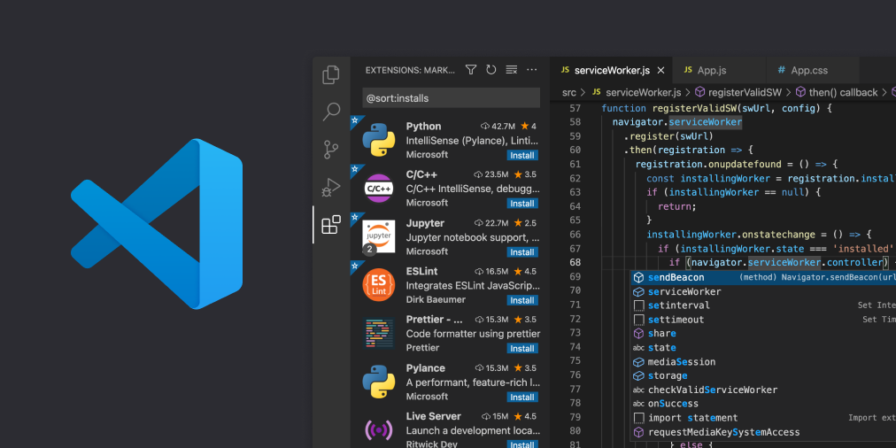

Now that you did that, go back to this tab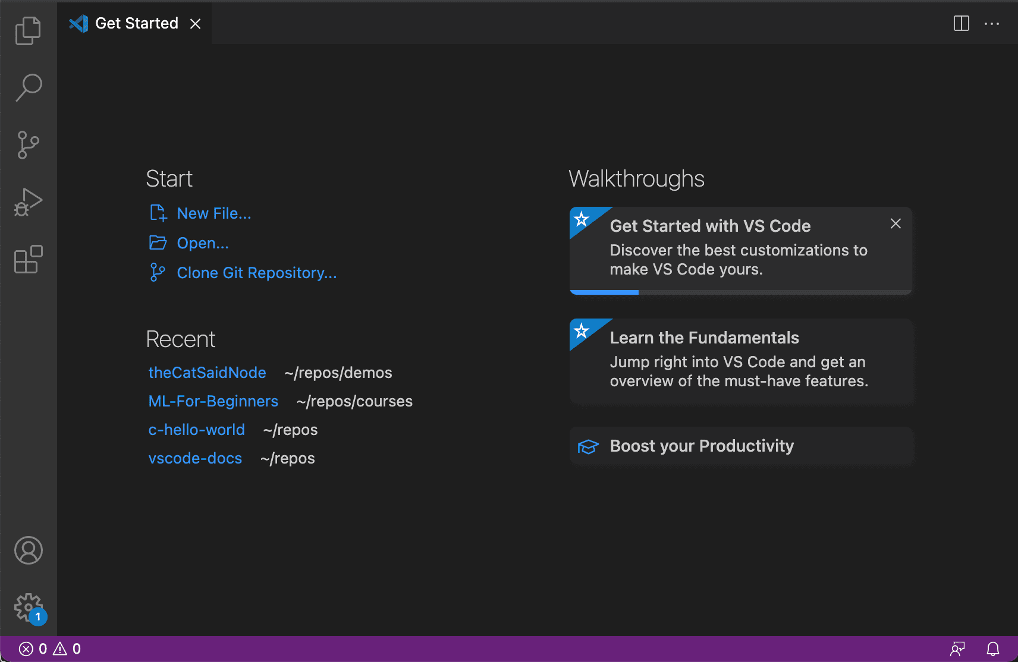

Click open.

Click the autoclicker folder you extracted and import it

Then go to run, and start debugging, now you can go back to the folder and see there is a bin folder, click on all the folders in the bin folder and run the .exe and that's it!