Cryptography Code Review and Reflection
Name: Stepan Varganov
Course: IT102 – Scripting for Cybersecurity (Fall 2026)
Date: October 25, 2026
Scripts reviewed: start/CH05/ASCIIgen.py, start/CH05/Rot13.py, start/CH05/CryptExample.py (GitHub repo PythonforCybersecurityTypicalTitan, run in WSL Ubuntu with Python 3.14 and cryptography 46.0.5).

Part 1: ASCII and Character Encoding
1. What relationship exists between letters and numbers in a computer?
A computer can only store numbers (ultimately binary), so every character is assigned a number by an encoding standard. ASCII maps the numbers 0–127 to characters: uppercase A–Z are 65–90, lowercase a–z are 97–122, and a space is 32. Running ASCIIgen.py prints this whole table. Numbers 0–31 are invisible control characters, which is why they print as blank or odd symbols.
2. What does the ord() function do?
ord() takes a single character and returns the number that represents it. For example, ord('a') returns 97. It is how the program turns a letter into something it can do math on.
3. What does the chr() function do?
chr() is the opposite of ord(): it takes a number and returns the character for it. For example, chr(97) returns 'a'. ASCIIgen.py uses chr(i) inside a loop to print the character for every number from 0 to 126.
for i in range(127):
print("{0}\t'{1}'".format(i, chr(i)))
4. Explain how the letter "a" can be converted into a number and then converted back into a letter.
ord("a") gives 97, and chr(97) gives back "a". Because the letter is just a number in between those two calls, you can change it. For example, chr(ord("a") + 13) is chr(110), which is "n". That one line is the whole idea behind ROT13. ASCIIgen.py prints this round trip:
ord('a') = 97
chr(97) = 'a'
5. Why is understanding ASCII useful when learning about encryption?
Encryption algorithms work on numbers, not letters. Once text becomes numbers, you can shift, add, or scramble them and then turn them back into characters. Knowing the ASCII ranges also tells the program which characters are letters (97–122) and when to wrap from z back to a. Modern ciphers like Fernet go one step further and work on raw bytes, which is why the code has to .encode() text first.

Part 2: Understanding ROT13
6. What is the purpose of the program?
Rot13.py encrypts or decrypts a message with ROT13. It replaces every letter with the letter 13 places later in the alphabet, wrapping around after z. Running Hello World! 123 through it produced uryyb jbeyq! 123.
7. Identify the section of code that converts a character into a numeric value. Explain what is happening.
ascii_num = ord(letter)
if ascii_num >= 97 and ascii_num <= 122:
ord(letter) turns the current character into its ASCII number and stores it in ascii_num. The if statement then checks whether that number is in the lowercase range (97–122), so only letters get shifted.
8. Identify the section of code that converts a numeric value back into a character. Explain what is happening.
new_ascii = ascii_num + 13
if new_ascii > 122:
new_ascii = new_ascii - 26
final_message = final_message + chr(new_ascii)
The program adds 13 to the number. If the result goes past 122 (z), it subtracts 26 to wrap back to the start of the alphabet. Then chr(new_ascii) turns the shifted number back into a letter, which gets added to the end of final_message.
9. Why does the program use a loop?
A cipher has to change every character, and a message can be any length. for letter in source_message: visits each character one at a time, so the same few lines of code handle a 1-letter message or a 1,000-letter message. The result is built up one character per pass of the loop.
10. How does the program handle spaces and other non-letter characters?
Any character outside 97–122 fails the if check and goes to the else branch, which adds it to final_message unchanged. That is why the space, the !, and 123 came through untouched. The message is also converted with .lower() first, so capital letters become lowercase. The program never has to handle uppercase separately, but the output loses its capitalization.
11. Why can the same ROT13 process be used for both encryption and decryption?
The alphabet has 26 letters and 13 is exactly half. Shifting by 13 twice is a shift of 26, which lands back on the original letter. So encrypting is the same as decrypting. Running uryyb jbeyq! 123 through the script gave back hello world! 123.
12. Suppose an attacker knows you used ROT13. How difficult would it be for the attacker to recover the original message? Explain your answer.
It would take them no effort at all. ROT13 has no key: the only secret is the method, and once the attacker knows it they just run ROT13 again. Even without knowing the shift amount, there are only 25 possible shifts to try, which a script checks instantly, and letter-frequency analysis gives it away too. ROT13 hides text from a casual glance (obfuscation). It does not provide real security.

Part 3: Understanding Fernet Encryption
13. What section of code generates the encryption key?
def fernet_create_key():
key = Fernet.generate_key()
return key.decode()
Fernet.generate_key() creates a new random key every time it is called. The function runs when the user picks k at the menu, and it returns the key as a string, for example DNIxemnfQORkgKPiZkQTAfbzmDKtw0aj06yu34xC9Cc=.
14. What is the purpose of the encryption key?
The key is the secret that locks and unlocks the data. Fernet is symmetric encryption: the same key that encrypts a message is the only thing that can decrypt it. The Fernet algorithm itself is public, so all of the security depends on keeping the key secret. Under the hood, the 32-byte key is split into two halves: one encrypts the data (AES-128) and the other signs it so tampering can be detected (HMAC-SHA256).
15. What section of code encrypts the message?
b_cipher = Fernet(b_key).encrypt(b_plain)
This line is in fernet_encrypt(). Fernet(b_key) builds a Fernet object from the key, and .encrypt(b_plain) turns the plain-text bytes into a cipher-text token.
16. What section of code decrypts the message?
b_plain = Fernet(b_key).decrypt(b_cipher)
This line is in fernet_decrypt(). It builds a Fernet object from the same key and calls .decrypt() on the cipher-text bytes to recover the original message.
17. Why does the program use .encode() when encrypting data?
Fernet only works on bytes, not on Python strings. .encode() converts a string such as "Hello There" into bytes (b'Hello There') using UTF-8. The key the user types is also a string, so it gets .encode() too. Passing a plain string to encrypt() raises a TypeError.
18. Why does the program use .decode() when displaying data?
encrypt() and decrypt() return bytes, which print with a b'...' wrapper around them. .decode() turns the bytes back into a normal string, so the output is clean and can be copied into the decrypt prompt. A Fernet token is all printable base64 characters and always starts with gAAAAA.
19. What would happen if you lost the encryption key?
The data would be gone for good. There is no backdoor or reset option, and the program does not save the key anywhere. Running the k option again just creates a different random key that cannot decrypt the old message. That is why keys need to be stored somewhere safe, such as a password manager or key vault.
20. Would someone be able to decrypt the message if they had the encrypted text but not the key? Why or why not?
No. They would have to guess a random 128-bit AES key, which is about 3.4 × 10³⁸ possibilities and not feasible to brute-force. When I tried decrypting with a different key, the script stopped with cryptography.fernet.InvalidToken instead of printing garbage, because Fernet checks its HMAC signature first. Encrypting the same message twice with the same key also gave two different tokens (Fernet adds a random IV and a timestamp), so an attacker cannot even tell when two messages are the same.

Part 4: Reflection
21. Compare ROT13 and Fernet encryption. What are the most important differences?
The biggest difference is that ROT13 doesn't use a key and Fernet does. With ROT13 anyone who knows how it works can just run it again, and when I put "uryyb jbeyq! 123" back into my script it gave me "hello world! 123" right away. Fernet needs the exact key that was used to encrypt it, and when I tried to decrypt with a different key it just crashed with an InvalidToken error instead of giving me the message. It was also interesting that Fernet gave me a different cipher text every time, even with the same message and key.
22. Why do cybersecurity professionals generally recommend against creating their own encryption algorithms?
Because something that seems hard to break to you could be really easy for someone else. ROT13 looked scrambled to me at first, but there are only 25 possible shifts, so a script could try all of them in under a second. Libraries like cryptography have been tested by a lot of experts for years, so it makes way more sense to use those and just keep the key secret, since the method is supposed to be public anyway.
23. What was the most interesting or surprising thing you learned during this module?
The most interesting thing to me was that letters are pretty much just numbers to the computer. When I ran ASCIIgen.py I saw that "a" is 97, and ROT13 is literally just adding 13 to that number and turning it back into a letter. I was also surprised how little code it took to do real encryption with Fernet compared to writing ROT13 by hand, since the library does all the hard work.

Screenshots: Scripts Running in WSL
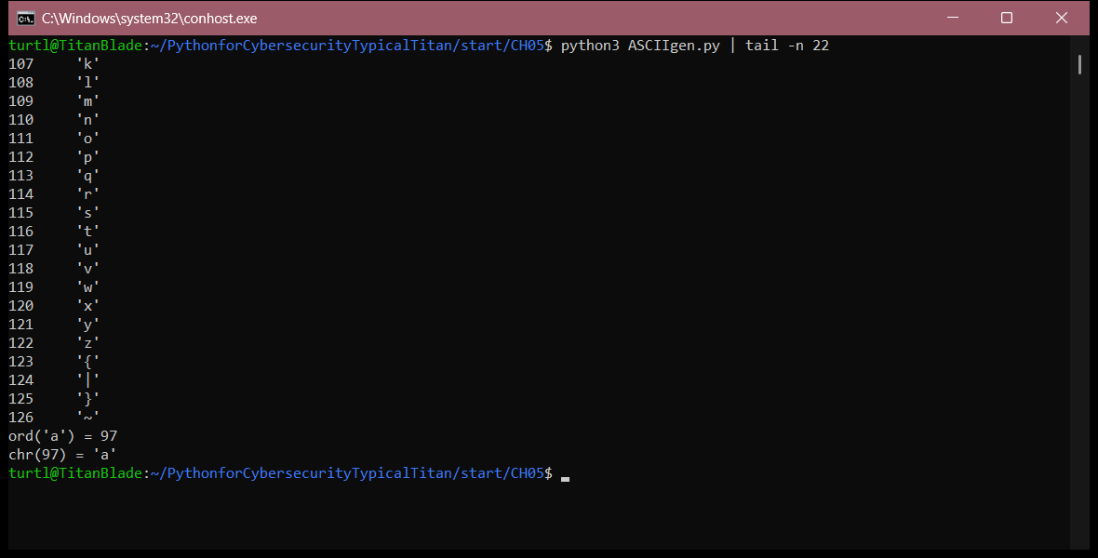
ASCIIgen.py: the last 22 lines of the ASCII table, plus the ord()/chr() round trip
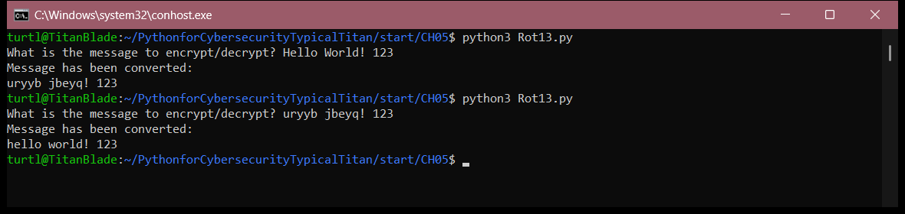
Rot13.py: encrypting "Hello World! 123", then running the output back through to decrypt it
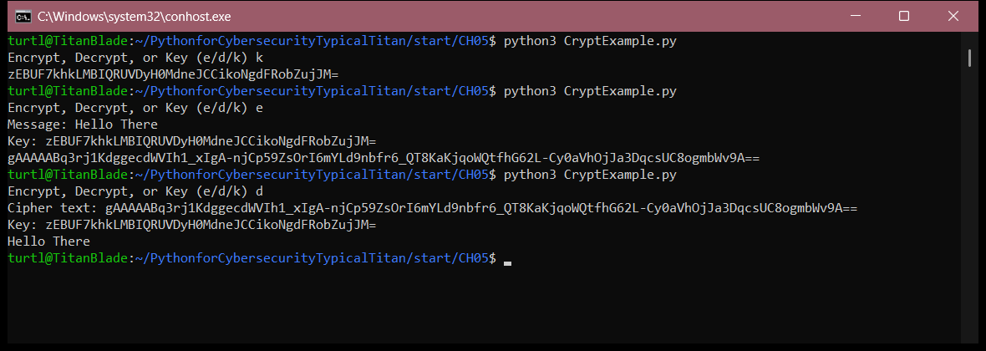
CryptExample.py: generating a key (k), encrypting "Hello There" (e), and decrypting it with the same key (d)
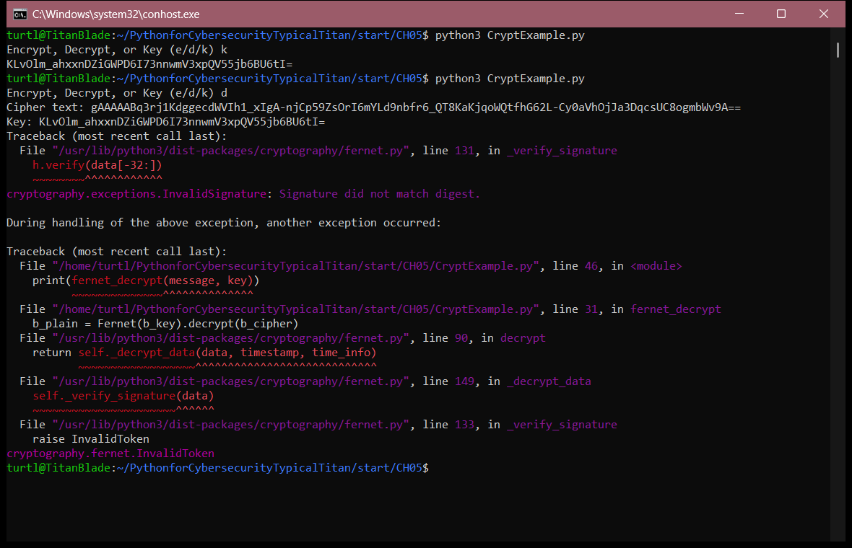
CryptExample.py: generating a different key and trying to decrypt the same token with it, which raises InvalidToken

