

# SCHOOL OF ADVANCED TECHNOLOGY

### ICT - Applications & Programming

### Computer Engineering Technology – Computing Science

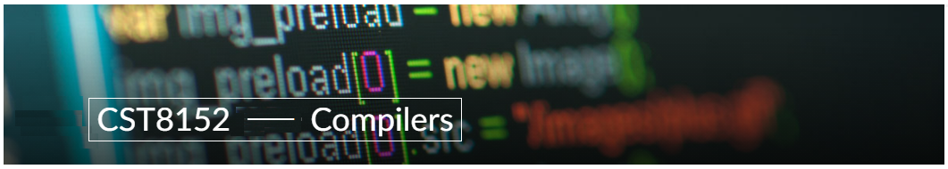

A21

Model Definitions (RE/Automaton)

Lab Professor / Lab Session:

[Paulo Sousa /CST8152_011]

Team:

[Mugeni Lys Turatsinze] - Id: [041065770] / [Brayden Johnston] - Id: [041079392]

Language Name [Joe]

***This template is suggested (not mandatory) to answer A11 Specification.***

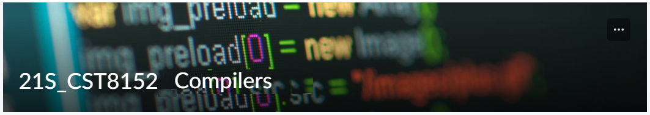

# MODEL TASK[1] FOR ASSIGNMENT 2.1 – YOUR LANGUAGE

* ***Note:*** *This task is part of the Assignment 2 from Compilers Course. Any problem, contact your lab professor.*

### Task 1: Language Symbols (2.0 marks)

**List examples:** Define main symbols to be used:

* Special symbols (ex: “{“, “(“, “<=”, etc.)
* Comments
* Variables
* Functions
* Literals (numbers, strings)
* Keywords
* Datatypes

**Answer:**

**KEYWORDS = {def, if, else, while, return, try, except,for,and,or,not,true,false,break}**

**DATATYPESS = {int, str, float,bool}**

**SPECIAL SYMBOLS = #,**''',\**n, :, (, ), ‘, <, >, ==, !=, {,},::, .…**

**VARIABLES = (data, val, factorial)**

**FUNCTION = (fact(val), … input(…), int(…)**

**LITERALS(Numerical = 1, 0, 3.141569…, ‘Input data’**

### Task 2: RE – Regular Expression (3.0 mark)

**Lexeme Classes:** Define the classes to be used in your regular expression:

**Answer:**

H = ‘#’(Comments in Python)

N = ‘\n’ (New line)

L = A…Z | a…z (Letters)

D = 0…9(Digits)

P = .

Q = ‘

M = QQQ (Multiline comments)

U = _

B1 = (

B2 =)

C = ,

E = :

S = ‘ \b’, ‘\t’, ‘\0’

O = [^(HMNLDPUS) ](Other chars)

Define the RE to be used for: variables, literals and keywords:

**Answer:**

RE(KEYWORDS): ‘def’ (=SequenceOfLetters): L+ (Note: ‘Paulo’ is NOT a keyword)

RE(VAR): L+

RE(Function): L(L|D|U)*B1

RE(Integers): D+

RE(Floats): D+PD* | D*PD+

RE(Strings): Q(^Q)*Q

RE(Comments): H(^N)*N

RE(Comments): M(^M)*M

### Task 3: TD – Transition Diagram (3.0 marks)

**Activity:** Starting from the previous lexeme classes and obeying the RE, it is possible to define the automata for your language:

**Answer (draw / copy image of the automata):**

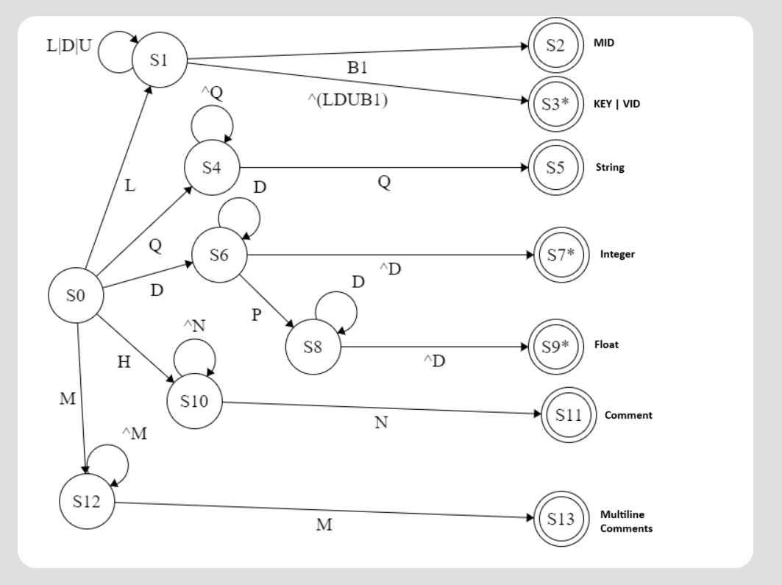

### Task 4: TT – Transition Table (2.0 marks)

**Activity:** Now, it is possible to define the TT for these lexemes:

**Answer (Transition Table):**

|  |  |  |  |  |  |  |  |  |  |  |
| --- | --- | --- | --- | --- | --- | --- | --- | --- | --- | --- |
| Input | Input Symbol | | | | | | | | | |
| State Classes | 1 | 2 | 3 | 4 | 5 | 6 | 7 | 8 | 9 | 10 |
|  | L(A-Z) | D(0-9) | U(_) | Q(‘) | P(.) | M(‘’’) | H(#) | N(\n) | B1[{] | O |
| S0 | 1 | 6 | FS | FS | FS | 12 | 10 | 10 | FS | FS |
| S1 | 1 | 1 | 1 | 3 | 3 | 3 | 3 | 3 | 2 | 4 |
| S2 | FS | FS | FS | FS | FS | FS | FS | FS | FS | FS |
| S3 | FS | FS | FS | FS | FS | FS | FS | FS | FS | FS |
| S4 | 4 | 4 | 4 | 5 | 4 | 4 | 4 | 4 | 4 | 4 |
| S5 | FS | FS | FS | FS | FS | FS | FS | FS | FS | FS |
| S6 | 7 | 6 | 7 | 7 | 8 | 7 | 7 | 7 | 7 | 7 |
| S7 | FS | FS | FS | FS | FS | FS | FS | FS | FS | FS |
| S8 | 9 | 8 | 9 | 9 | 9 | 9 | 9 | 9 | 9 | 9 |
| S9 | FS | FS | FS | FS | FS | FS | FS | FS | FS | FS |
| S10 | 10 | 10 | 10 | 10 | 10 | 10 | 10 | 11 | 10 | 10 |
| S11 | FS | FS | FS | FS | FS | FS | FS | FS | FS | FS |
| S12 | 12 | 12 | 12 | 12 | 12 | 13 | 12 | 12 | 12 | 12 |
| S13 | FS | FS | FS | FS | FS | FS | FS | FS | FS | FS |

GITHUB: <https://github.com/TyrZeg/Compilers.Joe>

*Update: Feb 4th 2024.*

1. Adapted from resources developed by Prof. Svillen Ranev (Algonquin College, 2019)