# 1

## a)

|  |  |
| --- | --- |
| SISD | MISD |
| SIMD | MIMD |

Flynn’s taxonomy is a system to classify architectures. The differences are whether the architecture uses single or multiple instruction streams and similarly for data streams.

### i)

Using MPI you write one program, which means you only write one set of instructions, but when executed, there are multiple processes with its own instruction stream, so in that sense MPI seems to fall under multiple instruction. As for the data streams, you can write to different places individually, but you might want to collect the data before writing it once, but given that you have the choice I would then say that it falls under MIMD.

## b)

### i)

MPI uses message passing to coordinate between ranks. Otherwise there is no shared memory, so MPI does not fit under Shared Memory.

## c)

### i)

Given that memory isn’t shared, it would then naturally be distributed.

# 2

## a)

### i)

My implementation uses the stupid approach where all the ranks compute their sums then send them off to rank 0. This means that rank 0 has to receive p times, where p is the number of other ranks. The other ranks might also have to wait for the preceding ranks to do their send operations before they can do their own send and then carry on.

### ii)

It is possible to reduce this bottleneck by applying a binary tree. For example half of the ranks can have a buddy rank, who sends them their sum, then in the next iteration half of those ranks send their sums to another one. This way the amount of ranks left is halved each time. Eventually one rank is the only one left, and that rank has only received O(lg p) messages, which is certainly better than O(p)

## b)

### i)

As of now, the load is split between each rank, where the job is to sum up a number of unit calculations, where each calculation is the reciprocate of the log of an integer

### ii)

Computationally my program doesn’t have a simple fix that will reduce the bottleneck without changing the structure of the problem. One thing that could be done would be to simply use more ranks, so that each process gets less work to do, but that’s not really the best way to optimize it since we have a limited amount of processors. A better way might be to use calculus to try to find a way to calculate the sum directly with some integral or something.

# 2

### i)

The amount of operations as a function of the interval n and number of processes p has two parts. The calculations per process are O(n/p), so the program as a whole has to do O(n) calculations.

### ii)

Due to my implementation, the total amount of MPI operations are O(n).

### iii)

The average amount of MPI operations per process is about 2.

### iv)

The maximum number of MPI operations is O(n), which is horrible.

### v)

The full table of run times:

|  |  |  |  |  |
| --- | --- | --- | --- | --- |
|  | 1 | 2 | 4 | 8 |
| 5 | 27 | 1051 | 1044 | 1057 |
| 10 | 24 | 1039 | 1043 | 1060 |
| 15 | 23 | 1030 | 1041 | 1055 |
| 20 | 23 | 1031 | 1041 | 1054 |
| 25 | 22 | 1034 | 1033 | 1055 |
| 30 | 22 | 1041 | 1043 | 1054 |
| 35 | 23 | 1042 | 1051 | 1061 |
| 40 | 24 | 1045 | 1042 | 1065 |
| 45 | 22 | 1036 | 1040 | 1055 |
| 50 | 22 | 1034 | 1043 | 1051 |
| 55 | 23 | 1040 | 1039 | 1058 |
| 60 | 24 | 1046 | 1043 | 1062 |
| 65 | 23 | 1040 | 1052 | 1054 |
| 70 | 22 | 1039 | 1038 | 1053 |
| 75 | 22 | 1039 | 1038 | 1053 |
| 80 | 22 | 1042 | 1032 | 1056 |
| 85 | 22 | 1037 | 1047 | 1053 |
| 90 | 22 | 1036 | 1036 | 1056 |
| 95 | 22 | 1042 | 1039 | 1054 |
| 100 | 22 | 1033 | 1041 | 1056 |
|  |  |  |  |  |
| 50000 | 23 | 1030 | 1045 | 1054 |
| 100000 | 24 | 1042 | 1040 | 1054 |
| 150000 | 25 | 1032 | 1042 | 1054 |
| 200000 | 26 | 1028 | 1041 | 1055 |
| 250000 | 28 | 1040 | 1043 | 1047 |
| 300000 | 28 | 1043 | 1045 | 1061 |
| 350000 | 29 | 1032 | 1042 | 1056 |
| 400000 | 30 | 1038 | 1037 | 1054 |
| 450000 | 31 | 1043 | 1046 | 1059 |
| 500000 | 32 | 1036 | 1041 | 1051 |
| 550000 | 34 | 1048 | 1045 | 1042 |
| 600000 | 34 | 1039 | 1041 | 1052 |
| 650000 | 34 | 1033 | 1042 | 1054 |
| 700000 | 36 | 1038 | 1045 | 1054 |
| 750000 | 37 | 1043 | 1053 | 1054 |
| 800000 | 38 | 1050 | 1039 | 1049 |
| 850000 | 38 | 1055 | 1038 | 1048 |
| 900000 | 40 | 1034 | 1047 | 1055 |
| 950000 | 48 | 1051 | 1041 | 1059 |
| 1000000 | 53 | 1040 | 1056 | 1054 |
|  |  |  |  |  |
| 50000000 | 1013 | 1544 | 1451 | 1275 |
| 100000000 | 2001 | 2618 | 1560 | 1476 |
| 150000000 | 2988 | 2567 | 1828 | 1687 |
| 200000000 | 3993 | 3032 | 2076 | 1907 |
| 250000000 | 5011 | 3520 | 2366 | 2112 |
| 300000000 | 5977 | 4010 | 3586 | 2321 |
| 350000000 | 6923 | 4485 | 3864 | 2522 |
| 400000000 | 10659 | 5014 | 4308 | 2777 |
| 450000000 | 8915 | 5501 | 3442 | 2953 |
| 500000000 | 9976 | 8979 | 3647 | 3216 |
| 550000000 | 10922 | 6498 | 5545 | 3369 |
| 600000000 | 11884 | 7113 | 4234 | 3581 |
| 650000000 | 12819 | 7526 | 6337 | 3826 |
| 700000000 | 13820 | 8046 | 4684 | 4095 |
| 750000000 | 14750 | 8458 | 4968 | 4508 |
| 800000000 | 15830 | 9048 | 7488 | 4497 |
| 850000000 | 16820 | 9504 | 7957 | 4668 |
| 900000000 | 17777 | 10035 | 8385 | 4852 |
| 950000000 | 18824 | 16192 | 8834 | 5032 |
| 1000000000 | 19854 | 11000 | 9217 | 5355 |

Which can be represented visually in a couple of graphs

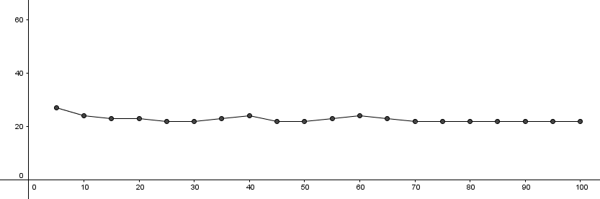

First off, the smallest intervals running with 1 processor. This is a very boring result, because the run time doesn’t vary at all. 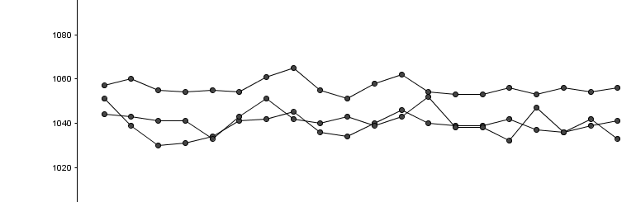

Second graph shows the same phenomenon when multiple processors are in use. The run time is pretty much the same across all of them as well, which indicates that there is an iherent cost in running in parallel, but it doesn’t seem to matter much how many programs are run in parallell. 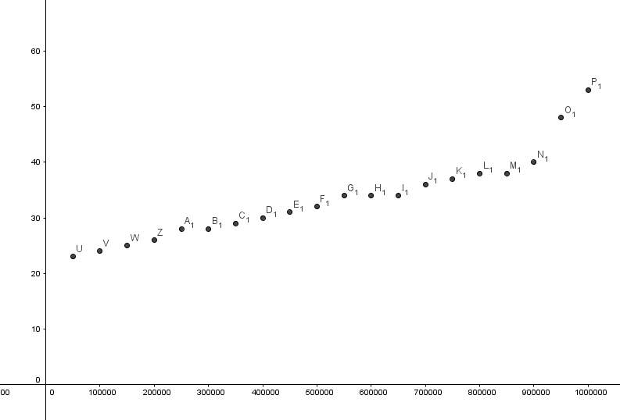

Thist graph shows the run time for 1 process in the medium range of intervals. At least here we see that the program starts to spend more time to compute the larger intervals. For the multi proccess results, the values were pretty much the same as in the smallest range, and not changing, so I deceided to not graph those values. This seems to indicate cost of doing the computations must still have been small enough for the MPI interface to be the most important factor.

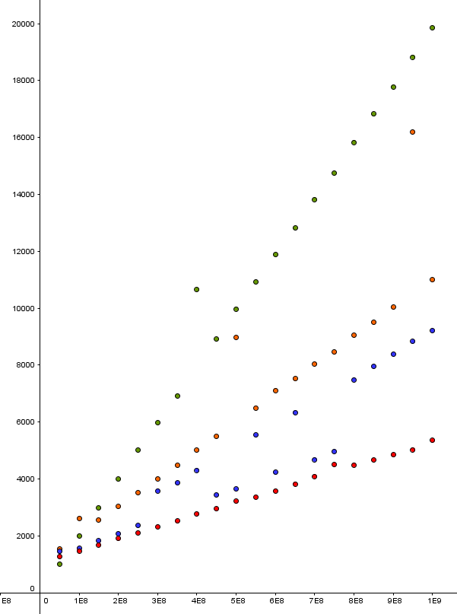

Lastly, for the largest intervals, I placed all of the results in one graph, and they seem to make very straight lines. The data points are colour coded where the results from running one, two, four and eight processes are codes as green, orange, blue and red respectively. There seems to be some outliers from the lines, which might happen because the computer might not have run all of our processes at the same time. Interestingly the blue dots seem to fall on two different lines, which might be because the amount of processes running at the same time just happened to be about the same several times