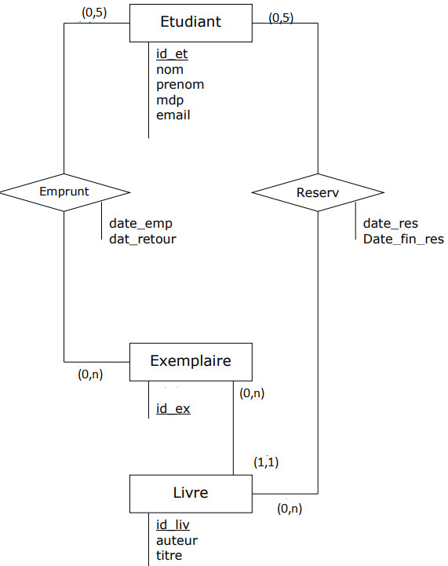

Etudiant (id_et, nom, prenom, email, mdp)

Exemplaire (id_ex, id_liv)

Emprunt (id_ex, id_et, date_emp, date_retour)

Reserv (id_liv, id_et, date_res, date_fin_res)

Livre (id_liv, auteur, titre)

create table ETUDIANT  
(  
 id_et int generated as identity primary key,  
 nom varchar(50) not null,  
 prenom varchar(50) not null,  
 mdp varchar(50) not null,  
 email varchar(50) not null UNIQUE  
)  
/  
create table LIVRE  
(  
 id_liv int generated as identity primary key,  
 auteur varchar(50) not null,  
 titre varchar(200) not null,  
 genre varchar(50) not null,  
 categorie varchar(50) not null  
)  
/  
create table EXEMPLAIRE  
(  
 id_ex int generated as identity PRIMARY KEY,  
 id_liv int not null,  
 foreign key (id_liv) references LIVRE (id_liv)  
)  
/  
create table EMPRUNT  
(  
 date_emp date not null,  
 date_retour date not null,  
 id_ex int not null UNIQUE,  
 id_et int not null,  
 foreign key (id_et) references ETUDIANT (id_et),  
 foreign key (id_ex) references EXEMPLAIRE(id_ex)  
)  
/  
create table RESERVATION  
(  
 date_res date not null,  
 date_fin_res date not null,  
 id_liv int not null UNIQUE,  
 id_et int not null,  
 foreign key (id_et) references ETUDIANT (id_et),  
 foreign key (id_liv) references LIVRE (id_liv)  
)  
/