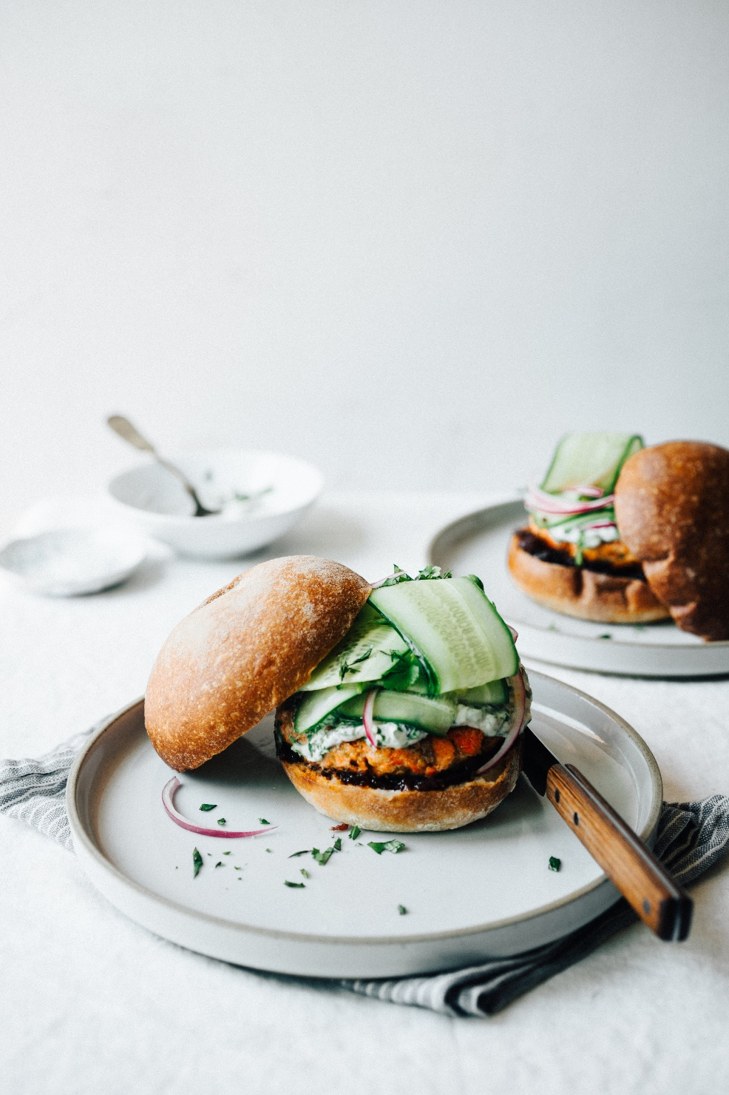

**Salmon Burgers with Lemongrass and Ginger**

Serves 2

INGREDIENTS

FOR THE SALMON BURGERS

1 8-ounce salmon fillet

1 teaspoon salt

freshly cracked black pepper

2 stalks lemongrass

1/2 inch piece of fresh ginger, peeled

zest and juice from 1 lime

1/4 cup + 1 tablespoon mayonnaise

1/2 teaspoon red pepper flakes

3 tablespoons ground flax

3 tablespoons oil

PROCEDURE

Preheat the oven to 350 degrees. Place the salmon on a parchment lined baking sheet and sprinkle with the salt and pepper. Bake in the oven for 10-15 minutes until just cooked through, but still pink and moist.

Remove from the oven and set aside to cool.

Meanwhile, trim the lemongrass stalks, keeping only the bottom 3-4 inches. Remove the outer leaves and finely chop the tender core. Place the chopped lemongrass and ginger in a spice grinder and grind until it begins to form a paste. Add the lime zest and juice, mayonnaise and red pepper flakes and blend until combined. Transfer to a medium bowl. Once the salmon has cooled, break it into medium sized pieces, removing any bones and discarding the skin. Add the salmon and the ground flax to the bowl with the mayonnaise mixture and stir to combine.

Heat the oil in a skillet over medium heat. Shape the salmon cakes into patties about 4 inches in diameter and 1 inch thick. Fry until golden brown on both sides. Remove from the pan and place on a cooling rack.

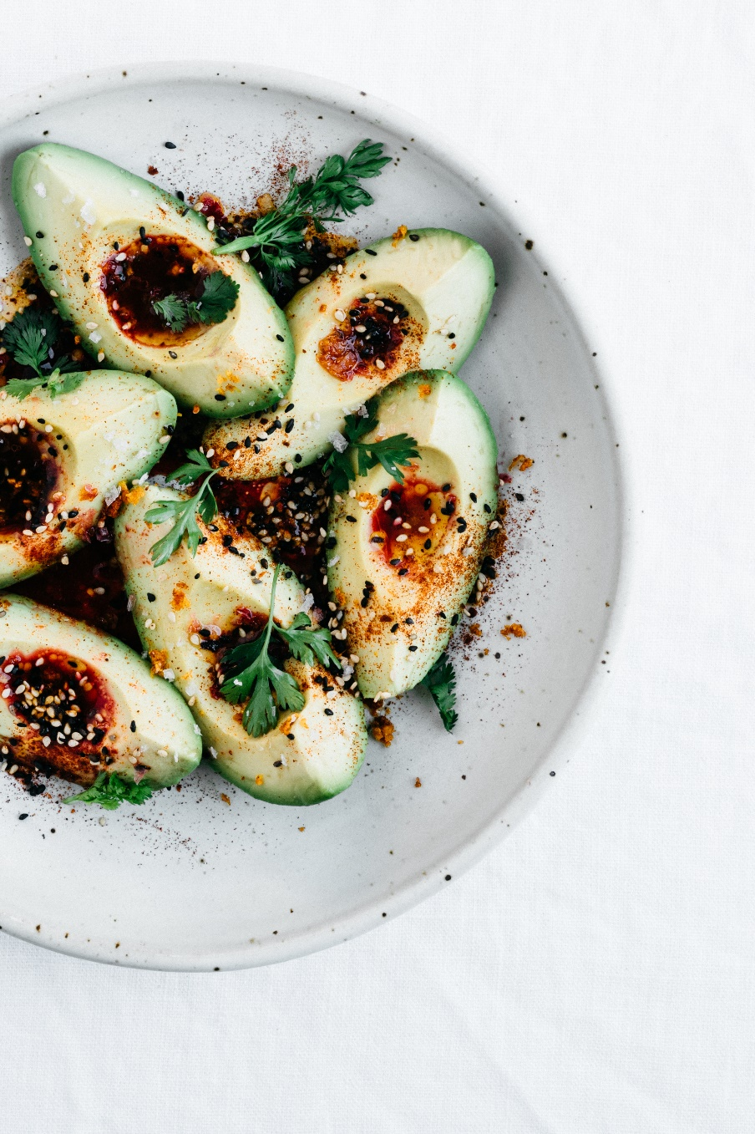

**A Simple Avocado Salad**

Serves 3-4 (as a side dish)

INGREDIENTS

3 ripe avocados

2 tablespoons olive oil

2 tablespoons freshly squeezed blood orange juice

1/2 teaspoon smoked paprika

1/4 teaspoon chili powder

1/4 teaspoon red pepper flakes

1 1/2 teaspoons toasted white sesame seeds

1 1/2 teaspoons black sesame seeds

1 teaspoon blood orange zest

flaky sea salt and cilantro leaves to garnish

**PROCEDURE**

Cut the avocados in half, remove the pits, peel and quarter. Arrange on a plate.

Combine the olive oil and blood orange juice in a small bowl and whisk to combine. Set aside.

Combine the paprika, chili, red pepper flakes, sesame seeds and zest in a small bowl and mix well.

When ready to serve, drizzle the dressing over the avocado, sprinkle with some of the spice mixture and garnish with the flaky salt and cilantro.

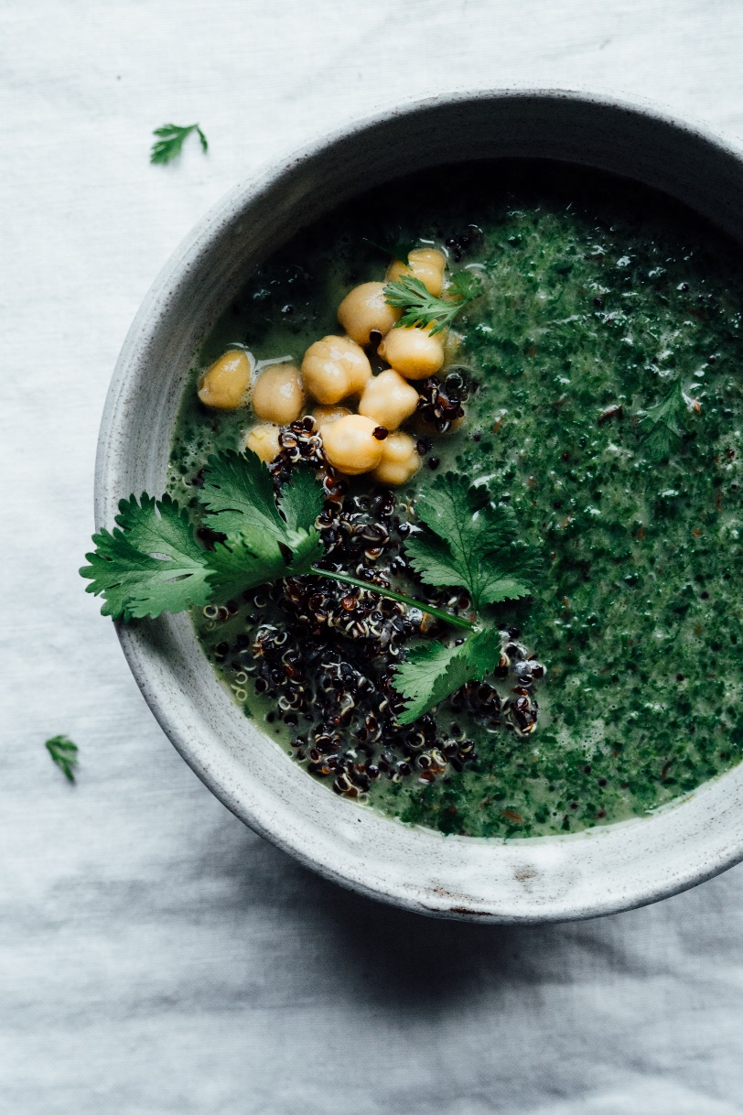

**Chana Palaak**

Serves 2

INGREDIENTS

2 tablespoons coconut oil

2 teaspoons brown mustard seeds

2 teaspoons cumin seeds

2 teaspoons coriander seeds

5 curry leaves

1/2 onion, diced

1 teaspoon salt

1 inch fresh ginger, peeled and minced

6 cups loosely packed spinach leaves

lemon juice

1 cup full fat coconut milk

1 15-ounce can chickpeas

cooked quinoa or rice for serving

PROCEDURE

Heat the oil in a large skillet over medium heat. Add the spices and the curry leaves and cook until fragrant and beginning to pop, about 10-20 seconds. Add the onion, ginger and salt and sautee until the onion is soft and translucent. Add the spinach and cook until just wilted. Add a squeeze of lemon to keep the spinach vibrant and remove the pan from the heat. Transfer the mixture to a blender and pulse 5-10 times until you have a chunky puree. Return the mixture to the pan. Add in the coconut milk and chickpeas and stir to combine. Serve with rice or quinoa

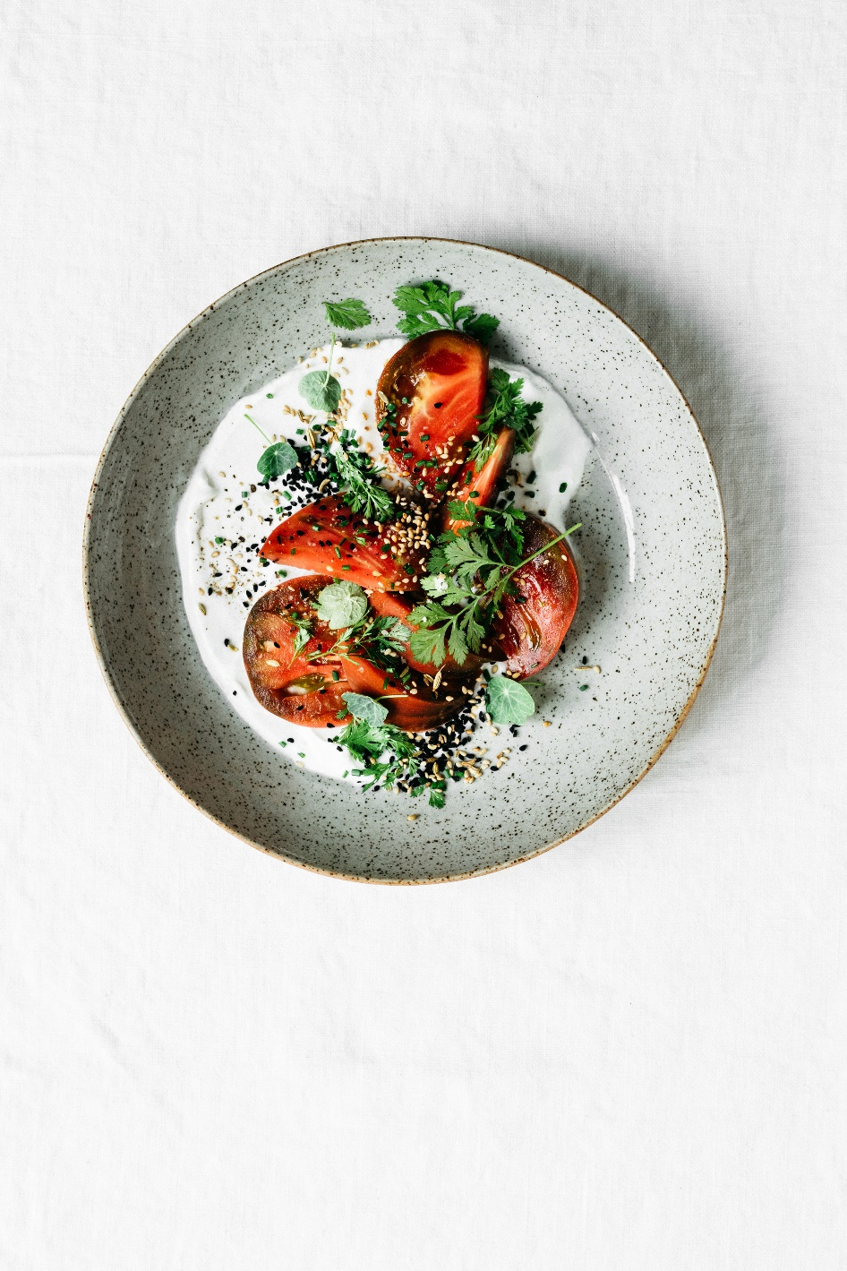

**Savory Breakfast Bowl**

INGREDIENTS

unsweetened coconut yogurt

ripe tomatoes, sliced into thick wedges

toasted sesame seeds

nigella seeds

fennel seeds

salt

pepper

cilantro leaves

chives, minced

nasturtium leaves

PROCEDURE

Spread a heaping spoonful of yogurt across a shallow bowl or plate. Arrange the tomato wedges on top of the yogurt. Sprinkle with the seeds, salt, pepper, and fresh herbs. Serve alone or with crusty breads.

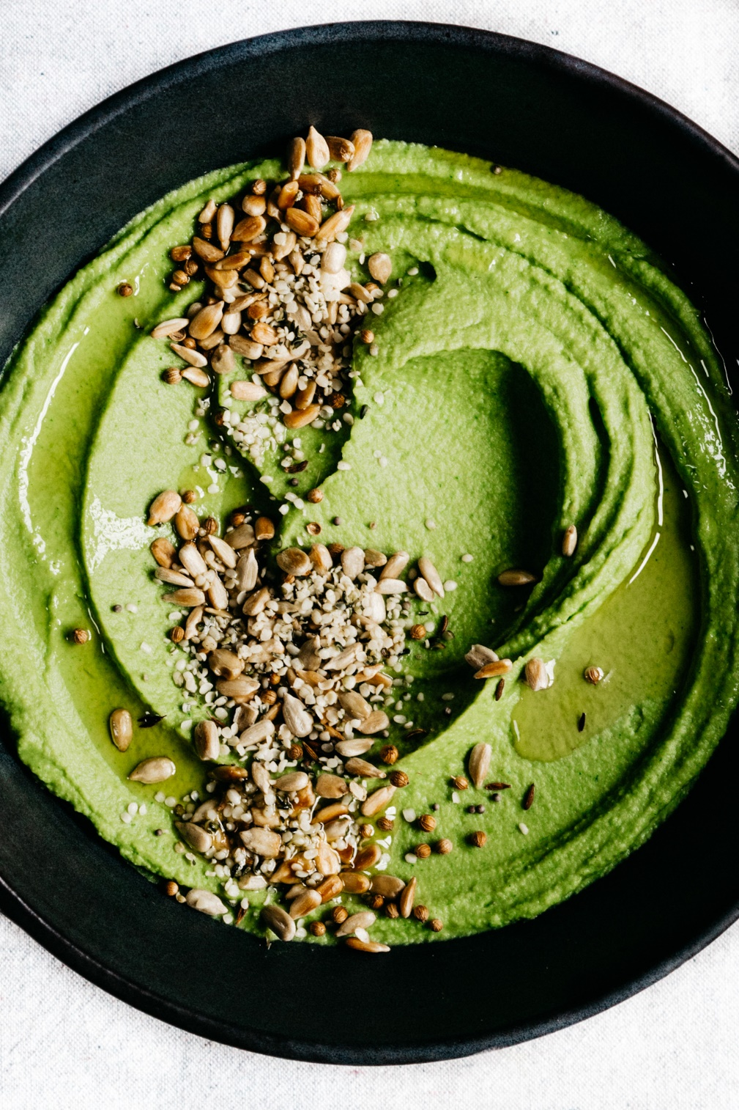

**Green Pea Hummus**

Slightly adapted from First We Eat by Eva Kosmas Flores

Makes 1 3/4 cups

INGREDIENTS

1 cup shelled fresh peas or blanched frozen peas

1 1/4 cups coarsely chopped fresh cilantro

1 cup garbanzo beans, drained and rinsed

2 tablespoons tahini

2 tablespoons fresh lemon juice

2 tablespoon extra virgin olive oil, plus extra to garnish

3/4 teaspoon flake kosher sea salt

1/4 teaspoon freshly cracked black pepper

Toasted sunflower seeds, coriander seeds, cumin seeds, and mustard seeds to garnish

PROCEDURE

Combine the peas, cilantro, garbanzo beans, tahini, lemon juice, oil, salt and pepper in a high speed blender and puree until completely smooth.

Transfer to a shallow bowl and garnish with a drizzle of olive oil and the toasted seeds.

Serve with roasted sweet potato wedges or toasted bread.