Appendix 1 Double Machine Learning: Formal Derivation
This appendix derives the rationale for the Step 1 estimator used in the main text. Section A.X.1 states the target parameter and shows why a plug-in estimator built from machine-learned nuisances cannot support root-n inference. Section A.X.2 derives the orthogonal score and verifies Neyman orthogonality. Section A.X.3 repeats the argument for the partially linear model that supplies the parametric benchmark. Section A.X.4 derives the role of cross-fitting and states the asymptotic distribution. Section A.X.5 covers variance estimation, A.X.6 collects the rate conditions, A.X.7 relates the estimator to the causal forest of Step 2, and A.X.8 states what the estimator does not deliver.
Notation. Let $W=(Y,D,X)$, with $Y$ an outcome, $D∈\{0,1\}$ a treatment indicator, and $X$ a vector of covariates. Potential outcomes are $Y(1)$ and $Y(0)$. Define $μ(d,x)=E[Y|D=d,X=x]$ and $e(x)=P(D=1|X=x)$. The target parameter is the average treatment effect $θ_{0}=E[Y(1)−Y(0)]$. All expectations are taken over the target population.
The target parameter and the failure of plug-in
Identification rests on three conditions: unconfoundedness, $\{Y(0),Y(1)\}⊥D|X$; overlap, $0<e(x)<1$ for every value of $x$; and consistency with no interference. Under these conditions,
$θ_{0}=E[μ(1,X)−μ(0,X)]$ (A.X.1)
The nuisance functions $η_{0}=(μ(1,⋅),μ(0,⋅),e(⋅))$ are infinite-dimensional. The natural plug-in estimator replaces them with machine-learned estimates $\hat{η}=({\hat{μ}}_{1},{\hat{μ}}_{0},\hat{e})$ and averages over the sample:
${\hat{θ}}_{plug}=\frac{1}{n}\sum_{i}{\left[\hat{μ}(1,X_{i})−\hat{μ}(0,X_{i})\right]}$ (A.X.2)
Write $γ_{d}(x)=\hat{μ}(d,x)−μ(d,x)$ for the estimation error at treatment level $d$. Then
$E[{\hat{θ}}_{plug}]−θ_{0}=E[γ_{1}(X)]−E[γ_{0}(X)]$ (A.X.3)
which is a first-order functional of the nuisance error: the bias is of the same order as the $L_{2}$ error of $\hat{μ}$ itself. Flexible learners achieve at best a nonparametric rate such as $‖γ_{d}‖_{2}=O(n^{−1/4})$ under smoothness restrictions. Because $\sqrt{n}⋅n^{−1/4}=n^{1/4}$ diverges, the scaled bias does not vanish, (A.X.2) is not asymptotically normal around $θ_{0}$ at rate $\sqrt{n}$, and confidence intervals built from it undercover. The source is regularization bias: the shrinkage that improves prediction accuracy is what shifts the functional. This is the problem that orthogonalization is designed to solve.
The orthogonal score for the average treatment effect
Consider the augmented inverse-probability-weighted (AIPW) score with generic nuisance $η=(μ_{1},μ_{0},e)$:
$ψ(W;θ,η)=μ_{1}(X)−μ_{0}(X)+\frac{D(Y−μ_{1}(X))}{e(X)}−\frac{(1−D)(Y−μ_{0}(X))}{1−e(X)}−θ$ (A.X.4)
Mean zero at the truth. Evaluating (A.X.4) at $η=η_{0}$ and taking expectations term by term,
$E\left[\frac{D(Y−μ_{1}(X))}{e(X)}\right]=E\left\{E[D|X]⋅\frac{E[Y−μ_{1}(X)|X,D=1]}{e(X)}\right\}=E[μ(1,X)−μ_{1}(X)]=0,$
and symmetrically for the control term. Hence $E[ψ(W;θ_{0},η_{0})]=E[μ_{1}(X)−μ_{0}(X)]−θ_{0}=0$ by (A.X.1). The estimator solves the empirical analogue:
$\hat{θ}=(1/n)\sum_{i}{\left\{{\hat{μ}}_{1}(X_{i})−{\hat{μ}}_{0}(X_{i})+\frac{D_{i}(Y_{i}−{\hat{μ}}_{1}(X_{i}))}{\hat{e}(X_{i})}−\frac{(1−D_{i})(Y_{i}−{\hat{μ}}_{0}(X_{i}))}{1−\hat{e}(X_{i})}\right\}}$ (A.X.5)
Neyman orthogonality. A score is Neyman-orthogonal if its Gateaux derivative with respect to the nuisance vanishes at the truth, $∂_{η}E[ψ(W;θ_{0},η_{0})][η−η_{0}]=0$. Take directions $Δ_{1}$ and $Δ_{0}$ for the outcome regressions and $Δ_{e}$ for the propensity score. Differentiating (A.X.4),
$(i) w.r.t. μ_{1}: E[Δ_{1}(X)]−E\left[\frac{DΔ_{1}(X)}{e(X)}\right]=E[Δ_{1}(X)]−E[Δ_{1}(X)]=0;$
$(ii) w.r.t. μ_{0}: −E[Δ_{0}(X)]+E\left[\frac{(1−D)Δ_{0}(X)}{1−e(X)}\right]=−E[Δ_{0}(X)]+E[Δ_{0}(X)]=0;$
$(iii) w.r.t. e: E\left[\frac{D(Y−μ_{1}(X))Δ_{e}(X)}{e(X)^{2}}\right]−E\left[\frac{(1−D)(Y−μ_{0}(X))Δ_{e}(X)}{(1−e(X))^{2}}\right]=0,$ (A.X.6)
where the last line uses $E[D(Y−μ_{1}(X))|X]=e(X)[μ(1,X)−μ_{1}(X)]=0$ at $η=η_{0}$, and analogously for the control term. All three derivatives vanish.
The consequence is a bias statement. Expand $E[ψ(W;θ_{0},\hat{η})]$ around $η_{0}$: the first-order term is exactly the derivative that the previous display shows to be zero, so the leading bias is second order in the nuisance errors,
$E[ψ(W;θ_{0},\hat{η})]=O\left(‖γ_{1}‖_{2}‖γ_{0}‖_{2}+‖γ_{1}‖_{2}‖Δ_{e}‖_{2}+‖μ_{1}−μ_{0}‖_{2}‖Δ_{e}‖_{2}\right)$ (A.X.7)
with $Δ_{e}=\hat{e}−e$. The plug-in bias in (A.X.3), by contrast, is first order. This is the sense in which the estimator is debiased, and it is what licenses $\sqrt{n}$ inference when the nuisances are estimated at rates slower than $\sqrt{n}$.
Double robustness. Two cases follow from the same algebra. If $e$ is correct but $μ_{1}$ and $μ_{0}$ are arbitrary, then $E[D(Y−μ_{1}(X))/e(X)]=E[μ(1,X)−μ_{1}(X)]$, so $E[ψ(W;θ_{0},η)]=E[μ(1,X)−μ_{0}(X)]−θ_{0}+E[μ(1,X)−μ_{1}(X)]−E[μ(0,X)−μ_{0}(X)]=0$. If $μ_{1}$ and $μ_{0}$ are correct but $e$ is arbitrary, then $Y−μ_{1}(X)=U$ with $E[U|X,D=1]=0$, so $E[DU/e(X)]=E\{E[D|X]E[U|X,D=1]/e(X)\}=0$, and again $E[ψ]=0$. Consistency therefore requires only one of the two nuisance components to be correct.
The partially linear benchmark
Step 1 also compares the DML estimate with the parametric estimate reported in the study. That parametric estimate is the least-squares fit of the partially linear model
$Y=Dθ_{0}+g_{0}(X)+U, E[U|X,D]=0,$ (A.X.8)
$D=m_{0}(X)+V, E[V|X]=0,$ (A.X.9)
with $g_{0}(X)$ linear in the theorist's specification. Identification follows from (A.X.8) and (A.X.9):
$θ_{0}=\frac{E\left[(D−m_{0}(X))(Y−g_{0}(X))\right]}{E\left[(D−m_{0}(X))^{2}\right]}$ (A.X.10)
because $E[(D−m_{0})(Y−g_{0})]=θ_{0}E[(D−m_{0})^{2}]+E[(D−m_{0})U]$, and the second term is zero since $E[U|X]=0$ and $E[DU|X]=E[DE[U|X,D]|X]=0$. The Robinson (1988) score is
$ψ_{PL}(W;θ,η)=(Y−Dθ−g(X))(D−m(X)),$ (A.X.11)
evaluated at $η=(g,m)$ and solved for $θ$. At the truth, writing $γ=\hat{g}−g_{0}$ and $δ=\hat{m}−m_{0}$,
$ψ_{PL}(W;θ_{0},\hat{η})=(U−γ(X))(V−δ(X))=UV−Uδ(X)−γ(X)V+γ(X)δ(X),$
and every term has zero expectation except the last: $E[UV]=0$ because $E[U|X,D]=0$, $E[Uδ(X)]=E[δ(X)E[U|X]]=0$, and $E[γ(X)V]=E[γ(X)E[V|X]]=0$. Hence
$E[ψ_{PL}(W;θ_{0},\hat{η})]=E[γ(X)δ(X)]=⟨γ,δ⟩.$ (A.X.12)
The bias is the inner product of the two nuisance errors, not a first-order term in either. Neyman orthogonality of (A.X.11) follows from the same differentiation: in direction $Δ_{g}$ the derivative is $−E[Δ_{g}(X)(D−m_{0}(X))]=−E[Δ_{g}(X)E[V|X]]=0$, and in direction $Δ_{m}$ it is $−E[(Y−Dθ_{0}−g_{0}(X))Δ_{m}(X)]=−E[UΔ_{m}(X)]=−E[Δ_{m}(X)E[U|X]]=0$.
Note that the algebraically adjacent score $(Y−g(X)−θ(D−m(X)))(D−m(X))$, which is the naive choice, is not orthogonal: its derivative in $Δ_{m}$ equals $−θ_{0}E[m_{0}(X)Δ_{m}(X)]$, which is nonzero, so its bias is first order in $δ$. Residualizing both $Y$ and $D$ is not a cosmetic decision.
Cross-fitting and asymptotic normality
Orthogonality alone does not deliver inference, because $\hat{η}$ is fitted on the same observations used to evaluate the sample average of the score. The empirical average then inherits a term of order $E[{\hat{γ}}^{2}]+E[{\hat{δ}}^{2}]$ from the learner's own noise, and that term is not second order when the model is high-dimensional or nonparametric.
Cross-fitting removes it. Partition the sample into $K$ folds of equal size, let $k(i)$ denote the fold containing observation $i$, and let ${\hat{η}}_{−k(i)}$ be estimated on all folds except $k(i)$. The estimator is
$\hat{θ}=(1/n)\sum_{i}{ψ(W_{i};θ,{\hat{η}}_{−k(i)})}=0.$ (A.X.13)
Because ${\hat{η}}_{−k(i)}$ is independent of $W_{i}$, the summands within each fold are independent and identically distributed conditional on the training folds, and the empirical average converges to its expectation at rate $n^{−1/2}$, up to a term that is second order by (A.X.7) and (A.X.12). Under the rate conditions in A.X.6,
$\sqrt{n}(\hat{θ}−θ_{0})=\frac{1}{\sqrt{n}}\sum_{i}{ψ(W_{i};θ_{0},η_{0})}+o_{p}(1)→N(0,σ^{2}), σ^{2}=E[ψ(W;θ_{0},η_{0})^{2}]$ (A.X.14)
where the arrow denotes convergence in distribution. For the AIPW score, $ψ(W;θ_{0},η_{0})$ is itself the influence function. For the partially linear score, the influence function is $J^{−1}ψ_{PL}$ with $J=E[V^{2}]$, so that $σ^{2}=J^{−2}E[V^{2}U^{2}]$.
Three remarks follow. First, (A.X.14) holds although $‖\hat{η}−η_{0}‖_{2}$ converges more slowly than $n^{−1/2}$: the estimator attains a parametric rate for a finite-dimensional functional while the nuisances remain nonparametric. Second, $K=5$ or $10$ is standard, and estimates are reported as averages over repeated random partitions when $K$ is small. Third, cross-fitting is not cross-validation: the folds exist to break the dependence between nuisance estimation and score evaluation, not to select a model or to tune hyperparameters.
Variance estimation and confidence intervals
The plug-in variance estimator is ${\hat{σ}}^{2}=(1/n)\sum_{i}{ψ(W_{i};\hat{θ},{\hat{η}}_{−k(i)})^{2}}$, and the interval $\hat{θ}±1.96\hat{σ}/\sqrt{n}$ has asymptotic coverage of 95 percent under (A.X.14). Because the summands are not independent across folds, small-sample standard errors are mildly downward biased. The standard correction replaces $n$ by the number of folds in the variance of the fold-level means, or reports fold-clustered standard errors. For the average treatment effect we report the interval based on ${\hat{σ}}^{2}$ and record the alternative in the replication code.
A.X.6 Rate conditions
(A.X.14) requires the second-order bias to vanish faster than $n^{−1/2}$. The conditions are collected in Table A.X.1.
Table A.X.1. Rate conditions for root-n inference.
Quantity | Condition | Interpretation
Outcome error | $$‖γ_{d}‖_{2}=o(n^{−1/4})$$ | each outcome regression converges faster than $n^{−1/4}$
Propensity error | $$‖Δ_{e}‖_{2}=o(n^{−1/4})$$ | the propensity score converges faster than $n^{−1/4}$
Product term | $$‖γ_{d}‖_{2}⋅‖Δ_{e}‖_{2}=o(n^{−1/2})$$ | implied by the two rows above
Partially linear term | $$⟨γ,δ⟩=o(n^{−1/2})$$ | the bias expression in (A.X.12)
Overlap | $e(x)$ bounded away from 0 and 1 | controls the variance of the augmentation term
Note: $‖⋅‖_{2}$ denotes the $L_{2}(P)$ norm, $γ_{d}={\hat{μ}}_{d}−μ_{d}$, and $Δ_{e}=\hat{e}−e$. $o(⋅)$ is the usual order symbol.
Relation to the causal forest
The causal forest of Step 2 targets a different functional with the same architecture. Its local score is the R-learner objective of Nie and Wager (2021),
$\hat{τ}(⋅)={arg min}_{τ}\sum_{i}{α_{i}(x){\left[(Y_{i}−\hat{g}(X_{i}))−τ(X_{i})(D_{i}−\hat{m}(X_{i}))\right]}^{2}}$ (A.X.15)
where the weights $α_{i}(x)$ are the fraction of trees in which $x$ and $X_{i}$ share a leaf, that is, an adaptively learned kernel. Two differences follow. First, the target changes from a scalar to a function, so pointwise rates are slower than $\sqrt{n}$ and the interval in (A.X.14) has no direct analogue; valid pointwise inference comes from honest splitting, which keeps $α_{i}(x)$ independent of the observations used to estimate $τ$ inside the leaf. Second, because $α_{i}(x)$ depends on the data, the weights must be treated as fixed when standard errors are computed, which is exactly what honest splitting licenses. Both estimators share orthogonalization and sample splitting; they differ in the dimension of the target functional.
What the estimator does not deliver
Three boundaries should be stated explicitly in any application.
1. Identification is untouched. Every result above conditions on unconfoundedness, overlap, and no interference. The estimator does not relax, test, or repair these conditions; it only ensures that their consequences can be estimated flexibly without losing valid inference.
2. A gap against the parametric estimate is a diagnostic, not a test. Both estimates target $θ_{0}$ and are consistent under the same identifying assumptions, so their difference does not estimate treatment-effect heterogeneity. A systematic gap indicates that a shared premise fails somewhere, most often inconsistent sample construction or weak overlap, and Steps 2 and 3 are what adjudicate whether unmodeled heterogeneity is the source.
3. The estimand is scalar. The score in (A.X.4) delivers $θ_{0}=E[τ(X)]$, not $τ(x)$. Questions about who benefits require the CATE function and therefore the forest of Step 2.
REFERENCES
Athey, S., & Wager, S. (2019). Estimating treatment effects with causal forests: An application. Observational Studies, 5(2), 37-51.
Chernozhukov, V., Chetverikov, D., Demirer, M., Duflo, E., Hansen, C., Newey, W., & Robins, J. (2018). Double/debiased machine learning for treatment and structural parameters. The Econometrics Journal, 21(1), C1-C68.
Nie, X., & Wager, S. (2021). Quasi-oracle estimation of heterogeneous treatment effects. Biometrika, 108(2), 299-319.
Robinson, P. M. (1988). Root-N-consistent semiparametric regression. Econometrica, 56(4), 931-954.
Wager, S., & Athey, S. (2018). Estimation and inference of heterogeneous treatment effects using random forests. Journal of the American Statistical Association, 113(523), 1228-1242.

Appendix 2 Causal Forest: Formal Derivation
This appendix derives the rationale for the Step 2 estimator used in the main text, in the same order of exposition as Appendix A.X. Section A.Y.1 states the estimand and explains why a scalar moment condition cannot recover it. Section A.Y.2 derives the local moment that identifies the conditional average treatment effect. Section A.Y.3 defines the forest estimator and shows that its weights act as an adaptively learned kernel. Section A.Y.4 derives the role of honest splitting, and A.Y.5 derives the splitting rule. A.Y.6 covers pointwise inference, A.Y.7 the tests for heterogeneity, A.Y.8 the relation to double machine learning and the boundaries of the estimator, and A.Y.9 the conditions under which the pointwise limit holds.
Notation. As in Appendix A.X, $W=(Y,D,X)$, with $Y$ an outcome, $D∈\{0,1\}$ a treatment indicator, and $X$ a vector of covariates. Define $μ(d,x)=E[Y|D=d,X=x]$, $e(x)=P(D=1|X=x)$, and $g_{0}(X)=E[Y|X]$ and $m_{0}(X)=E[D|X]$. The target is the function $τ(⋅)$ rather than the scalar $θ_{0}=E[τ(X)]$.
The estimand: from a scalar to a function
The causal forest estimates the conditional average treatment effect,
$τ(x)=E[Y(1)−Y(0)|X=x]$ (A.Y.1)
which is the average effect among units with covariates equal to $x$. Under unconfoundedness, $\{Y(0),Y(1)\}⊥D|X$; overlap, $0<e(x)<1$; and consistency with no interference, the estimand equals a difference of observed conditional means,
$τ(x)=μ(1,x)−μ(0,x).$ (A.Y.2)
The difference from Appendix A.X is dimensional, and it changes the estimation problem rather than merely its notation. The score in (A.X.4) identifies the scalar $E[τ(X)]$; it contains no information about $τ(x)$ at a particular $x$. Recovering a function requires localizing in $X$, and every method in this class differs only in how the localization is chosen. A parametric interaction model fixes the localization in advance, by the functional form the researcher imposes. The forest learns it from the data.
Identification and the local moment
Write the outcome equation in residualized form. Since $μ(0,X)=g_{0}(X)−m_{0}(X)τ(X)$ and $μ(1,X)=g_{0}(X)+(1−m_{0}(X))τ(X)$,
$Y=g_{0}(X)+(D−m_{0}(X))τ(X)+ε, E[ε|X,D]=0,$ (A.Y.3)
so the deviation of the outcome from its conditional mean is the residualized treatment times the effect, plus noise. Multiplying (A.Y.3) by $D−m_{0}(X)$ and conditioning on $X$ gives
$τ(x)=\frac{E\left[(D−m_{0}(X))(Y−g_{0}(X))|X=x\right]}{E\left[(D−m_{0}(X))^{2}|X=x\right]}.$ (A.Y.4)
Equation (A.Y.4) is the local counterpart of the partially linear identification in (A.X.10). The numerator is a conditional covariance between the residualized outcome and the residualized treatment; the denominator is the conditional variance of the residualized treatment, which vanishes wherever overlap fails. Both are functions of $x$, so the target is identified pointwise, but it is not identified by any single moment condition. This is why the estimator must be a local one, and why its precision varies across the covariate space rather than being summarized by a single standard error.
The forest as an adaptive kernel
The forest replaces the conditional expectations in (A.Y.4) with weighted averages. Let ${\hat{R}}_{i}=Y_{i}−\hat{g}(X_{i})$ and ${\hat{V}}_{i}=D_{i}−\hat{m}(X_{i})$ be the residualized outcome and treatment, obtained from separate regression forests, and let $α_{i}(x)$ be a weight attached to observation $i$ at the evaluation point $x$. The estimator is
$\hat{τ}(x)=\frac{\sum_{i}{α_{i}(x){\hat{V}}_{i}{\hat{R}}_{i}}}{\sum_{i}{α_{i}(x){\hat{V}}_{i}^{2}}},$ (A.Y.5)
which is the weighted least-squares solution of $\sum_{i}{α_{i}(x)({\hat{R}}_{i}−τ{\hat{V}}_{i})^{2}}$ and therefore the local analogue of the residual-on-residual regression. The weights are the fraction of trees in which $x$ and $X_{i}$ fall in the same leaf,
$α_{i}(x)=\frac{1}{T}\sum_{t}{\frac{1\{X_{i}∈L_{t}(x)\}}{\left|L_{t}(x)\right|}}, \sum_{i}{α_{i}(x)}=1,$ (A.Y.6)
with $L_{t}(x)$ the leaf of tree $t$ that contains $x$ and $T$ the number of trees. Three properties follow directly from (A.Y.6), and together they are the precise sense in which the procedure is data-driven.
First, $α_{i}(x)$ defines a metric on the covariate space that is learned rather than fixed in advance. Two units are close at $x$ if the ensemble places them in the same leaves, and the splits that produce those leaves are chosen to separate variation in $τ$ rather than in $Y$. Second, $α_{i}(x)$ is a step function of $x$, so $\hat{τ}(⋅)$ is piecewise constant and the effective neighborhood contracts as the trees grow deeper. Third, the covariates enter only through the weights. The estimator is a kernel regression with an adaptive bandwidth, not a parametric interaction model written in a different notation.
Honest splitting
Estimating the weights and the effect from the same observations creates a selection problem. Substituting (A.Y.3) into (A.Y.5) and writing ${\hat{R}}_{i}−τ(x){\hat{V}}_{i}$ in terms of population quantities gives the decomposition
$\hat{τ}(x)−τ(x)=\frac{\sum_{i}{α_{i}(x)V_{i}ε_{i}}}{\sum_{i}{α_{i}(x)V_{i}^{2}}}+\frac{\sum_{i}{α_{i}(x)V_{i}^{2}(τ(X_{i})−τ(x))}}{\sum_{i}{α_{i}(x)V_{i}^{2}}}.$ (A.Y.7)
The first term is a weighted average of noise. The second is the smoothing bias, which vanishes when $τ$ is Lipschitz and the weights concentrate in a shrinking neighborhood. If $α(x)$ is computed on the estimation sample, then the weights are functions of $ε_{i}$, the conditional mean $E[ε_{i}|α_{i}(x)]$ is no longer zero, and the first term acquires a bias that does not shrink with $n$: the trees select precisely those observations whose realized effect looks extreme. Honest splitting closes this channel by partitioning the sample into a structure subsample $S$, used only to grow the trees and to compute $α(x)$, and an estimation subsample $E$, used only to compute $\hat{R}$ and $\hat{V}$ inside the leaves.
Because $α(x)$ is then measurable with respect to $S$ while $ε$ is independent of $S$, the first term in (A.Y.7) has conditional mean zero and conditional variance
$Var\left[\hat{τ}(x)|S\right]=\frac{σ^{2}(x){\left\|α(x)\right\|}^{2}}{{\left(\sum_{i}{α_{i}(x)V_{i}^{2}}\right)}^{2}}.$ (A.Y.8)
Honesty therefore buys two things at once. It keeps the bias from depending on the realized noise, and it turns the leading term into a weighted sum of independent zero-mean variables, which is what a central limit theorem requires. The requirement is the same as the one that cross-fitting imposes in Appendix A.X, but its target differs: cross-fitting protects a scalar moment, honesty protects the weights themselves, because in a forest the weights are estimated objects that enter the moment.
The splitting rule
The trees are grown to maximize heterogeneity in $τ$, not to fit $Y$. Consider a candidate split of a parent node into children $C_{1}$ and $C_{2}$, with a constant effect fitted in each child. The relevant loss is the residualized least-squares objective $\sum_{i}{(R_{i}−τ(X_{i})V_{i})^{2}}$. Within a child, the minimizer is ${\hat{τ}}_{c}=\sum_{i∈C_{c}}{R_{i}V_{i}}/\sum_{i∈C_{c}}{V_{i}^{2}}$, so the reduction in loss relative to a single fit at the parent is
$Δ(C_{1},C_{2})=\sum_{c=1,2}{\frac{{\left(\sum_{i∈C_{c}}{R_{i}V_{i}}\right)}^{2}}{\sum_{i∈C_{c}}{V_{i}^{2}}}}−\frac{{\left(\sum_{i}{R_{i}V_{i}}\right)}^{2}}{\sum_{i}{V_{i}^{2}}},$ (A.Y.9)
which is the generalized random forest splitting criterion specialized to this loss (Athey, Tibshirani and Wager, 2019). When $V^{2}$ is approximately constant across children, the first term of (A.Y.9) simplifies, and the criterion collapses to
$Δ(C_{1},C_{2})≈σ_{V}^{2}⋅\frac{n_{1}n_{2}}{n}{\left({\hat{τ}}_{1}−{\hat{τ}}_{2}\right)}^{2},$ (A.Y.10)
because the weighted between-child variation equals $n_{1}n_{2}({\hat{τ}}_{1}−{\hat{τ}}_{2})^{2}/n$ up to the scale $σ_{V}^{2}$. Maximizing (A.Y.10) is therefore equivalent to maximizing the squared difference in estimated effects across children, with more weight given to splits that leave both children large. This is the criterion reported in the main text, and it also marks the difference from a prediction forest: a forest grown on $Y$ splits on variation in $E[Y|X]$, which is dominated by $g_{0}(X)$ and is uninformative about $τ(X)$.
Pointwise inference
Under honesty, (A.Y.7) is a weighted average of independent zero-mean terms plus a bias that is of smaller order, and a Lindeberg argument applied within the neighborhood gives
$\frac{\hat{τ}(x)−τ(x)}{\hat{σ}(x)}→N(0,1)$ (A.Y.11)
in distribution, with the variance estimated by the weighted residual sum
${\hat{σ}}^{2}(x)=\frac{\sum_{i}{α_{i}(x)^{2}{\left({\hat{R}}_{i}−\hat{τ}(x){\hat{V}}_{i}\right)}^{2}}}{{\left(\sum_{i}{α_{i}(x){\hat{V}}_{i}^{2}}\right)}^{2}},$ (A.Y.12)
and the interval $\hat{τ}(x)±1.96\hat{σ}(x)$. Two qualifications matter. First, the result is pointwise: simultaneous coverage over many values of $x$ requires a multiplier bootstrap over trees, which the standard implementation supplies. Second, the approximation is asymptotic in the number of observations per neighborhood. Where overlap is weak the effective sample size is small, the interval is wide, and the estimate extrapolates beyond the support of the data. The forest does not repair weak overlap; it reports the consequence as a wide interval.
Testing for heterogeneity
The forest delivers $\hat{τ}(x)$, not a verdict on whether heterogeneity exists. The verdict comes from a separate test computed on an honest sample. Define the augmented pseudo-outcome
$Γ_{i}=\hat{μ}(1,X_{i})−\hat{μ}(0,X_{i})+\frac{D_{i}(Y_{i}−\hat{μ}(1,X_{i}))}{\hat{e}(X_{i})}−\frac{(1−D_{i})(Y_{i}−\hat{μ}(0,X_{i}))}{1−\hat{e}(X_{i})},$ (A.Y.13)
which satisfies $E[Γ_{i}|X_{i}]=τ(X_{i})$ under unconfoundedness and overlap, with a variance that inflates where the propensity score approaches its bounds. A test of heterogeneity regresses $Γ$ on the out-of-fold forest prediction,
$Γ_{i}=α+β\left({\hat{τ}}_{−i}(X_{i})−\bar{τ}\right)+ε_{i},$ (A.Y.14)
and tests $β=0$, which is the hypothesis of no detectable heterogeneity; a calibration test of $β=1$ asks instead whether the predicted differences are of the right magnitude (Athey and Wager, 2019). Two features of (A.Y.14) are essential. The pseudo-outcome is a doubly robust score, so the test is consistent if either the outcome model or the propensity model is correct. And ${\hat{τ}}_{−i}$ is computed without observation $i$, so the regressor is independent of the error and the least-squares inference is valid. Regressing $Γ$ on a forest fitted to the full sample produces an upward-biased slope, because the prediction for observation $i$ contains the noise of observation $i$. That is the selective-inference problem of A.Y.4 restated for the test rather than for the estimator.
A magnitude summary follows the same logic. Units are sorted by $\hat{τ}(X)$ into groups, group average treatment effects are estimated with the orthogonal scores of Appendix A.X on an honest subsample, and the difference between the extreme groups,
$TMT=\hat{E}\left[τ(X)|\hat{τ}(X)≥q_{0.8}\right]−\hat{E}\left[τ(X)|\hat{τ}(X)≤q_{0.2}\right],$ (A.Y.15)
measures how far the effect moves across the distribution of predicted effects, with $q_{0.8}$ and $q_{0.2}$ the corresponding quantiles of the predictions. Comparing covariate means across the extreme groups describes which units are most affected. That comparison is descriptive, and it does not identify the mechanism.
Relation to double machine learning, and what the estimator does not deliver
The two estimators share their architecture. Both residualize on flexible estimates of the nuisance functions, both rely on a score that is insensitive to first-order nuisance error, and both use sample splitting to break the dependence between nuisance estimation and evaluation of the moment. They differ in the dimension of the target. Appendix A.X recovers a scalar at rate $\sqrt{n}$; the forest recovers a function, pointwise and more slowly. The slower rate is the price of the richer object, not a defect of the implementation, and it is also why the forest cannot be used to report a single effect size with a single confidence interval.
Four boundaries should be stated in any application.
1. Identification is untouched. The forest estimates $τ(x)$ conditional on unconfoundedness, overlap, and no interference. It neither tests nor relaxes them. Unmeasured confounding remains a threat that no estimator in this class addresses, and a well-calibrated forest fitted to confounded data returns a precisely estimated biased function.
2. Only covariate-explainable heterogeneity is recovered. $τ(x)$ is an average within a stratum of $X$. Individual effects may differ within the stratum for reasons that are not measured, and that variation is invisible to any estimator that conditions on $X$. The forest is therefore not an estimator of individual treatment effects.
3. Failure to reject is not evidence of homogeneity. A test with little power, in a region of weak overlap, will fail to reject. The correct reading of a null result is that the data do not distinguish the effects, not that the effects are equal.
4. The output describes where effects vary, not why. Variable importance and comparisons of covariate means across predicted-effect groups describe the covariates along which $τ(x)$ moves. They do not establish that those covariates are the mechanism. A policy rule learned from $\hat{τ}(⋅)$ is a further step, and consistency of the function does not by itself deliver a consistent rule, because the argmax functional is discontinuous.
A.Y.9 Rate and regularity conditions
The pointwise limit in (A.Y.11) requires the variance in (A.Y.8) to vanish and the bias in (A.Y.7) to vanish faster. The conditions are collected in Table A.Y.1.
Table A.Y.1. Conditions for pointwise normality.
Requirement | Condition | Role in the derivation
Honest weights | $α(x)$ independent of $E$ | removes the selection term in (A.Y.7)
Shrinking neighborhood | $${\left\|α(x)\right\|}^{2}→0$$ | drives the variance in (A.Y.8) to zero
Local constancy | leaf diameter $→0$ | drives the bias term in (A.Y.7) to zero for Lipschitz $τ$
Structure sample | $s→∞$ and $s/n→0$ | Lindeberg condition for the weighted sum
Overlap | $e(x)$ bounded away from 0 and 1 | keeps $V_{i}$ from vanishing inside a leaf
Note: $S$ is the structure subsample and $E$ the estimation subsample; $s$ is the size of $S$; $\left\|⋅\right\|$ is the Euclidean norm of the weight vector. Leaf diameter is the maximum distance between two observations in the same leaf.
References
Athey, S., Tibshirani, J., & Wager, S. (2019). Generalized random forests. The Annals of Statistics, 47(2), 1148–1178.
Chernozhukov, V., Chetverikov, D., Demirer, M., Duflo, E., Hansen, C., Newey, W., & Robins, J. (2018). Double/debiased machine learning for treatment and structural parameters. The Econometrics Journal, 21(1), C1–C68.
Haans, R. F. J., Pieters, C., & He, Z.-L. (2016). Thinking about U: Theorizing and testing U- and inverted U-shaped relationships in strategy research. Strategic Management Journal, 37(7), 1177–1195.
Morris, T. P., White, I. R., & Crowther, M. J. (2019). Using simulation studies to evaluate statistical methods. Statistics in Medicine, 38(11), 2074–2102.
Simonsohn, U. (2018). Two lines: A valid alternative to the invalid testing of U-shaped relationships with quadratic regressions. Advances in Methods and Practices in Psychological Science, 1(4), 538–555.
Wager, S., & Athey, S. (2018). Estimation and inference of heterogeneous treatment effects using random forests. Journal of the American Statistical Association, 113(523), 1228–1242.

Appendix 3 Workflow validation: Semi-synthetic simulations

1. Research purpose
OrgCATE addresses a methodological problem in organizational research that a credible average treatment effect can coexist with substantively important differences across firms. The workflow estimates the ATE independently, recovers the CATE surface with one multivariable causal forest, reconstructs interpretable functional morphology such as a line, a U shape, a kink, or a threshold, then confirms the candidate on untouched data, and finally hands the evidence to the researcher for theory development.
Causal design → DML ATE → Joint causal forest → relevant firm characteristic → Morphology → test-sample confirmation → Theory development

2. Data architecture and candidate characteristics
2.1 Real firm-characteristic data
The benchmark uses a semi-synthetic design. Firm characteristics come from Compustat history for 8,648 firms. These data retain realistic ranges, correlations, and changes over time. Each simulation draws 3,000 distinct firms without replacement. The program generates treatment, potential outcomes, observed outcomes, and the true firm-level treatment effect. This combination retains the complexity of real firm data while providing a known answer for evaluating the method (Morris et al., 2019).
Firm characteristic | Code | Definition
Relative asset size | at_rank_year_currency | Asset-size position within year and currency
Cash intensity | cash_at | Cash and short-term investments / assets
Intangible-asset intensity | intangibles_at | Intangible assets / assets
Return on assets | roa_ni | Net income / assets
Leverage | debt_at | Debt / assets
Fixed-asset intensity | ppe_at | Property, plant and equipment / assets
Asset-growth trend | log_at_slope_L | Pre-treatment slope of log assets
Capital-expenditure intensity | capx_at | Capital expenditure / assets
Profitability change | roa_ni_slope_L | Pre-treatment slope of return on assets
Cash-holdings change | cash_at_slope_L | Pre-treatment slope of cash intensity
Leverage change | debt_at_slope_L | Pre-treatment slope of leverage
Relative sales scale | sale_rank_year_currency | Sales-size position within year and currency

2.2 A common scale for a firm's position on each characteristic
The 12 characteristics use different units. Total assets are measured in currency, cash intensity is a ratio, and growth is a slope. The program therefore converts every continuous characteristic to a position between 0 and 1. A value of 0.10 means that the firm is near the lower 10% of that characteristic, 0.50 is near the middle, and 0.90 is near the upper 10%. A turning point at 0.50 then has the same clear interpretation across variables, and location errors can be evaluated on one common scale.
2.3 Treatment assignment
Treatment T is binary. The program calculates each firm's probability of receiving treatment from profitability, leverage, relative asset size, fixed-asset intensity, asset growth, and change in leverage. The formula includes one nonlinear term and one interaction. Its intercept is adjusted so that approximately 30% of firms receive treatment, after which T is drawn from each firm's probability. The coefficients were specified before the final confirmation runs to create moderate treatment selection and adequate overlap between treated and untreated firms.
$$s\left(X\right)=0.60z_{ROA}−0.50z_{debt}+0.35z_{size}+0.30sin\left(πz_{PPE}/2\right)+0.25z_{ROA}z_{growth}+0.20z_{debt−change}$$
$$e\left(X\right)=logistic\left(α+std\left[s\left(X\right)\right]\right), mean\{e\left(X\right)\}=0.30, T∼Bernoulli\left(e\left(X\right)\right)$$
2.4 Potential outcomes and observed outcome
The program first generates the outcome that each firm would have without treatment, Y(0). This outcome depends on profitability, leverage, fixed-asset intensity, asset growth, capital expenditure, change in profitability, and change in cash holdings, together with random variation. Firm characteristics explain approximately half of the variation. The program then adds the CATE function for the current simulation to obtain Y(1), and uses the observed treatment status to obtain Y. Both relationships below are checked before estimation begins.
$$Y\left(0\right)=\sqrt{0.50} std\left[μ\left(X\right)\right]+\sqrt{0.50} std\left[ε\right]$$
$$Y\left(1\right)=Y\left(0\right)+τ\left(u\right), Y=Y\left(0\right)+Tτ\left(u\right)$$
The program stores estimation data and simulation answers separately. Estimation uses only the firm identifier, 12 observed characteristics, T, Y, and the training/test assignment. The true treatment probability, Y(0), Y(1), true CATE, true shape, and true parameters are opened only after estimation is complete. Separate random seeds govern firm sampling, treatment assignment, outcome noise, the training/test split, the auxiliary prediction models, shape fitting, and the causal forest, so each step can be reproduced.
Implementation: simulation_runner_v2/src/simulation_runner_v2.py; execution/run_nine_shape_capability_demo_v4.py

3. DML-ATE
DML-ATE uses five-fold cross-fitting. The training sample is divided into five parts. In each round, four parts train three auxiliary prediction models: one predicts treatment probability, and two predict outcomes for treated and untreated firms. The remaining part receives predictions from models that did not use those observations for training. Rotating this process across all five parts gives every firm an out-of-sample prediction. This retains flexible machine-learning adjustment while reducing bias from using the same observation for both model fitting and evaluation (Chernozhukov et al., 2018).
$$ψ_{i}=m_{1}\left(X_{i}\right)−m_{0}\left(X_{i}\right)+\frac{T_{i}\left[Y_{i}−m_{1}\left(X_{i}\right)\right]}{e\left(X_{i}\right)}−\frac{\left(1−T_{i}\right)\left[Y_{i}−m_{0}\left(X_{i}\right)\right]}{1−e\left(X_{i}\right)}$$
- The ATE is the average of the firm-level scores; its standard error is the standard deviation of those scores divided by the square root of the sample size; the confidence level is 95%.
- The three auxiliary models use scikit-learn gradient boosting with max_iter=150, learning_rate=.05, max_leaf_nodes=15, min_samples_leaf=20, and L2 regularization=1.0.
- Four conditions are checked before the causal forest is fitted: T contains both 0 and 1; the treatment rate is between 10% and 90%; predicted treatment probabilities are not concentrated near 0 or 1; and no more than 10% of observations require probability limiting.
DML-ATE provides an independent estimate of the population average effect. The next step tests whether that estimate is sufficiently consistent with the average level of the reconstructed CATE before the program interprets its morphology.
Implementation: src/orgcate_sim/ate.py; configs/public_workflow_contract_v1.json
3.1 DML-ATE/CATE failure test
The failure test compares two estimates for the same training firms: the five-fold cross-fitted DML-ATE and the reconstructed CATE averaged over the training distribution of the focal characteristic. The absolute difference is divided by the standard deviation of the training outcome:
standardized gap = |CATE_TRAIN_TARGET - DML-ATE_TRAIN| / SD(Y_train)
Decision | Threshold | Consequence
Primary pass rule | standardized gap <= 0.10 | Continue to morphology reconstruction and confirmation
Failure rule | standardized gap > 0.10 | Return INCONCLUSIVE and stop morphology interpretation
Sensitivity values | 0.05 and 0.15 | Report robustness without changing the primary 0.10 decision
All nine confirmed situations pass the primary rule. The largest standardized gap is 0.07457 in the kinked situation, below the fixed 0.10 threshold. The comparison uses the training population for both quantities; the untouched test sample remains reserved for independent confirmation.
Implementation: src/orgcate_sim/ate.py; src/orgcate_sim/public_contract.py; configs/public_workflow_contract_v1.json
3.2 Supplementary fixed-effects comparison
For reference, the panel fixed-effects estimate is reported beside True ATE, DML-ATE, and CATE for the nine situations. Each entry is the mean over 10 replications. Progression to morphology is determined by the DML-ATE/CATE failure test above.
Situation | True ATE | Firm + period FE | DML-ATE | CATE | FE - ATE
homogeneous | 1.0000 | 0.9967 | 1.0274 | 0.9824 | -0.0033
linear-monotone | 1.6104 | 1.8995 | 1.6298 | 1.5718 | +0.2895
nonlinear-monotone | 1.9220 | 2.1814 | 1.9429 | 1.8644 | +0.2598
steep-continuous | 1.4852 | 1.8708 | 1.5058 | 1.4514 | +0.3863
inverted-u | 0.9209 | 0.9910 | 0.9526 | 0.9078 | +0.0668
u-shaped | -0.9209 | -0.9975 | -0.8946 | -0.8302 | -0.0734
kinked | 2.2770 | 2.7763 | 2.2965 | 2.2093 | +0.5019
threshold-step | 1.2178 | 1.5006 | 1.2432 | 1.1880 | +0.2828
sign-reversal | 0.8994 | 0.4087 | 0.9250 | 0.8827 | -0.4913
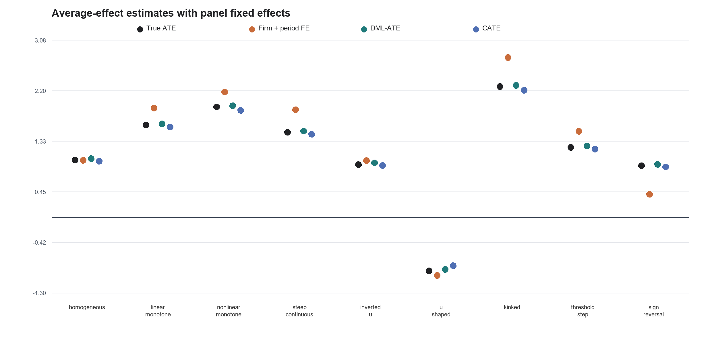
Figure A2. True ATE, panel fixed-effects, DML-ATE, and CATE point estimates across the nine situations.
Implementation: src/orgcate_sim/fixed_effects_comparison.py; configs/fixed_effects_comparison_v1.json; command: orgcate fixed-effects-comparison

4. Primary CATE learner
Each simulation fits one econml.dml.CausalForestDML containing all 12 firm characteristics. All characteristics participate jointly in the heterogeneity analysis. Firms are divided into 80% training and 20% test samples, with no firm appearing in both. Inside the training sample, cv=2 estimates treatment probability and baseline outcomes, while honest=True uses different subsamples to choose tree splits and estimate effects within leaves. The test sample is used only after the forest and shape have been selected (Wager & Athey, 2018; Athey et al., 2019).
Element | Setting | Purpose
External split | 80% training / 20% independent test | Independent confirmation
Forest | 1,000 trees; honest=True | Estimate treatment-effect differences across firms
Internal auxiliary models | cv=2 | Estimate treatment probability and baseline outcomes inside training data
Leaf and sampling | minimum leaf=5; sample fraction=.45 | Control forest complexity
Feature set | 12 characteristics jointly | Multivariable CATE surface
Characteristic importance order | Reported for all 12 characteristics | Shows which characteristics help separate treatment effects

The program reports the importance order of all 12 characteristics to show which variables help most in separating treatment effects across firms. In the single-shape simulations, the characteristic that generates heterogeneity is specified before the run. The joint forest and test sample must still recover its CATE curve, shape, and numerical features.
Implementation: econml.dml.CausalForestDML; configs/unified_morphology_v2.json

5. From forest predictions to a clear CATE curve
The causal forest first estimates a treatment effect for each firm, but an average across many trees does not directly provide a slope, turning point, or boundary. To obtain a function that can be used in theory development, the program first predicts baseline outcomes and treatment probability through five-fold cross-fitting and removes these predictable parts from Y and T. The remaining outcome and treatment variation isolates the treatment-effect relationship. Within the training sample, the program then compares a constant, a straight line, a quadratic curve, a smooth S curve, two joined lines, and a piecewise-constant function. Comparing these forms avoids treating a quadratic specification alone as sufficient evidence of a reversal in direction (Simonsohn, 2018).
$$Prediction error\left(f\right)=mean​\left\{{\left[{\tilde{y}}_{i}−{\tilde{t}}_{i}f\left(u_{i}\right)\right]}^{2}\right\}$$
Candidate function | Functional form | Key quantities
Constant | $$b_{0}$$ | Level and span
Linear | $$b_{0}+b_{1}u$$ | Direction and slope
Quadratic | $$b_{0}+b_{2}{\left(u−c\right)}^{2}$$ | Turning point and curvature
Smooth S curve (tanh) | $$b_{0}+b_{1}tanh\{k\left(u−c\right)\}$$ | Center, amplitude, steepest slope, width
Hinge | $$b_{0}+b_{1}u+b_{2}max\left(u−c,0\right)$$ | Kink and left/right slopes
Piecewise constant | 0 to 3 boundaries | Interval effects and adjacent differences

Parameters for every candidate function are selected by five-fold cross-validation. The complete estimation is repeated three times with different random seeds, and the middle estimate is reported. When an additional boundary produces only a small improvement that is difficult to distinguish from a simpler model, the program chooses the model with fewer boundaries. The function type, turning point, and boundaries are determined in the training sample. The test sample then checks whether the selected function explains the data better than a constant treatment effect.
Implementation: execution/run_unified_morphology_v2.py; NumPy; scikit-learn KFold

6. Diagnosing the morphology of heterogeneous treatment effects
The procedure examines the morphology of the estimated CATE function along three dimensions: sign, monotonicity, and continuity. These dimensions locate changes in treatment effects and describe their magnitude across the distribution of a firm characteristic.
Sign concerns whether the CATE is positive or negative. A flip point occurs where the effect crosses zero, distinguishing firms with treatment responses of opposite signs. Monotonicity concerns whether the CATE increases or decreases as the characteristic changes. A turning point occurs where the slope changes sign, as in U-shaped or inverted U-shaped relationships. The program reports its location, slopes on either side, curvature, and the contrast between the turning point and surrounding effect levels (Haans et al., 2016).
Continuity distinguishes smooth variation from a discrete change in the effect function. A threshold step involves a jump in treatment effect levels, whereas a kink involves a change in slope without a jump. A steep but smooth transition remains continuous. The procedure reports the location of each relevant feature on the common scale from 0 to 1, together with differences in effect levels or slopes. These quantities provide the basis for considering alternative explanations of treatment responses.
The benchmark covers nine representative situations: homogeneous, linear monotone, nonlinear monotone, steep continuous, inverted U, U-shaped, kinked, threshold step, and sign reversal. The decision rules below assign one primary shape to each fitted curve. A curve may nevertheless exhibit more than one feature; an inverted U, for example, may also cross zero on either side of its maximum. The shape label and the associated numerical features are therefore considered together.
Order | Decision condition | Output
1 | The test sample does not support a nonconstant function | homogeneous or insufficient evidence
2 | A piecewise-constant function performs better than continuous functions | threshold step
3 | A quadratic curve has a supported maximum or minimum in the middle of the sample | U-shaped or inverted U
4 | A monotone curve crosses zero | sign reversal
5 | A straight line adequately describes the curve | linear monotone
6 | Two joined lines show a stable change in slope | kinked
7 | Other smooth monotone curves, separated by their steepest slope | nonlinear monotone or steep continuous

The nine simulation settings
In the single-shape simulations, relative asset size generates treatment effect differences. Each firm has a relative position u between 0 and 1. The program defines $x=5\left(u−.5\right)$, so $x=0$ corresponds to the middle of the size distribution. The table below lists the nine generating CATE functions. Turning points and boundaries are placed near the middle so that observations lie on both sides. All functions and parameters were specified before final confirmation.
Situation | CATE function used to generate the simulation | Shape represented
Homogeneous | $$τ\left(x\right)=1.0$$ | No HTE
Linear monotone | $$τ\left(x\right)=1.7+.6x$$ | Constant positive slope
Nonlinear monotone | $$τ\left(x\right)=2.0+tanh\left(1.2x\right)$$ | Smooth saturation
Steep continuous | $$τ\left(x\right)=.2+\frac{2.8}{1+exp\left(−4x\right)}$$ | Sharp continuous transition
Inverted U | $$τ\left(x\right)=2.0−.55x^{2}$$ | Interior maximum
U-shaped | $$τ\left(x\right)=−2.0+.55x^{2}$$ | Interior minimum
Kinked | $$τ\left(x\right)=\left\{\begin{matrix}1.6+.4x, & x<0 \\ 1.6+1.8x, & x≥0\end{matrix}\right.$$ | Continuous slope break
Threshold step | $$τ\left(x\right)=\left\{\begin{matrix}.3, & x<0 \\ 2.3, & x≥0\end{matrix}\right.$$ | One level jump
Sign reversal | $$τ\left(x\right)=.75−x$$ | Interior zero crossing

Implementation: execution/run_nine_shape_capability_demo_v4.py; configs/unified_morphology_v2.json

7. How success is defined
Validation has two steps. The first uses checks that are also available in an empirical study: the training sample selects a function, the test sample checks whether it improves on a constant effect, and three repeated estimates check stability. The second step is available in simulation because the generating function is known. After the first step is complete, the estimate is compared with the known CATE curve and parameters. Shape name, full curve, and numerical features such as turning point, slope, curvature, and boundary must all be accurate. Empirical applications report the first step; simulations can also report recovery rates (Morris et al., 2019).
Check | Passing standard
Test-sample confirmation | At least two of three estimates show that the selected function improves on a constant effect
Shape name | Correct classification among the nine situations
Ordering of firms by treatment effect | Spearman correlation between estimated and generating curves $≥0.95$
CATE values | Normalized RMSE $≤0.20$
Turning point, boundary, and width | Error $≤0.10$ on the common 0-to-1 position scale
Effects, slopes, curvature, and interval differences | Error $≤20\%$ of the true CATE range
Agreement across three estimates | Curve Spearman $≥0.80$; maximum location difference $≤0.20$
Overall result for a situation | At least 9 of 10 new replications meet every requirement above

Each shape has its own required quantities. Linear monotone effects require direction, slope, and endpoint effects. Smooth nonlinear effects require the center, amplitude, steepest slope, and transition width. U shapes require the turning point, curvature, and center-to-tail contrast. Kinks require the location and slopes on both sides. Threshold steps require the number and location of boundaries, effects within each interval, and differences between adjacent intervals. Sign reversals require the zero crossing, signs on both sides, endpoint effects, and overall and local slopes. Both the shape name and these numerical quantities must meet the standard.
Implementation: src/orgcate_sim/morphology_acceptance.py; execution/evaluate_unified_morphology_v2.py

8. Preliminary single-morphology results
Final confirmation used the 8,648-firm characteristic dataset, drew 3,000 firms in each replication, and applied the same estimation and classification procedure to every situation. Shape selection used only X, T, and Y. The generating shape and correct numerical answer were used only after the program had produced its result. All nine situations met the prespecified 90% recovery standard.
Situation | Complete recovery | Median Spearman | Median normalized RMSE
Homogeneous | 9/10 | - | .037
Linear monotone | 10/10 | 1.000 | .034
Nonlinear monotone | 10/10 | 1.000 | .052
Steep continuous | 10/10 | 1.000 | .034
Inverted U | 9/10 | 1.000 | .034
U-shaped | 10/10 | 1.000 | .053
Kinked | 9/10 | 1.000 | .029
Threshold step | 10/10 | 1.000 | .041
Sign reversal | 10/10 | 1.000 | .027

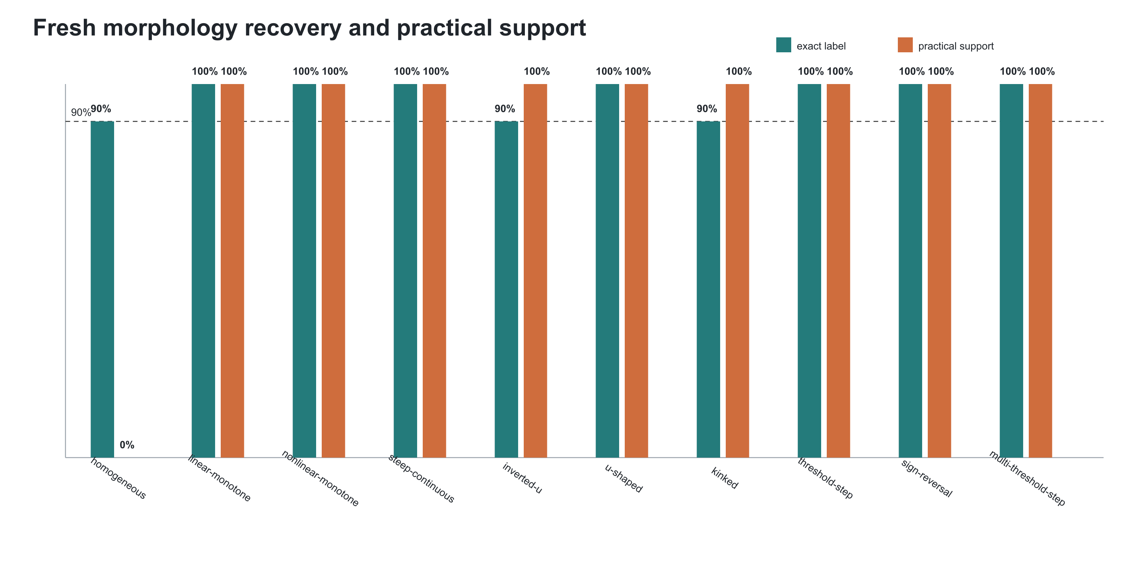
Figure A2. Recovery and practical evidence across the nine situations.
Green bars show the proportion of replications in which the shape name, CATE curve, and required numerical quantities all met the standard. Orange bars show the proportion supported by the test sample. Homogeneous, inverted-U, and kinked effects were completely recovered in 9 of 10 replications; the other six shapes were recovered in all 10. The two sets of bars are generally close, indicating that shapes selected in training are also supported in new data.
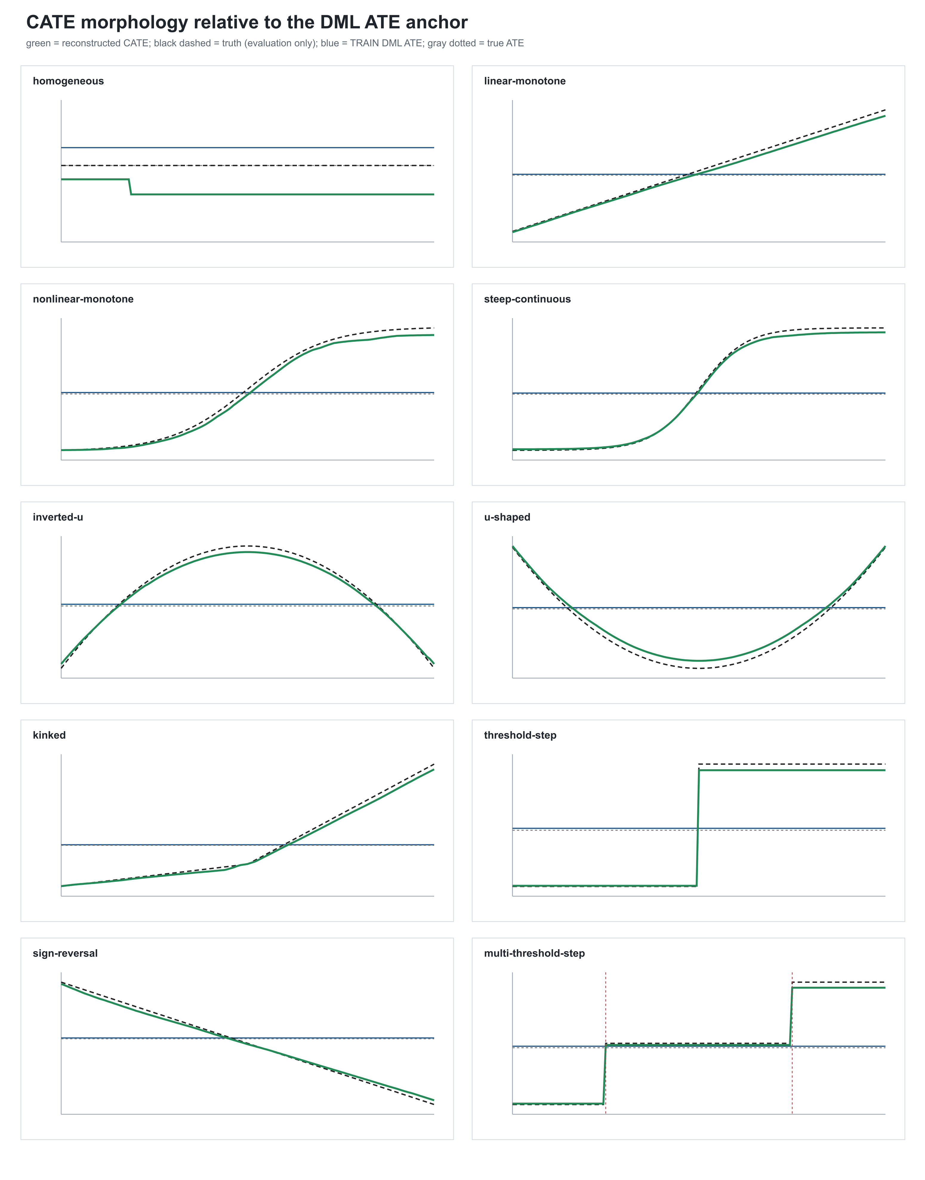
Figure A3. Reconstructed CATE, DML ATE, and simulation truth.
The blue horizontal line is the population ATE estimated by DML, the green curve is the reconstructed CATE, and the black dashed curve is the function used to generate the simulation. The ATE reports one population average. The CATE curve additionally shows effect ordering, sign changes, turning points, kinks, and boundaries. The horizontal axis moves from firms with relatively low values of the characteristic to firms with relatively high values. The figure also includes a multi-threshold step as an additional illustration.

9. Additive coexistence capability
The additive coexistence module examines whether two or three firm characteristics can generate different CATE shapes in the same dataset and still be recovered separately. Each replication continues to fit one causal forest containing all 12 characteristics. During shape reconstruction, the program estimates one component, subtracts it from total CATE, estimates the next component, and repeats these updates until the curves stabilize. The test sample first evaluates the complete model and then removes one component at a time to check whether that component adds explanatory value. The characteristics included in the two- and three-component examples are specified before the run; interactions are not included in this stage.
Example | Component | Morphology | Complete recovery
Two components | Fixed-asset intensity | Inverted U | 18/20 (90%)
Two components | Intangible-asset intensity | U-shaped | 20/20 (100%)
Three components | Change in cash holdings | Sign reversal | 19/20 (95%)
Three components | Change in leverage | U-shaped | 20/20 (100%)
Three components | Intangible-asset intensity | Inverted U | 18/20 (90%)

- In the two-component example, total-CATE accuracy met the standard in all 20 replications. The median Spearman correlation of the component curves was 0.997 and median normalized RMSE was 0.025. In 20 additional simulations with no true heterogeneity, the program did not confirm a false component.
- In the three-component example, total-CATE accuracy met the standard in all 20 replications. The median Spearman correlation of the component curves was 0.993 and median normalized RMSE was 0.025. In 20 additional simulations with no true heterogeneity, one replication confirmed at least one false component, a rate of 5%.
- Every component uses the same requirements as a single-shape simulation: correct shape, accurate curve, accurate numerical quantities, stable repeated estimates, and support in the test sample.
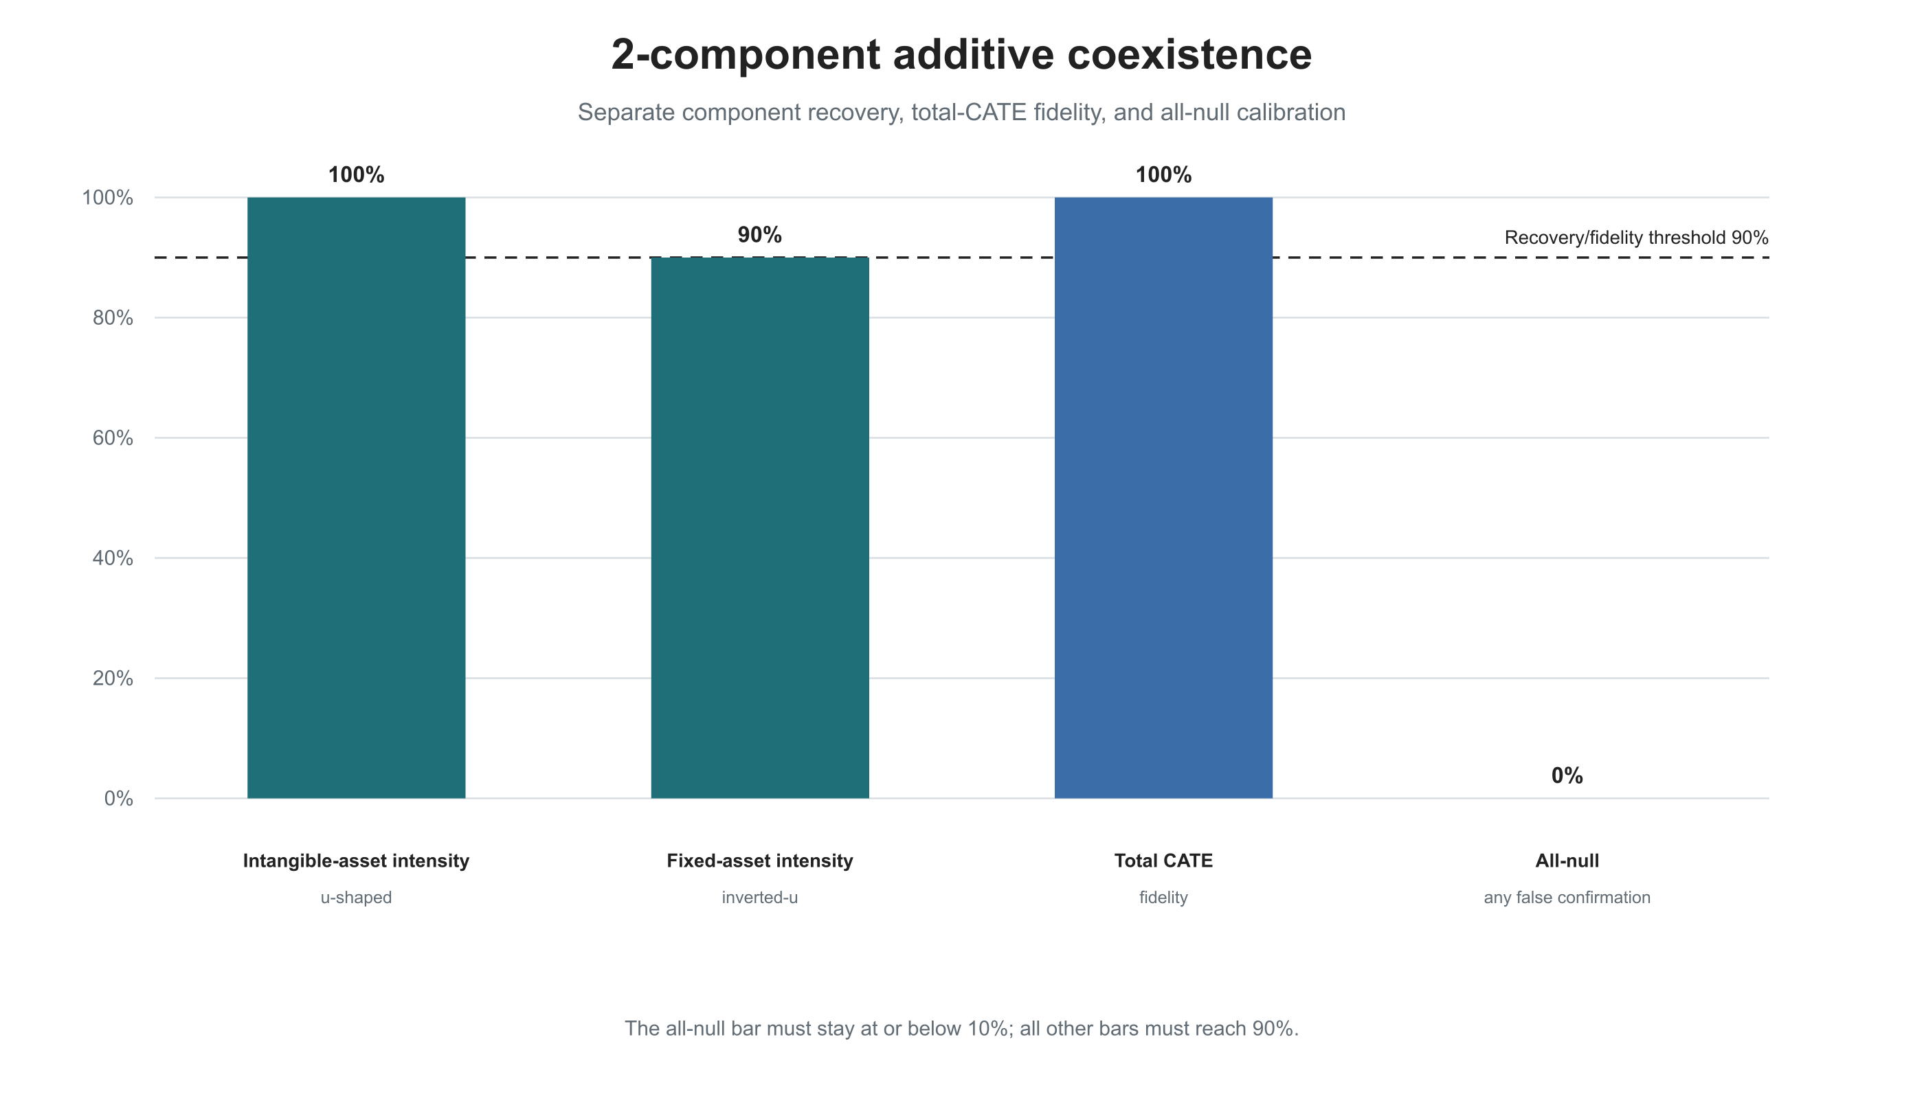
Figure A4. Two-component recovery and all-null control.
The inverted-U shape for fixed-asset intensity was recovered in 18 of 20 replications, and the U shape for intangible-asset intensity was recovered in all 20. Total CATE met the standard in all 20 replications. None of the 20 no-heterogeneity simulations confirmed a false component. The result shows that two prespecified additive sources of heterogeneity can be separated from one CATE surface.
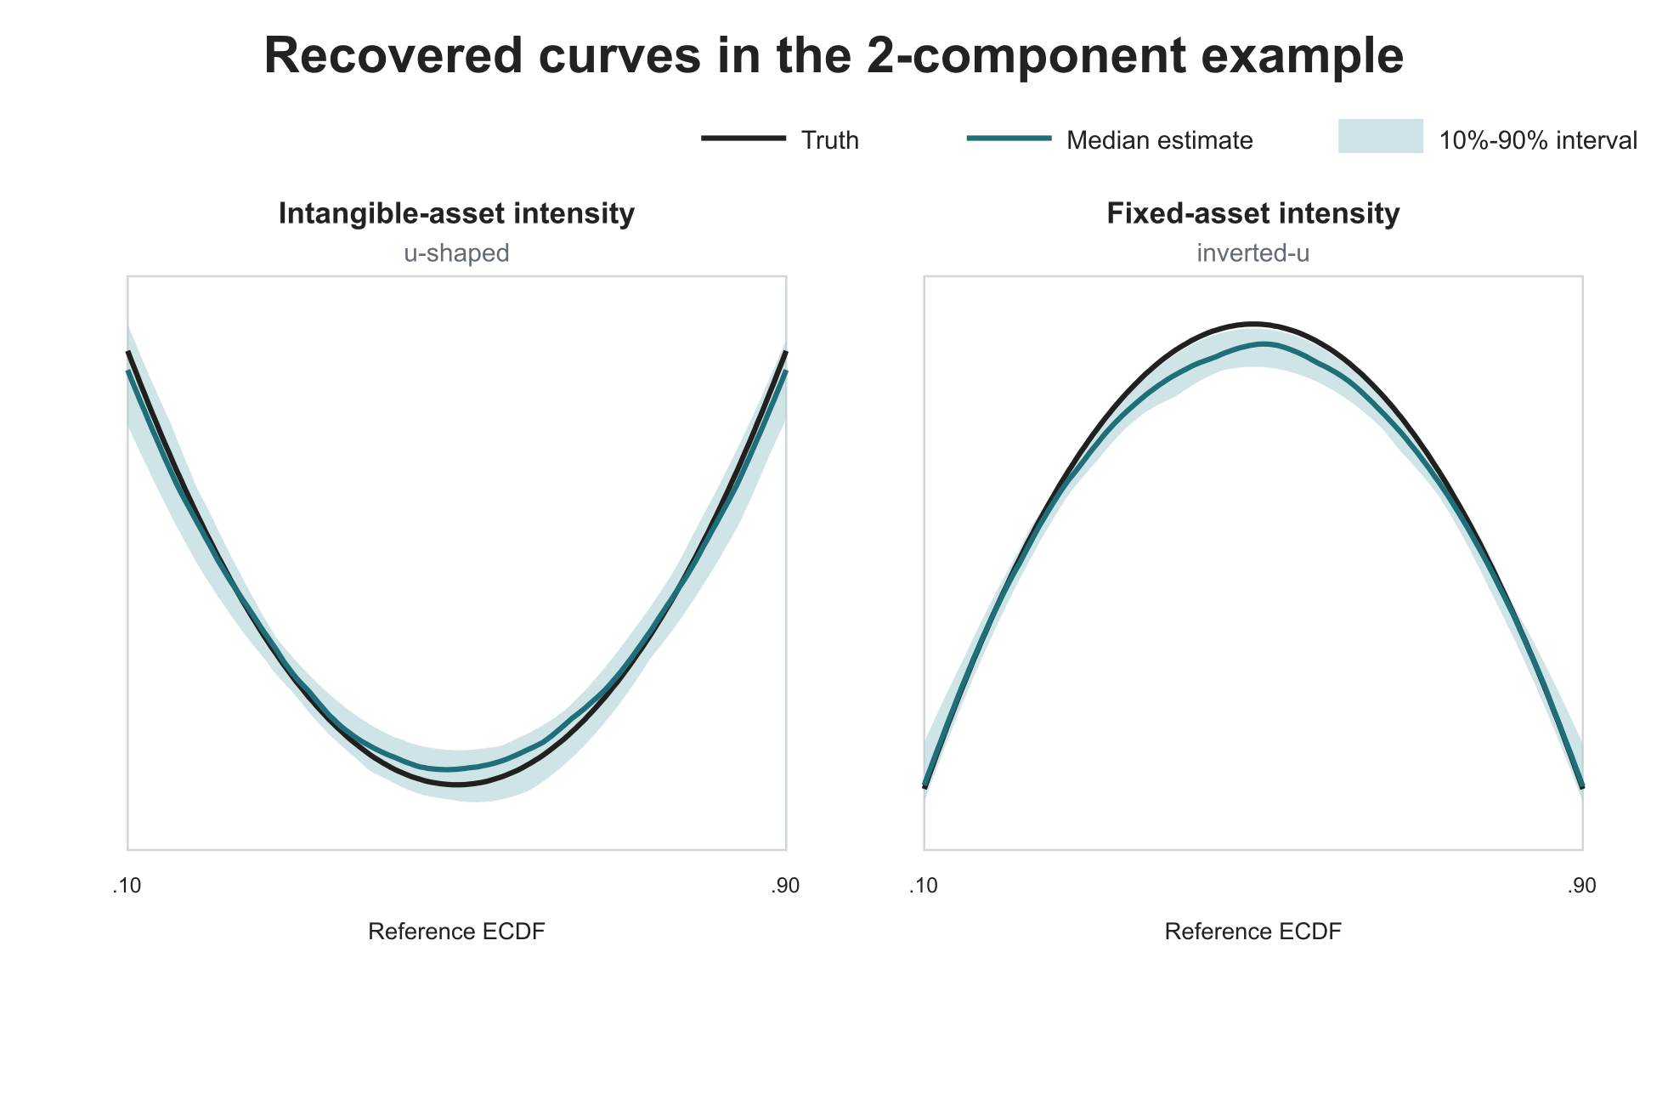
Figure A5. Reconstructed curves in the two-component example.
Black lines show the functions used to generate the simulations, blue-green lines show the median estimates across 20 replications, and shaded areas show the middle 80% of estimates. The U shape for intangible-asset intensity and the inverted U for fixed-asset intensity both follow the generating curves closely. The horizontal axis moves from relatively low to relatively high values of each characteristic.
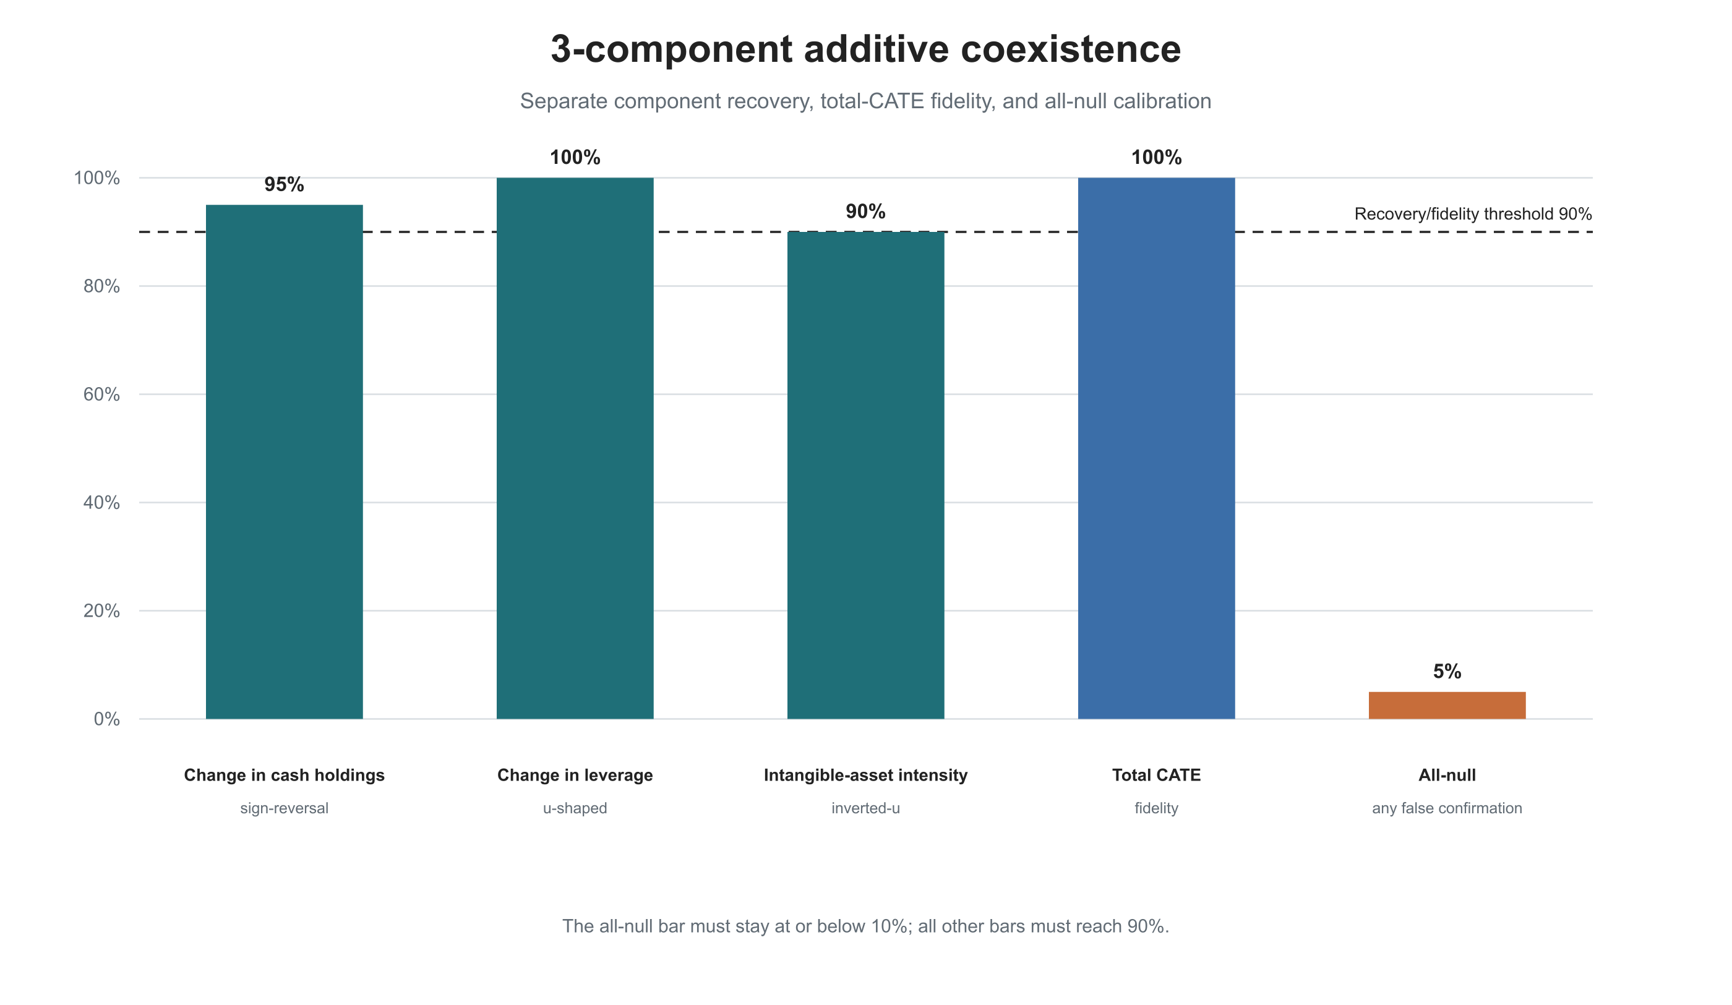
Figure A6. Three-component recovery and all-null control.
The sign reversal for change in cash holdings was recovered in 19 replications, the U shape for change in leverage in all 20, and the inverted U for intangible-asset intensity in 18. Total CATE met the standard in all 20 replications. One of the 20 no-heterogeneity simulations confirmed at least one false component, a 5% rate below the prespecified 10% limit.
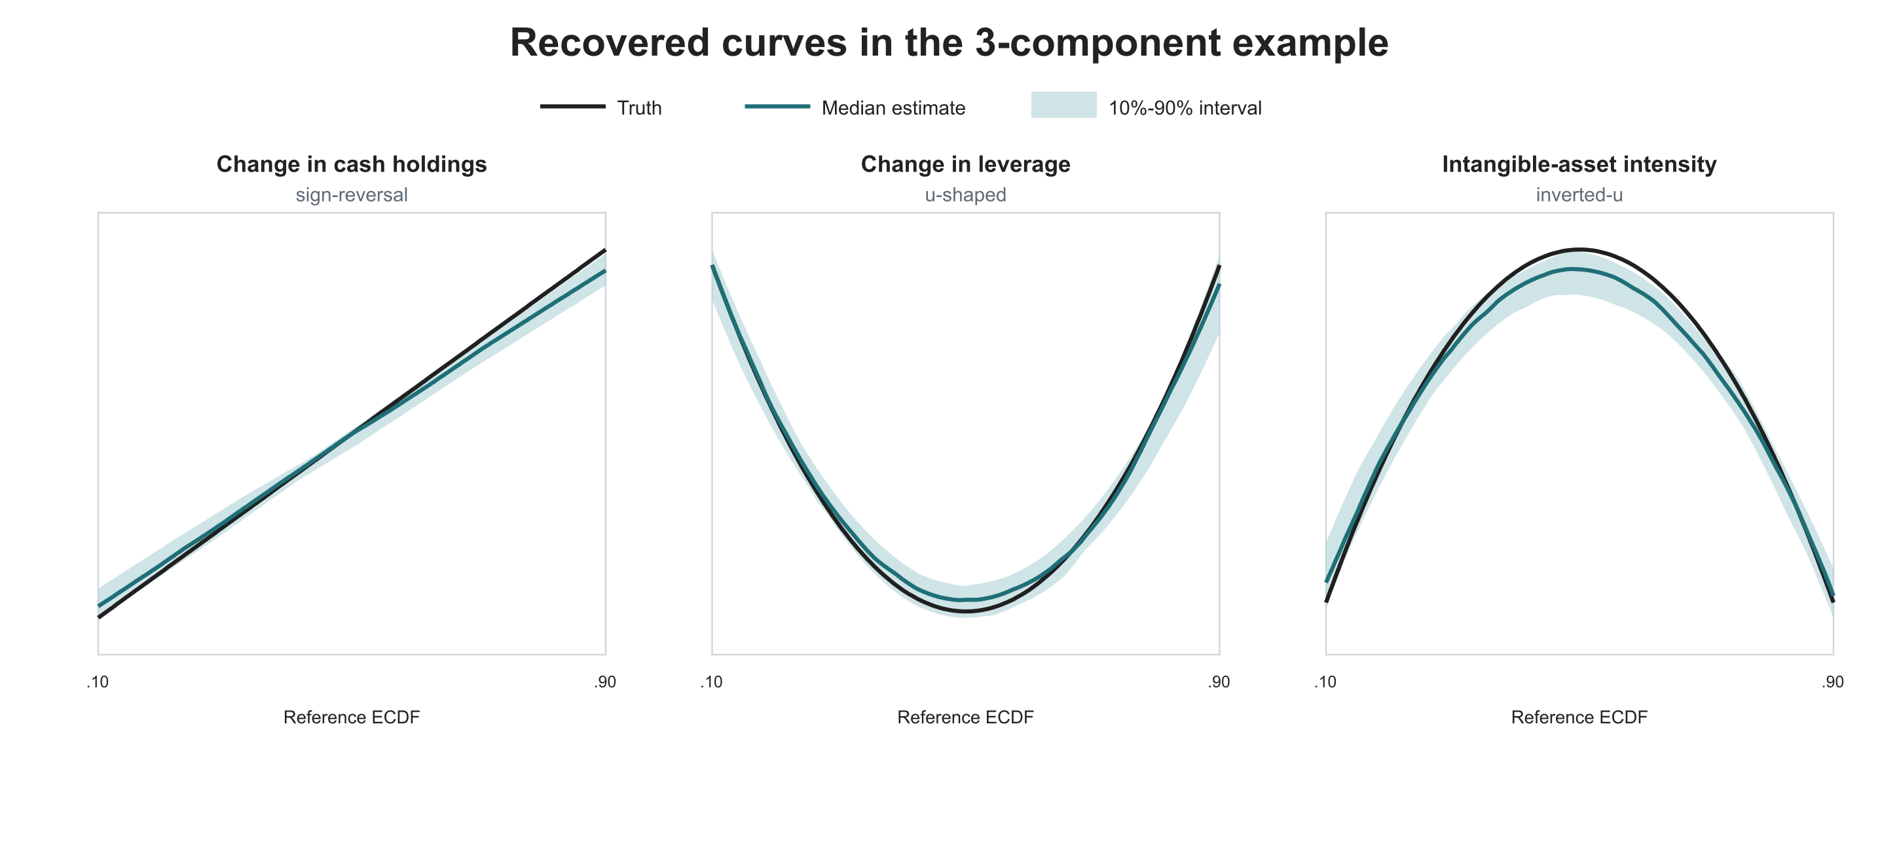
Figure A7. Reconstructed curves in the three-component example.
The three black lines show the functions used to generate each component, and the blue-green lines show the median estimates. The program simultaneously recovers a sign reversal for change in cash holdings, a U shape for change in leverage, and an inverted U for intangible-asset intensity. Under the current sample size and clear-signal design, three prespecified additive sources of heterogeneity can be recovered separately.

10. Software, code locations, and reproduction
The table links each step to its software package, code file, and main output. The repository also records configuration files, random seeds, and SHA256 checks for inputs and outputs. The end-to-end command starts from the firm-characteristic data, generates T and Y again, estimates DML-ATE, fits the nine causal forests, reconstructs shapes, and writes statistical tables, figures, reports, and a run manifest.
Research step | Package | Code file | Main output
Firm data and simulation | pandas 3.0.5; NumPy 2.5.2 | simulation_runner_v2/src/simulation_runner_v2.py | Firm sample, relative positions, T, Y(0), Y(1), and Y
DML-ATE | scikit-learn 1.6.1; SciPy 1.18.1 | src/orgcate_sim/ate.py | Five-fold predictions
CATE learner | EconML 0.17.0 | execution/run_unified_morphology_v2.py | One joint CausalForestDML and CATE predictions
CATE shape selection | NumPy; scikit-learn KFold | execution/run_unified_morphology_v2.py | Candidate functions, parameter comparison, and shape decision
Result checks | SciPy Spearman; pandas | src/orgcate_sim/morphology_acceptance.py | Curve and numerical-feature checks
End-to-end run | Python CLI | src/orgcate_sim/public_demo.py | Tables, figures, report, and run manifest
Fixed-effects comparison | NumPy, SciPy, pandas | src/orgcate_sim/fixed_effects_comparison.py | Nine-situation FE/DML/CATE table and figure
Optional theory development | Research LLM chosen by the researcher | optional_theory_development/PROMPT.md | Mechanisms, propositions, and next evidence

The current workflow provides a complete path from DML estimation of the population average effect to one joint causal forest, firm-level treatment-effect differences, CATE shapes and numerical features, and confirmation on an independent test sample. The single-shape study covers all nine situations, and the two- and three-component studies show that several clear additive sources of heterogeneity can be recovered separately in one dataset. The optional final module converts a supported empirical pattern into a transparent prompt for mechanism comparison, proposition development, and literature-guided follow-up research.

11. Optional LLM-assisted theory development
The final module translates a supported statistical result into a structured theory-development task. It is optional and begins only after DML-ATE, the causal forest, morphology reconstruction, and independent confirmation have produced an interpretable result. The model receives estimated quantities from the analysis, not simulation answers. The researcher defines the substantive treatment, outcome, population, period, and organizational meaning of the focal characteristic.
11.1 Complete prompt framework and worked example
1. How to use this file
This file serves two purposes:
1. The worked example shows how an estimated CATE morphology can be translated into a theory-development prompt.
2. The reusable template can be applied to a different treatment, outcome, population, focal characteristic, or morphology.
In the reusable template, every item that the researcher must replace is shown in bold square brackets. The text following “Example” demonstrates the level of specificity expected; it is not part of the general template.
The language model receives estimated results from the analysis workflow, not data-generating truth. DML supplies the average treatment effect, one multivariable causal forest supplies the focal heterogeneity signal and firm-level CATE estimates, orthogonal morphology reconstruction supplies the functional form and its parameters, and the untouched test sample supplies independent confirmation.
2. Worked example
Substantive inputs
- Treatment: Formal deployment of an AI-enabled strategic decision-support system in 2021 (1 = deployed, 0 = not deployed).
- Outcome: Standardized innovation productivity during 2022-2024, defined as quality-adjusted patent output relative to R&D expenditure.
- Population and period: U.S. publicly listed manufacturing and knowledge-intensive business-service firms observed from 2018 through 2024; 2018-2020 supplies pre-treatment firm characteristics.
- Focal firm characteristic: Relative position u in the pre-adoption total-asset distribution. u=.10 represents relatively small firms, u=.50 the middle, and u=.90 relatively large firms.
Estimated analysis output
Analysis stage | Estimated output | Organizational interpretation
DML | ATE = .9246; 95% CI = [.8210, 1.0283] | AI deployment increases the standardized outcome by about .925 units on average.
DML-ATE/CATE check | TRAIN-target CATE mean = .9966; standardized gap = .0572; threshold = .10; result = PASS | The two estimates target the same firms and are sufficiently aligned to continue the morphology analysis.
Causal forest | Relative firm-size importance = .6573; rank = 1 of 12 | Firm size is the leading heterogeneity signal in this analysis.
Test-sample CATE | Mean = .8772; SD = .9876; P10 = -.7369; median = 1.2560; P90 = 1.9005 | The positive average effect conceals substantial cross-firm variation.
Reconstructed morphology | Inverted U: tau_hat(u) = 1.9296 - 13.1243(u-.50)^2 | The curve rises and then falls; the quadratic coefficient is -13.1243.
Peak and curvature | Peak at u=.50; curvature = -26.2485 | Estimated gains are greatest near the middle of the size distribution.
Refit stability | Curvatures = -26.5643, -26.2485, -26.6378; median = -26.5643 | All three refits imply closely aligned concavity.
Point effects | At u=.10/.25/.50/.75/.90: -.1703/1.1093/1.9296/1.1093/-.1703 | Effects rise from smaller firms to the middle and then decline.
Arm-specific quantities | Peak-minus-endpoint contrasts = 2.0999/2.0999; average slopes below/above peak = +5.2497/-5.2497 | Both the rising and declining arms are substantively large.
Independent confirmation | 3 of 3 refits pass test-sample confirmation; cross-refit curve agreement = .999997 | The pattern remains stable across repeated fitting and held-out evidence.
The function and its coefficients are outputs of orthogonal morphology reconstruction after the causal forest. They are not direct coefficients from the forest. Simulation truth, oracle accuracy metrics, and preassigned active-variable labels are excluded.
3. Reusable prompt template with example entries
Copy the block below. Replace each bold bracketed field while preserving the headings and task structure.
Role
Act as an Organization Science scholar specializing in [RESEARCH DOMAIN. Example: artificial intelligence, organization design, and innovation]. Use abductive theory development to explain an empirically estimated pattern of treatment-effect heterogeneity, compare plausible organizational mechanisms, and derive propositions that can be tested in subsequent research.
Study setting
- Treatment: [DEFINE THE SUBSTANTIVE INTERVENTION, ITS TIMING, AND CODING. Example: formal deployment of an AI-enabled strategic decision-support system in 2021; 1 = deployed, 0 = not deployed]
- Outcome: [DEFINE THE OUTCOME, MEASUREMENT WINDOW, AND UNIT. Example: standardized innovation productivity during 2022-2024, measured as quality-adjusted patent output relative to R&D expenditure]
- Population and period: [DEFINE INDUSTRIES, COUNTRY OR REGION, SAMPLE, AND YEARS. Example: U.S. publicly listed manufacturing and knowledge-intensive business-service firms observed from 2018 through 2024, with 2018-2020 as the pre-treatment period]
- Focal characteristic: [DEFINE THE ORGANIZATIONAL CHARACTERISTIC AND ITS SCALE. Example: relative pre-adoption firm size `u`, measured by position in the total-asset distribution]
Estimated analytical result
- DML average effect: [ENTER THE ESTIMATED ATE, STANDARD ERROR OR CONFIDENCE INTERVAL, AND OUTCOME UNIT. Example: ATE = .9246 standardized units; 95% CI [.8210, 1.0283]]
- DML-ATE/CATE check: [ENTER THE TRAIN-TARGET CATE MEAN, STANDARDIZED GAP, PRE-SPECIFIED THRESHOLD, AND RESULT. Example: TRAIN-target CATE mean = .9966; standardized gap = .0572; threshold = .10; result = PASS]
- Causal-forest signal: [ENTER THE FOCAL CHARACTERISTIC, ITS IMPORTANCE OR RANK, AND THE NUMBER OF CANDIDATE CHARACTERISTICS. Example: relative firm size ranks 1st among 12 characteristics; importance = .6573]
- Held-out CATE distribution: [ENTER THE MEAN, DISPERSION, AND RELEVANT QUANTILES. Example: mean = .8772, SD = .9876, P10 = -.7369, median = 1.2560, P90 = 1.9005]
- Selected morphology: [ENTER THE ESTIMATED FUNCTIONAL FORM AND EQUATION. Example: inverted U, `tau_hat(u) = 1.9296 - 13.1243(u-.50)^2`]
- Key morphology parameters: [ENTER ALL PARAMETERS NEEDED TO INTERPRET THIS SHAPE. Depending on the morphology, these may include slopes, curvature, turning point, zero crossing, kink location, threshold location, band effects, or two-side contrasts. Example: peak at `u=.50`, curvature = `-26.2485`, peak-minus-endpoint contrasts = `2.0999/2.0999`, average slopes below/above the peak = `+5.2497/-5.2497`]
- Representative CATE values: [ENTER ESTIMATED EFFECTS AT SUBSTANTIVELY MEANINGFUL POSITIONS. Example: at `u=.10/.25/.50/.75/.90`, CATE = `-.1703/1.1093/1.9296/1.1093/-.1703`]
- Stability and independent confirmation: [ENTER REFIT STABILITY AND HELD-OUT CONFIRMATION RESULTS. Example: 3 of 3 refits pass test-sample confirmation; cross-refit curve agreement = .999997]
Use the theory-development tasks only when the DML-ATE/CATE check passes and the morphology result is supported by the analysis workflow. Treat these estimated quantities as the empirical phenomenon to explain. Keep the statistical pattern separate from the theoretical mechanisms proposed to explain it. Variable importance identifies a focal characteristic; it does not itself establish an organizational mechanism.
Research question
[STATE THE ORGANIZATIONAL QUESTION IMPLIED BY THE ESTIMATED MORPHOLOGY. Example: Why does deployment of an AI-enabled strategic decision-support system produce its largest innovation-productivity gains among medium-sized firms, with weaker or negative gains toward both ends of the firm-size distribution?]
Tasks
1. Define the theoretical phenomenon in 150-200 words. Explain what is organizationally consequential about the difference between the average treatment effect and the estimated CATE pattern. Keep statistical evidence and theoretical interpretation distinct.
2. Search peer-reviewed literature published since [LITERATURE START YEAR. Example: 2018], adding a small number of foundational studies when necessary. Prioritize Organization Science, Academy of Management Journal, Academy of Management Review, Administrative Science Quarterly, Strategic Management Journal, Management Science, and other UTD journals or authoritative journals in organization and management research.
3. Develop four to six theoretically distinguishable organizational mechanisms that could produce the estimated morphology. For each mechanism, specify the focal constructs, causal chain, explanation for each segment or region of the curve, observable mediator, boundary conditions, and at least one prediction that distinguishes it from the alternatives.
4. Select the two mechanisms that most completely explain the estimated pattern. State whether they compete, complement one another, or operate at different levels of analysis. Translate them into two to four testable propositions. Each proposition must identify the treatment, outcome, relevant range or region of the focal characteristic, expected direction, and theoretical mechanism.
5. Propose follow-up evidence that can distinguish the selected mechanisms. Include at least one mediation test, one additional boundary condition, and organizational- or individual-level variables that should be collected.
6. Return four sections: Phenomenon statement, Mechanism-comparison table, Propositions, and Next evidence. The comparison table must include theoretical lens, focal constructs, shape-specific explanatory logic, key literature, observable prediction, and data needed.
7. For every reference, provide authors, year, title, journal, DOI, and publisher webpage. Verify every source before including it and omit references that cannot be verified.
4. Suggested output structure
A. Phenomenon statement
A concise account of the average effect, heterogeneous pattern, focal organizational characteristic, and theoretical puzzle.
B. Mechanism-comparison table
Theoretical lens | Focal constructs | Why it produces the estimated shape | Mediator | Boundary condition | Distinguishing prediction | Key sources
C. Propositions
Two to four propositions that connect the treatment, outcome, focal characteristic, estimated region of the curve, and organizational mechanism.
D. Next evidence
The empirical evidence needed to adjudicate between the leading explanations.
5. Execution record
Use a multi-source research model such as ChatGPT Deep Research. Record the visible model name, run date, complete prompt, complete response, and source list. The researcher remains responsible for checking the literature, judging theoretical coherence, and deciding which explanation merits formal development and testing.
11.2 Worked model output
The following output is the worked example produced from the prompt above. It is included to show the form of the theory-development handoff; substantive claims remain subject to researcher review and literature verification.
AI-ASSISTED STRATEGIC DECISION-MAKING AND INNOVATION PRODUCTIVITY
AN ABDUCTIVE THEORY DEVELOPMENT BRIEF | ENGLISH EDITION
Population: U.S. publicly listed manufacturing and knowledge-intensive business service firms Study window: 2018–2024 | Treatment year: 2021
01 Empirical Phenomenon
Among U.S. publicly listed manufacturing and knowledge-intensive business service firms observed during 2018–2024, the DML-estimated average treatment effect of formally deploying AI-assisted strategic decision systems in 2021 on innovation productivity in 2022–2024 is 0.9246 standardized units (95% CI: [0.8210, 1.0283]).
A causal forest ranks pretreatment relative firm size (u) first among 12 candidate heterogeneity predictors (variable importance = 0.6573). A training-only reconstruction, confirmed in held-out data, identifies an inverted-U pattern: the estimated treatment effect peaks at u = 0.50 (1.9296) and declines to approximately −0.1703 at u = 0.10 and u = 0.90.
These estimates establish a phenomenon to explain, not its organizational cause. Variable importance does not identify a mechanism, and replication of a fitted functional form does not establish why the pattern exists. The theoretical puzzle is why medium-sized firms appear best positioned to turn AI-assisted strategic decisions into innovation productivity.
02 Competing Organizational Mechanisms
Two complementary—but empirically distinguishable—mechanisms are proposed:
A KNOWLEDGE RECOMBINATION CONVERTIBILITY B ATTENTION–DECISION AUTHORITY ALIGNMENT
COMPARATIVE MECHANISM MATRIX ································
01 Theoretical Lens
A Knowledge-based view; organizational search; hybrid problem-solving B Attention-based view; organization design; innovation selection
02 Core Constructs
A Knowledge coverage; interoperability; technical validation B Managerial attention; authority clarity; resource-allocation friction
03 Causal Pathway
A AI deployment → wider strategic search → knowledge recombination → viable innovations → higher productivity B AI deployment → strategic recommendations → managerial attention → approval and execution → higher productivity
04 Why Returns Rise Among Smaller Firms
A Small firms initially lack expertise and validation capacity; increasing size makes AI insights more convertible B Small firms initially lack specialized evaluation capabilities; increasing size strengthens informed adoption
05 Why Returns Fall Among Larger Firms
A Knowledge fragmentation, incompatible systems, and cross-unit integration costs undermine gains B Agenda competition, approval delays, and resource-allocation conflicts hinder implementation
06 Observable Mediators
A Validated recombination rate; technical feasibility; knowledge-transfer costs B Recommendation adoption rate; funding approval; decision latency; veto counts
07 Boundary Conditions
A Data interoperability; modular R&D architecture B Decision authority clarity; cross-unit innovation governance
08 Distinguishing Prediction
A Knowledge integration explains AI gains even after accounting for decision friction B Decision friction explains AI gains even after accounting for knowledge quality
09 Data Requirements
A IT architecture; R&D knowledge structures; AI recommendation and project logs B Organizational charts; decision records; budget approvals; employee surveys
10 Key References
A [1]–[3] B [4]–[9]
The mechanisms can operate jointly, but they generate competing empirical predictions. Mechanism A explains whether AI recommendations become technically valuable innovation opportunities; Mechanism B explains whether those opportunities receive attention, resources, and execution. Their relative explanatory power may differ across firm-size ranges.
A relevant counterpoint is Babina et al. (2024) [10], who find that broader AI investment can disproportionately stimulate product innovation in larger firms. The present theory therefore concerns the incremental effect of AI-assisted strategic decision systems on quality-adjusted innovation productivity, not the universal impact of AI on innovation.
03 Testable Theoretical Propositions
P1 KNOWLEDGE CONVERTIBILITY AND THE ASCENDING SEGMENT
Among firms with pretreatment size ranks u in [0.10, 0.50], the positive effect of 2021 AI deployment, relative to nondeployment, on 2022–2024 innovation productivity increases with firm size. The mechanism is a larger stock of usable expertise and stronger cross-domain knowledge-recombination and validation capabilities.
P2 DECISION FRICTION AND THE DESCENDING SEGMENT
Among firms with u in [0.50, 0.90], the effect of 2021 AI deployment, relative to nondeployment, on 2022–2024 innovation productivity weakens with increasing firm size and may become nonpositive at the upper end. The mechanism is growing managerial attention competition, hierarchical approval delays, and resource-allocation conflict.
P3 KNOWLEDGE INTEROPERABILITY AS A MODERATOR
Among large firms with u in [0.75, 0.90], higher pretreatment knowledge interoperability makes the treatment effect of 2021 AI deployment on 2022–2024 innovation productivity more favorable and attenuates the right-side decline. The mechanism is lower cross-unit knowledge-integration cost.
P4 DECISION AUTHORITY AS A MODERATOR
Among large firms with u in [0.75, 0.90], clearer pretreatment professional decision authority and cross-unit budget coordination make the treatment effect of 2021 AI deployment on 2022–2024 innovation productivity more favorable and attenuate the right-side decline. The mechanism is more effective AI-recommendation adoption and execution.
All propositions concern conditional treatment effects (deployment versus nondeployment), not the direct association between firm size and innovation.
04 Next Evidence
4.1 TEST COMPETING MEDIATORS
Measure M_A as the share of cross-domain AI recommendations technically validated and converted into R&D projects; measure M_B as the share of formally reviewed AI recommendations receiving committed implementation resources. Assess whether these pathways differentially explain treatment-effect heterogeneity. Where feasible, link 2021–2022 process measures to 2023–2024 outcomes and use longitudinal causal mediation methods with sensitivity analysis for posttreatment confounding.
4.2 INTRODUCE A NEW BOUNDARY CONDITION
Measure pretreatment cross-unit task interdependence. Mechanism A predicts a stronger knowledge-integration bottleneck when interdependence is high. Mechanism B predicts that the productivity consequences hinge primarily on coordination structures and the alignment of expertise with decision authority.
4.3 COLLECT MULTILEVEL ORGANIZATIONAL EVIDENCE
At the firm level, collect data standards, R&D knowledge dispersion, hierarchy, and approval rights. At the project level, collect AI recommendation quality, knowledge combinations, funding approvals, and cycle times. At the employee level, measure practices for questioning AI, perceived autonomy, cross-unit collaboration, and responsibility clarity. A 2 × 2 business-unit field experiment crossing knowledge-integration support with decision-authority reform could distinguish independent and complementary effects.
4.4 IDENTIFICATION AND INTERPRETATION
The fitted quadratic's symmetry around u = 0.50 is partly imposed by its functional form; it is not independent evidence of symmetric organizational mechanisms. The negative point estimates at the size extremes require local uncertainty estimates before being treated as statistically established. Follow-up work should allow asymmetric nonlinearities and test pretreatment trends, treatment overlap, patent-outcome timing, and mediator-outcome confounding.
05 Verified Peer-Reviewed References
Bibliographic years refer to journal issue years; some articles appeared online earlier.
[1] Raisch, Sebastian, and Kateryna Fomina (2025). “Combining Human and Artificial Intelligence: Hybrid Problem-Solving in Organizations.” Academy of Management Review, 50(2), 441-464. DOI: 10.5465/amr.2021.0421 Publisher: https://journals.aom.org/doi/full/10.5465/amr.2021.0421
[2] Boussioux, Leonard, Jacqueline N. Lane, Miaomiao Zhang, Vladimir Jacimovic, and Karim R. Lakhani (2024). “The Crowdless Future? Generative AI and Creative Problem-Solving.” Organization Science, 35(5), 1589-1607. DOI: 10.1287/orsc.2023.18430 Publisher: https://pubsonline.informs.org/doi/full/10.1287/orsc.2023.18430
[3] Waardenburg, Lauren, Marleen Huysman, and Anastasia V. Sergeeva (2022). “In the Land of the Blind, the One-Eyed Man Is King: Knowledge Brokerage in the Age of Learning Algorithms.” Organization Science, 33(1), 59-82. DOI: 10.1287/orsc.2021.1544 Publisher: https://pubsonline.informs.org/doi/10.1287/orsc.2021.1544
[4] Raisch, Sebastian, and Sebastian Krakowski (2021). “Artificial Intelligence and Management: The Automation-Augmentation Paradox.” Academy of Management Review, 46(1), 192-210. DOI: 10.5465/amr.2018.0072 Publisher: https://journals.aom.org/doi/abs/10.5465/amr.2018.0072
[5] Ocasio, William, Tomi Laamanen, and Eero Vaara (2018). “Communication and Attention Dynamics: An Attention-Based View of Strategic Change.” Strategic Management Journal, 39(1), 155-167. DOI: 10.1002/smj.2702 Publisher: https://sms.onlinelibrary.wiley.com/doi/full/10.1002/smj.2702
[6] Keum, Dongil D., and Kelly E. See (2017). “The Influence of Hierarchy on Idea Generation and Selection in the Innovation Process.” Organization Science, 28(4), 653-669. DOI: 10.1287/orsc.2017.1142 Publisher: https://pubsonline.informs.org/doi/abs/10.1287/orsc.2017.1142
[7] Lebovitz, Sarah, Hila Lifshitz-Assaf, and Natalia Levina (2022). “To Engage or Not to Engage with AI for Critical Judgments: How Professionals Deal with Opacity When Using AI for Medical Diagnosis.” Organization Science, 33(1), 126-148. DOI: 10.1287/orsc.2021.1549 Publisher: https://pubsonline.informs.org/doi/abs/10.1287/orsc.2021.1549
[8] Kocak, Ozgecan, Daniel A. Levinthal, and Phanish Puranam (2023). “The Dual Challenge of Search and Coordination for Organizational Adaptation: How Structures of Influence Matter.” Organization Science, 34(2), 851-869. DOI: 10.1287/orsc.2022.1601 Publisher: https://pubsonline.informs.org/doi/10.1287/orsc.2022.1601
[9] Bottcher, Lucas, and Ronald Klingebiel (2025). “Organizational Selection of Innovation.” Organization Science, 36(1), 387-410. DOI: 10.1287/orsc.2023.17357 Publisher: https://pubsonline.informs.org/doi/10.1287/orsc.2023.17357
[10] Babina, Tania, Anastassia Fedyk, Alex He, and James Hodson (2024). “Artificial Intelligence, Firm Growth, and Product Innovation.” Journal of Financial Economics, 151, 103745. DOI: 10.1016/j.jfineco.2023.103745 Publisher: https://www.sciencedirect.com/science/article/pii/S0304405X2300185X
Central Theoretical Contribution
AI-assisted strategic decision-making may yield the greatest innovation productivity gains when firms possess sufficient knowledge-conversion capabilities without incurring excessive coordination and decision-execution costs. Medium-sized firms may occupy this configuration more frequently, but the proposed causal explanation rests on organizational mechanisms rather than firm size itself.

References
Athey, S., Tibshirani, J., & Wager, S. (2019). Generalized random forests. The Annals of Statistics, 47(2), 1148–1178.
Chernozhukov, V., Chetverikov, D., Demirer, M., Duflo, E., Hansen, C., Newey, W., & Robins, J. (2018). Double/debiased machine learning for treatment and structural parameters. The Econometrics Journal, 21(1), C1–C68.
Haans, R. F. J., Pieters, C., & He, Z.-L. (2016). Thinking about U: Theorizing and testing U- and inverted U-shaped relationships in strategy research. Strategic Management Journal, 37(7), 1177–1195.
Morris, T. P., White, I. R., & Crowther, M. J. (2019). Using simulation studies to evaluate statistical methods. Statistics in Medicine, 38(11), 2074–2102.
Simonsohn, U. (2018). Two lines: A valid alternative to the invalid testing of U-shaped relationships with quadratic regressions. Advances in Methods and Practices in Psychological Science, 1(4), 538–555.
Wager, S., & Athey, S. (2018). Estimation and inference of heterogeneous treatment effects using random forests. Journal of the American Statistical Association, 113(523), 1228–1242.

