# Add code to GitHub with git

1. I launch the command prompt git
2. I go to the directory where is my code



1. Then I do “git init” to initialize a local Git repository
2. I run “git add .” to add all the files to the repository
3. Then to commit the change to the repository I do

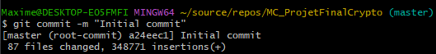

1. We rename the branch main
2. Then we push it to the link of the remote repository in GitHub

