Assignment 1: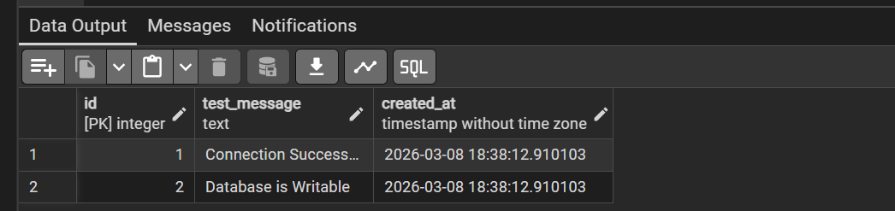

Assignment 2:
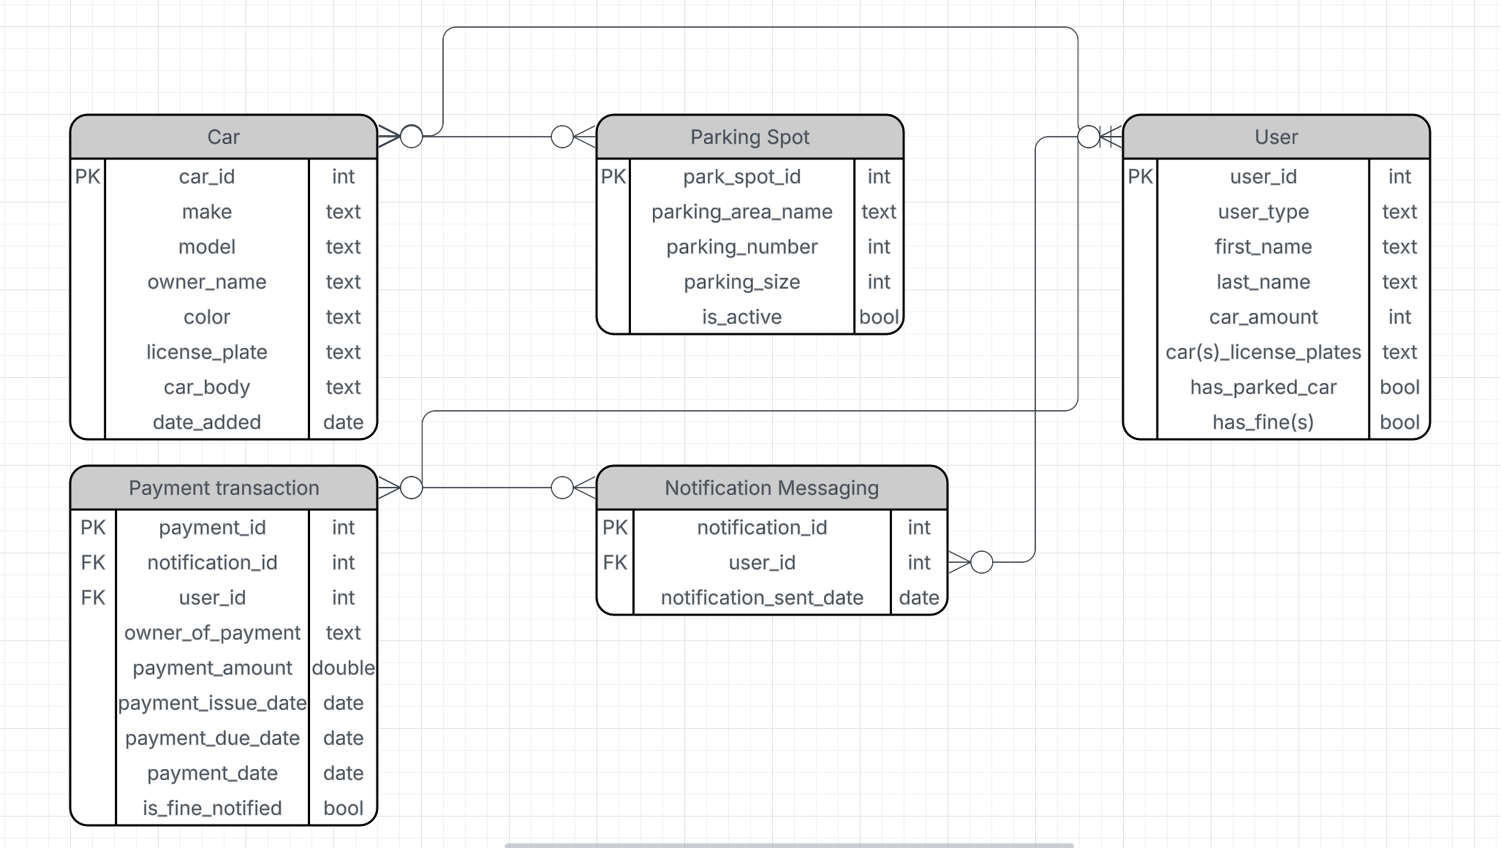
I included for example the relationship between Car and User as many:one because users can have as many cars as their pockets permit while cars can only belong to only one owner. I included a primary key (PK) on every table and made it simple enough to the point where it made sense. For example, for the Parking Spot table, I made the PK as the parking_spot_id, something that gets added as you add a car onto the table, it increments with the addition of every car, and something that will never change nor is duplicated. I included the two foreign keys in payment transactions because when we make a payment transaction, we want to know exactly who the notification was sent to after the payment and the specific notification by id.

