Steps to take
Step 1:
Start by running the docker container using the credentials from the .yml file and login in to the localhost on the computer and then navigate to UMBC Parking System -> Databases -> parking_system

Step 2:
Open a new Query Tool by UMBC Parking System -> Databases -> parking_system then double-clicking on parking_system and scrolling until you find Query Tool and then click it.

Step 3:
DROP TABLE IF EXISTS smoke_test2;
- Run this command to delete the previous smoke_test run I had from Part 1 of this project
- Delete/comment the smoke_test drop code, then copy all the code from createDDL.sql and paste it. After pasting it highlight it and press the 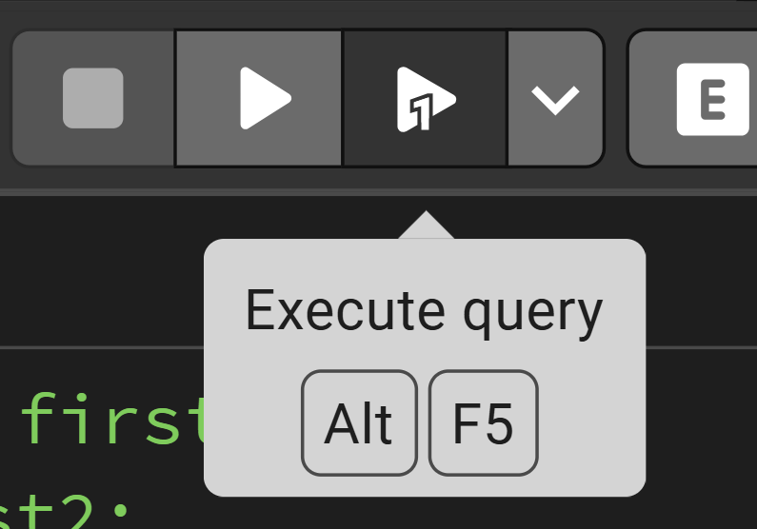 Execute query button then press continue.

Step 4:
- Now Delete/comment the code from createDDL.sql and then copy all the code from loadAll.sql and then paste it into the Query Tool and then select it and click the Execute query button and press continue.

Step 5:
SELECT count(*) AS total_users FROM users;
- Should return 10.
SELECT count(*) AS total_spots FROM spots;
- Should return 10.
SELECT count(*) AS total_tickets FROM tickets;
- Should return 10.

Step 6:
SELECT u.full_name, v.license_plate, l.lot_name, s.spot_number
FROM users u
JOIN vehicles v ON u.user_id = v.owner_id
JOIN reservations r ON u.user_id = r.user_id
JOIN spots s ON r.spot_id = s.spot_id
JOIN lots l ON s.lot_id = l.lot_id;
- Join the table and display which user is parked in which lot

Step 7:
SELECT license_plate, violation_reason, amount
FROM tickets
WHERE is_paid = FALSE;
- Show users who haven’t paid their tickets

Sanity Check

