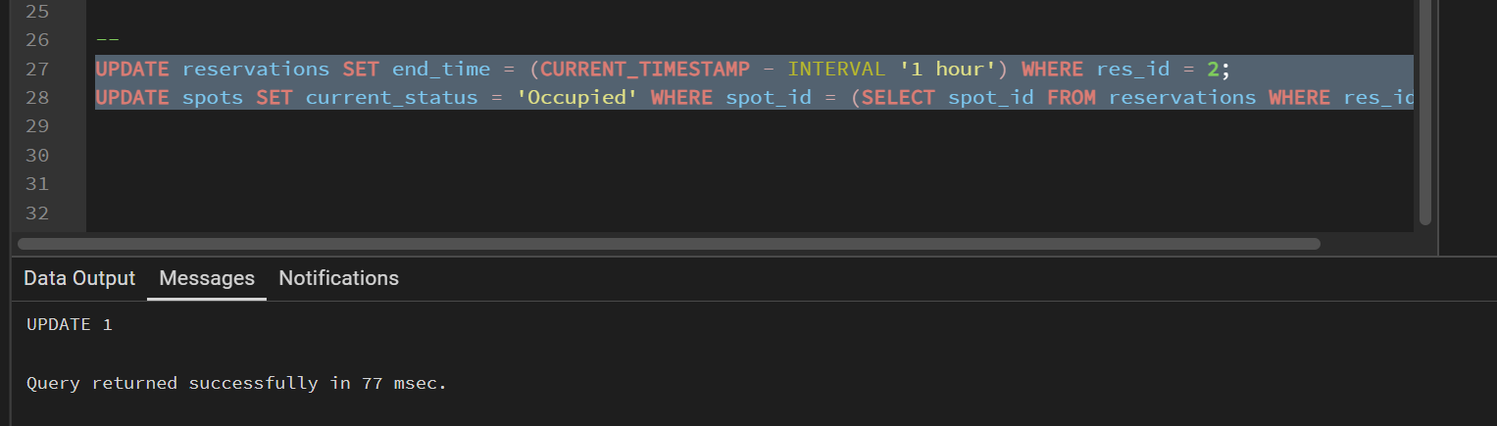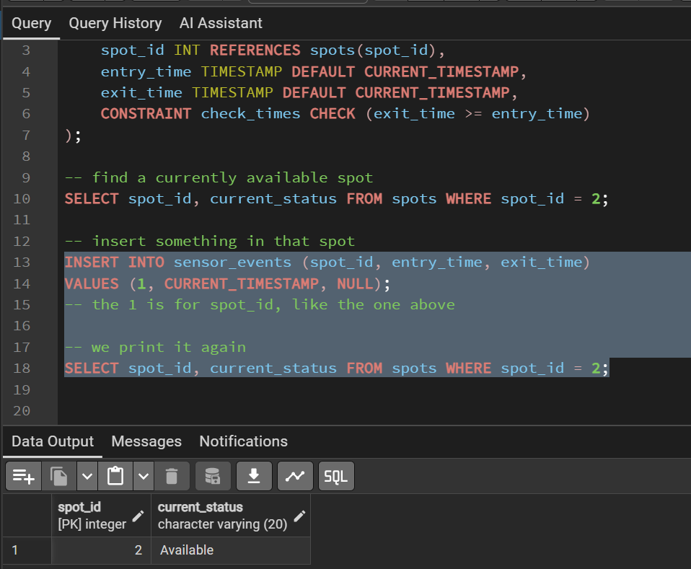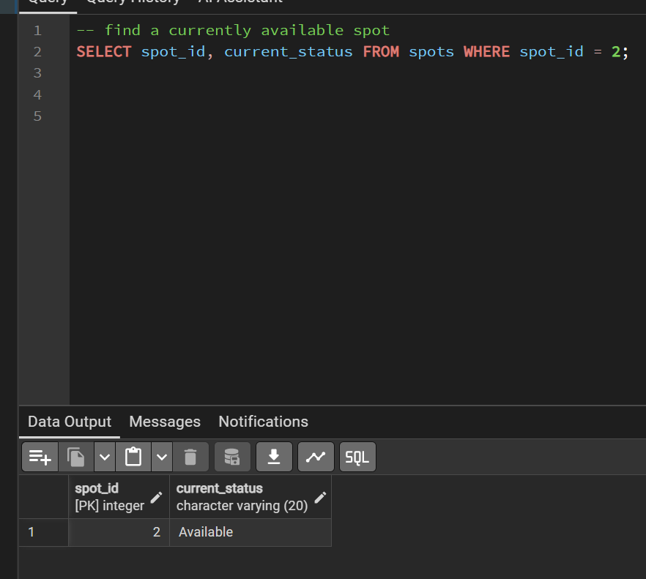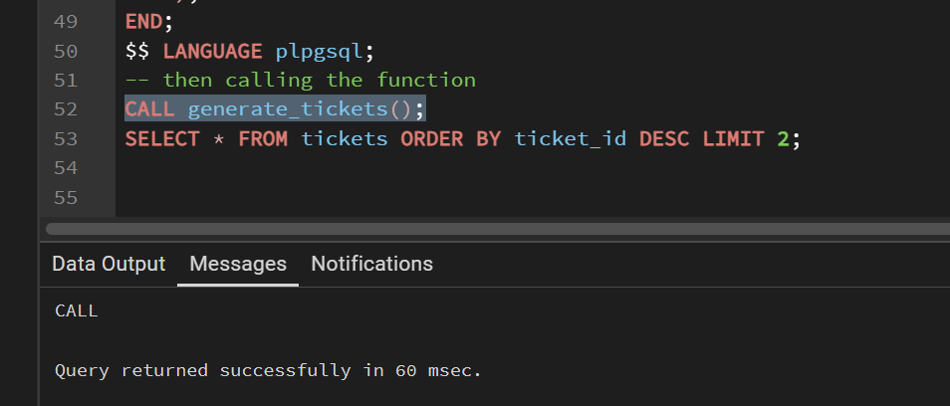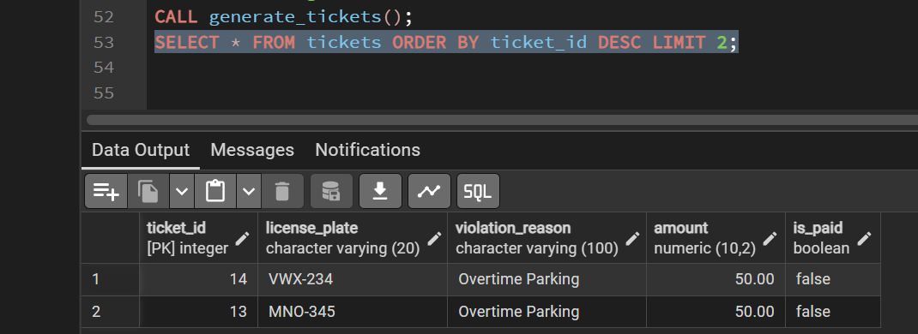

In the images here are some explanations:
CREATE TABLE sensor_events (
event_id SERIAL PRIMARY KEY,
spot_id INT REFERENCES spots(spot_id),
entry_time TIMESTAMP DEFAULT CURRENT_TIMESTAMP,
exit_time TIMESTAMP DEFAULT CURRENT_TIMESTAMP,
CONSTRAINT check_times CHECK (exit_time >= entry_time)
);
- We first add the table
SELECT spot_id, current_status FROM spots WHERE spot_id = 1;
- find a currently available spot

INSERT INTO sensor_events (spot_id, entry_time, exit_time)
VALUES (2, CURRENT_TIMESTAMP, NULL);
- the 2 is for spot_id, like the one above
- insert something in that spot

SELECT spot_id, current_status FROM spots WHERE spot_id = 2;
- we print it again

SELECT COUNT(*) FROM tickets;
- we check the number of tickets we're at now
- We show the current # of tickets in the DB

CREATE OR REPLACE PROCEDURE generate_tickets()
AS $$
BEGIN
INSERT INTO tickets (license_plate, violation_reason, amount, is_paid)
SELECT v.license_plate, 'Overtime Parking', 50.00, FALSE
FROM reservations r
JOIN vehicles v ON r.user_id = v.owner_id
JOIN spots s ON r.spot_id = s.spot_id
WHERE r.end_time < CURRENT_TIMESTAMP -- Reservation is over
AND s.current_status = 'Occupied' -- Car hasn't left
-- Ensure we don't duplicate the same ticket
AND NOT EXISTS (
SELECT 1 FROM tickets t
WHERE t.license_plate = v.license_plate
AND t.violation_reason = 'Overtime Parking'
AND t.is_paid = FALSE
);
END;
$$ LANGUAGE plpgsql;
- then calling the function
CALL generate_tickets();
SELECT * FROM tickets ORDER BY ticket_id DESC LIMIT 2;
- Then when we run we get the final image, this 

