Find a dummy backend where data can be stored: KU2.3

Run the provided backend and provide a screenshot of the
terminal output.

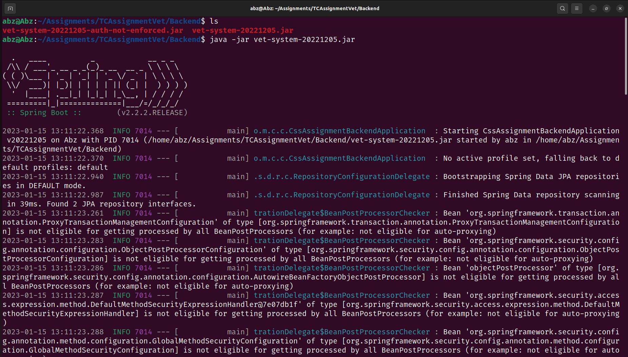
Access the API’s documentation in the browser and provide a
screenshot.
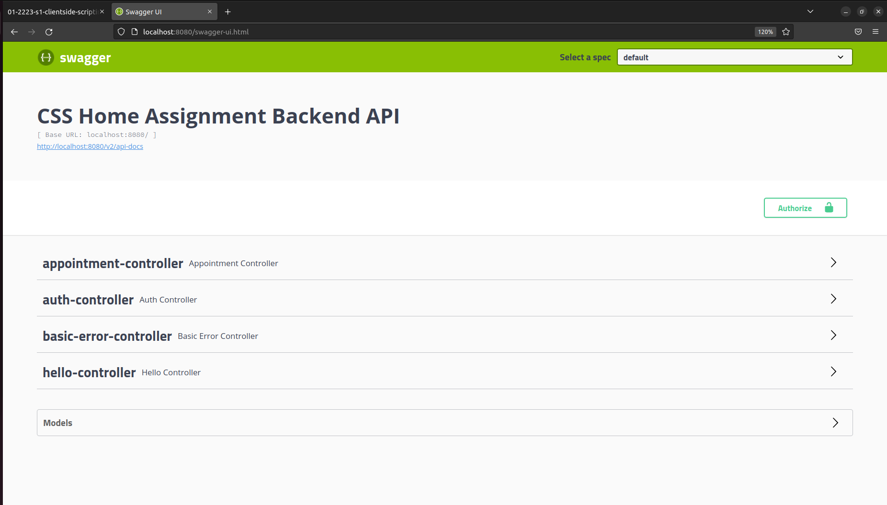
Execute the GET request to retrieve all appointments from
within the API documentation and provide a screenshot.
