Here are the my “Create Table” scripts for homework 2. I was originally going to upload this as a seperate .sql in conjunction with this file, however canvas didn't accept the .sql file. Thus, I have just added the scripts into this file.

/* Tyrus Malmstrom :: CS430 --> Database Managment Systems :: Homework 2 */
/* Script that will setup all the tables required from the ER Diagram */

-- Good Etique --

\echo '\nDropping schema if it already exists.'

DROP SCHEMA IF EXISTS thisMusicProduction CASCADE;

\echo '\nDropping tables if they exist.'

DROP TABLE IF EXISTS thisMusicProduction.Musicians CASCADE;
DROP TABLE IF EXISTS thisMusicProduction.Instrument CASCADE;
DROP TABLE IF EXISTS thisMusicProduction.Album CASCADE;
DROP TABLE IF EXISTS thisMusicProduction.Songs CASCADE;
DROP TABLE IF EXISTS thisMusicProduction.Place CASCADE;
DROP TABLE IF EXISTS thisMusicProduction.Telephone CASCADE;

-----------------------------------------------

\echo '\nCreating schema \'thisMusicProduction\' in which all my relational tables will reside.'

-- Creating the Schema in which all my relational tables will live:
CREATE SCHEMA thisMusicProduction;

\echo '\nCreating Musicians table.'

-- Creating the Musicians table:
CREATE TABLE thisMusicProduction.Musicians(

ssn varchar (11) PRIMARY KEY,
name varchar (15)
);

\echo '\nInserting values into Musicians table.'

-- Insterting values into the Musicians
INSERT INTO thisMusicProduction.Musicians(
ssn,
name
)
VALUES
('147-45-4789','John'),
('256-69-7858', 'Smith'),
('123-45-6789','Tyrus'),
('789-45-6123','Bob'),
('159-52-1563','deadmau5');

------------------------------------------------------

-----------------------------------------------------

\echo '\nCreating Instrument table.'

-- Creating the instrument table:
CREATE TABLE thisMusicProduction.Instrument(

instrid integer PRIMARY KEY,
dname varchar(15),
key varchar(15)

);

\echo '\nInserting values into Instrument table.'

-- Inserting values into the Instruments table:
INSERT INTO thisMusicProduction.instrument(
instrid,
dname,
key
)
VALUES
(1,'Violin','C#'),
(2,'Piano', 'A Minor'),
(3,'Guitar', 'G'),
(4,'Electronic DAW','All keys'),
(5,'Harmonica','A Major');

--------------------------------------------------

--------------------------------------------------

\echo '\nCreating Album table. Also including the \"Producer\" relationship with the \"Musicians\" table'.

-- Creating the Album table:
CREATE TABLE thisMusicProduction.Album(

albumIdentifier INTEGER PRIMARY KEY,
copyrightDate DATE NOT NULL,
speed INTERVAL MINUTE,
title varchar(25),
Musician_ssn varchar(11) NOT NULL REFERENCES thisMusicProduction.Musicians( ssn ) ON DELETE CASCADE -- Producer relationship

);

\echo '\nInserting values into Album table.'

-- Inserting values for the Album table:
INSERT INTO thisMusicProduction.Album(
albumIdentifier,
copyrightDate,
speed,
title,
Musician_ssn
)
VALUES
( 1,'2010-07-29','10:30','For Lack of a Better Name','159-52-1563' ),
( 2,'2008-04-29','5:00', 'While(1<2)', '159-52-1563' ),
( 3,'2009-08-29','6:50', 'Random Ablum Title', '159-52-1563' ),
( 4,'2016-06-29','2:00', '>Album Title Goes Here<', '159-52-1563' ),
( 5,'2007-05-29','8:30', 'W:/2016 Ablum', '159-52-1563' );

-- SELECT * FROM thisMusicProduction.Album;

-------------------------------------------------------

-------------------------------------------------------

\echo '\nCreating Songs table. Also including the \"Appears\" relationship with the Album table.'

-- Creating the Songs table:
CREATE TABLE thisMusicProduction.Songs(

songId integer PRIMARY KEY,
title varchar(30),
suthor varchar(10),
Album_albumIdentifier INTEGER NOT NULL REFERENCES thisMusicProduction.Album( albumIdentifier ) ON DELETE CASCADE -- Appears relationship.

);

\echo '\nInserting values into Songs table.'

-- Inserting values for the Songs table:
INSERT INTO thisMusicProduction.Songs(
songId,
title,
suthor,
Album_albumIdentifier
)
VALUES
(1,'Strobe','deadmau5' , 1),
(2,'My Pet Coelacanth','deadmau5' , 2),
(3,'I Remeber ft. Kaskade','deadmau5', 3),
(4,'The Vedlt','deadmau5' , 4),
(5,'4ware','deadmau5' , 5);

-- SELECT * FROM thisMusicProduction.Songs;

-------------------------------------------------

--------------------------------------------------

\echo '\nCreating Place table.'

-- Creating Place table:
CREATE TABLE thisMusicProduction.Place(

address varchar(45) PRIMARY KEY

);

\echo '\nInserting values into Place table.'

-- Inserting values for the Places table;
INSERT INTO thisMusicProduction.Place(
address
)
VALUES
('3140. Ontario drive'),
('5148. 7 Panagioti Gyanapolou'),
('2250 W. South Drive'),
('1337 Leet Drive'),
('7331 A. This address is cool');

------------------------------------------------

--------------------------------------------------

\echo '\nCreating Telephone table.'

-- Creating Telephone table:
CREATE TABLE thisMusicProduction.Telephone(
phone_no TEXT UNIQUE NOT NULL
);

\echo '\nInserting values into Telephone table.'

INSERT INTO thisMusicProduction.Telephone(
phone_no
)
VALUES
('303-653-5478'),
('654-251-4789'),
('125-458-7963'),
('111-454-7888'),
('111-222-3334');

--------------------------------------------------------

\echo '\nNow, creating and setting up the relational tables between entities. Some may be many-to-many while others 1-to-many.\n'

-- Identifiying relationships (tables):

-- Creating the relationship talbe between Musicians and Instruments:
-- This is a *m*any to *m*any relationship --> m:m
-- Introducing foreign key constraints:

\echo '\nCreating Perform table: m:m'

CREATE TABLE thisMusicProduction.Perform(

Musician_ssn varchar(11) REFERENCES thisMusicProduction.Musicians( ssn ) ON UPDATE CASCADE, -- update automatically if upddated in referenced / parent table.
Songs_songId integer REFERENCES thisMusicProduction.Songs( songId ) ON UPDATE CASCADE,
PRIMARY KEY( Musician_ssn,Songs_songId )

);

\echo '\nInserting values into Perfom table. Values are *dependent* on values from other previously defined tables. Specifically Musicians and Songs.'

INSERT INTO thisMusicProduction.Perform(
Musician_ssn,
Songs_songId
)
Values
('147-45-4789',1),
('256-69-7858',3),
('123-45-6789',2),
('789-45-6123',5),
('159-52-1563',4);

------------~~~~~~~~~~~~~~~~~~~~~~~~~~~~~~~~~~~~~~~~-----------------

-- Creating the relationship talbe between Musicians and Instruments:
-- This is a *m*any to *m*any relationship --> m:m
-- Introducing foreign key constraints:\

\echo 'Creating Plays table: m:m'

CREATE TABLE thisMusicProduction.Plays(

Musician_ssn varchar(11) REFERENCES thisMusicProduction.Musicians( ssn ) ON UPDATE CASCADE,
Instrument_instrid integer REFERENCES thisMusicProduction.Instrument( instrid ) ON UPDATE CASCADE,
PRIMARY KEY( Musician_ssn, Instrument_instrid )

);

\echo '\nInserting values into Plays table. Values are *dependent* on values from other previously defined tables. Specifically Musicians and Instrument.'

INSERT INTO thisMusicProduction.Plays(
Musician_ssn,
Instrument_instrid
)
VALUES
('159-52-1563',2),
('123-45-6789',4),
('256-69-7858',1),
('789-45-6123',3),
('147-45-4789',5);

-- SELECT COUNT(*) FROM thisMusicProduction.Plays;

-------------------------------------------------------

\echo '\nCreating the \"Home\" table for the \"Place\" and \"Telephone table relationship\".'

CREATE TABLE thisMusicProduction.Home(

Place_address varchar(45) REFERENCES thisMusicProduction.Place( address ) ON UPDATE CASCADE,
Telephone_phone_no TEXT UNIQUE NOT NULL REFERENCES thisMusicProduction.Telephone( phone_no ) ON UPDATE CASCADE,
PRIMARY KEY( Place_address )

);

\echo '\nInserting values into Home table. Values are *dependent* on values from other previously defined tables. Specifically \"Place\" and \"Telephone\".'

INSERT INTO thisMusicProduction.Home(
Place_address,
Telephone_phone_no
)
VALUES
('3140. Ontario drive', '303-653-5478'),
('5148. 7 Panagioti Gyanapolou','654-251-4789'),
('2250 W. South Drive', '125-458-7963'),
('1337 Leet Drive', '111-454-7888'),
('7331 A. This address is cool','111-222-3334');

-- SELECT * FROM thisMusicProduction.Home;

-----------------------------------------------------------

\echo '\nCreating the \"Lives\" relationship bewteen the two tables \"Musicians\" and the aggregation of \"Home\" entity relationship set.'

CREATE TABLE thisMusicProduction.Lives(

Musician_ssn varchar(11) REFERENCES thisMusicProduction.Musicians(ssn) ON UPDATE CASCADE,
Place_address varchar(45) REFERENCES thisMusicProduction.Home( Place_address ) ON UPDATE CASCADE,
PRIMARY KEY( Musician_ssn, Place_address )

);

\echo '\nInserting values into \"Lives\" table. Values are *dependent* on values from other previously defined tables. Specifically \"Musicians\" and the aggregation of \"Home\" entity relationship set.'

INSERT INTO thisMusicProduction.Lives(

Musician_ssn,
Place_address

)
Values
('147-45-4789','2250 W. South Drive'),
('256-69-7858', '1337 Leet Drive'),
('123-45-6789','5148. 7 Panagioti Gyanapolou'),
('789-45-6123','7331 A. This address is cool'),
('159-52-1563','3140. Ontario drive');

-- SELECT * FROM thisMusicProduction.Lives;

-- Show all list of relations in PostgreSQL:
\dt thisMusicProduction.*;

-- done.

Below are all my tables. Both showing the schema of the tables, and the tables populated with data.
The picture below just showcases all the relations / tables within the database (specifically under the 'thismusicproduction' schema). It is the \dt <schema_name>.* command used in PostgreSQL.

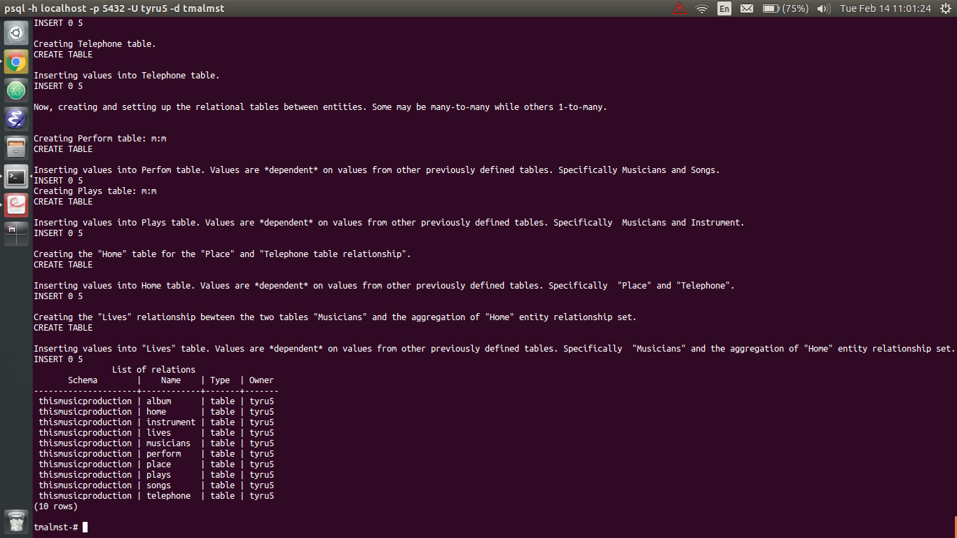
~~~~~~~~~~~~~~~~~~~~~Now starts the listing of the relations / tables:~~~~~~~~~~~~~~~~~~~~~~
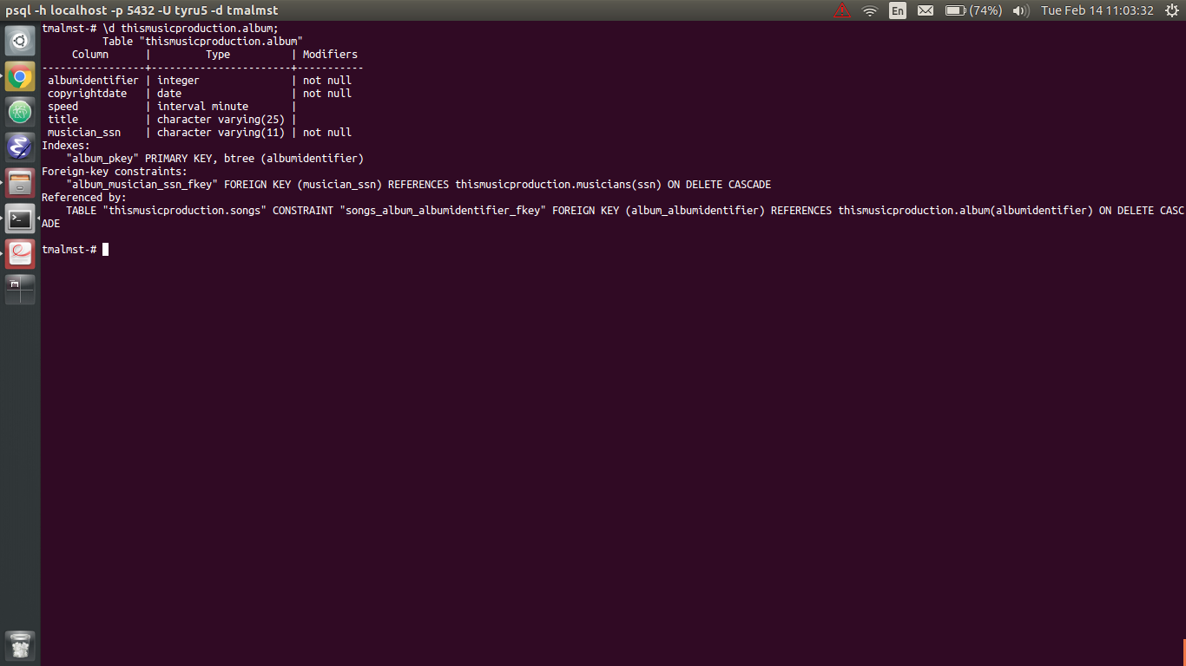

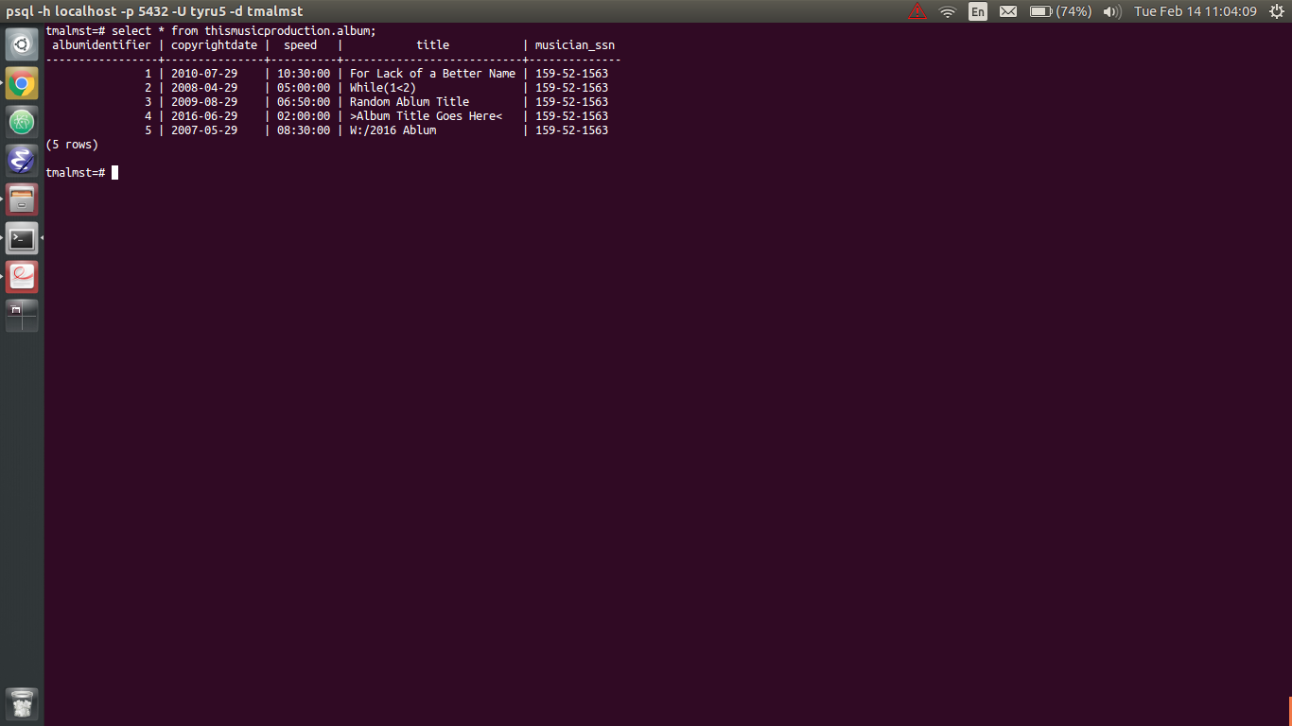

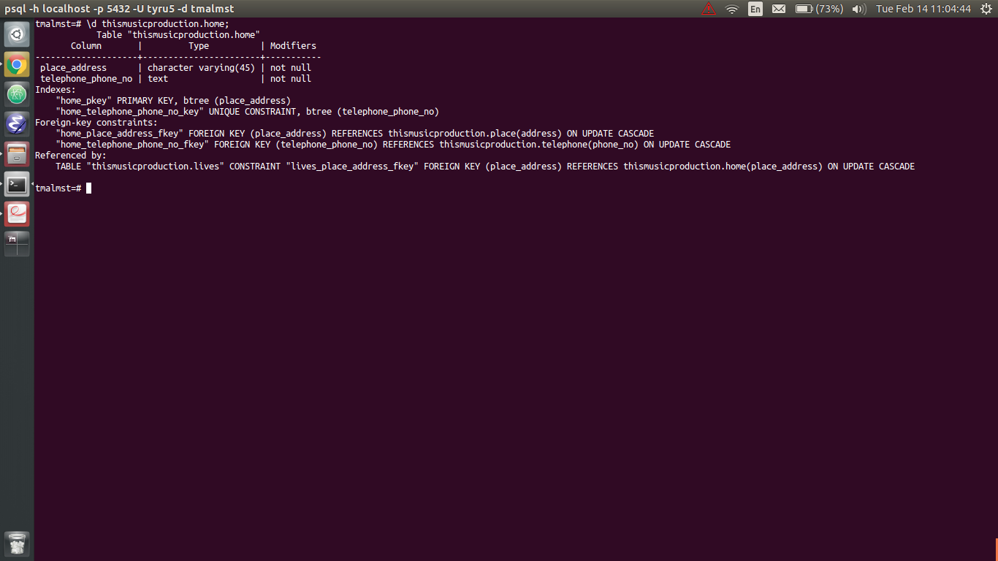

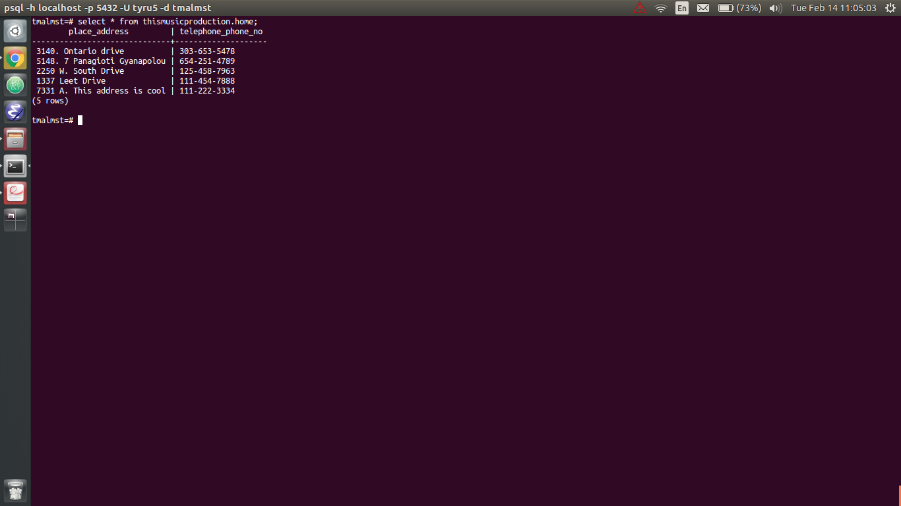

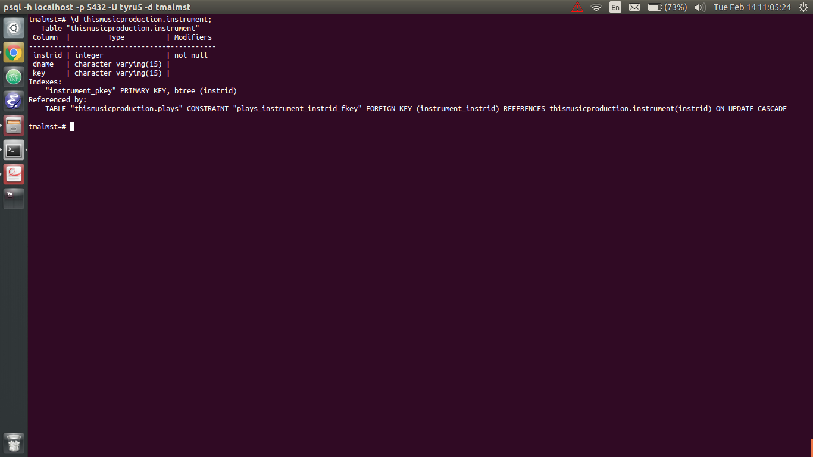

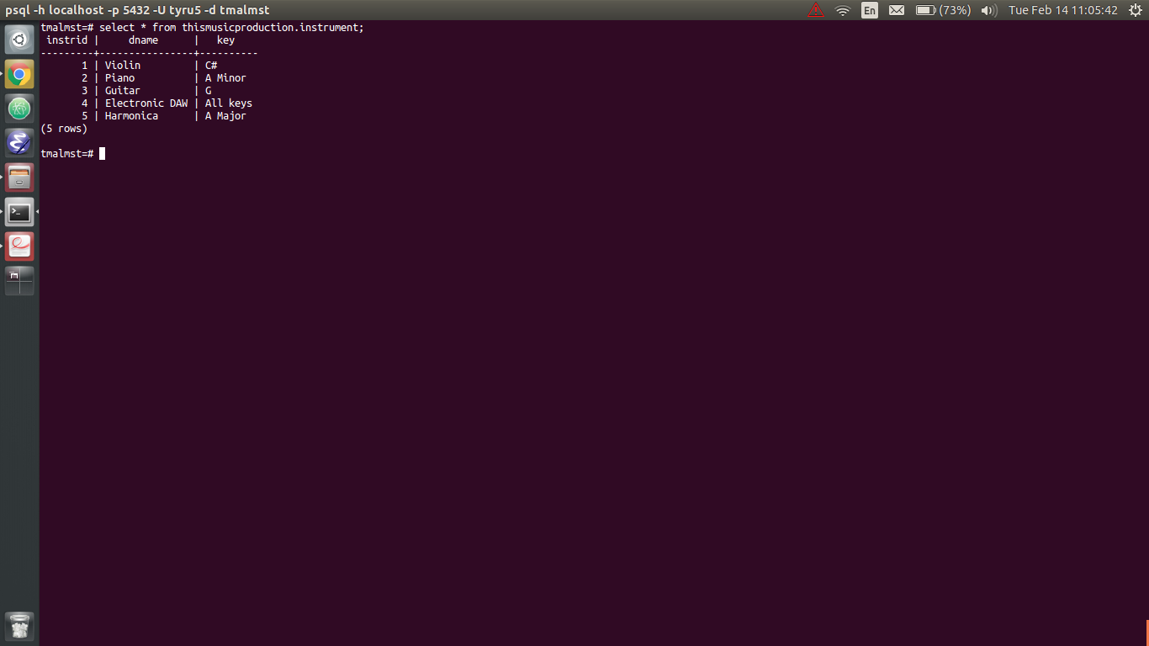

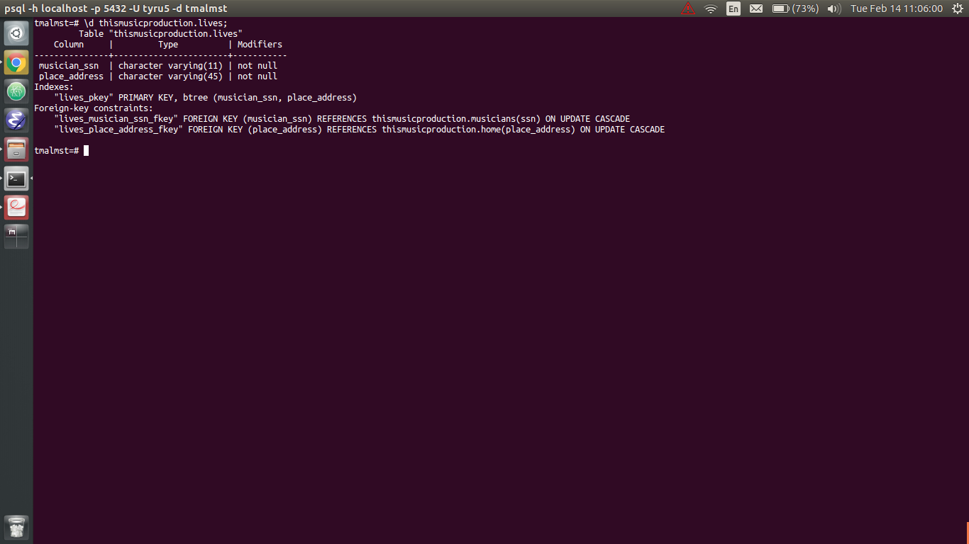

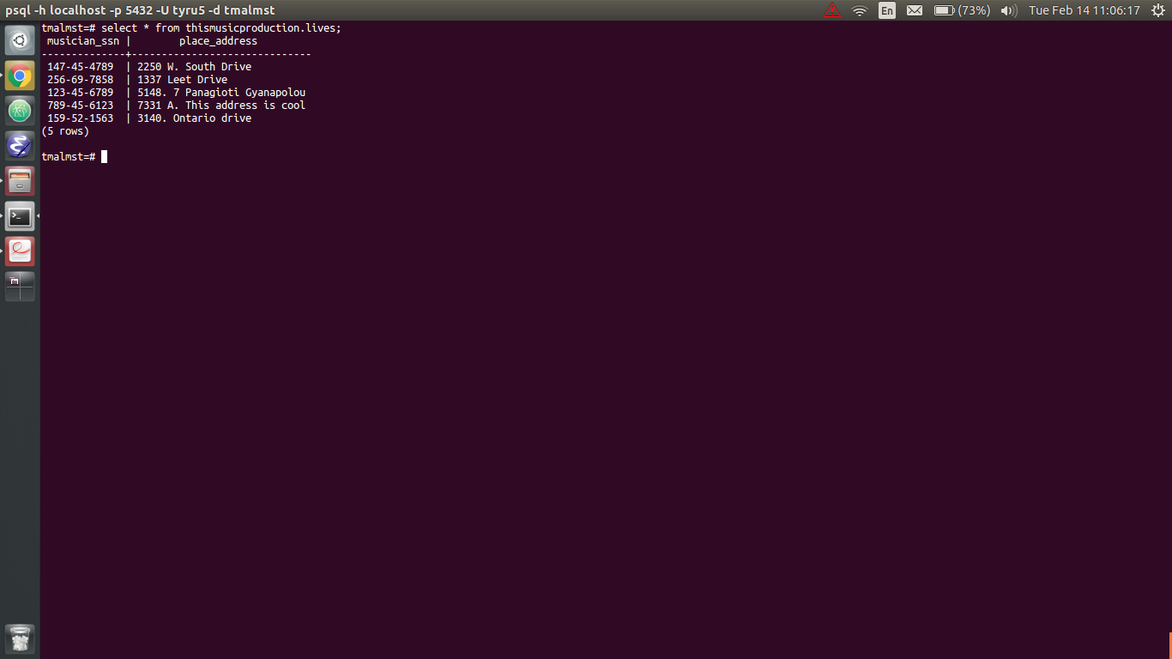

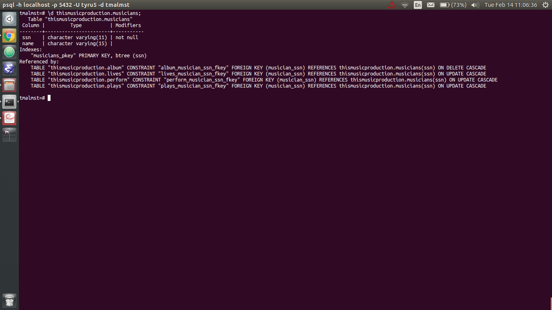

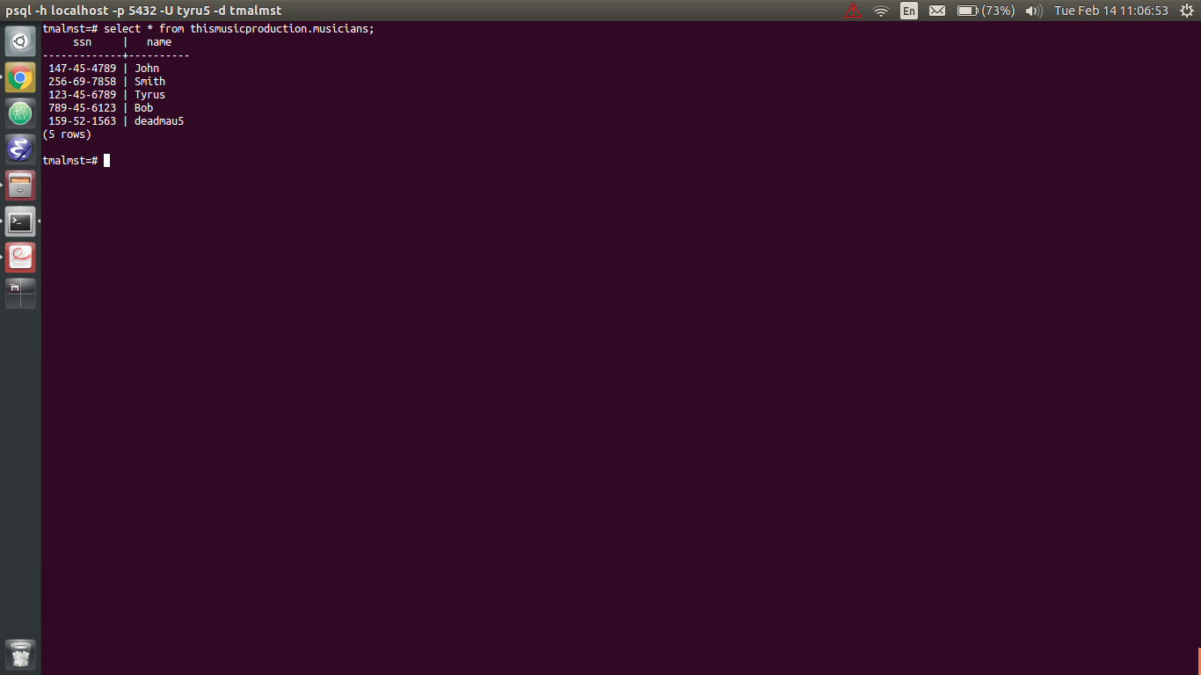

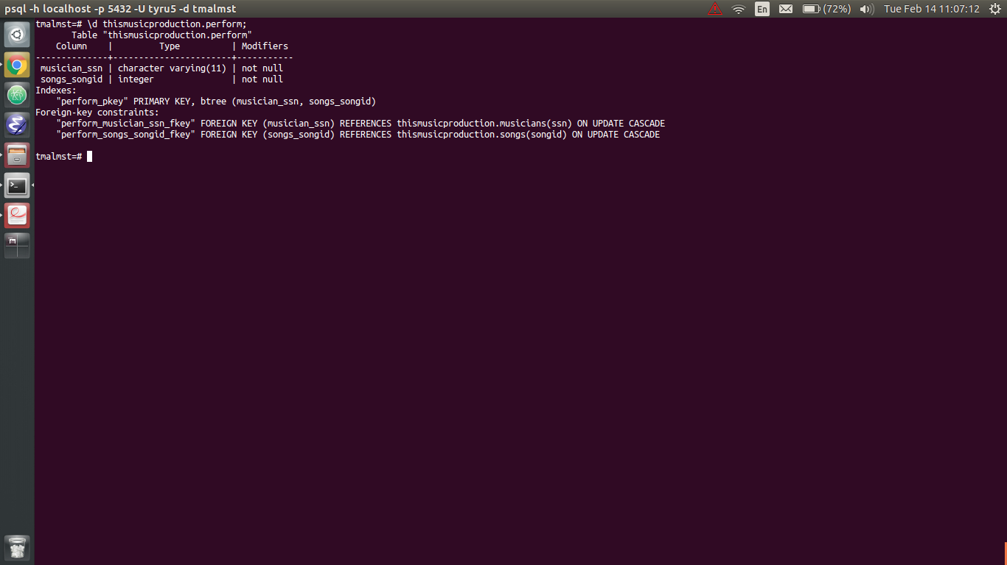

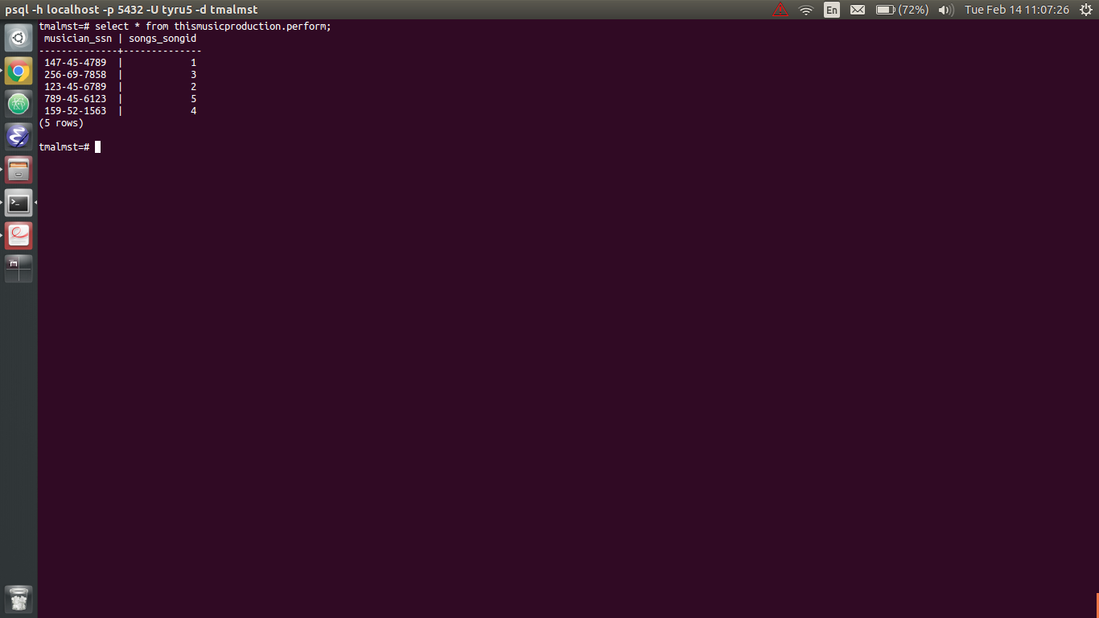
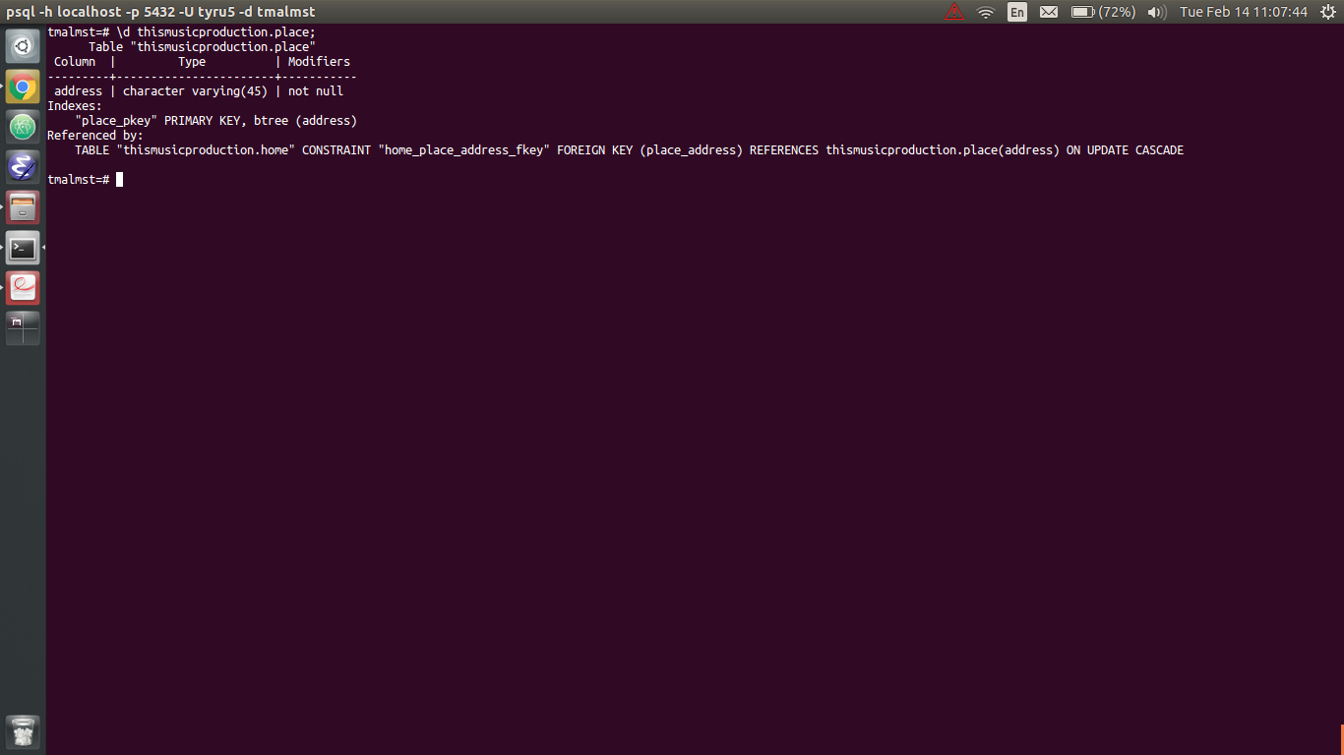

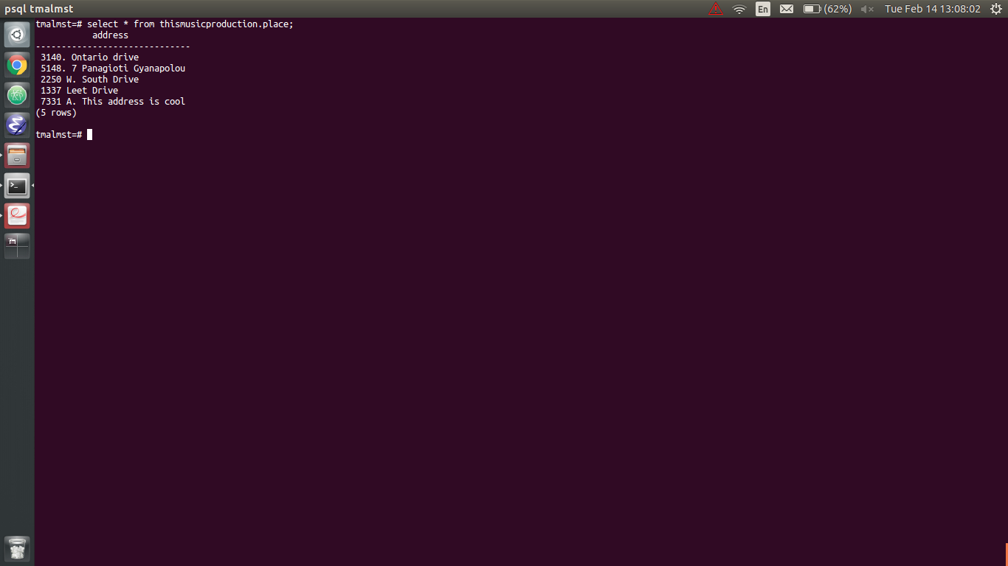

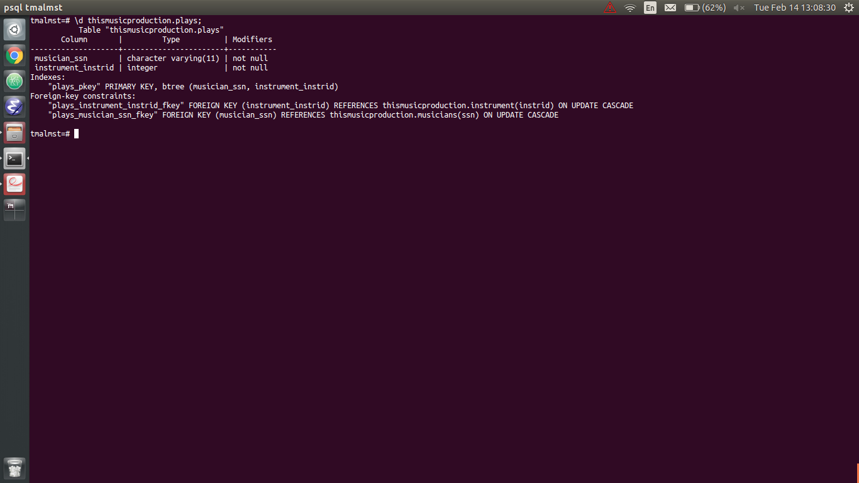

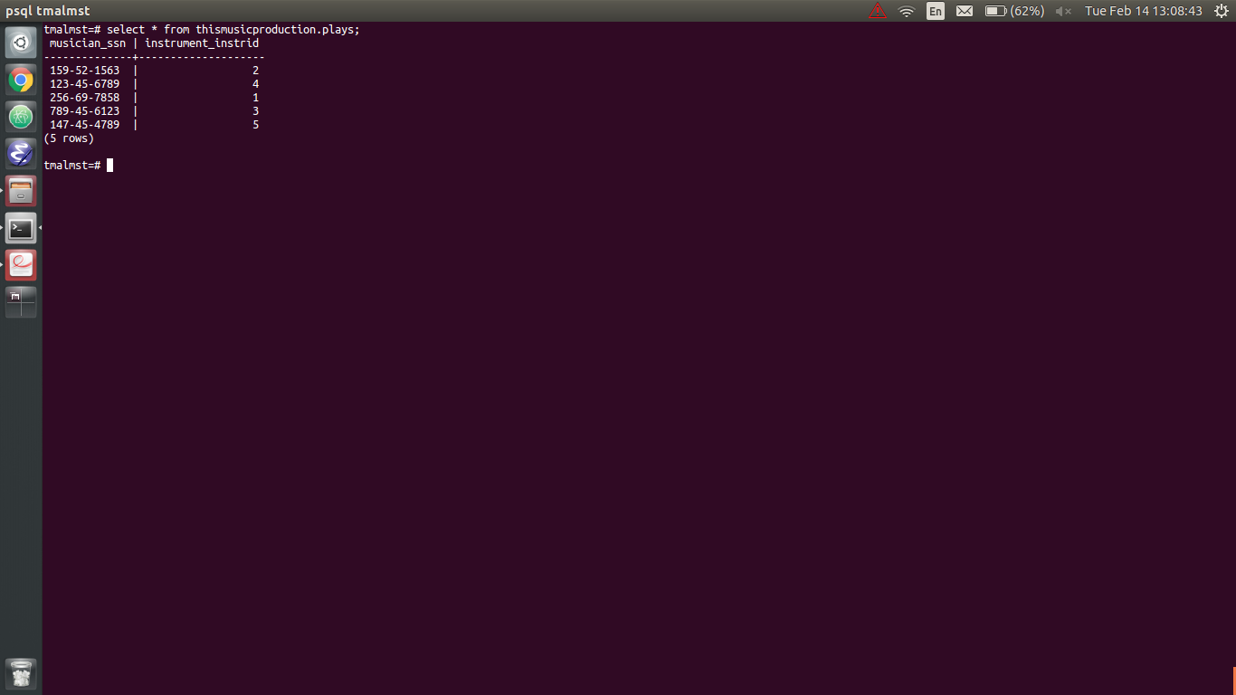

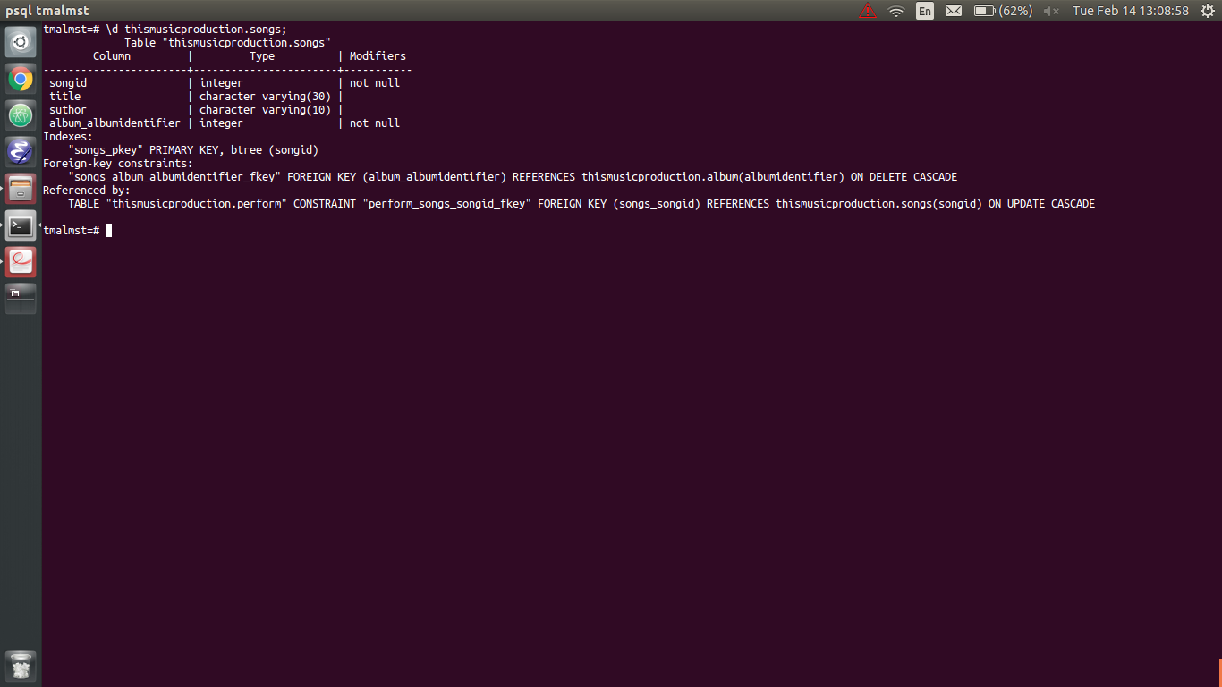

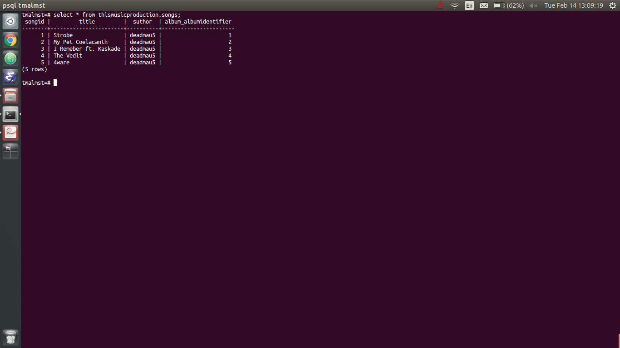

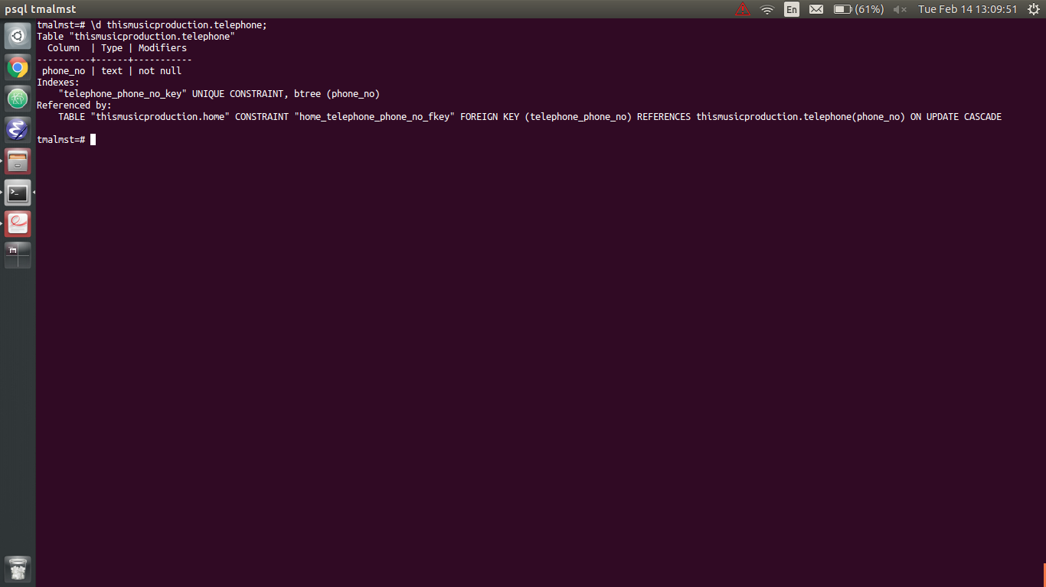

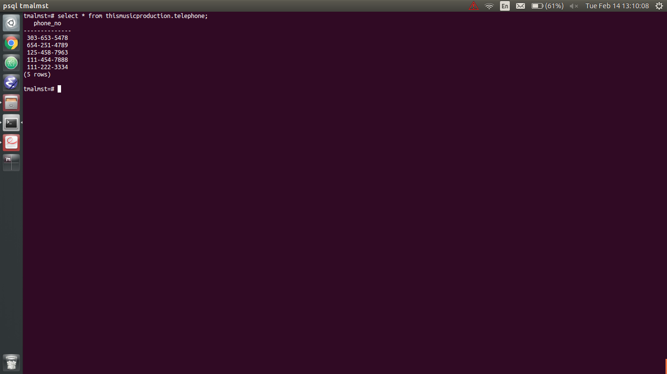
Those are all my tables, including all entities, attributes, relationships, and primary, foreign key constraints stated within the assignment description.

Best,
Tyrus Malmstrom.

