Pearson correlation coefficient
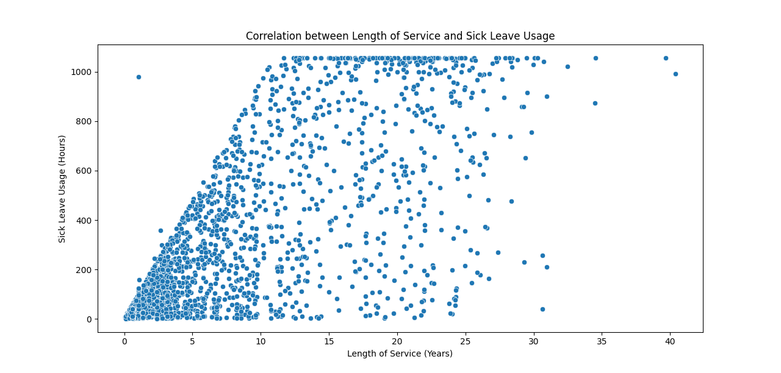
Correlation Coefficient (0.73):
This number quantifies the strength and direction of the linear relationship between the length of service (in years) and sick leave usage (in hours).
A value of 0.73 means there is a strong positive relationship between the two variables. In practical terms, as the length of service increases, the amount of sick leave usage also tends to increase.
P-value (0.0000):
This number helps us determine the statistical significance of the correlation coefficient.
A p-value of 0.0000 is extremely low, which means there is very strong evidence against the null hypothesis (which states that there is no relationship between the variables).
This low p-value indicates that the observed correlation is highly unlikely to have occurred by chance, and therefore, the relationship between length of service and sick leave usage is statistically significant.

Data Summary
Statistic | Employee ID | AdjustedLengthOfServiceYears | PayRate | AvailableHours
Count | 2038 Entries
Mean |  | 8.652002 | 53.798332 | 341.699751
STD |  | 7.963936 | 20.318772 | 349.13149
MIN |  | 0.07 | 20.89 | 0.530044
25% |  | 2.18 | 39.62 | 56.532961
50% |  | 5.86 | 50.845 | 194.646031
75% |  | 13.63 | 64.38 | 561.5579
max |  | 40.39 | 250.79 | 1056.0024

- Count: This indicates the number of entries in the dataset, which is 2038.
- Mean (Average):
  - Adjusted Length of Service Years: The average length of service is approximately 8.65 years.
  - Pay Rate: The average pay rate is $53.80 per hour.
  - Available Hours: The average number of available hours is 341.70
- Standard Deviation (STD): This measures the amount of variation or dispersion from the mean.
  - Adjusted Length of Service Years: A standard deviation of 7.96 years indicates variability in the length of service.
  - Pay Rate: A standard deviation of $20.32 shows variability in pay rates.
  - Available Hours: A standard deviation of 349.13 hours indicates variability in available hours.
- Minimum (MIN): The smallest value in the dataset.
  - Adjusted Length of Service Years: The shortest length of service is 0.07 years.
  - Pay Rate: The lowest pay rate is $20.89 per hour.
  - Available Hours: The fewest available hours are 0.53.
- 25th Percentile (25%): 25% of the data falls below this value.
  - Adjusted Length of Service Years: 2.18 years.
  - Pay Rate: $39.62 per hour.
  - Available Hours: 56.53 hours.
- Median (50%): The middle value of the dataset.
  - Adjusted Length of Service Years: 5.86 years.
  - Pay Rate: $50.85 per hour.
  - Available Hours: 194.65 hours.

- 75th Percentile (75%): 75% of the data falls below this value.
  - Adjusted Length of Service Years: 13.63 years.
  - Pay Rate: $64.38 per hour.
  - Available Hours: 561.56 hours.
- Maximum (MAX): The largest value in the dataset.
  - Adjusted Length of Service Years: The longest length of service is 40.39 years.
  - Pay Rate: The highest pay rate is $250.79 per hour.
  - Available Hours: The most available hours are 1056.00.

