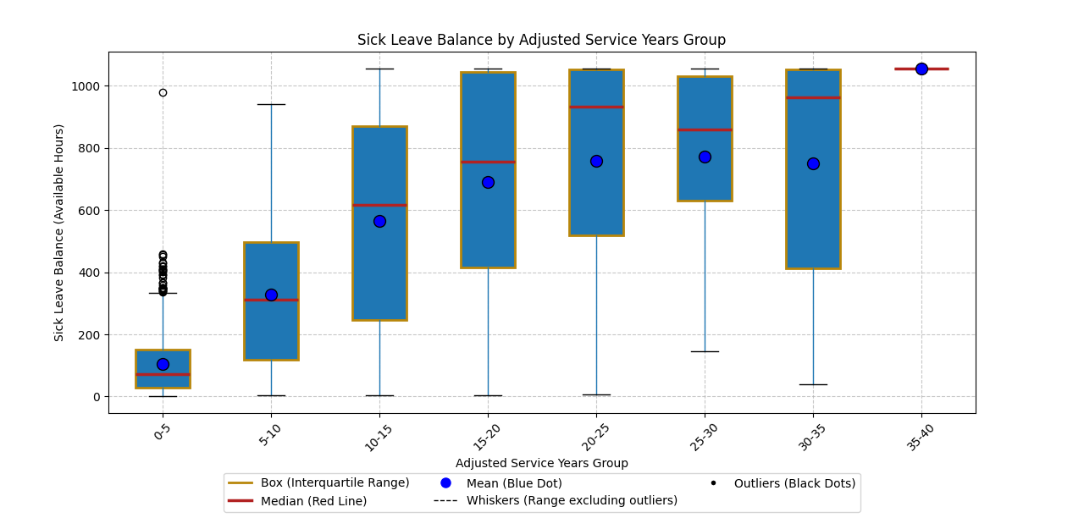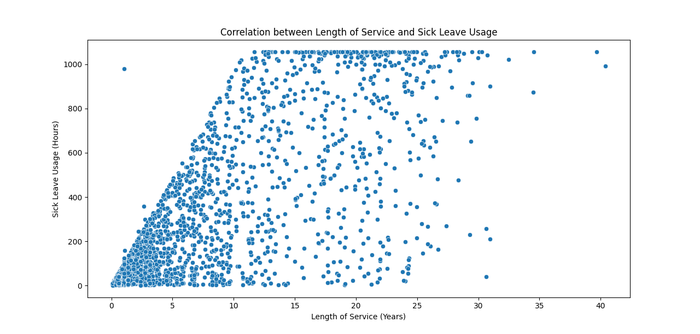

Analysis of Subgroups in Sick Leave Balance
This analysis focuses on the Sick Leave Balance (Available Hours) for different subgroups based on Adjusted Service Years. The data is visualized using a boxplot, which provides a clear representation of the distribution of Sick Leave Balance within each subgroup.

Key Points:
1. **Subgroups**: The data is divided into subgroups based on ranges of Adjusted Service Years.
2. **Boxplot**: Each box represents the distribution of Sick Leave Balance within a specific subgroup.
- **Box (Interquartile Range)**: The box shows the interquartile range (IQR), which contains the middle 50% of the data.
- **Median (Red Line)**: The red line inside the box represents the median Sick Leave Balance for each subgroup.
- **Mean (Blue Dot)**: The blue dot represents the mean Sick Leave Balance for each subgroup.
- **Whiskers (Range excluding outliers)**: The whiskers extend from the box to the smallest and largest values within 1.5 times the IQR from the lower and upper quartiles.
- **Outliers (Black Dots)**: Individual points outside the whiskers are considered outliers.

ANOVA Results:
The ANOVA (Analysis of Variance) test was conducted to determine if there are statistically significant differences between the means of different subgroups based on Adjusted Service Years. The results are as follows:
F-statistic: 354.4523
p-value: 0.0000
The F-statistic is a measure of the ratio of variance between the groups to the variance within the groups. A higher F-statistic indicates a greater difference between group means. The p-value indicates the probability that the observed differences are due to chance. A p-value of 0.0000 suggests that there is a statistically significant difference between the means of different subgroups.

Tukey's HSD Test Results:
Tukey's HSD (Honestly Significant Difference) test was performed as a post hoc analysis to identify which specific groups differ from each other. The results are as follows:
- **0-5 years vs. Other Groups**: Significant differences were found between the 0-5 years group and all other groups, with p-values of 0.0, indicating strong evidence of differences in Sick Leave Balance.
- **10-15 years vs. 5-10 years**: The 10-15 years group showed significant differences with the 5-10 years group, with a p-value of 0.0.
- **Other Comparisons**: Comparisons such as between the 15-20 years and 20-25 years groups did not show significant differences, with p-values greater than 0.05.
These results help identify significant differences in Sick Leave Balance between different subgroups based on Adjusted Service Years.

