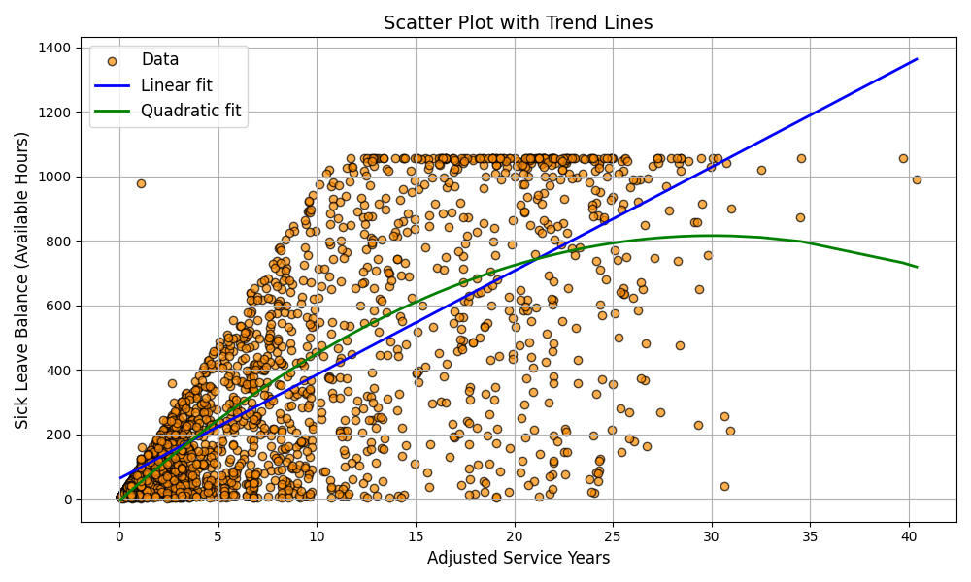

Analysis of Trend Lines in the Correlation Between Adjusted Service Years and Sick Leave Balance
This report provides a specific analysis of the trend lines in the scatter plot visualizing the correlation between Adjusted Service Years and Sick Leave Balance (Available Hours) for employees. The analysis focuses on the linear and quadratic trend lines to capture the relationship between these two variables.

Key Points:
1. **Linear Trend Line (Blue)**: This line represents a linear relationship between Adjusted Service Years and Sick Leave Balance. It shows the general trend of how Sick Leave Balance changes with Adjusted Service Years.
2. **Quadratic Trend Line (Green)**: This line represents a quadratic relationship between Adjusted Service Years and Sick Leave Balance. It provides a more flexible fit to capture any non-linear patterns in the data.

Interpretation:
- If the Linear Trend Line fits well, it suggests a consistent rate of change in Sick Leave Balance with Adjusted Service Years.
- If the Quadratic Trend Line fits better, it indicates that the rate of change in Sick Leave Balance varies with Adjusted Service Years. For example, there might be an initial increase followed by a decrease or vice versa.

Additional Calculations:
Linear Fit Parameters:
- Slope (a) = 32.1713: This indicates that for each additional year of adjusted service, the sick leave balance increases by approximately 32.1713 hours. It shows a positive linear relationship between service years and sick leave balance.
- Intercept (b) = 63.3539: This is the expected sick leave balance when the adjusted service years are zero. It provides a starting point for the linear trend line.
- R-squared = 0.5385: This value indicates how well the linear model fits the data. An R-squared value of 0.5385 means that approximately 53.85% of the variability in sick leave balance can be explained by the linear relationship with adjusted service years. While this shows a moderate fit, it suggests that other factors might also influence sick leave balance.
Quadratic Fit Parameters:
- a = -0.9095: This coefficient indicates the curvature of the quadratic trend line. A negative value suggests that the relationship between service years and sick leave balance initially increases and then decreases, forming a parabolic shape.
- b = 54.6785: This is the linear coefficient in the quadratic equation, showing the initial rate of change in sick leave balance with service years.
- c = -5.6452: This is the constant term in the quadratic equation, representing the expected sick leave balance when the adjusted service years are zero.
- R-squared = 0.5646: This value indicates how well the quadratic model fits the data. An R-squared value of 0.5646 means that approximately 56.46% of the variability in sick leave balance can be explained by the quadratic relationship with adjusted service years. This slightly higher R-squared value compared to the linear model suggests that the quadratic model captures the data’s variability a bit better, indicating a more complex relationship.
Summary:
- The linear model shows a steady increase in sick leave balance with service years, but it only explains about 53.85% of the variability in the data.
- The quadratic model suggests a more nuanced relationship, with an initial increase in sick leave balance followed by a decrease, explaining about 56.46% of the variability.

