Report on Sick Leave Usage Analysis 2022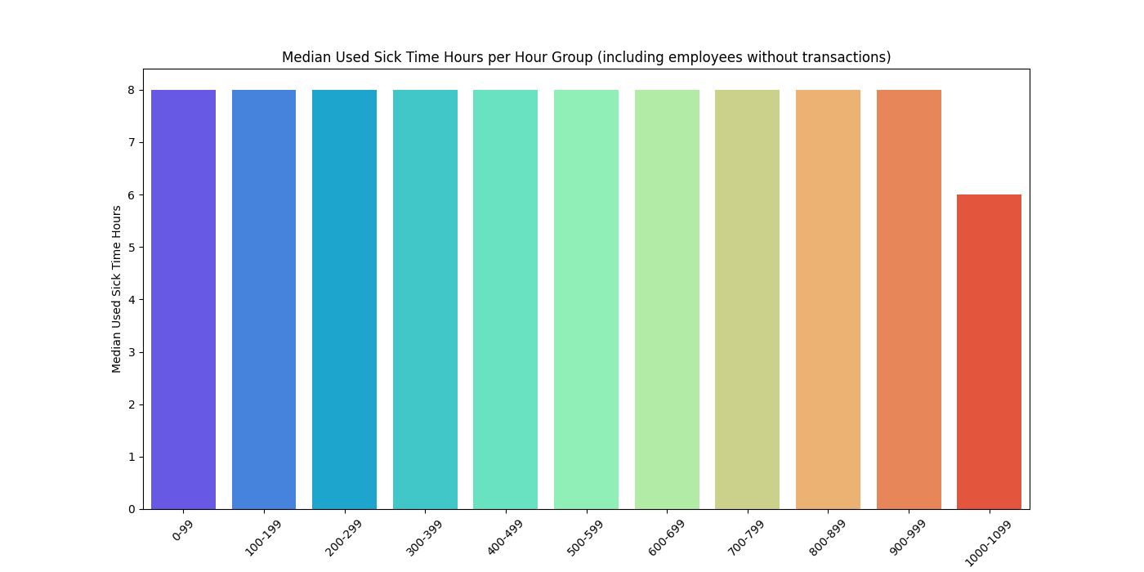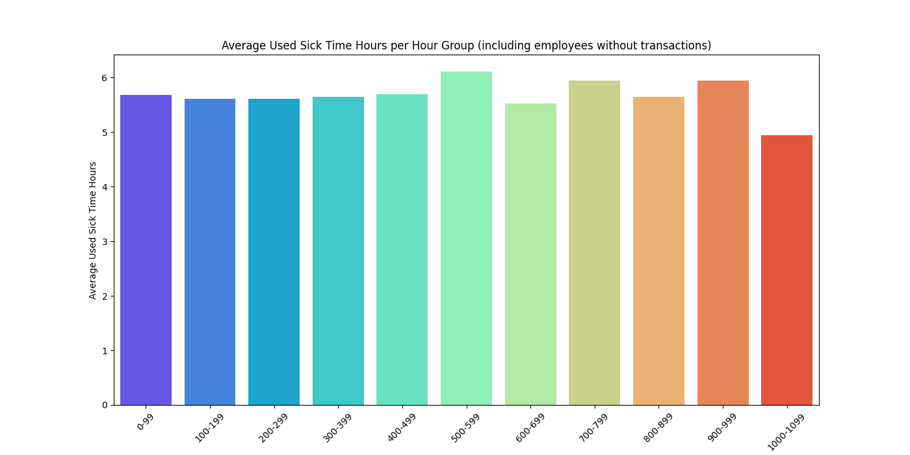

Introduction
This report provides an analysis of sick leave usage among employees, focusing on the distribution of sick leave hours, the median and mean values, and the implications for liability accounting. The analysis aims to understand common sick leave patterns and provide insights for budgeting and policy making.

Data Overview
The dataset contains records of sick leave transactions, including the number of hours taken and the available hours per employee. Employees are grouped based on their current balance of available hours, and the analysis includes employees with no recorded sick leave transactions, accounted for with zero hours.
Hour Group | Mean | Median | Total Employee Count | Employees with Transactions | Employees without Transactions | Percentage of Total Employees
0-99 | 5.688979 | 8.0 | 337 | 317 | 20 | 16.54%
100-199 | 5.611805 | 8.0 | 280 | 224 | 56 | 13.74%
200-299 | 5.611074 | 8.0 | 171 | 135 | 36 | 8.39%
300-399 | 5.643039 | 8.0 | 140 | 121 | 19 | 6.87%
400-499 | 5.69051 | 8.0 | 91 | 77 | 14 | 4.47%
500-599 | 6.116006 | 8.0 | 91 | 69 | 22 | 4.47%
600-699 | 5.527586 | 8.0 | 70 | 50 | 20 | 3.43%
700-799 | 5.946435 | 8.0 | 60 | 40 | 20 | 2.94%
800-899 | 5.643003 | 8.0 | 71 | 50 | 21 | 3.48%
900-999 | 5.950784 | 8.0 | 92 | 65 | 27 | 4.51%
1000-1099 | 4.947743 | 6.0 | 169 | 68 | 101 | 8.29%

Key Metrics

Employee Counts:

Total Employees: 1572

Employees With Transactions: 1216

Employees Without Transactions: 356

Percentages:

Employees with transactions: 77.35%

Employees without transactions: 22.65%

Weighted Average of Sick Leave Hours per Month:
Weighted Average: 5.62 hours
- The weighted average provides a more accurate reflection of overall sick leave usage by considering the distribution of employees across different hour groups. It accounts for the fact that some groups have more employees than others.

Analysis and Explanations
Median Value of 8:
o The median value of 8 hours in many groups suggests that a significant number of employees are taking exactly one full workday (8 hours) of sick leave.
(This in other words means about half of employees take half days or more.)
o This is likely since standard workdays are typically around eight hours.
Mean Values:
o The mean values vary across different hour groups indicating that while some employees take full days off others might take partial days.
o The mean values are generally lower than the median values in groups with a median of eight suggesting that there are many instances of partial day sick leaves as well.
Count of Employees in Each Group:
o The count of employees in each group provides insight into how many employees fall into each hour group category.
o This helps in understanding the distribution of available hours among employees and how it correlates with their sick leave usage.

Employees Without Transactions:
o A significant number of employees have no recorded sick leave transactions.
o These employees have been accounted for with zero hours used in the analysis to ensure accurate metrics.

Practical Application
Budgeting for Sick Leave:
o We can use the median to estimate the typical sick leave usage per employee which helps in setting realistic expectations for most employees.
o We can use the mean to estimate the total sick leave liability for the entire workforce which helps in understanding the overall financial impact and ensuring sufficient reserves are in place.
By using both the median and mean we can gain a comprehensive understanding of sick leave usage and make informed decisions for liability accounting and policy making.

