**Desktop Organizer User Guide**

*Copyright © 2010 by Surgical Grade Software*

**About Organizer**

Organizer is a simple yet powerful desktop notepad application that helps you to manage your notes, files, links, and other information in one convenient place.

**Layout**

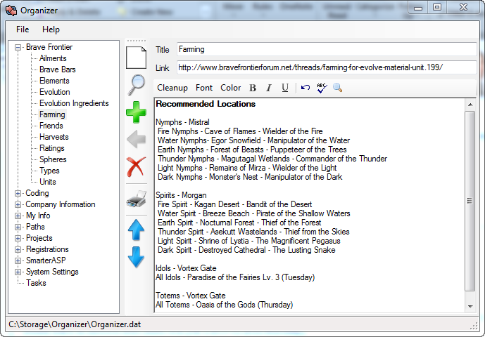

On the left is the outline Treeview which organizes your topics. You can create any hierarchy you like to best manage your information. Click on any topic to view the details on the right.

Down the middle is a toolbar that gives you quick access to the operations you commonly need to perform.

On the right is the details section. On the top right is the topic name, below that is any file or web link associated with that topic, and the large area is the editor notepad that contains the information describing the selected topic. Above the editor is the editor toolbar.

**Creating a New Item**

1. Enter information in the Description, Link, and Editor Boxes.
2. Drag using the Drag button (green plus sign) to the target parent in the Treeview. Drag to an open area in the Treeview to place the new topic at the root level.
3. All items will appear in alphabetical order beneath their parent item. To specify a particular order, you should “trick” it using numbers or letters to begin each item.

**Updating an Existing Item**

1. Select an item in the Treeview on the left.
2. Edit the Description, Link, and/or Details on the right.
3. Click the Update button (green left arrow) to save your changes. Be aware that, by design, if you do not explicitly update any changes will NOT be saved.

**Copying an Item**

1. Just use the Drag button (green plus sign) to copy any existing Item to a new parent item.

**Deleting an Item**

1. Select the item in the Treeview on the left.

2. Click the Delete button (red x sign).

**Moving an Item**

1. To move, you can just copy the item to a new parent and then delete the old item.

**Creating Items from External Sources**

1. Drag any file, URL, or text from Word, IE, etc to the target parent item in the Treeview. You will automatically create a new topic.
2. Copy and paste any text or images from any external source to the editor to insert content.

**Opening a Link**

1. Select an item in the Treeview on the left.
2. Click the Open button (the magnifier)
3. Note: this is only enabled if there is a valid URL or file path in the Link field.
4. Organizer will open the file or URL specified in the Link field in the appropriate viewer.

**Saving Changes**

1. All changes will be saved automatically when you add, update, or delete an item.

**Printing an Item**

1. To send the current item to the default printer, just click the Printer icon.
2. Note that this will only print the current topic, not the children. To print a topic with children, use the “Save to Clipboard” feature to get the contents for printing through Word or another application.

**Copying to Clipboard**

1. Right click on the topic you wish to copy to the Windows Clipboard.
2. Click the desired option to copy to the Windows Clipboard.
   1. Copy Topic -> Text Format
   2. Copy Topic -> Rich Format
   3. Copy Topic -> Organizer Format
   4. Copy Branch -> Text Format
   5. Copy Branch -> Rich Format
   6. Copy Branch -> Organizer Format
3. Text format is plain unformatted text.
4. Rich format is Rich Text Format (RTF) that should retain all graphics and formatting.
5. Organizer format can only be pasted back into Organizer (see below).

**Pasting Topics into Organizer**

1. Copy a topic or branch in Organizer format (see above).
2. Right click on the topic to copy to and select the paste option.
   1. Paste Topic (or Branch) -> At Same Level
   2. Paste Topic (or Branch) -> Under This Topic
3. Note that you can copy between Organizer databases or instances using this capability.

**Expanding and Collapsing**

1. To collapse all tree items, click the “collapse all” button (the blue up arrow).
2. To expand all tree items, click the “expand all” button (the blue down arrow).

**Cleaning Up your Text**

1. Often times the text you paste in, particular if copied from a browser session, may have a lot of unwanted formatting. To quickly clean up this formatting and return to plain text, just click the Cleanup button in the toolbar above the text editor.

**Text Formatting**

1. Use the toolbar above the editor window to change your font, font color, bold, italic, and underlined formatting. There is also a button to undo recent changes, to spell-check, and to search and replace within your topic.

**Managing your Data Files**

1. Organizer automatically saves all your topics in a file called Organizer.dat by default. You can change the name or location of this by using the Save As item in the File Menu.
2. Alternatively, you if you manually move your data file, or wish to change your data file, you can open a new file using the Open item in the File Menu.
3. To create a backup copy of your data file, you can do this quickly using the Backup To item in the File Menu. This option copies your file without making it your current working file.
4. Your current working file is shown in the Status Bar on the bottom of the Organizer window.
5. Note that if you want to access your data file from different locations, you can locate your data file in Dropbox, Skydrive, or some other shared file system.